WireMock standalone server test case evidences and json mappings

1. Downloaded the Wiremock standalone jar file
2. Inorder to start the server ran the command “java –jar Wiremock-standalone- 2.26.3.jar” then the server by default starts at port numer 8080

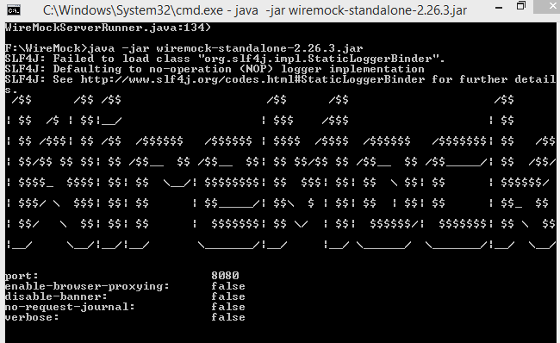

1. Then in the root directory of this wiremock server we can see couple of folders generated called “mappings” and “__files”

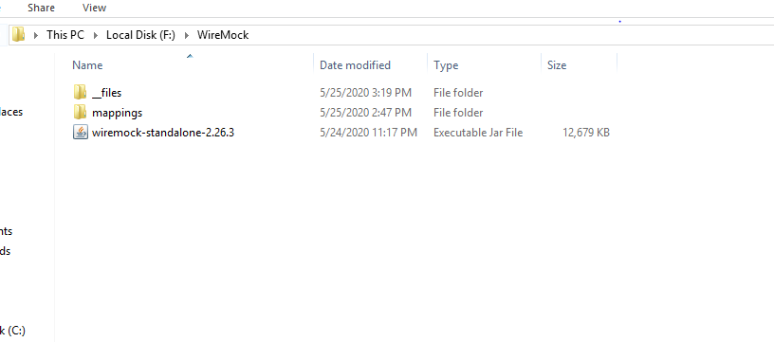

Mappings:- we must save the request specification json files, this will set the contract for the request

__files:- this folder contains response specifications

1. We can also create a request specification by hitting the following endpoint

<http://localhost:8080/__admin/mappings>

sample body message

{

"request": {

"method": "GET",

"url": "/login"

},

"response": {

"status": 200,

"body" : "username is pradeep",

"headers":{

"content-type":"application/json"

}

}

}

Response:

{

  "id": "922bcbee-8de2-415b-bbb9-55cc16f83c46",

  "request": {

    "url": "/login",

    "method": "GET"

  },

  "response": {

    "status": 200,

    "body": "username is pradeep",

    "headers": {

      "content-type": "application/json"

    }

  },

  "uuid": "922bcbee-8de2-415b-bbb9-55cc16f83c46"

}

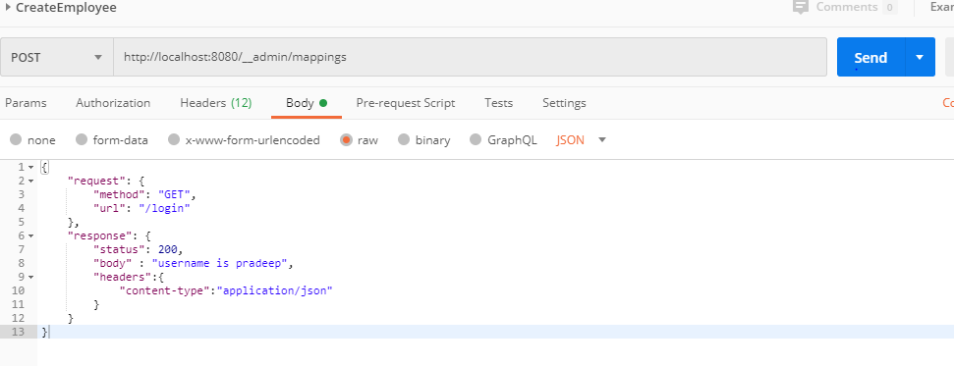

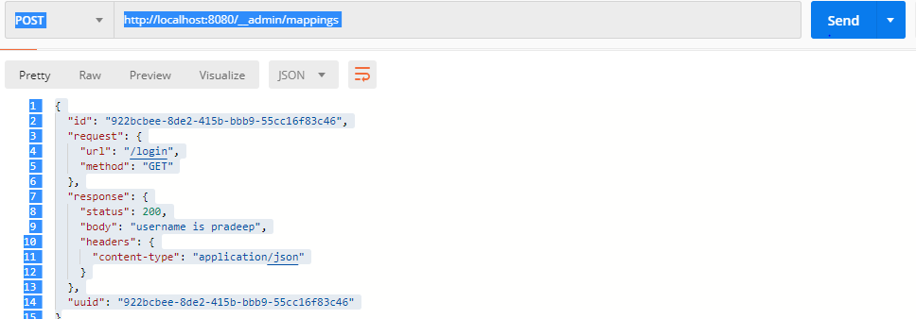

Since we have created a stub for basic user login, endpoint when we perform a get request we get the following response

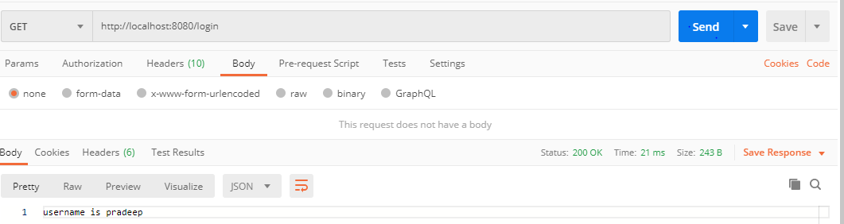

If at all the wrong URL is being called we will get the following error from the server.

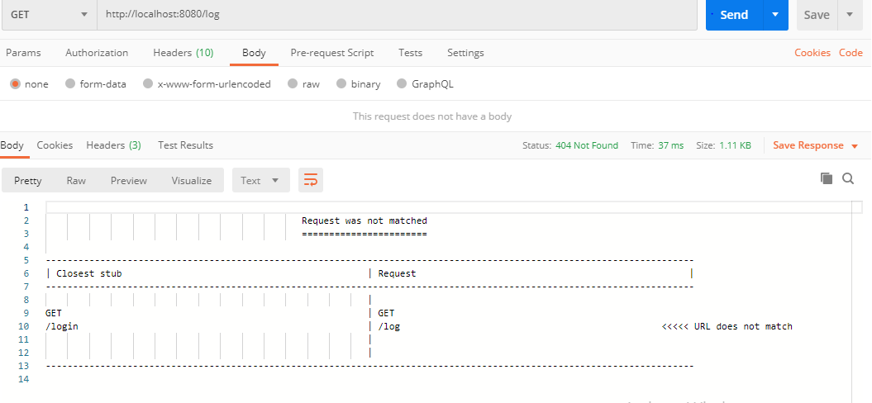

Here are a couple of stubs created for login and logout operations

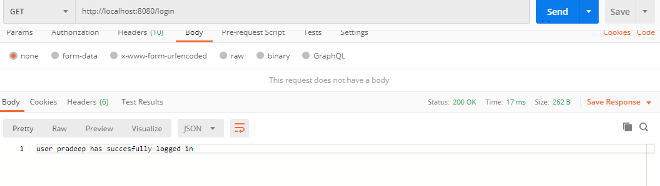

Here is the stub for logout operation

