CHARITY HUB
A PROJECT REPORT
Submitted by
MILONI PATEL

In partial fulfillment for the award of the degree
Of
BACHELOR OF ENGINEERING
In
INFORMATION TECHNOLOGY

SILVER OAK COLLEGE OF ENGINEERING & TECHNOLOGY, AHMEDABAD
GUJARAT TECHNOLOGICAL UNIVERSITY, AHMEDABAD
April 2015

SILVER OAK COLLEGE OF ENGINEERING & TECHNOLOGY
INFORMATION TECHNOLOGY

CERTIFICATE
Date:

This is to certify that the project work entitled “CHARITY HUB” has been justification
carried out by MILONI PATEL under my guidance in partial fulfillment of the degree of Bachelor of Engineering in INFORMATION TECHNOLOGY of Gujarat Technological University, Ahmadabad during the academic year 2014- 15.

Guides: DARSHIL SHAH Head of the Department
.

Acknowlegement

At this moment of my substantial enhancement I rarely find enough words to express my gratitude towards those who have constantly involved with me during my project.

We heartily thank our faculty of I.T Dept. who gave us the opportunity to develop the project of the “NGO “for a company.

We are sincerely indebted to my internal guide Mr.DARSHIL SHAH would like to thank them for their guidance and time to time inspirational remarks that help us in timely completion of the project.

We thank to college who have allowed me to do project and provide me all the related facilities.

Table of contents
(list of figures)

Figure No. | Figure Name | Page No.
2.1 | Time Line Chart | 0
5.1 | Use-Case Diagram | 05
5.2 | E-R Diagram | 07
5.3 | Class Diagram | 08
5.4 | Activity Diagram | 09
5.6 | Control Flow Diagram(Level-0) | 012
5.5 | Data Flow Diagram(Level-1) | 013
5.6 | Data Flow Diagram(Level-2) | 014
8.1 | Testing Process

Figure No. | Figure Name | Page No.
2.1 | Time Line Chart
5.1 | Use-Case Diagram
5.2 | E-R Diagram | 07
5.3 | Class Diagram | 08
5.4 | Activity Diagram | 09
5.6 | Control Flow Diagram(Level-0) | 012
5.5 | Data Flow Diagram(Level-1) | 013
5.6 | Data Flow Diagram(Level-2) | 014
8.1 | Testing Process

ABSTRACT

NGOs play a complementary role to government in fulfilling the needs of bottom of the pyramid. They are instrumental in lowering the gap between haves and have notes. They act as caretakers of downtrodden strata of society. NGOs carry out varied activities in the field of human rights, health, women empowerment, child welfare, education, women welfare, welfare for blind, tribal up-liftmen, vocational training etc. Trust a differentiated NGO which plays a central role in protecting the flora and fauna of the most neglected desert region. The function of trust becomes more reflective and imperative as its functioning is funded by individual donors without any aid of government. trust supplements this role further by actively working for the noble cause of education, environmental awareness, and financial support for education of girls, dissemination of environmental knowledge, literature and promoting camps for removal of addiction. trust operates in a unique niche, when compared to other NGOs. The all time support and full time role played by trust is commendable as it serves the animals, birds, environment and humanity on selfless grounds, which depicts the social service in true sense. The miniature activities of trust are giant enough to cast a gleam on the face of rural desert people. Trust is an NGO with a factual and splendid difference.

INTRODUCTION

Purpose and scope
Project planning and scheduling
System analysis

- Project Summary
trusts set up for the social causes and approved by the Income Tax Department, get not only exemption from payment of tax but also the donors to such trusts can deduct the amount of donation to the trust from their taxable income

2.Purpose
The legal framework in India recognizes activities including "relief of the poor, education, medical relief, preserving monuments and environment and the advancement of any other object of general public utility" as charitable purposes

3.Scope
charity also receive benefits under law including exemption from various procedural provisions of the Companies Act, either fully or in part, and are also entitled to such other exemptions that the Central Government may accord through its orders

Objective

2. | To construct the building etc. for boarding and lodging for those who are interested in charity.
3. | To organize charities trust in the country and abroad in order to propagate the seminars for charity trust.
4. | To open and establish charitable hospitals for the treatment of the helpless poor out caste and also to distribute free medicines, cloths and food articles in the tribal areas.
5. | To furnish and equip the charitable hospital with modern medical facilities.
6. | To find out the new facilities of children and women in charity trust.

2. PROJECT PLANNING AND SCHEDULING: PREPARE GANTT CHART
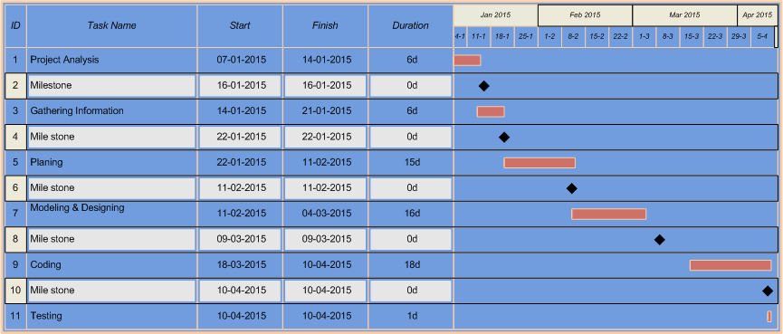
Fig 1.1

3. SYSTEM ANALYSIS
A.CURRENT SYSTEM:
Only NGOs that perform well are likely to survive and grow in the long term. Organization’s that fail to manage themselves appropriately, struggle to achieve their mission and find it difficult to create real change are likely to ultimately found themselves cast by the wayside in favor of more efficient ones. Therefore, the ability to be able to strategically evaluate your organization’s performance is crucial to its long term sustainability.

B.PROBLEMS:
. Strengths and Weaknesses describe ‘where the project or organization is now: the existing resources that can be used immediately and current problems that won’t go away. It can help identify where new resources, skills or allies will be needed’. Both refer to ‘technical, financial, promotional, networking, knowledge’ or competency based factors internal to the programmers. ‘When thinking of strengths it is useful to think of real examples of success to ground and clarify the conversation’. Strengths are ‘those things that are working well in a project or situation. The aspects people are proud to talk about’ and which differentiate the program from others. Weaknesses are ‘those things that have not worked well’ or that the program is less efficient in than others.

C.NEW SYSTEM
The SWOT analysis is a highly effective tool for understanding and decision making for all businesses including NGOs. SWOT is an acronym for Strengths, Weaknesses, Opportunities and Threats. The tool can be used for business planning, strategic planning, competitor evaluation, marketing, product development and more.
D.LIST OF MODULES:
- Register: Any new user needs to register for Use system.
- Login: Registered user can use this system for track order and other facilities.
- Admin: Admin who can full authority to change the system & manage all data.
- User/ customer: User who use this system and gives order to the Company.
- Manager/Receptionist: Who manage data and stores data in system and also manage raw material purchase details.

E.SYSTEM REUIREMNTS:
S/W Requirements:
- Front-End: PHP 5.5.12, JAVA SCRIPT,CSS
- Back-End: MYSQL Server
- : INTERNET EXPLORER 7.0 OR ANY BROWSER
H/W Requirement:
Intel Pentium II or above Processor
- 64 MB RAM or Above
- 5 GB Hard Disk or Above
- 15” Color Monitor (800*600 Resolution 32 bit High Color)

1. USE-CASE Diagram

2. E-R Diagram

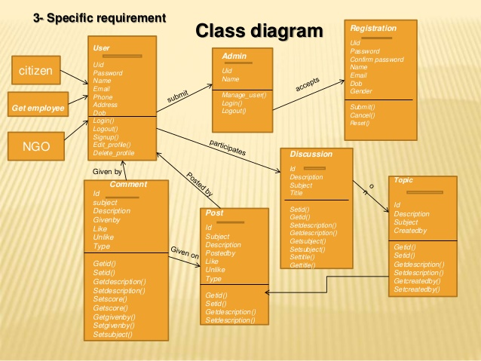

4. Activity- Diagram
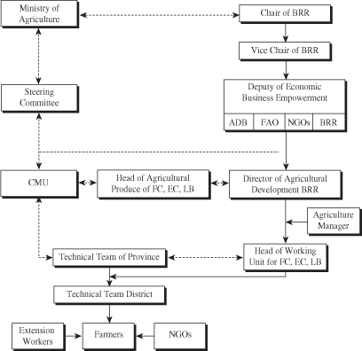

5. DATA FLOW Diagram
6. Data Dictionary
Login table
Field name | Data type | Size | Constraint | Description
Id | Int | 15 | Primary key | Particular id of user
Email | Varchar | 50 |  | Email id of user
Password | Varchar | 15 |  | Paw for login

Registration table
Field name | Data type | Size | Constraint | Description
Id | Int | 15 | Primary key | Particular id of user
Name | Varchar | 50 |  | User name
Mobile-no. | Varchar | 15 |  | User’s mobile no.
City | Varchar | 50 |  | City of user
Password | Varchar | 15 |  | Paw of user for login

Track table
Field name | Data type | Size | Constraint | Description
Id | Int | 11 | Primary key | Particular id of user
Order_id | Int | 5 |  | Order no. of user
Status | Varchar | 15 |  | Display status of order

Conclusion
As this volume illustrates, civil society generally, and NGOs in particular, have played and continue to play an important role in ensuring the optimal effectiveness and success of the African regional human rights system and its aim to prohibit and prevent torture and other ill-treatment in Africa

References
www.codeproject.com
http://www.stackoverflow.com
http://www.php.net
www.php5-tutorial.com/
http://en.wikipedia.org/wiki/Systems_design
http://www.w3school.com
http://www.tutorialspoint.com/php/

