**STEPS FOR INSTALL WAMP SERVER:-**

**STEP-1**  select the exe file of wamp server and follow the steps as following

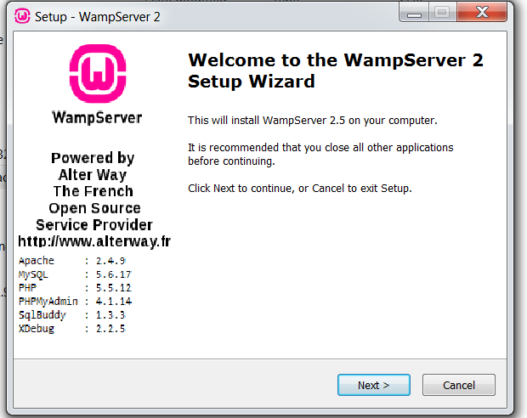

**STEP-2**

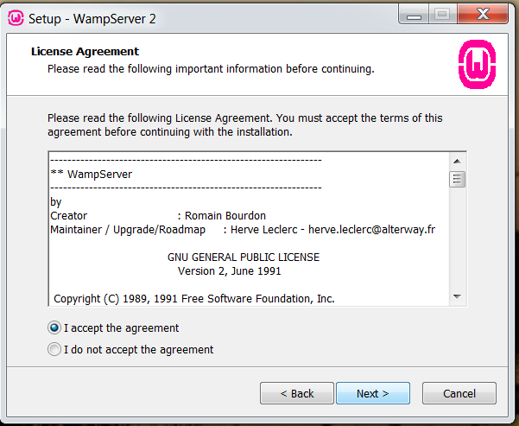

**STEP-3**

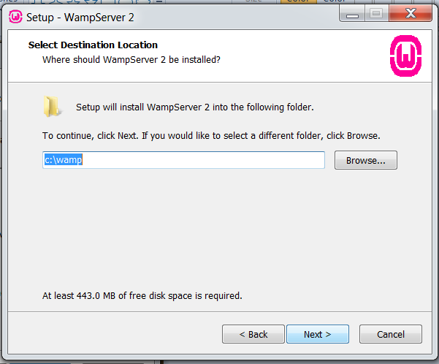

**STEP-4**

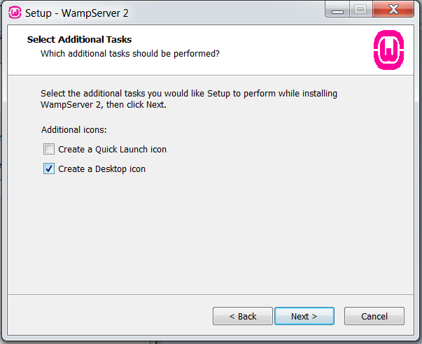

**STEP-5**

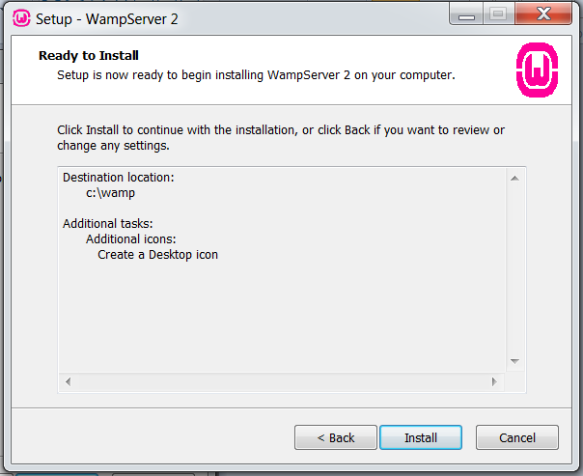

**STEP-6**

