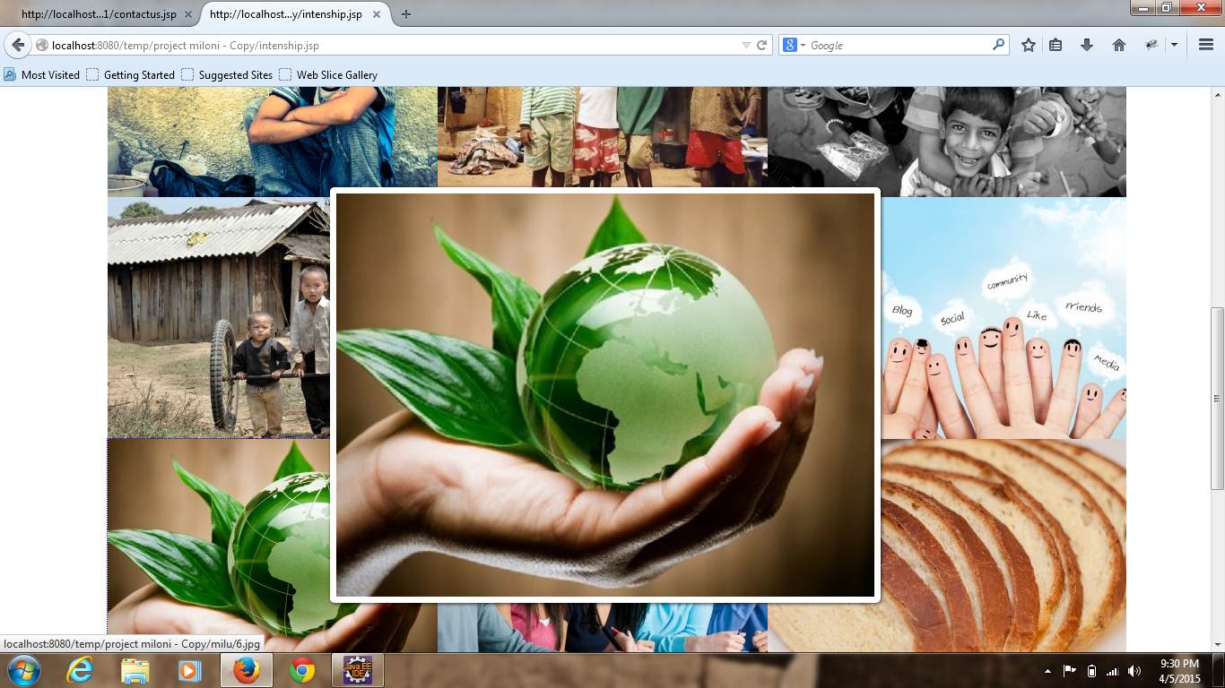

<html>

<head>

<link href=*"style.css"* rel=*"stylesheet"*></link>

<link href=*"style4.css"* rel=*"stylesheet"*></link>

</head>

<body>

<div class=*"main"*>

<header>

<div class=*"header"*>

<div class=*"he"*>

<a href=*"#"*><div class=*"he1"*></div></a>

<div class=*"he2"*>

<div class=*"he3"*></div>

<div class=*"he4"*>1800-222-223-22</div>

<div class=*"he5"*>

<div class=*"he6"*></div>

<div class=*"he7"*>Contact@charityhubWP.org</div>

</div>

</div>

</div>

</div>

</header>

<div class=*"menu"*>

<div class=*"menu1"*>

<div class=*"mn"*></div>

<div class=*"mn1"*></div>

</div>

<div class=*"menu2"*>

<div class=*"men"*>

<a href=*"#"*><div class=*"men1"* style="background-repeat:*no-repeat*;background:*url('krunal/k1.png')*;"></div></a>

<a href=*"#"*><div class=*"men1"* style="background-repeat:*no-repeat*;background:*url('krunal/k2.png')*;"></div></a>

<a href=*"#"*><div class=*"men1"* style="background-repeat:*no-repeat*;background:*url('krunal/k3.png')*;"></div></a>

<a href=*"#"*><div class=*"men1"* style="background-repeat:*no-repeat*;background:*url('krunal/k4.png')*;"></div></a>

<a href=*"#"*><div class=*"men1"* style="background-repeat:*no-repeat*;background:*url('krunal/k5.png')*;"></div></a>

</div>

<nav class=*"men2"*>

<ul>

<li><a href=*"index.html"*><b>HOME</b></a></li>

<li><a href=*"service.html"*><b>SERVICE</b></a></li>

<li><a href=*"ourstory.html"*><b>OUTSTORY</b></a></li>

<li><a href=*"whatwedo.html"*><b>WHAT WE DO</b></a></li>

<li><a href=*"intenship.html"*><b>INTENSHIP</b></a></li>

<li><a href=*"contactus.html"*><b>CONTACT US</b></a></li>

<li><a href=*"#"*><b>LOGIN</b></a></li>

</ul>

</nav>

</div>

<div class=*"menu3"*>

<div class=*"mn"*></div>

<div class=*"mn1"*></div>

</div>

</div>

<div class=*"gallary"*>

<div class=*"gallary1"*><b>Gallery 3 Columns</b></div>

</div>

<div class=*"gal"*>

<div class=*"gal1"*>Gallery 3 Columns Without Caption</div>

<div class=*"gae"*>

<div class=*"gae1"* style="background:*url('img/9918584196_f0dcbcff49_b-400x300.jpg')*;background-repeat:*no-repeat*;background-size:*358px 250px*;"></div>

<div class=*"gae1"* style="background:*url('img/10178237_50029f600e_b-400x300.jpg')*;background-repeat:*no-repeat*;background-size:*358px 250px*;"></div>

<div class=*"gae1"* style="background:*url('img/8373693614_5f747ee310_b-400x300.jpg')*;background-repeat:*no-repeat*;background-size:*358px 250px*;"></div>

<div class=*"gae1"* style="background:*url('img/4000413429_4a58947d77_b-400x300.jpg')*;background-repeat:*no-repeat*;background-size:*358px 250px*;"></div>

<div class=*"gae1"* style="background:*url('img/Fotolia_32292396_Subscription_Monthly_XL-400x300.jpg')*;background-repeat:*no-repeat*;background-size:*358px 250px*;"></div>

<div class=*"gae1"* style="background:*url('img/Fotolia_40836542_Subscription_Monthly_XL-400x300.jpg')*;background-repeat:*no-repeat*;background-size:*358px 250px*;"></div>

<div class=*"gae1"* style="background:*url('img/Fotolia_32494698_Subscription_Monthly_XL-400x300.jpg')*;background-repeat:*no-repeat*;background-size:*358px 250px*;"></div>

<div class=*"gae1"* style="background:*url('img/Fotolia_22324506_Subscription_Monthly_XL-400x300.jpg')*;background-repeat:*no-repeat*;background-size:*358px 250px*;"></div>

<div class=*"gae1"* style="background:*url('img/4126611734_4faae6760d_o-400x300.jpg')*;background-repeat:*no-repeat*;background-size:*358px 250px*;"></div>

</div>

</div>

<div class=*"footer"*>

<div class=*"footer-in"*>

<div class=*"footer1"*>

<div class=*"f1"*><b>Contact Information</b></div>

<div class=*"f2"*>

<div class=*"f3"*>

<div class=*"f4"*></div>

<div class=*"f5"*>Phone :

1800-222-222</div>

</div>

<div class=*"f6"*>

<div class=*"f7"*></div>

<div class=*"f5"*>Email :

contact@charityhubwp.org</div>

</div>

<div class=*"f8"*>

<div class=*"f9"*></div>

<div class=*"f5"*>Address : 654

Kingsland Rd. Bighouse London 198765</div>

</div>

<div class=*"f10"*>

<div class=*"f11"*></div>

<div class=*"f12"*></div>

<div class=*"f13"*></div>

<div class=*"f14"*></div>

<div class=*"f15"*></div>

<div class=*"f16"*></div>

</div>

</div>

</div>

<div class=*"footer2"*>

<div class=*"f1"*><b>Latest Works</b></div>

<div class=*"f2"*>

<div class=*"f2-1"*></div>

<div class=*"f2-2"*></div>

<div class=*"f2-3"*></div>

<div class=*"f2-4"*></div>

<div class=*"f2-5"*></div>

<div class=*"f2-6"*></div>

</div>

</div>

<div class=*"footer3"*>

<div class=*"f1"*><b>Recent Posts</b></div>

<div class=*"f2"*>

<div class=*"clear"*>

<ul>

<li><a href=*"#"*>Sem

Porta Mollis Parturient</a></li>

<li><a href=*"#"*>Bibendum

Tristique Etiam</a></li>

<li><a href=*"#"*>Nullam

Lorem Mattis Purus</a></li>

<li><a href=*"#"*>Nibh

Sem Sit Ullamcorper</a></li>

<li><a href=*"#"*>SDonec

luctus imperdiet</a></li>

</ul>

</div>

</div>

</div>

<div class=*"footer4"*>

<div class=*"ft"*></div>

<div class=*"ft-1"*><p>Praesent commodo cursus magna, vel scelerisque nisl

consectetur et. Donec sed odio dui. Nullam id dolor id nibh

ultricies vehicula ut id elit.</p></div>

</div>

</div>

</div>

</div>

</html>