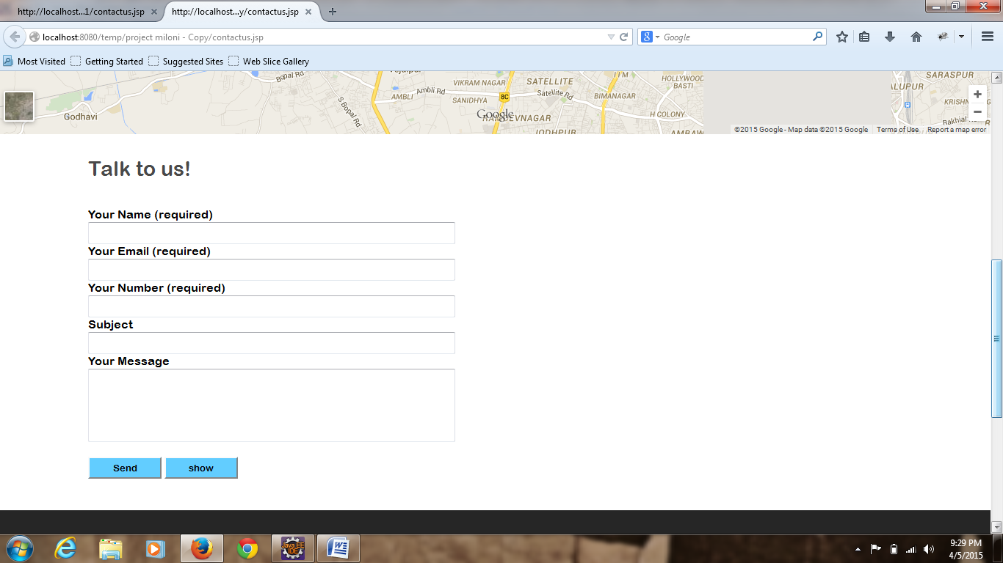

<%@ page language=*"java"* contentType=*"text/html; charset=ISO-8859-1"*

pageEncoding=*"ISO-8859-1"*%>

<html>

<head>

<link href=*"style.css"* rel=*"stylesheet"*></link>

<link href=*"style5.css"* rel=*"stylesheet"*></link>

<script>

**function** fn()

{

**var** q=document.getElementById("j");

**var** q1=document.getElementById("kr");

**var** t=document.getElementById("pa");

t.style.display="";

q.style.display="none";

q1.style.display="";

}

**function** fn1()

{

**var** q=document.getElementById("j");

**var** q1=document.getElementById("kr");

**var** t=document.getElementById("pa");

t.style.display="none";

q1.style.display="none";

q.style.display="";

}

**function** validate(){

phone = document.getElementById("uNum").value;

mail = document.getElementById("email").value;

ifm = mail.indexOf('@');

lifm = mail.lastIndexOf('@');

ifd = mail.lastIndexOf('.');

len = mail.length;

**if**(phone.length!=10 || isNaN(phone)){

alert("Phone is not valid");

}

**if**(ifm==-1 || ifm!=lifm || ifd-ifm<3 || (len-ifd!=3 && len-ifd!=4)){

alert("email id is not valid");

}

}

</script>

</head>

<body>

<div class=*"main"*>

<header>

<div class=*"header"*>

<div class=*"he"*>

<a href=*"#"*><div class=*"he1"*></div></a>

<div class=*"he2"*>

<div class=*"he3"*></div>

<div class=*"he4"*>1800-222-223-22</div>

<div class=*"he5"*>

<div class=*"he6"*></div>

<div class=*"he7"*>Contact@charityhubWP.org</div>

</div>

</div>

</div>

</div>

</header>

<div class=*"menu"*>

<div class=*"menu1"*>

<div class=*"mn"*></div>

<div class=*"mn1"*></div>

</div>

<div class=*"menu2"*>

<div class=*"men"*>

<a href=*"#"*><div class=*"men1"* style="background-repeat:*no-repeat*;background:*url('krunal/k1.png')*;"></div></a>

<a href=*"#"*><div class=*"men1"* style="background-repeat:*no-repeat*;background:*url('krunal/k2.png')*;"></div></a>

<a href=*"#"*><div class=*"men1"* style="background-repeat:*no-repeat*;background:*url('krunal/k3.png')*;"></div></a>

<a href=*"#"*><div class=*"men1"* style="background-repeat:*no-repeat*;background:*url('krunal/k4.png')*;"></div></a>

<a href=*"#"*><div class=*"men1"* style="background-repeat:*no-repeat*;background:*url('krunal/k5.png')*;"></div></a>

</div>

<nav class=*"men2"*>

<ul>

<li><a href=*"index.jsp"*><b>HOME</b></a></li>

<li><a href=*"service.jsp"*><b>SERVICE</b></a></li>

<li><a href=*"ourstory.jsp"*><b>OURSTORY</b></a></li>

<li><a href=*"whatwedo.jsp"*><b>WHAT WE DO</b></a></li>

<li><a href=*"intenship.jsp"*><b>INTENSHIP</b></a></li>

<li><a href=*"contactus.jsp"*><b>CONTACT US</b></a></li>

</ul>

</nav>

</div>

<div class=*"menu3"*>

<div class=*"mn"*></div>

<div class=*"mn1"*></div>

</div>

</div>

<div class=*"contact"*><iframe src=*"https://www.google.com/maps/embed?pb=!1m18!1m12!1m3!1d29368.433138064695!2d72.50512314999999!3d23.058476550000012!2m3!1f0!2f0!3f0!3m2!1i1024!2i768!4f13.1!3m3!1m2!1s0x395e9ca1402b2107%3A0xc6b7cfd374cb4bcb!2sThaltej%2C+Ahmedabad%2C+Gujarat!5e0!3m2!1sen!2sin!4v1424883996575"* width=*"100%"* height=*"500"* frameborder=*"0"* style="border:*0*"></iframe></div>

<div class=*"contact1"*>

<div class=*"contact2"*>Talk to us!</div>

<form action=*"*<%=request.getContextPath()%>*/Student"* method=*"post"*>

<div class=*"contact3"*>Your Name (required)</div>

<div class=*"contact4"*>

<input type=*"text"* name=*"fname"* value=*""* id=*""* style="height:*30px*;width:*500px*;">

</div>

<div class=*"contact3"*>Your Email (required)</div>

<div class=*"contact4"*>

<input type=*"text"* name=*"email"* value=*""* id=*"email"* style="height:*30px*;width:*500px*;">

</div>

<div class=*"contact3"*>Your Number (required)</div>

<div class=*"contact4"*>

<input type=*"text"* name=*"number"* value=*""* id=*"uNum"* style="height:*30px*;width:*500px*;">

</div>

<div class=*"contact3"*>Subject</div>

<div class=*"contact4"*>

<input type=*"text"* name=*"sub"* value=*""* id=*""* style="height:*30px*;width:*500px*;">

</div>

<div class=*"contact3"*>Your Message</div>

<div class=*"contact4"*>

<input type=*"text"* name=*"message"* value=*""* id=*""* style="height:*100px*;width:*500px*;">

</div>

<div class=*"contact3"*></div>

<div class=*"contact4"*>

<input type=*"submit"* name=*""* value=*"Send"* id=*""* onclick="validate()" style="height:*30px*;width:*100px*;background-color:*#62cdff*;font-family:*Arial Rounded MT Bold*;">

<input type=*"button"* name=*""* value=*"show"* id=*"j"* onclick="fn()" style="height:*30px*;width:*100px*;background-color:*#62cdff*;font-family:*Arial Rounded MT Bold*;">

<input type=*"button"* name=*""* value=*"hide"* id=*"kr"* onclick="fn1()" style="height:*30px*;width:*100px*;background-color:*#62cdff*;font-family:*Arial Rounded MT Bold*;display:*none*;">

</div>

</form>

<div id=*"pa"* style="width:*100%*;float:*left*;display:*none*">

<table border=*"1"* style="margin-left:*120px*;color:*#000000*;">

<tr>

<td>fname</td>

<td>email</td>

<td>number</td>

<td>subject</td>

<td>message</td>

</tr>

<%@taglib prefix=*"c"* uri=*"http://java.sun.com/jstl/core_rt"* %>

<c:forEach var=*"i"* items=*"*${sessionScope.list}*"*>

<tr>

<td>${i.fname}</td>

<td>${i.email}</td>

<td>${i.number}</td>

<td>${i.sub}</td>

<td>${i.message}</td>

</tr>

</c:forEach>

</table>

</div>

</div>

<div class=*"footer"*>

<div class=*"footer-in"*>

<div class=*"footer1"*>

<div class=*"f1"*><b>Contact Information</b></div>

<div class=*"f2"*>

<div class=*"f3"*>

<div class=*"f4"*></div>

<div class=*"f5"*>Phone :

1800-222-222</div>

</div>

<div class=*"f6"*>

<div class=*"f7"*></div>

<div class=*"f5"*>Email :

contact@charityhubwp.org</div>

</div>

<div class=*"f8"*>

<div class=*"f9"*></div>

<div class=*"f5"*>Address : 654

Kingsland Rd. Bighouse London 198765</div>

</div>

<div class=*"f10"*>

<div class=*"f11"*></div>

<div class=*"f12"*></div>

<div class=*"f13"*></div>

<div class=*"f14"*></div>

<div class=*"f15"*></div>

<div class=*"f16"*></div>

</div>

</div>

</div>

<div class=*"footer2"*>

<div class=*"f1"*><b>Latest Works</b></div>

<div class=*"f2"*>

<div class=*"f2-1"*></div>

<div class=*"f2-2"*></div>

<div class=*"f2-3"*></div>

<div class=*"f2-4"*></div>

<div class=*"f2-5"*></div>

<div class=*"f2-6"*></div>

</div>

</div>

<div class=*"footer3"*>

<div class=*"f1"*><b>Recent Posts</b></div>

<div class=*"f2"*>

<div class=*"clear"*>

<ul>

<li><a href=*"#"*>Sem

Porta Mollis Parturient</a></li>

<li><a href=*"#"*>Bibendum

Tristique Etiam</a></li>

<li><a href=*"#"*>Nullam

Lorem Mattis Purus</a></li>

<li><a href=*"#"*>Nibh

Sem Sit Ullamcorper</a></li>

<li><a href=*"#"*>SDonec

luctus imperdiet</a></li>

</ul>

</div>

</div>

</div>

<div class=*"footer4"*>

<div class=*"ft"*></div>

<div class=*"ft-1"*><p>Praesent commodo cursus magna, vel scelerisque nisl

consectetur et. Donec sed odio dui. Nullam id dolor id nibh

ultricies vehicula ut id elit.</p></div>

</div>

</div>

</div>

</html>