**Generate a Report using Crystal Reports in Visual Studio 2010**

Crystal Report Installation

1. Install SAP Crystal Report version for Visual Studio 2010 (CRforVS_13_0_3.exe).
2. Follow the installation wizard.

Warehouse database

For this tutorial, we will use the **warehouse** database. Now let me show you the database table structure.

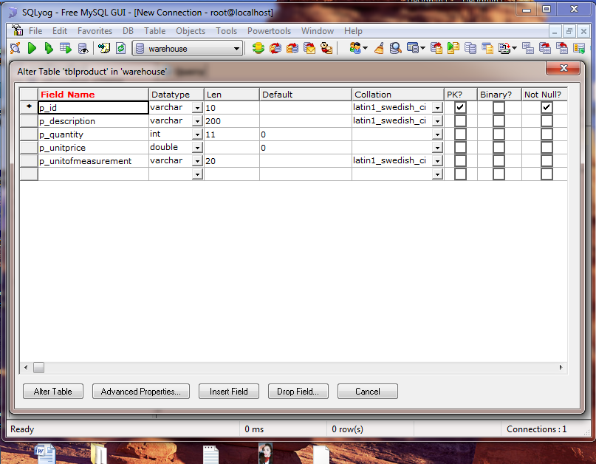

The above figure shows the **tblproduct** table structure. The figure below will show you some sample data in the table:

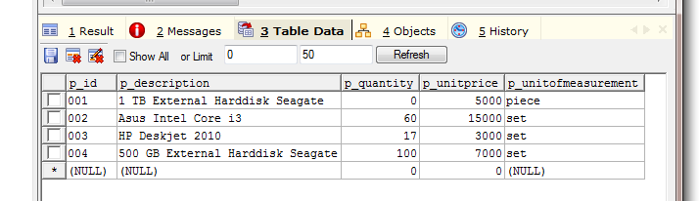

Simple Report using Crystal Report

The below figure shows you the process to create an XSD file.

For adding an XSD file, click on Solution Explorer -> Right Click on Project -> click on Add new Item and then it will show you the below screen.

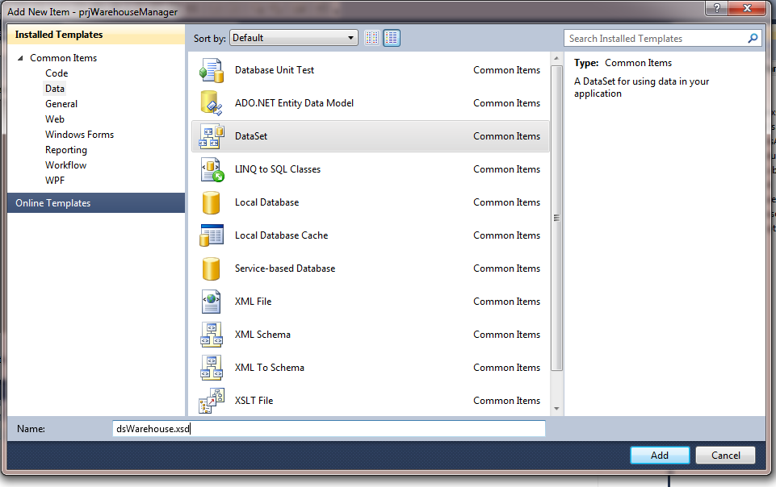

1. Now we will add one blank datatable to that XSDfile. Just right click on the file and select Add -> Datatable. It will add one DataTable1 to the screen. The figure below shows how to add datatable to XSD file. *To change the name of datatable1, click datatable1 and type its new name (dtProduct) or right-click datatable1 then select rename or you may change its name in properties window (just make sure that the datatable1 object is selected) and type dtProduct.*

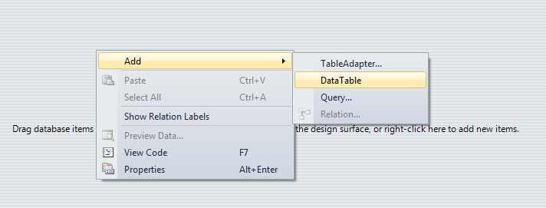

1. Now datatable1 is added to XSD file. Now we will add data column to the datatable1 (dtProduct) as shown below. Remember whatever fields (columns) we add here, it will be available to show on the report. So add column which you want to display in your reports one by one here. 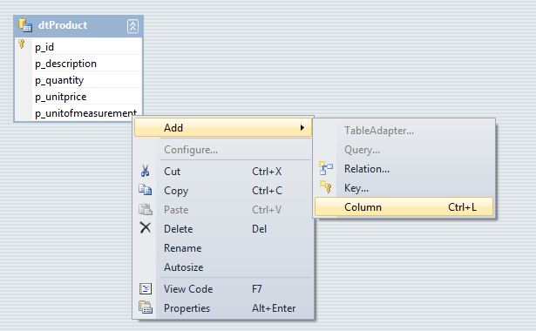
2. Remember to give the exact same name for data column as in database and also select data type which is the same as database, otherwise you will get an error for field and data type mismatch.

Once we add all the required columns in datatable, then set property for the datacolumn as it has in database. The below figure will show you how to set property for data columns. Default datatype for all the columns is string here so if datatype is other than string then only change it manually.

Just right click on the datacolumn in datatable and select property and from property window, select appropriate datatype from DataType Dropdown for that datacolumn.

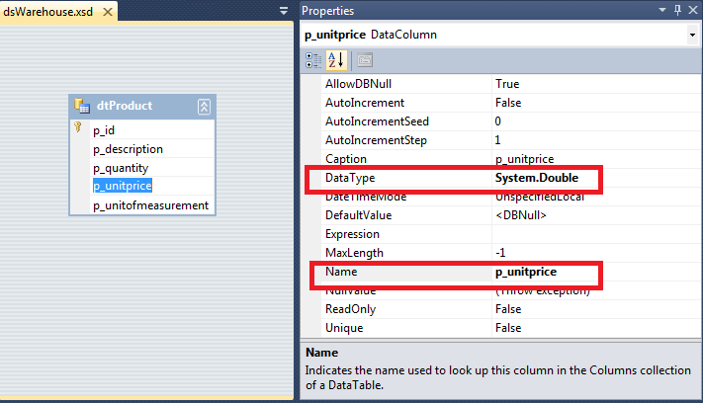

Note: p_quantity data type is int32 and p_unitprice is double

1. That's it. XSD file creation has been done. Now we will move to create Crystal report design.

Just click on the Solution Explorer -> Right click on the project name and select crystal reports. Name it as per your choice and hit the add button.

The figure below will show you the creation process of Crystal reports.

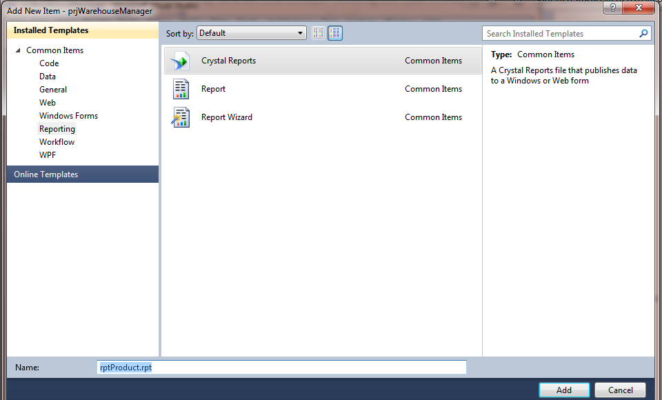

1. Click on the add button and one .rpt file will be added to the solution. And also, it will ask for the report creation type of how you want to create the report. The figure below will show you a screenshot.

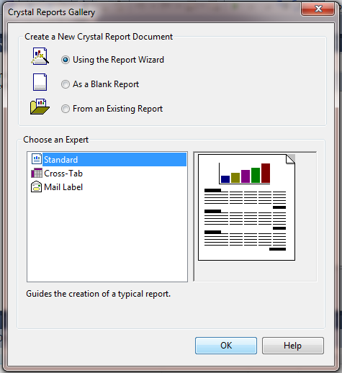

1. Just click ok button to proceed. It will lead you to the figure below:

Under project data, expand **ADO.NET Datasets**and select dtProduct and add to the selected table portion located at the right side of the windows using **>** button. Now click on the Finish button and it will show the next screen (below):

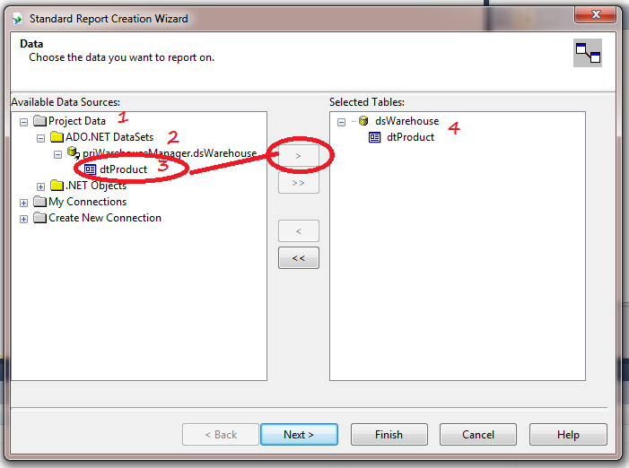

1. Once report file is added, you can see **Field Explorer** on the left side near server explorer.

Expand **Database Fields**,under that you will be able to find datatable (dtProduct) that we have created earlier. Just expand it and drag one by one filed from Field Explorer to the rpt file under **detail section.**

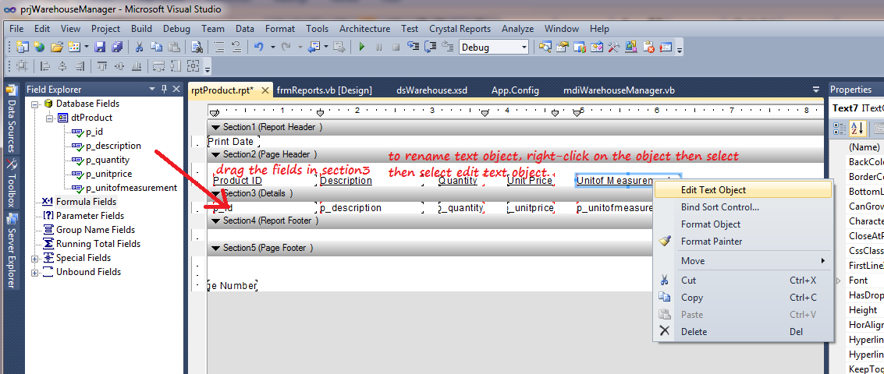

1. Now the report design part is over. Now we have to fetch the data from database and bind it to dataset and then bind that dataset to the report viewer.
2. Drag Crystal Report Viewer into new windows form (named as frmProductReport.vb).

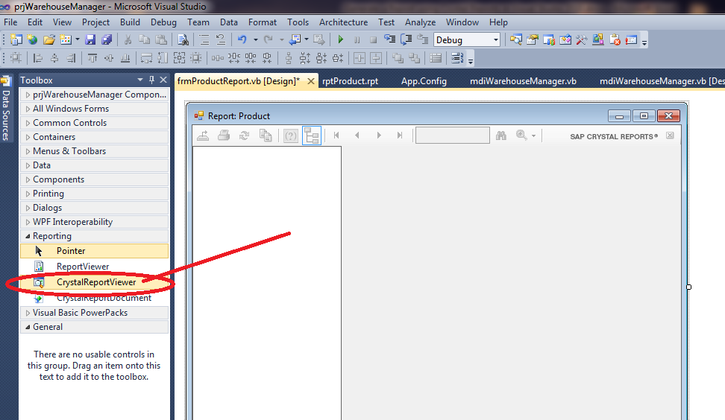

1. Now we will fetch the data, pass data to the dataset and then add that dataset to the Crystal Report. Below is the VB code which will do the job:

Imports CrystalDecisions.CrystalReports.Engine

Imports CrystalDecisions.Shared

Imports MySql.Data.MySqlClient

Public Class frmProductReport

Private Sub frmProductReport_Load(ByVal sender As System.Object, ByVal e As System.EventArgs) Handles MyBase.Load

Dim rptdoc = New ReportDocument()

Dim dsw As New dsWarehouse() ' .xsd file name

Dim dt As New DataTable()

' set the name of data table

dt.TableName = "dtProduct"

dt = getAllProducts() ' this function is located below

dsw.Tables(0).Merge(dt)

' your .rpt file path below

rptdoc.Load("C:\Users\asus\Desktop\prjWarehouseManager\prjWarehouseManager\rptProduct.rpt")

' set dataset to the report viewer.

rptdoc.SetDataSource(dsw)

CrystalReportViewer1.ReportSource = rptdoc

End Sub

Private Function getAllProducts() As DataTable

Dim query As String = "SELECT * FROM tblproduct"

Dim connection As New MySqlConnection(connStr)

Dim da As New MySqlDataAdapter(query, connection)

Dim ds As New DataSet()

connection.Open()

da.Fill(ds)

connection.Close()

Return ds.Tables(0)

End Function

End Class

1. Now just save everything and run report. It will look like the below figure:

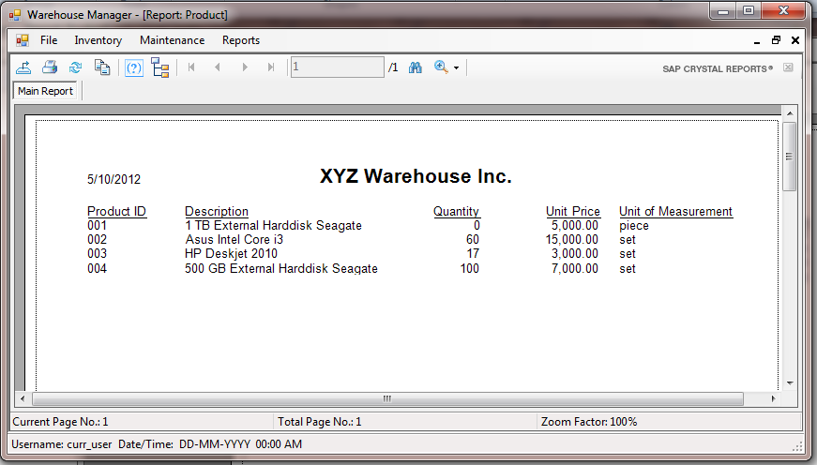

NOTE:

If you have installed it but cannot find the Crystal Report Viewer under the toolbox, it is most likely that you have not selected the correct framework version.

In order to use Crystal Reports 2010 for VB.NET you need to use Framework version 4.0.

Follow the steps below to see if you have the correct version.

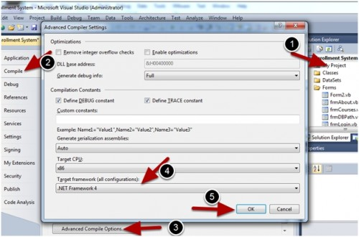

1. Double click My Project
2. Select Compile tab
3. Click Advanced Compile Options
4. Select Target framework (all configurations)
5. Finally, click OK button

If you come across this error as you run your frmProductReport.vb form “Could not load file or assembly 'file:///C:\Program Files (x86)\SAP BusinessObjects\Crystal Reports for .NET Framework 4.0\Common\SAP BusinessObjects Enterprise XI 4.0\win32_x86\dotnet1\crdb_adoplus.dll' or one of its dependencies. The system cannot find the file specified.” Do the following:

1. In your Solution Explorer window, locate App.Config file and open it.
2. Add the following codes:

<startup useLegacyV2RuntimeActivationPolicy="true">

<supportedRuntime version="v4.0"/>

</startup>

1. After adding the codes, it will look like the figure below.

