SALES DATA ANALYSIS
DASHBOARD REPORT

Skyrovix Internship Program
Task 1 — Exploratory Data Analysis & Visualization
Dataset: Superstore Sales Dataset
Tools: Python · Pandas · Matplotlib · Google Colab

1. Introduction
This project analyzes the Superstore sales dataset to understand sales performance, profitability, customer activity, and regional trends across the business.

2. Objective
- Clean and prepare the sales dataset
- Perform exploratory data analysis
- Identify important sales and profit trends
- Create meaningful visualizations
- Generate business insights

3. Tools Used
Python, Pandas, Matplotlib, and Google Colab.

4. Dataset
The project uses the Superstore Sales Dataset, which contains information about orders, customers, products, sales, quantity, discounts, and profit.

5. Data Cleaning
The dataset was loaded using Pandas. Duplicate records were checked, date columns were converted into datetime format, and Year and Month fields were created to support time-based analysis.

6. Key Performance Indicators
Metric | Value
Total Sales | $2,297,200.86
Total Profit | $286,397.02
Total Orders | 5,009
Total Customers | 793
Total Quantity Sold | 37,873
Profit Margin | 12.47%

7. Analysis and Visualizations
The analysis covers sales by category, sales by region, monthly sales trends, and profit by category. Additional analysis was performed for sub-categories, top products, discount versus profit, and low-profit products.

8. Sales Analysis Dashboard
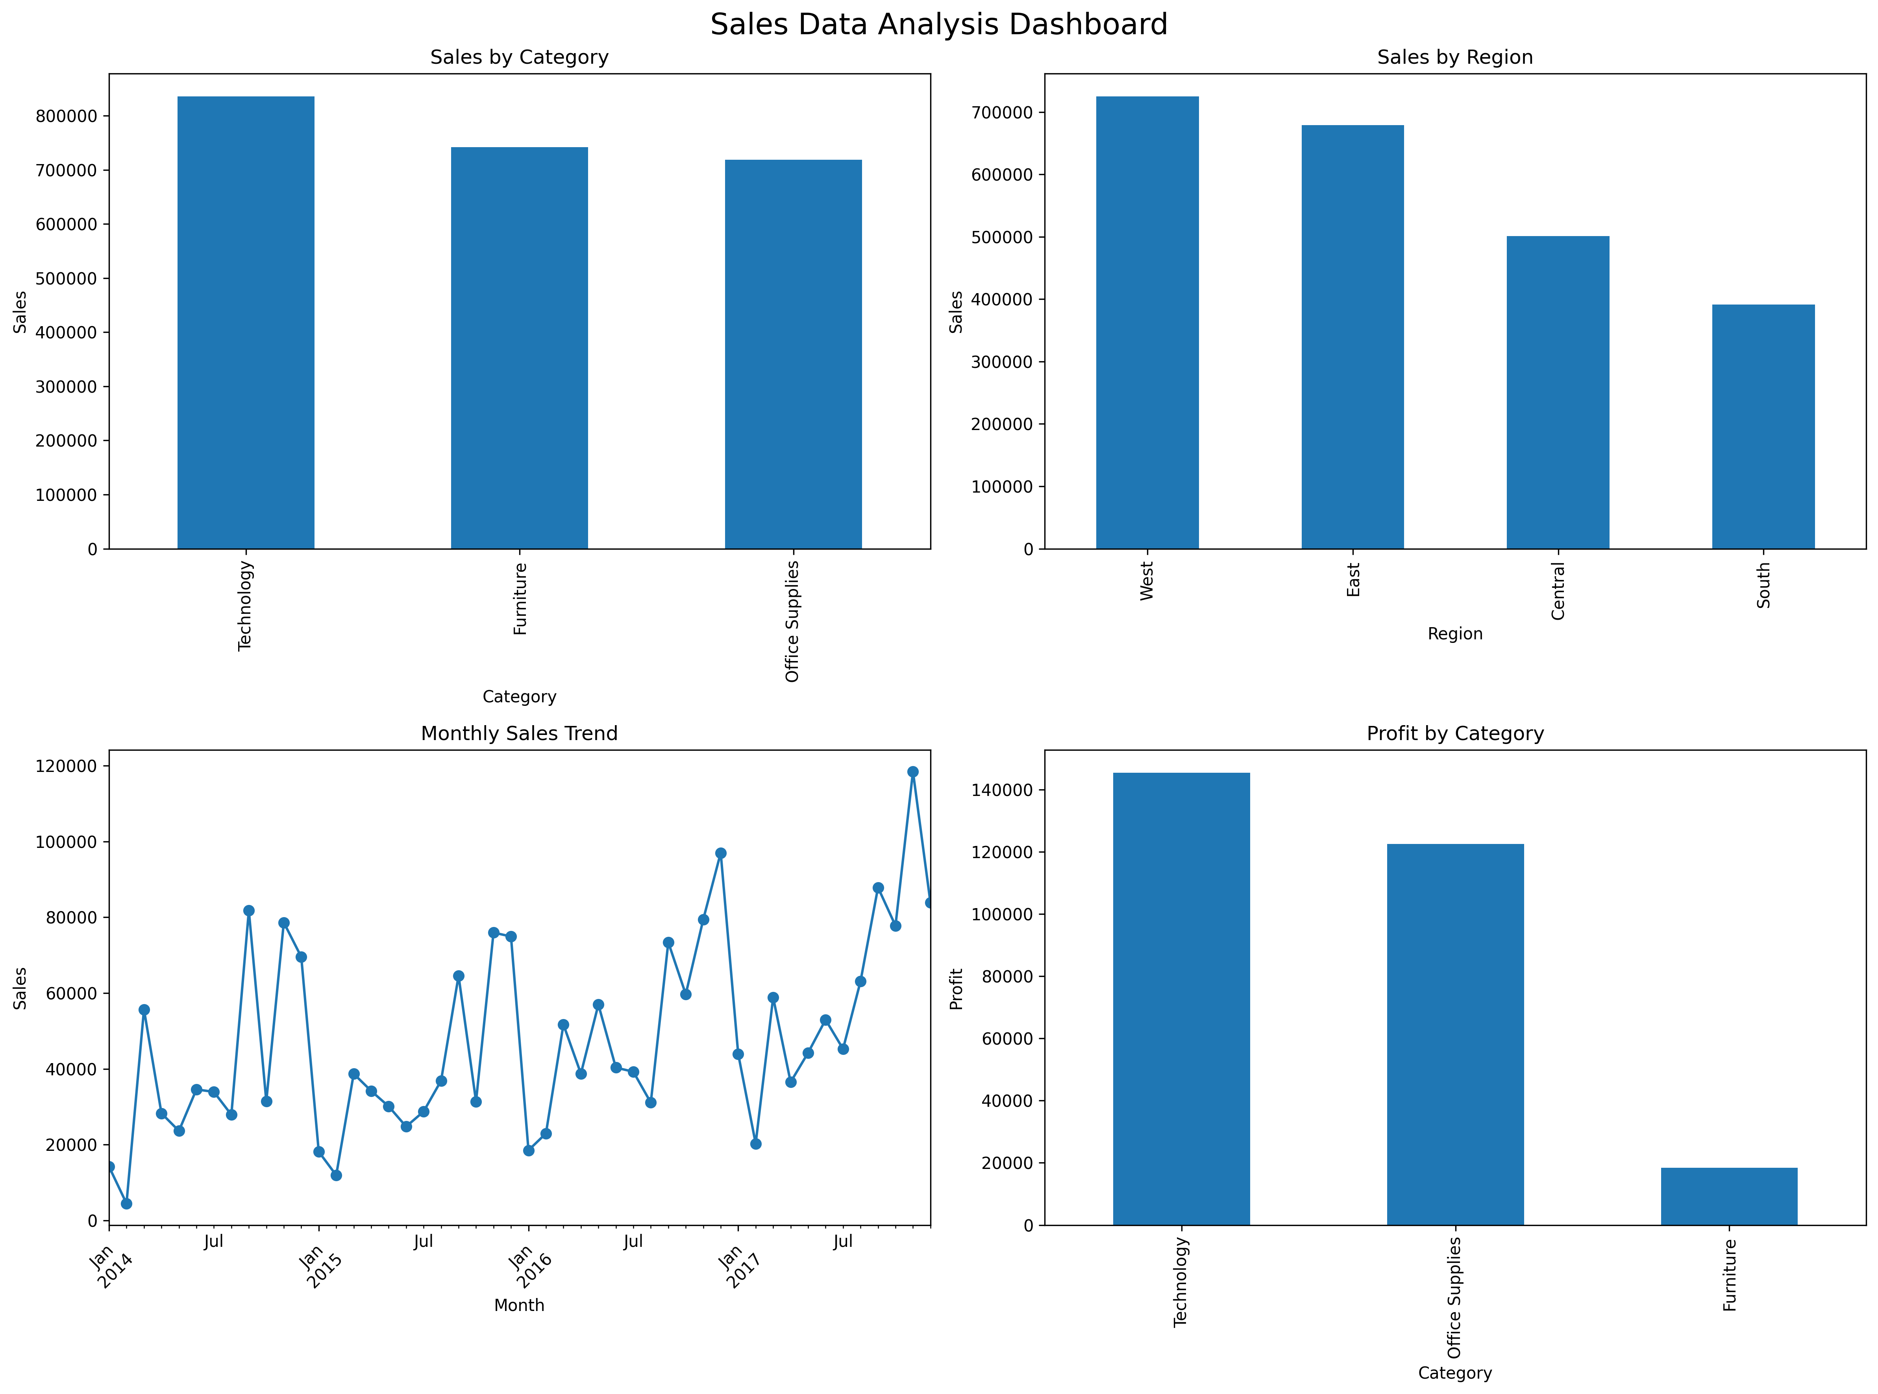
Figure 1: Sales by Category, Sales by Region, Monthly Sales Trend, and Profit by Category

9. Business Insights
- Technology is the highest-selling category.
- West is the highest-selling region.
- Phones and Chairs are among the top-performing sub-categories.
- Profitability varies across products and categories.
- Discount levels should be monitored carefully because they can affect profitability.

10. Conclusion
The analysis provided a clear understanding of sales and profit performance. The dashboard summarizes the major findings in an easy-to-understand format and can support data-driven business decisions.

