

FURTHER EDUCATION AND TRAINING CERTIFICATE: INFORMATION TECHNOLOGY: SYSTEMS DEVELOPMENT
ID 78965 LEVEL 4
BLOCK 1 SUMMATIVE ASSESEMENT

FULL NAME & SURNAME
ID NUMBER:
NAME OF ASSESSOR | Kabelo P. Matlakala
DATE OF ASSESSMENT
VENUE

 | ACHIEVED | NOT ACHIEVED
KNOWLEDGE
SKILLS

Signature of learner | Signature of Assessor

ASSESSMENT PACK
Please complete the following sections (A) before commencing with this assessment.
Section A Learner Information
Name:
Surname:
School:
Department:
Contact no:
Date:
ID

Results:

PRE-ASSESSMENT MEETING CHECKLIST
ACTION | YES/NO | COMMENTS
Set learner at ease; be friendly, polite and professional.
Explain to the learner and agree on the following issues.
- The unit standard that will be assessed
- Date, time, venue and process to be followed during the assessment.
- Summative assessment tools to be used for the assessment.
- The assessment plan
- Purpose of assessment
Explain to the learner and agree on the role of all involved during the assessment process.
Identify possible barriers and or disabilities of the learner.
Explain the meaning and application of RPL.
Explain, discuss and provide one complete set of the Appeals process documentation.
Explain to the learner when final results will be available and how feedback will be provided.
Discuss previous assessment results if applicable.

I, ______________________________ (initials and surname of learner), DECLARE THE FOLLOWING:

A copy of the unit standard(s) involved has been given to me prior to this meeting. I know I will be assessed against the criteria, which have been set to the applicable unit standards. The criteria have been discussed with me, and the procedures and purpose of the assessment has been clearly explained to me.

I am well aware of the venue, date and time that I will be assessed. I consider the period of time given to me to prepare myself for the assessment to be fair.

I understand clearly that I have the right to appeal against any decision made by the assessor during the assessment of the evidence provided by me, and that I have free access to the appeals procedures attached to this assessment pack. I understand that I have the right to be accompanied by another person during all procedures, and that I have free access to the Training Division of Health and Safety Procedures- filed at the offices.

Signature of learner | Date

Assessment Instruments
TAKE NOTE
- The instruments in this pack are all for summative assessment.
- Use these together with the formative assessment activities in the learner workbook.
- Both formative (workbook) and summative assessments must be kept in the learner’s Portfolio of Evidence (PoE).

A number of the assessment instruments contained in this assessment are workplace knowledge based questions. This means that you will arrange with the learner, a time that is suitable, during which the learner will complete each questions.
Instructions to Learner
1. Answer ALL questions in ALL five sections.
2. For Section A (MCQ): circle or tick ONE answer per question.
3. For Section B (Short Answer): write in clear, complete sentences or bullet points.
4. Write legibly. Illegible answers will not be marked.
5. No calculators, notes, or electronic devices permitted.

NOTE: Each section covers one module from Block 1. Manage your time — allow approximately 24 minutes per section.

Section | Module | Total | Mark Awarded
1 | 14924 — Systems Analysis | 20
2 | 14920 — Team Collaboration & Problem Solving | 20
3 | 14918 — Programming Principles Introduction | 20
4 | 14927 — Apply Problem-Solving Strategies | 20
5 | 14915 — Design a Computer Program to Specification | 20
 | TOTAL | 100

Section 1 · Module 14924 | Systems Analysis | [20 marks]

Section A: Multiple Choice Questions [10 marks — 2 marks each]

Circle or tick ONE correct answer for each question.
1. Which phase of the SDLC focuses specifically on gathering and documenting user requirements? (2)
A) Feasibility Study
B) Systems Analysis
C) Implementation
D) Maintenance

2. A systems analyst visits the CET registration office and watches how clerks process student enrolments without asking questions. Which fact-finding technique is this? (2)
A) Interview
B) Questionnaire
C) Observation
D) Document Review

3. Which DFD symbol represents a location where data is stored for later use? (2)
A) Circle (or rounded rectangle)
B) Arrow
C) Two parallel lines (open rectangle)
D) Rectangle with a shadow

4. A CET attendance system must be replaced. The analyst must first determine if the project is technically possible and cost-effective. Which SDLC phase does this describe? (2)
A) Requirements Analysis
B) Logical Design
C) Feasibility Study
D) Physical Design

5. Which development approach is MOST suitable when requirements change frequently and user feedback after each delivery is important? (2)
A) Waterfall — sequential phase-by-phase with formal sign-offs
B) Agile — iterative sprints with regular stakeholder review
C) Manual filing system with periodic updates
D) A single once-off requirements document approved before build

Section B: Short-Answer Questions [10 marks]
B1. Differentiate between Systems Analysis and Requirements Analysis. (4 marks)
Circle TWO correct points from the option lists.

Systems Analysis — select TWO correct points from the option lists.
Options:
- Looks at the whole current system and how parts work together
- Finds problems in workflows, data flow, and process gaps
- Maps existing inputs, outputs, and processing steps
- Focuses only on font style and screen colours
- Starts coding immediately without studying the current system
- Sets test dates without analysing processes

Requirements Analysis — select TWO correct points from the option lists.
Options:
- Defines what users need the new system to do
- Captures functional and non-functional requirements
- Specifies business rules, constraints, and expected outputs
- Documents user needs before design and development
- Captures developer preferences instead of user needs
- Finalizes deployment schedule only

B2. A CET college wants to replace its paper-based attendance system with a digital solution.
List THREE fact-finding techniques the analyst could use and give ONE reason why each is appropriate for this specific context. (6 marks)
Technique options:  - Observation  - Interview  - Questionnaire  - Document review  - Check existing records  - Trial-and-error coding | Reason options:  - See real current process and bottlenecks  - Get detailed needs directly from users  - Collect feedback quickly from many users  - Understand existing forms, rules, and data fields  - Verify what data is already captured and missing  - Only confirm existing assumptions

Answers:
Technique | Why appropriate for this context

B3. Refer to Figure A below. First identify the diagram type, then complete markers 1–4 using the selectors below.
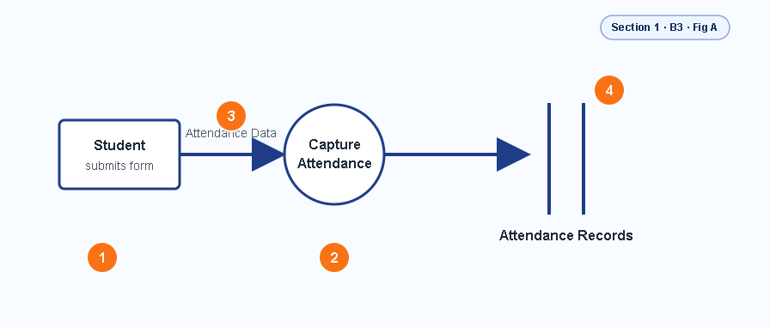
Figure A — identify diagram type for (1), then label parts for (2)

1) What type of diagram is shown above? Choose ONE. (1 mark)
- Flowchart
- Data Flow Diagram (DFD)
- Fishbone (Ishikawa) diagram
- Network diagram

2) Label the parts of the diagram using the selector pool. (4 marks)
Selector pool:
◾ External Entity ◾ Process ◾ Data Flow ◾ Data Store

Label
1
2
3
4
Section 2 · Module 14920 | Team Collaboration & Problem Solving | [20 marks]

Section A: Multiple Choice Questions [10 marks — 2 marks each]

Circle or tick ONE correct answer for each question.
1. What is the PRIMARY difference between a group and a team? (2)
A) A team always has more members than a group
B) A team shares a common goal and is mutually accountable for outcomes
C) A group meets more regularly than a team
D) A group always has a formal leader while a team does not

2. A CET project team is unable to agree on which student management system to adopt. Which problem-solving step should they take FIRST? (2)
A) Implement the cheapest option immediately
B) Clearly define and agree on the problem before evaluating solutions
C) Ask management to decide on their behalf
D) Wait until the conflict resolves itself

3. Which technique involves each team member independently writing ideas before sharing and ranking them as a group — ensuring equal participation? (2)
A) Round-robin brainstorming
B) Nominal Group Technique (NGT)
C) Open group discussion
D) Majority voting without discussion

4. Which characteristic MOST contributes to an effective team environment? (2)
A) Each member works independently to avoid conflict
B) Trust, open communication, and shared accountability
C) Strong leadership that makes all decisions
D) Keeping team roles undefined for flexibility

5. A team member consistently misses deadlines and blames others for delays. Which team quality is MOST clearly absent? (2)
A) Creativity
B) Flexibility
C) Accountability
D) Technical skill

Section B: Short-Answer Questions [10 marks]

B1. Choose a challenge and a best response for each row from the word banks below.
(6 marks)

Challenge options:
◾ Poor communication ◾ Conflict in team ◾ Missed deadlines ◾ Unclear roles
◾ Low participation

Response options:
◾ Hold team discussion ◾ Set clear roles ◾ Agree on deadlines ◾ Ask facilitator
◾ Improve communication

Challenge | How to address it

B2. Circle TWO ways an individual team member can actively contribute to solving a shared problem. (4 marks)

A) Share ideas
B) Help complete tasks
C) Communicate clearly
D) Take responsibility
E) Support other team members

B3. Refer to Figure A below. (4 marks)
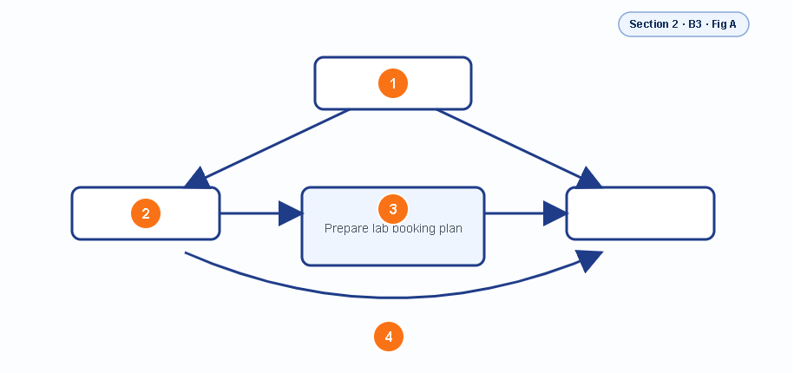
Figure A — identify diagram type for (1), then label parts for (2)

1) What type of diagram is shown above? Choose ONE. (1 mark)
  - Team collaboration diagram
  - Fishbone diagram
  - Gantt chart
  - Flowchart

2) Label the parts of the diagram using the selector pool. (4 marks)
Selector pool:
◾Team Leader ◾Team Member A / Team Member B ◾Task ◾Communication

Label
1
2
3
4

Section 3 · Module 14918 | Programming Principles Introduction | [20 marks]

Section A: Multiple Choice Questions [10 marks — 2 marks each]

Circle or tick ONE correct answer for each question.
1. Which control structure causes a section of code to repeat while a condition remains true? (2)
A) Sequence — steps run one after another in order
B) Selection — a condition determines which path to follow
C) Iteration (Loop) — steps repeat based on a condition
D) Function — a named block of reusable code

2. A programmer writes out the logic of a program in plain English steps before writing any code. What is this technique called? (2)
A) Debugging
B) Pseudocode
C) Compilation
D) Syntax checking

3. What is the key difference between validation and verification of data? (2)
A) Validation confirms data is in the correct format and range; verification confirms the data was entered accurately
B) Validation is only used for numbers; verification is only used for text
C) Validation runs after compilation; verification runs before
D) Validation and verification describe the same process

4. Which of the following is a valid reason to use documentation and comments inside program code? (2)
A) Comments make the program run faster
B) Documentation helps other developers understand and maintain the code
C) Comments prevent syntax errors at runtime
D) Documentation is only needed for hardware programs

5. A student writes code that has no syntax errors but produces an incorrect result. What type of error is this? (2)
A) Syntax error — the code breaks language rules
B) Compilation error — the code cannot be compiled
C) Logic error — the code runs but produces wrong output
D) Runtime error — the code crashes during execution

Section B: Short-Answer Questions [10 marks]

B1. Write simple pseudocode for a program that reads a student mark, checks if it is 50 or above, and prints either 'Pass' or 'Fail'. (4 marks)
BEGIN

INPUT _________________________

IF _________________________ THEN

PRINT '_________________________'

ELSE

PRINT '_________________________'

END IF

END

B2. Complete the table below by giving ONE example of each control structure. (6 marks)
Meaning options:
a) Choose between options; b) Do steps in order; c) Repeat steps;

Example options:
1.Read name, then print greeting 2.IF mark >= 50 THEN print 'Pass' ELSE print 'Fail' 3.WHILE attempts < 3 repeat input

Control Structure | Description | Example from everyday programming
Sequence
Selection
Iteration

B3. Refer to Figure A below. (2 marks)
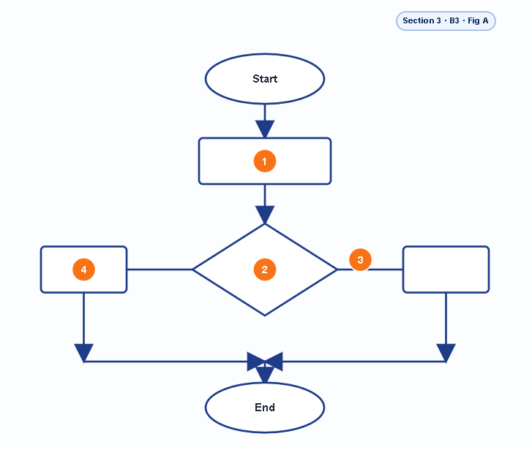
Figure A — identify diagram type for (1), then label parts for (2)

1) What type of diagram is shown above? Choose ONE. (1 mark)
A) Pseudocode listing
B) Flowchart
C) Data Flow Diagram
D) Entity Relationship Diagram

2) Label the parts of the diagram using the selector pool. (4 marks)
Selector pool:
◾Terminal (Start/End) ◾ Input/Output ◾ Decision ◾ Process (Output)

Label
1
2
3
4

Section 4 · Module 14927 | Apply Problem-Solving Strategies | [20 marks]

Section A: Multiple Choice Questions [10 marks — 2 marks each]

Circle or tick ONE correct answer for each question.
1. When evaluating possible solutions, an analyst checks whether a solution is Suitable, Feasible, and Flexible. What does FEASIBLE mean in this context? (2)
A) The solution is the most attractive option
B) The solution can realistically be implemented given available resources, time, and skills
C) The solution is the simplest to explain to management
D) The solution has already been tested in a similar environment

2. A CET lecturer notices that student results are captured incorrectly each term. She maps the process step-by-step and draws a diagram to find where data errors are introduced. Which tool is she most likely using? (2)
A) Pie chart
B) Fishbone (Ishikawa) diagram
C) Network diagram
D) Gantt chart

3. Which of the following is the FIRST step in the problem-solving cycle? (2)
A) Plan the solution
B) Implement the chosen option
C) Identify and define the problem clearly
D) Review whether the solution worked

4. After implementing a solution, a team checks whether the original problem has been resolved and documents lessons learned. Which step in the problem-solving cycle is this? (2)
A) Analyse
B) Plan
C) Implement
D) Review

5. A fishbone diagram is used to identify the root causes of a problem. Which of the following would most likely appear as a 'bone' (category) on this diagram? (2)
A) The proposed solution
B) People, Process, Environment, and Equipment
C) The project timeline and milestones
D) The budget approved for the project

Section B: Short-Answer Questions [10 marks]

B1. Complete the table below to show what happens at each step of the problem-solving cycle. choose the best matching action from the word bank. (5 marks)
Action options:
◾Define the real problem clearly ◾ List likely causes and evidence
◾ Carry out solution tasks ◾ Choose resources and timeline ◾ Blame users only
◾ Check if solution worked ◾ Ignore the problem

Step | What happens at this step
Identify
Analyse
Plan
Implement
Review

B2. Complete both parts by choosing from the options. (5 marks)
Part 1: Choose THREE root causes of workplace problems.
Root cause options:
◾Poor communication ◾Unclear roles ◾Lack of training ◾No clear process
◾Limited resource ◾Office paint colour ◾Weather forecast

Root Cause 1: ____________________________________________________________
Root Cause 2: ____________________________________________________________
Root Cause 3: ____________________________________________________________

Part 2: Choose TWO ways to evaluate possible solutions.
Evaluation options:
◾Compare pros and cons ◾Use SFF checks ◾Ask team feedback ◾Pilot test the solution ◾Check cost and time ◾Use a random coin toss

Evaluation Way 1: _________________________________________________________
Evaluation Way 2: _________________________________________________________

B3. Refer to Figure A below. (3 marks)
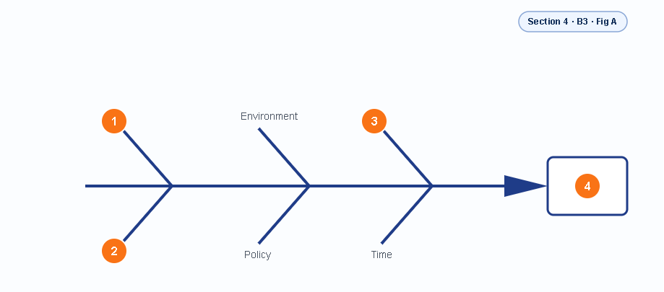
Figure A — identify diagram type for (1), then label parts for (2)

1) What type of diagram is shown above? Choose ONE. (1 mark)
A) Fishbone (Ishikawa) diagram
B) Flowchart
C) Network diagram
D) Pie chart

2) Label the parts of the diagram using the selector pool. (2 marks)
Selector pool:
◾ Process ◾ Equipment ◾ Problem / Effect (Timetabling Conflicts) ◾ Budget request
◾ Attendance register ◾People

Label
1
2
3
4

Section 5 · Module 14915 | Design a Computer Program to Specification | [20 marks]

Section A: Multiple Choice Questions [10 marks — 2 marks each]

Circle or tick ONE correct answer for each question.
1. A programmer manually traces through the logic of her algorithm using sample data and a table — without running the code. What is this technique called? (2)
A) Unit testing
B) Desk-checking
C) Compilation
D) Integration testing

2. Which program design tool uses branching paths to represent rules, conditions, and their outcomes in a tree structure? (2)
A) Flowchart
B) Decision tree
C) Pseudocode
D) Entity Relationship Diagram

3. What is the key difference between batch processing and online (real-time) processing? (2)
A) Batch processing handles one transaction at a time; online processing handles many simultaneously
B) Batch processing groups many transactions and processes them together; online processing handles each transaction immediately as it occurs
C) Batch processing is only used for financial systems; online is used for all other systems
D) Batch processing is faster and always preferable to online processing

4. Which of the following BEST describes a user-defined function in procedural programming? (2)
A) A built-in function provided by the programming language, such as len() or print()
B) A function created by the programmer to perform a specific, reusable task within the program
C) A hardware interrupt that pauses the program during execution
D) A database query written in SQL to retrieve records

5. During which phase of the program maintenance cycle would a developer fix a defect discovered by users after the system went live? (2)
A) Design — updating the original design specification
B) Test — running test cases for the first time
C) Maintain — applying corrective changes to the live system
D) Update — adding new features requested by the client

Section B: Short-Answer Questions [10 marks]

B1. Explain TWO benefits of desk-checking a program's logic before writing any code.
Select TWO valid benefits of desk-checking before coding. (4 marks)
Options:
◾Find logic errors early before coding ◾ Reduce rework during testing ◾Increase keyboard brightness ◾ Improve understanding of algorithm flow ◾Make internet speed faster

Benefit 1: ______________________________________
Benefit 2: ______________________________________

B2. Complete the table below to show what happens at each stage of the program maintenance cycle. (6 marks)

Description options:
◾Fix defects found after release ◾ Adjust system for new environment or rules ◾Rename folders for decoration only ◾ Change wallpaper every sprint ◾Improve performance, usability, or add enhancements

Maintenance Stage | What the developer does at this stage
Corrective
Adaptive
Perfective

ASSESSOR & MODERATOR SIGN-OFF

Assessor Name: | Kabelo Matlakala
Assessor Signature:
Date Assessed:
Moderator Name:
Moderator Signature:
Date Moderated:
ETQA / SDF Reference:

Notes:

This assessment instrument is aligned to SAQA ID 78965 — FETC: IT Systems Development, NQF Level 4.
Prepared by Data Science Academy · Facilitator: Kabelo Matlakala · Block 1 Assessment

