Agent Onboarding & Creation Workflow
Quantified ROI Analysis | Money, Time, Capacity, Error Reduction, and Governance Impact
Prepared for WFM / Access Management / NICE IEX Implementation
Date: 2026-06-01

Workflow Diagram
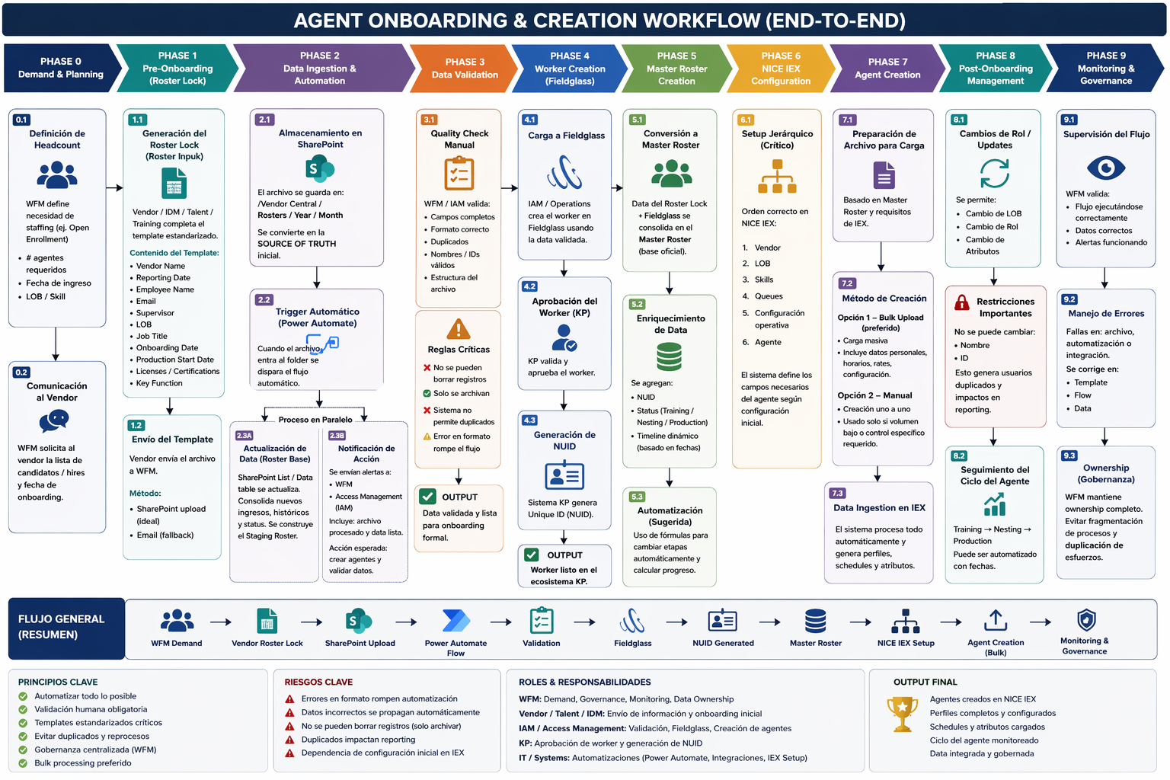
Figure 1. Current end-to-end onboarding workflow used as the process basis for this analysis.

1. Executive Summary
This document expands the current onboarding workflow into a quantified business case. It combines the current end-to-end process design (vendor roster lock to SharePoint ingestion to Power Automate to validation to Fieldglass to NUID to master roster to NICE IEX profile creation) with internal WFM automation benchmarks that already demonstrated measurable financial and capacity benefits in production. Where an exact value for this specific onboarding workflow is not documented in the available source material, the document labels the figure as a modeled estimate or as a benefit-tracking metric that should be measured during rollout.

Quantified headline values (internal benchmark data and transparent calculations):
Metric | Conservative | Higher-Value | Classification
Investment benchmark | $10,565 | $10,565 | Internal benchmark from a live WFM automation solution
Annual savings | $22,500 | $30,000 | Internal benchmark
Hours saved per analyst per year | 375 | 500 | Internal benchmark
Hours saved for 3-person team | 1,125 | 1,500 | Calculated from benchmark
Equivalent positions (FTE at 2,080 hrs/year) | 0.54 FTE | 0.72 FTE | Calculated from benchmark
Year 1 ROI | 94% | 165% | Internal benchmark
Payback period | ~6 months | ~4 months | Internal benchmark
3-year net benefit | $50,935 | $73,435 | Internal benchmark
Manual WFM process reduction | 40%+ | 40%+ | Internal benchmark
Recovered productive hours | 4,100+ hrs / quarter | 4,100+ hrs / quarter | Internal benchmark from staffing optimization case
Interpretation: if the onboarding workflow achieves even the conservative end of the internal WFM automation benchmark, the organization recovers more than one thousand hours per year for a 3-person analyst team and effectively frees between 0.54 and 0.72 full-time equivalent capacity without adding headcount.

2. Process Basis Used for This ROI
The current process design reflected in the workflow and meeting notes is based on the following logic:
- The vendor sends roster information that is placed in a SharePoint folder.
- The folder triggers an automated flow that updates the SharePoint roster and sends alerts in parallel to the teams responsible for profile creation.
- A human validation checkpoint remains mandatory because automation does not eliminate the need to verify completeness and format correctness.
- The workflow is intended to support larger groups (for example classes of 15–20 people) instead of repeated fully manual profile setup.
- The process objective is to keep an accurate headcount and support centralized ownership rather than fragmented ownership.
Operational controls visible in the workflow design include:
- Standardized roster template usage
- Validation for completeness and correct structure
- Duplicate prevention
- Records archived rather than deleted
- Parallel alerts plus data update
- Central monitoring and governance

3. Roles, Responsibilities, and Economic Ownership
Role / Team | Primary responsibility | Economic impact owner | Why it matters financially
KP WFM | Demand planning, governance, validation, monitoring, KPI ownership | Owns benefit realization | Controls how capacity savings are converted into labor value, service stability, and reduced rework
HCL WFM | IEX configuration, standards enforcement, centralized model | Owns standardization benefit | Reduces variation, duplicate work, and shadow-tool cost
Vendor teams | Roster submission and upstream data quality | Primary source of avoidable defects | Poor data quality creates delays, rework, and configuration defects
IAM / Access Management | Worker creation, profile provisioning, access readiness | Owns cycle-time impact | Faster provisioning reduces start delays and operational friction
IT / Systems / Power Platform | Automation, integrations, logging, support | Owns technical efficiency | Stable automation lowers recurring manual labor and defect correction work
NICE IEX / Platform team | Configuration, entity setup, profile ingestion | Owns platform enablement | Correct setup is required before bulk creation can scale safely

4. Quantified ROI by Benefit Category

4.1 Labor Time Savings
Internal WFM automation results already documented in production show 375–500 hours saved per analyst per year and direct annual savings of $22,500–$30,000 for a 3-person team. Using the same benchmark logic, a 3-person onboarding/administrative analyst team would recover 1,125–1,500 hours per year. Using a standard 2,080-hour work year, that equals 0.54–0.72 FTE of capacity released for higher-value work.
Benefit item | Value | How computed | Use in this document | Evidence type
Hours saved per analyst/year | 375–500 | Documented benchmark | Direct benchmark for repetitive manual work removal | Internal benchmark
Team hours saved/year (3 analysts) | 1,125–1,500 | 375–500 × 3 analysts | Modeled capacity for a small WFM admin team | Calculated from benchmark
Equivalent FTE capacity | 0.54–0.72 | team hours ÷ 2,080 | Position-equivalent capacity released | Calculated from benchmark
Direct annual dollar savings | $22,500–$30,000 | Documented benchmark | Conservative to higher-value scenario | Internal benchmark

4.2 Position / Capacity Impact
The workflow does not require headcount elimination to create value. The more defensible business case is capacity recovery: the time returned from manual file intake, repeat copy/paste profile creation, error correction, and follow-up coordination can be redeployed to analytics, governance, control, and vendor management. At benchmark performance, the recovered capacity is equivalent to approximately 0.54–0.72 FTE for a 3-person team.
Capacity impact type | Conservative | Higher-value | Notes
Recovered analyst days/year | 141 | 188 | Assumes 8-hour workday
Recovered work weeks/year | 28.1 | 37.5 | Assumes 40-hour workweek
Equivalent FTE | 0.54 | 0.72 | Assumes 2,080 hours/FTE/year
Recommended use of released capacity | QA, governance, analytics | QA, governance, analytics + intraday control | Recommended redeployment, not headcount elimination

4.3 Error Reduction and Rework Avoidance
Available internal sources explicitly document reduced risk of human error and rework, standardized data validation, and the need for a validation checkpoint because automation still requires review. However, the sources do not provide a numeric defect-rate baseline for this specific onboarding workflow. For that reason, the financial effect of error reduction is directionally positive and operationally important, but exact dollar savings from avoided onboarding defects must be measured during rollout rather than claimed upfront.
Error category | What the workflow changes | Expected effect | Quantified now? | Measurement recommendation
Missing mandatory fields | Standard template + validation checkpoint | Prevents incomplete submissions from moving downstream | No exact baseline available | Track # of rejected files and correction cycle time
Wrong file structure / formatting | Automation trigger + validation rules | Reduces downstream processing failures | No exact baseline available | Track # of format failures per month
Duplicate identity / profile creation | Duplicate prevention + master roster governance | Avoids cleanup effort and reporting distortion | No exact baseline available | Track # of duplicate records prevented / corrected
Late access / profile creation | Parallel alerting to responsible teams | Reduces waiting time between intake and provisioning | No exact baseline available | Track cycle time from file receipt to profile readiness
Roster-to-system mismatch | Master roster + enrichment + centralized ownership | Improves data consistency across SharePoint, Fieldglass, and IEX | No exact baseline available | Track variance between roster, worker record, and final profile

4.4 Governance and Shadow-Process Cost Avoidance
The internal IEX go-live plan explicitly states that no parallel WFM tools will be permitted post go-live, and it identifies vendor resistance, missing/dirty roster data, and lack of dedicated WFM points of contact as material risks. While the document does not attach a specific dollar value to eliminating shadow tools, the economic benefit is real: less duplicate reporting, fewer local workarounds, lower reconciliation overhead, and stronger auditability.
- Economic effect: lower recurring coordination friction and lower reconciliation effort.
- Operational effect: one system of record supports cleaner scheduling, forecasting, and reporting.
- Compliance effect: centralized ownership improves audit readiness and defensibility.

5. Investment, Payback, and Multi-Year Value
A live WFM automation benchmark documented an investment of $10,565, a payback period of approximately 4–6 months, year-1 ROI of 94%–165%, and a 3-year net benefit of $50,935–$73,435. Those values should be treated as an internal benchmark for the economic profile of WFM automation rather than as a guaranteed project quote for this onboarding workflow. They are still highly relevant because they show the order of magnitude of value that similar automation has already produced inside the same broader WFM context.
Financial metric | Conservative benchmark | Higher-value benchmark | Use guidance
Implementation / development investment | $10,565 | $10,565 | Use as internal benchmark unless a dedicated project estimate is approved
Annual savings | $22,500 | $30,000 | Strong directional reference for WFM automation value
Year-1 ROI | 94% | 165% | Useful executive benchmark
Payback period | ~6 months | ~4 months | Useful finance benchmark
3-year net benefit | $50,935 | $73,435 | Longer-term business case reference

6. Workflow-Specific Value Mapping
Workflow step | Primary benefit driver | Time impact | Dollar impact | Why it matters
Vendor roster lock submission | Standardized intake | Less follow-up for missing data | Indirect; reduces rework | Higher data consistency before processing
SharePoint ingestion | Automatic file landing in one source | Eliminates manual re-entry into tracking lists | Indirect labor reduction | Creates a single starting point for processing
Power Automate trigger | Automatic processing and alerting | Removes repetitive admin steps | Direct labor-saving driver | Key source of recurring efficiency
Parallel update + alert path | No serial waiting for basic notifications | Shorter cycle time | Indirect labor and delay reduction | Accelerates handoff to IAM / WFM
Validation checkpoint | Catch defects early | Avoids downstream cleanup | Avoided rework cost | Protects profile build quality
Fieldglass + NUID creation | Formal worker identity path | Reduces ambiguity and manual cross-checking | Avoided rework cost | Necessary for clean master roster creation
Master roster | One governed dataset | Reduces reconciliation work | Recurring labor avoidance | Improves downstream scheduling and reporting quality
Bulk onboarding in IEX | Scales creation for classes of 15–20 | Higher throughput than repeated manual setup | Strong direct labor-saving driver | Best candidate for repeatable annual savings
Governance & monitoring | Less drift, fewer workarounds | Reduces firefighting | Indirect but material | Protects benefits from eroding over time

7. KPI and Benefit-Tracking Framework
To convert the modeled business case into a measured business case, the following KPIs should be tracked from day 1 of pilot and then monthly after go-live:
KPI | Definition | Baseline needed? | Financial linkage | Recommended owner
Cycle time to profile readiness | Time from vendor file receipt to profile created / ready | Yes | Faster readiness reduces paid non-productive waiting and admin effort | WFM + IAM
Rejected roster files | Count of files rejected for missing data or bad format | Yes | Lower count means less rework and fewer delay costs | Vendor + WFM
Duplicate records prevented/corrected | Count of duplicate identity or profile issues | Yes | Lower cleanup effort and lower reporting distortion | IAM + WFM
Manual touchpoints per onboarding cohort | Count of human processing steps required | Yes | Direct driver of labor savings | WFM process owner
Profiles created per admin hour | Throughput rate for setup activity | Yes | Direct productivity metric | WFM / IAM
SharePoint-to-master-roster variance | Mismatch count between staging and mastered records | Yes | Lower reconciliation effort and stronger trust in data | Data governance owner
Profile creation defect rate | Errors found after account/profile setup | Yes | Direct rework and access-delay cost | IAM / QA
Vendor correction SLA compliance | Percent of corrections returned within target SLA | Yes | Protects schedule and go-live date | Vendor owner

8. Executive Readout
- This workflow is financially credible because similar WFM automation already produced documented savings of $22,500–$30,000 per year with 94%–165% year-1 ROI and 4–6 month payback.
- The most defensible position-based value is capacity recovery, not position elimination: 1,125–1,500 hours per year for a 3-person admin/analyst team, equivalent to 0.54–0.72 FTE.
- The workflow likely creates additional value through avoided errors, avoided duplicate records, and faster provisioning, but those amounts should be measured during rollout because the current source set does not provide a numeric defect baseline.
- Centralized governance, one source of truth, and removal of shadow tooling protect the savings and make the process more audit-ready.

9. Source Notes and Evidence Classification
The document uses three evidence classes so leadership can distinguish facts from calculations and implementation recommendations:
- Documented benchmark: directly stated in internal source material.
- Calculated from benchmark: arithmetic performed from a documented internal benchmark (for example team hours or FTE equivalent).
- Measurement recommendation: important impact area identified in source material, but no exact numeric baseline was available in the sources reviewed.
Source | What it supported | Reference ID
WFM Helper Suite - Executive Report | Investment, annual savings, ROI, payback, time savings per analyst, 45–60 minute manual extraction benchmark | turn8search42 / turn8search43
WFM Key Wins, Impact, and Auto | 40%+ manual process reduction, 4,100+ productive hours recovered in one quarter, 16+ LOBs, recurring savings framing | turn8search46
WFM & Access Management Workflow Alignment transcript | SharePoint folder, automatic flow, parallel alerts, review checkpoint, classes of 15–20, centralized ownership preference | turn8search53
Roster Lock Template | Required onboarding fields | turn8search45
IEX WFM plans and RAID materials | Centralized model, no parallel tools, go-live timing, risk register, governance cadence, data-quality risk | turn8search51 / turn8search60 / turn8search62 / turn8search65

Appendix A. Calculation Logic Used in This Document
- Team hours saved = hours saved per analyst × 3 analysts.
- Equivalent FTE = team hours saved ÷ 2,080 hours.
- Recovered analyst days = team hours saved ÷ 8.
- Recovered analyst weeks = team hours saved ÷ 40.
Calculation | Formula | Result
Team hours saved (low) | 375 × 3 | 1,125 hours
Team hours saved (high) | 500 × 3 | 1,500 hours
Equivalent FTE (low) | 1,125 ÷ 2,080 | 0.54 FTE
Equivalent FTE (high) | 1,500 ÷ 2,080 | 0.72 FTE
Recovered analyst days (low) | 1,125 ÷ 8 | 141 days
Recovered analyst days (high) | 1,500 ÷ 8 | 188 days

