Deep Learning
> Neuron
-
- sigmoid or logit function to convert a line into values between 0 and 1 Using sigmoid function one can do a classification.
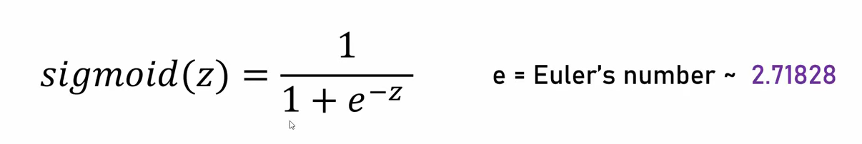

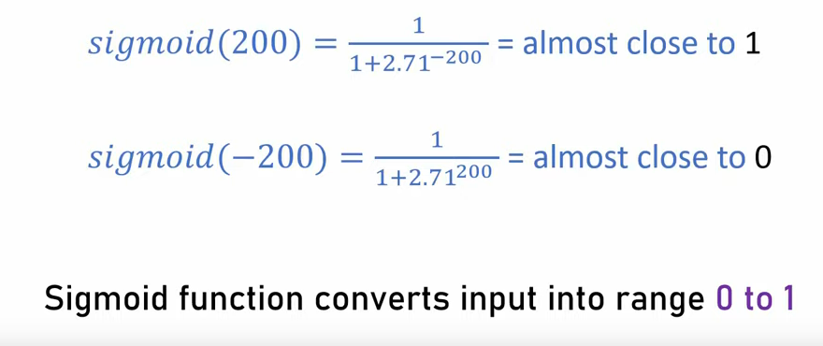

> Neural Network
3Blue1Brown - https://www.youtube.com/watch?v=aircAruvnKk

