First Notes

> Neuron
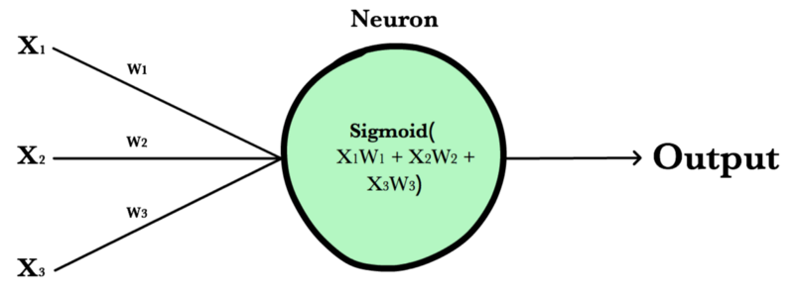
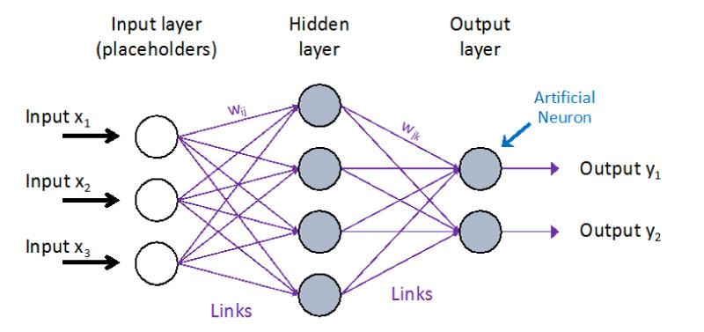
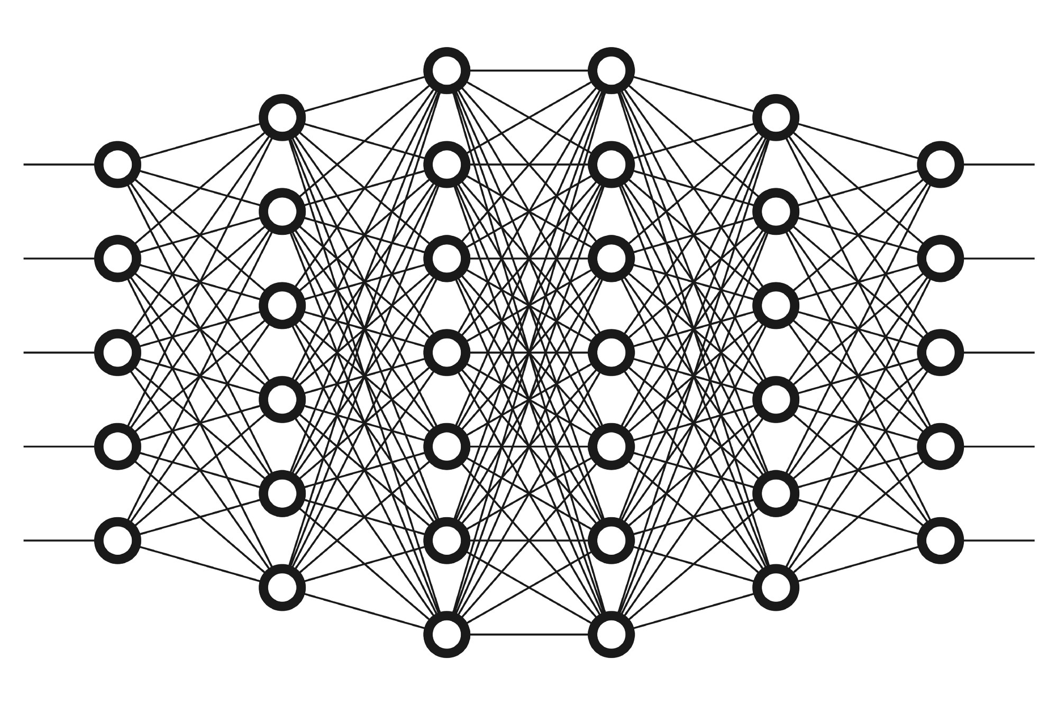

- Simple linear regression -
https://www.javatpoint.com/simple-linear-regression-in-machine-learning
chapter-7-correlation-and-simple-linear-regression

+ Book -
https://milnepublishing.geneseo.edu/natural-resources-biometrics/front-matter/table-of-contents/

+ Extra
https://machinelearningmastery.com/linear-regression-for-machine-learning/

- Linear equation
https://ww.mathsisfun.com/algebra/linear-equations.html
https://www.cuemath.com/algebra/linear-equations/

- Linear Regression Multiple Variables
Multiple linear regression refers to a statistical technique that is used to predict the outcome of a variable based on the value of two or more variables.





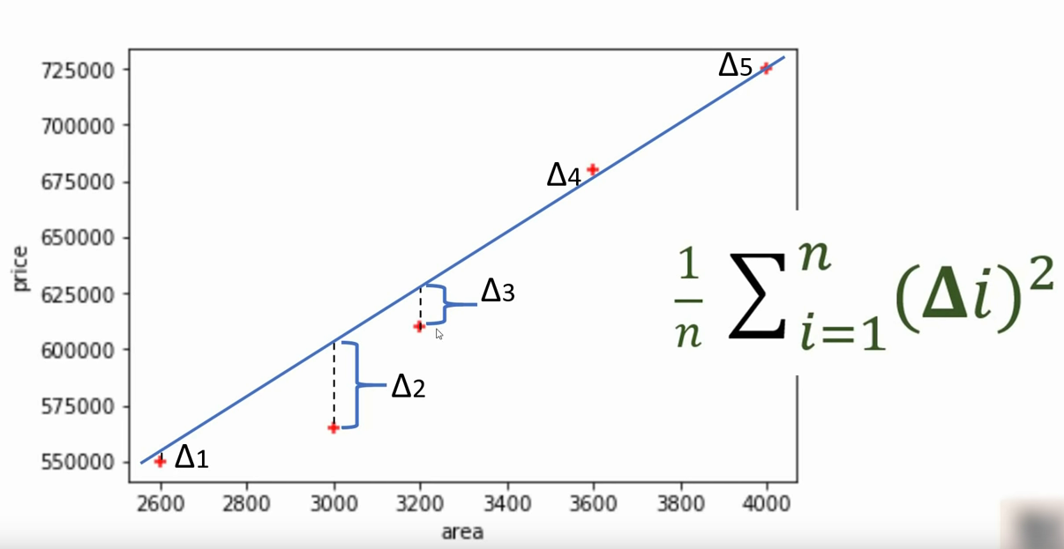

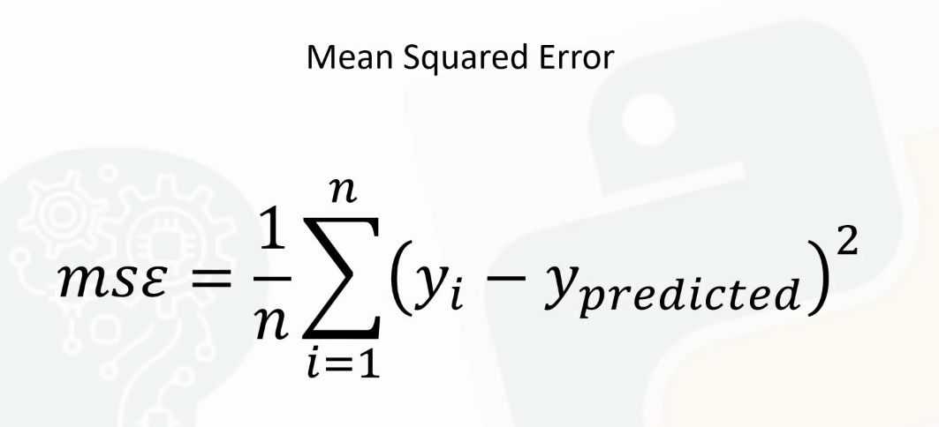

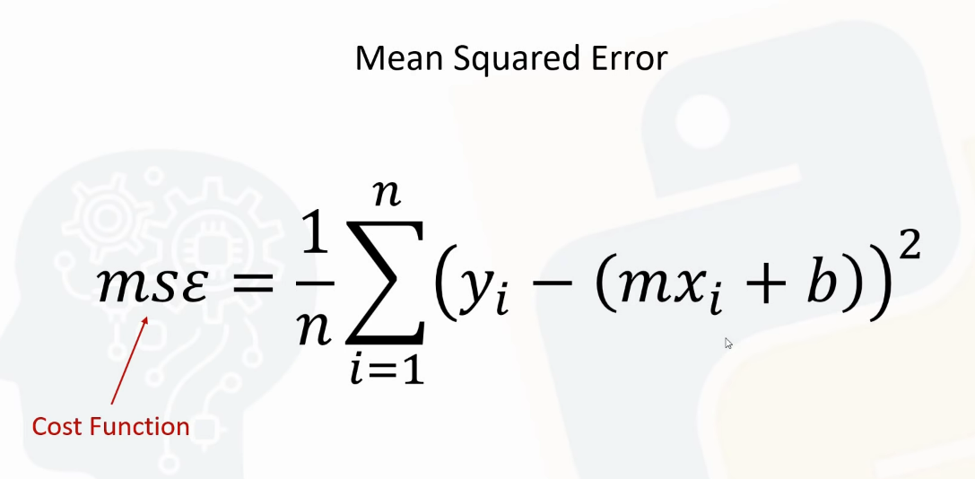



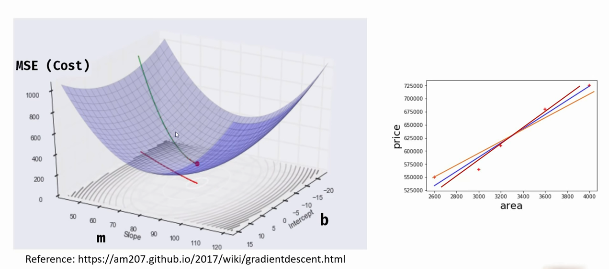

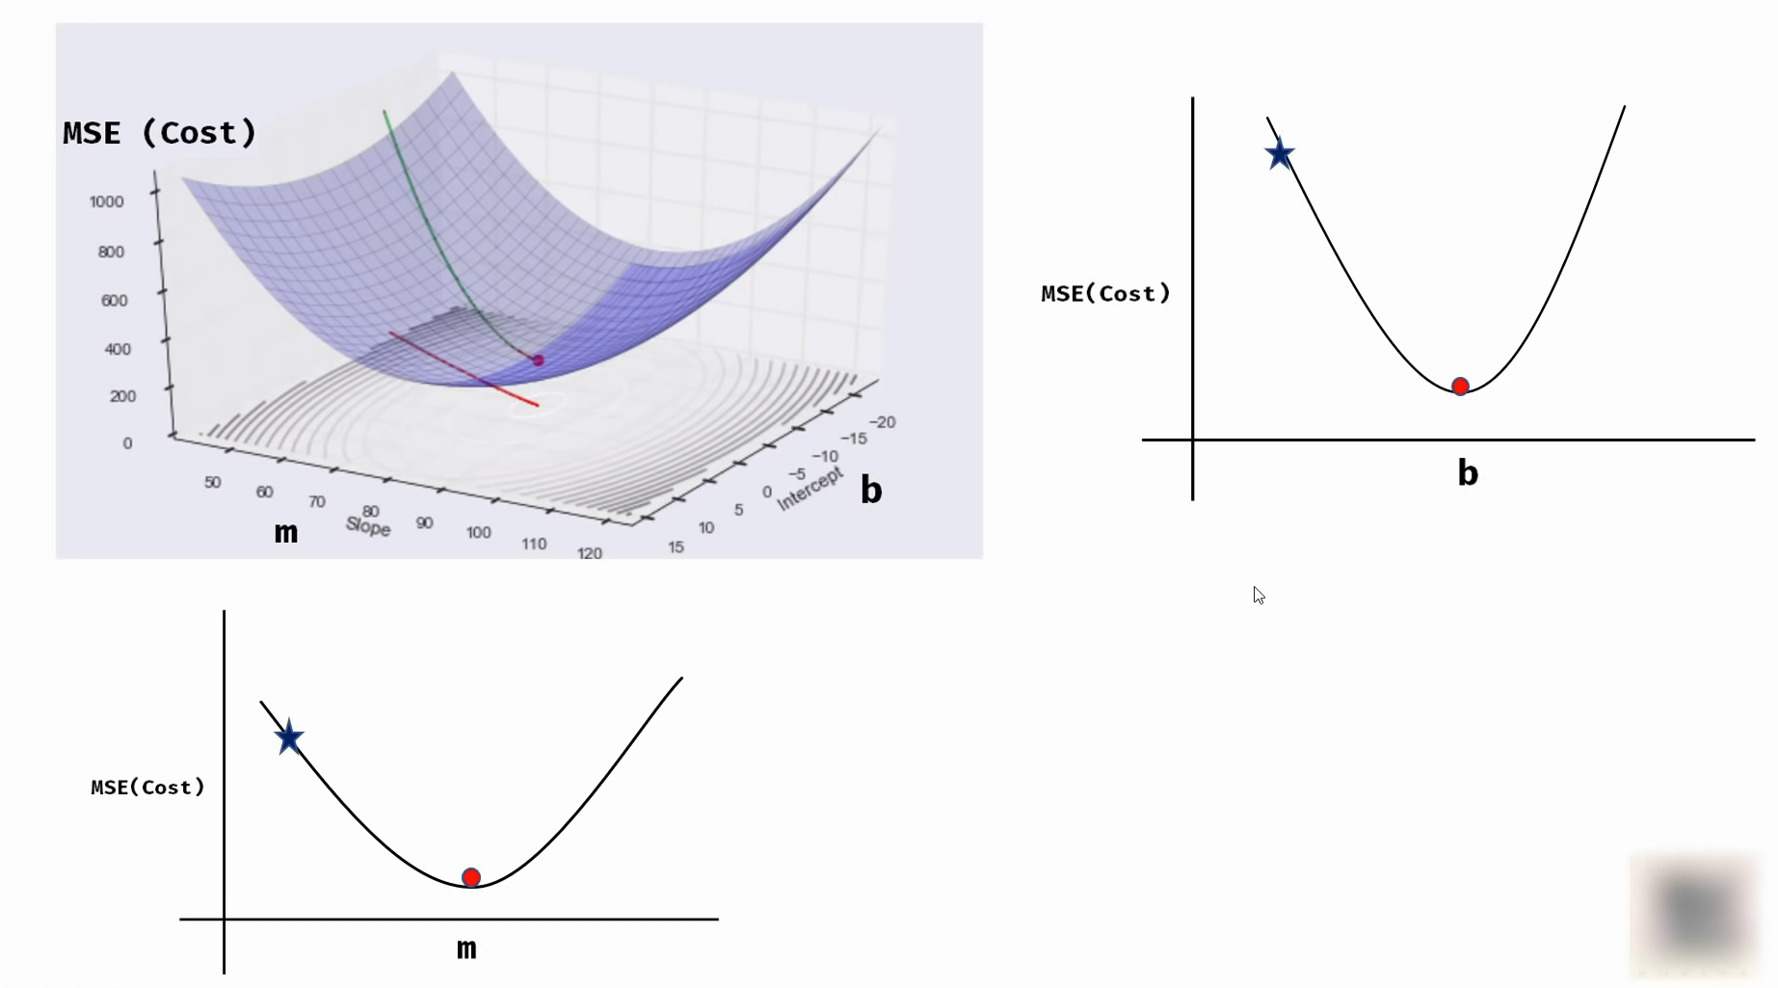

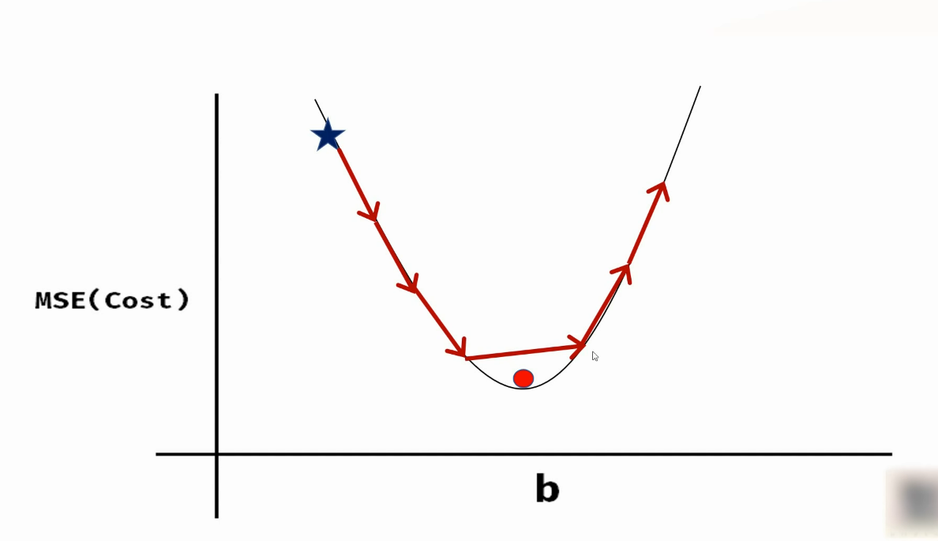

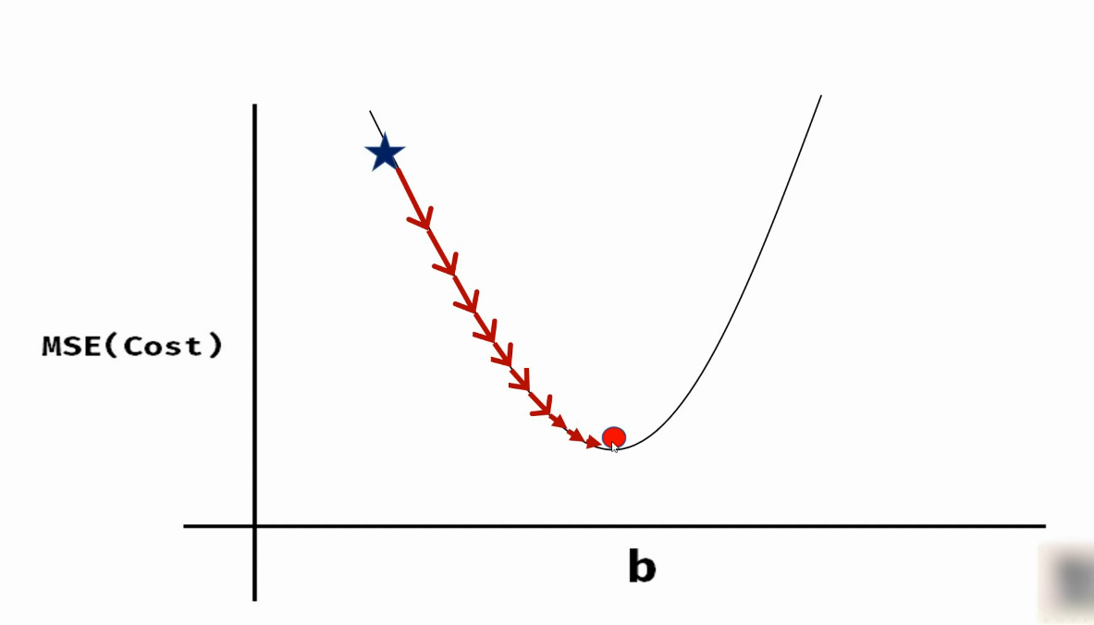

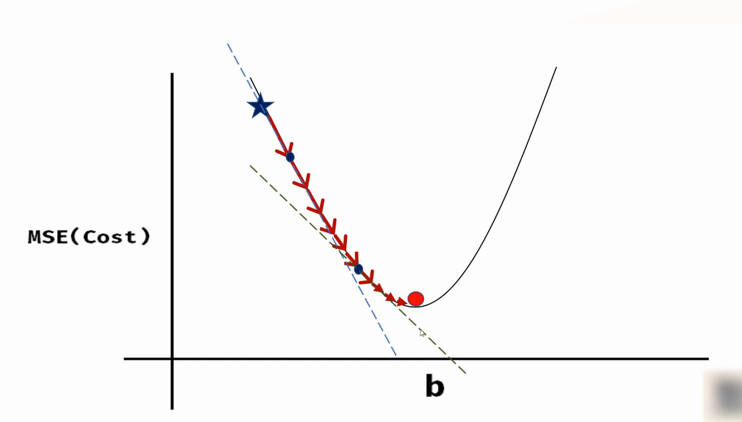

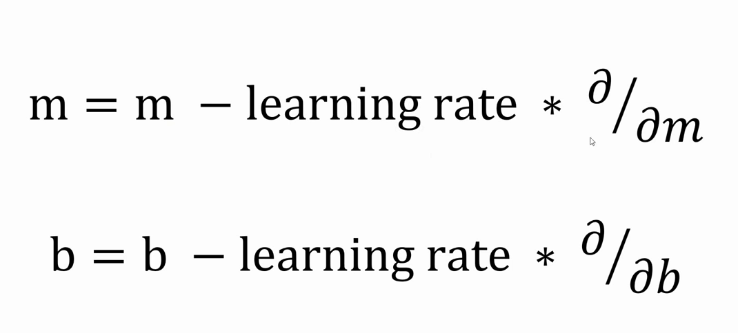

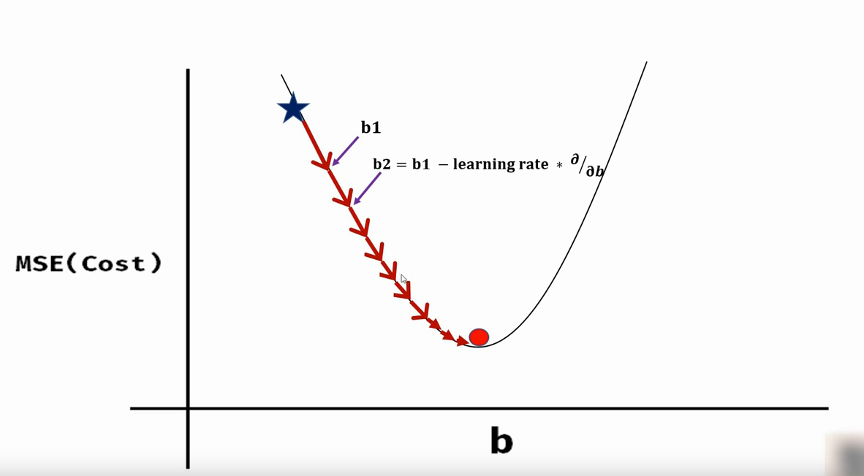

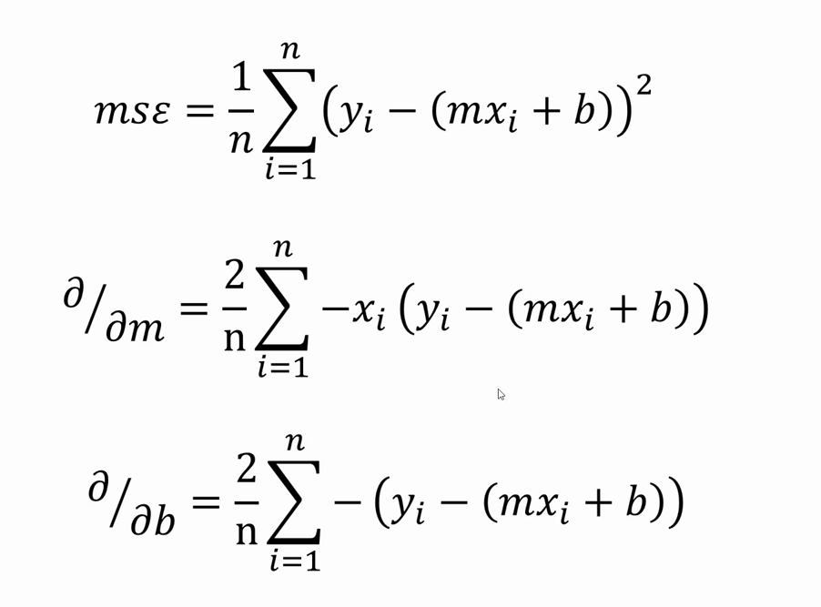
https://www.mathsisfun.com/calculus/derivatives-introduction.html

> Save trained Model
- pickle module
- joblib module

> Dummy Variables & One Hot Encoding
One hot encoding is a process by which categorical variables are converted into a form that could be provided to ML algorithms to do a better job in prediction.
- Machine learning models work very well for dataset having only numbers.
- But how do we handle text information in dataset?
- Simple approach is to use interger or label encoding but when categorical variables are nominal, using simple label encoding can be problematic.
- One hot encoding is the technique that can help in this situation.
- we can use pandas get_dummies method to create dummy variables that allows us to perform one hot encoding on given dataset.
- we can use sklearn.preprocessing OneHotEncoder as well to create dummy variables.

- Example
Gujarat, Rajasthan and UP
if we set number as
Gujarat = 1, Rajasthan = 2 and UP = 3
problem is model think like this
Gujarat < Rajasthan < UP
or
Gujarat + Rajasthan = UP
Obviously that line of thinking by your model is going to lead to it getting correlations completely wrong, so we need to introduce one-hot encoding.

> Training and Testing Data
- sklearn.model_selection.train_test_split method
- For fix train and test dataset use random_state = int.

