**Machine meter**

**The solution**

This hardware & software solution is designated to watch and signal the end of washer and dryer programs.

Long story short, when we moved to a bigger house, we’ve decided to put the washer and dryer machines in the cellar instead of the living area. As our current devices don’t have smart functionalities I’ve decided to design and create a solution that can watch and signal the end of the programs to let my wife remove the cloths exactly when needed avoiding multiple unnecessary checks while the devices are still working.

In the cellar all required pipes and endpoints were available to install the machines.

While a machine is working, it’s consuming power that can be measured with a specific appliance. The measured amount can be read, averaged and the value can be sent though WiFi to a database/service storing the measurements. We can define machine-specific thresholds indicating that the machine is working or already stopped, meaning the service can be programmed to determine the state of the machine and indicate it in human readable way. Even we can see the status on a mobile phone.

The solution consists of 3 hardware items with the required software components:

* Metering device – custom made hardware device based on a measuring transformer, an Arduino Nano and an ESP8266 WiFi module
* Central storage, database – Raspberry Pi 3 running a Python service and SQLite
* Informational dashboard – custom made hardware device based on a 20x4 display, an Arduino Nano and an ESP8266 WiFi module

Measuring device and the washer:

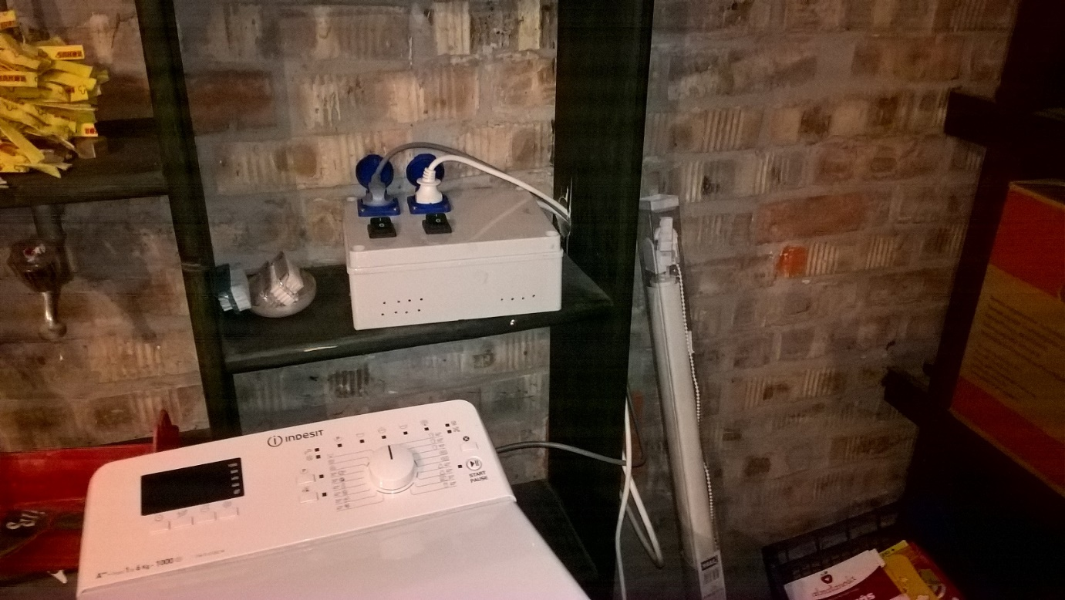

Dryer machine:

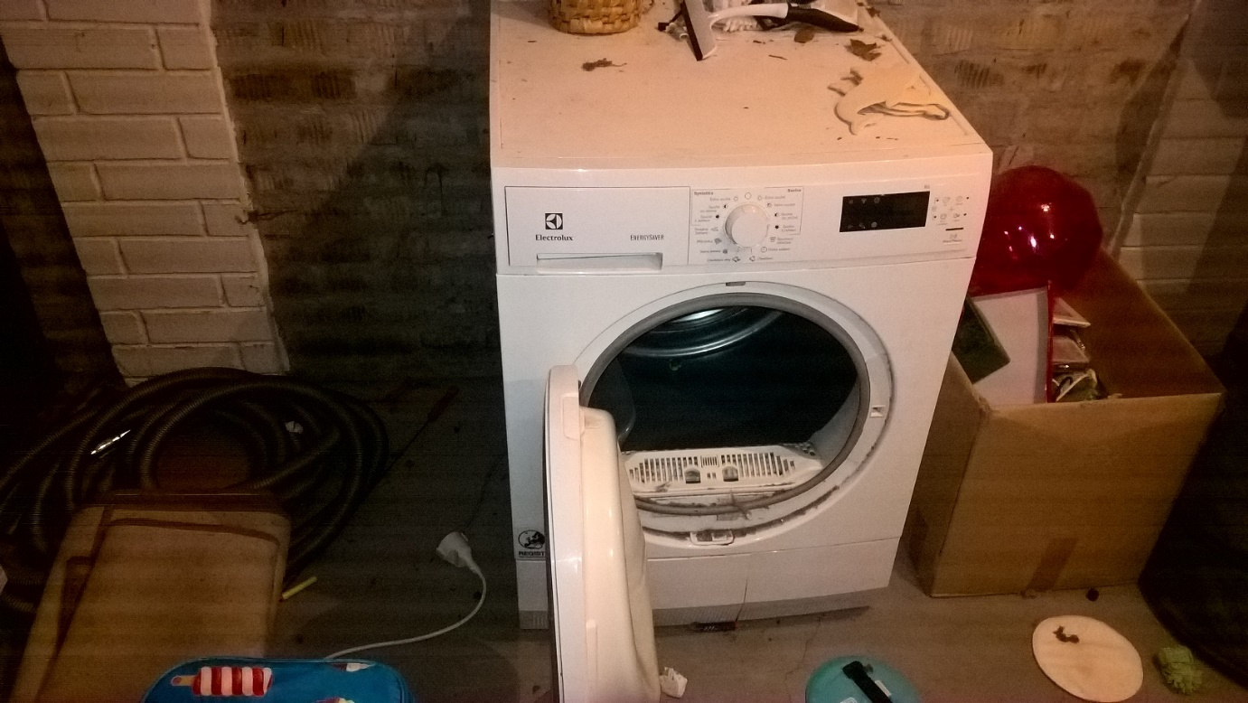

Devices in the cellar:

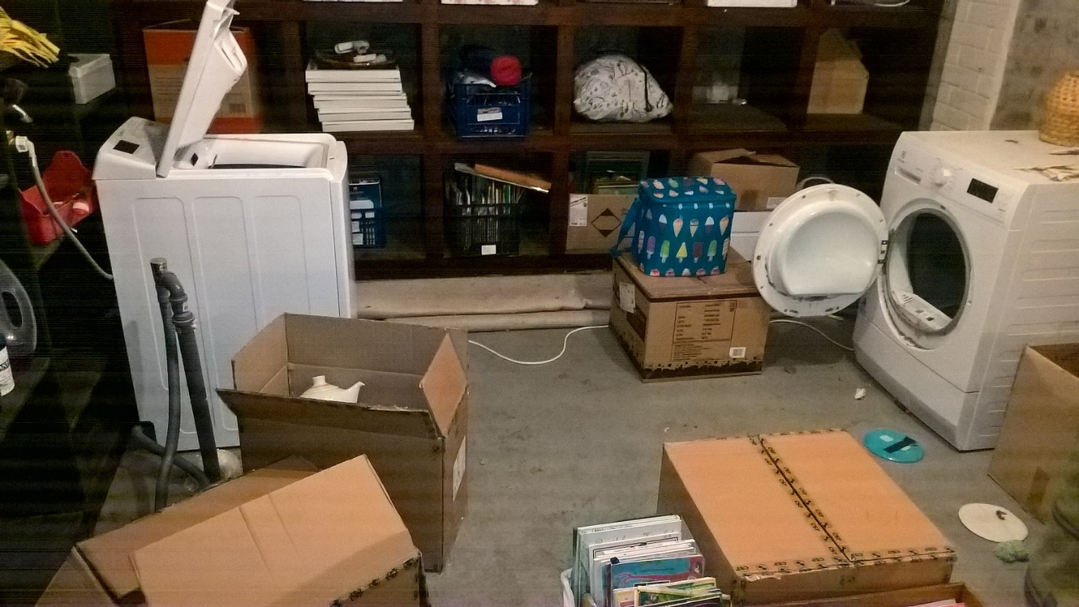

Everybody can image a Raspberry Pi 3, so no photo taken.

Information dashboard device:

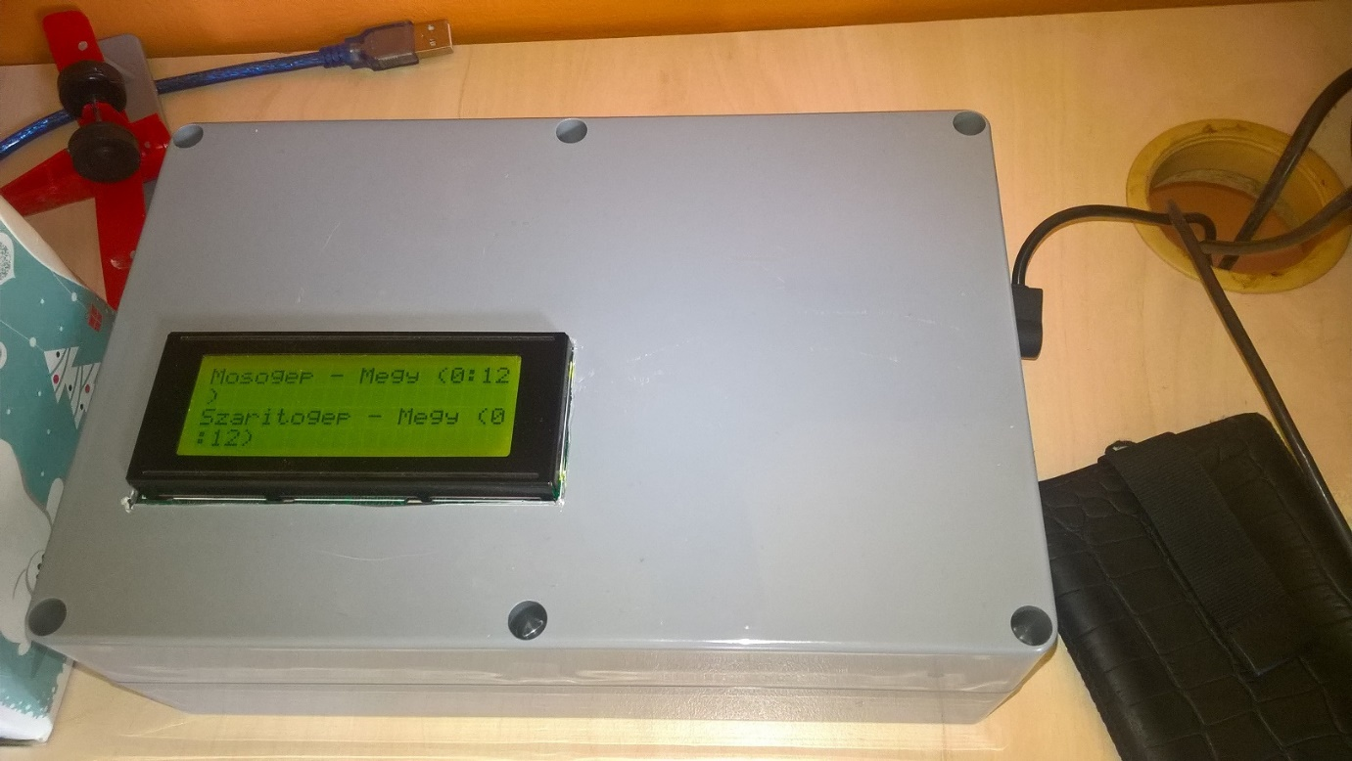

At the time when the photo was taken, the information dashboard was displaying (in Hungarian) that both the washer (mosogép) and the dryer (szárítógép) are working (megy) for 12 minutes.

**Current measurement theory and basics**

The following page describes the theory behind measuring current and gives detailed description on the making of such measuring appliance:

<https://learn.openenergymonitor.org/electricity-monitoring/ct-sensors/introduction>

I’ve made several software and hardware tweaks to this solution, so I’ll briefly explain the main points of the theory and the practical stuff again highlighting the differences.

The idea is to use HYDC split core current transformer (CT). The original design has a 100 Amps primary side CT, however washers and driers consume at most 10 Amps so I’ve decided to use a smaller primary side CT which means that I can achieve more accurate measurement on the secondary side. The webshop I ordered stuff, had 30 Amps HYDC CT. The secondary side produces +-1 V alternating voltage.

The analogue input of Arduino transforms input in range of 0-5 Volts to 0-1023. 2.5 V is 511. What we must do is to shift the +-1 Volts to 2.5V so that the analogue input will receive alternating voltage in the range 1.5 – 3.5. To achieve this, we must make a voltage divider.

As we measure alternating current which follows the shape of the sine wave the appropriate discrete current should be calculated via the RMS (Root Mean Square) method. The methodology is to read any number whole sine cycles (reading time should be multiple of 1/50 secs in case of 50 Hz AC) and execute the RMS method on the read values.

The original design reads only one analogue input and continuously refines the zero value. It means that we don’t know exactly the zero value (is it 511 or 512 or “511.5”) however the algorithm adds 1/1024 of the difference from the currently anticipated zero value.

I’ve changed this methodology in the following way:

1. Not only one but two values are read (the zero as well), meaning that the slightly moving zero value gives us more accurate results
2. The sine wave is continuously averaged by taking the previously read value into account as well

Based on my experience the correctness of the measurements is enhanced especially in case of the first 3 reads.