**OncoreCHHS Homepage Design Specification**

**Story: The CHHS application for Foster Parent's needs a home page**

**URL :: https://www.pivotaltracker.com/story/show/119699875**

05/18/2016

1. Page description narrative:

As a working group with the business analysts and end users, we decided that the homepage should be a clean and concise page that presents to the foster care parent all the features of the site. We initially considered not showing buttons and links that required the context of a parent, but felt that the presentation of all features made the most sense.

The decision to have the features in both the banner navigation as well as the main content area would fit into our decision to use JSF where the framework can use the banner navigation as a left hand navigation to satisfy the requirement to be responsive.

We also discussed that for this prototype no cookies would be implemented to support a ‘remember me’ type of experience. We also noted that we would want to add disclaimer text on this page as it will be a public URL

1. Page interactions:

|  |  |  |
| --- | --- | --- |
| **Control** | **Action** | **Response** |
| Home | Click | Go to home page |
| My Profile | Click | If the user is Iogged in, go to edit profile |
|  |  | If the user is not Iogged in, go to login page and carry destination context |
| Locate | Click | Go to locate agency page |
| Messages | Click | If the user is Iogged in, go to messages page |
|  |  | If the user is not Iogged in, go to login page and carry destination context |
| Login | Click | If the user is Iogged in, display firstname of user |
|  |  | If the user is not Iogged in, go to login page and carry destination context |

1. The Whiteboard Wireframe is below.

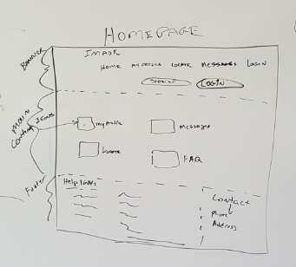

1. Required Services

No backend services are needed for this page

1. Required Data Model

No Data Model impacts for this page

1. Usability testing results

See Pivotal Tracker for Enhancements and defects from usability testing