**OncoreCHHS Login Design Specification**

**Story: The Foster Parent needs a login page**

**URL :: https://www.pivotaltracker.com/story/show/119791569**

05/18/2016

1. Page description narrative:

As a working group with the business analysts and end users we decided that the login page should be a page and not a pop-up. This makes the experience more consistent, and more predictable in the mobile-mode

1. Page interactions:

|  |  |  |
| --- | --- | --- |
| **Control** | **Action** | **Response** |
| Home | Click | Go to home page |
| My Profile | Click | If the user is Iogged in, go to edit profile |
|  |  | If the user is not Iogged in, go to login page and carry destination context |
| Locate | Click | Go to locate agency page |
| Messages | Click | If the user is Iogged in, go to messages page |
|  |  | If the user is not Iogged in, go to login page and carry destination context |
| Login | Click | If the user is Iogged in, display firstname of user |
|  |  | If the user is not Iogged in, go to login page and carry destination context |
| Cancel | Click | Return to homepage |
| Login | Click | Go to destination context page |

1. The Whiteboard Wireframe is below.

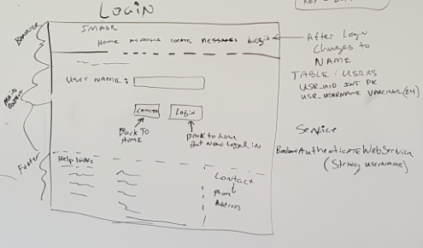

During the design session, we also did a quick tech/implementation rundown so that we could have a general inventory of the backend and datamodel activities.

1. Services

|  |  |
| --- | --- |
| **Service** | **Operation** |
| AuthenticationWebService | Boolean authenticateUser (String username) |

1. Data Model

|  |  |
| --- | --- |
|  | **TABLE** |
|  | USERS |
|  |  |

1. Usability testing results

See Pivotal Tracker for Enhancements and defects from usability testing