**OncoreCHHS Messages Design Specification**

**Story: The Foster Parent be able to send messages to the foster care agency**

**URL :: https://www.pivotaltracker.com/story/show/119875725**05/18/2016

1. Page description narrative:

This page will display the messages for the foster care parent. The user needs to be logged in to access this page. We also considered popups for the messages, but wanted to stay consistent with the application to this point.

1. Page interactions:

|  |  |  |
| --- | --- | --- |
| **Control** | **Action** | **Response** |
| Cancel | Click | Calls the search service and renders search results table |
| New | Click | Clears the message text box |
| Message Text Box | TextBox | Captures of displays the selected message, default sort by most recent messages |
| Send | Click | Saves the message to the DB |

1. The Whiteboard Wireframe

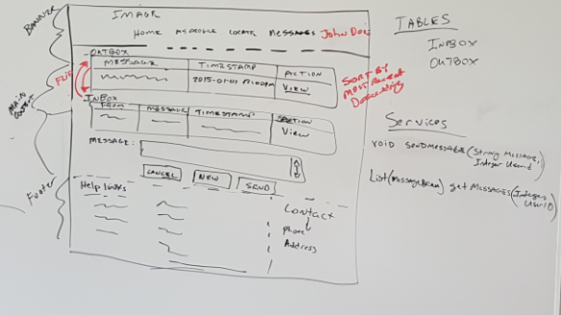

1. Services

|  |  |
| --- | --- |
| **Service** | **Operation** |
| MessageWebService | void sendMessage(String message, Integer userID |
| MessageWebService | List (MessageBean) getMessage (integer userID) |

1. Data Model

|  |  |
| --- | --- |
|  | **TABLE** |
|  | INBOX |
|  | OUTBOX |

1. Usability testing results

See Pivotal Tracker for Enhancements and defects from usability testing