**OncoreCHHS Registration Design Specification**

**Story: The Foster Parent needs to create a profile & The Foster Parent needs to edit the profile**

**URL ::** [**https://www.pivotaltracker.com/story/show/119700095**](https://www.pivotaltracker.com/story/show/119700095) **& https://www.pivotaltracker.com/story/show/119699849**

05/18/2016

1. Page description narrative:

The add profile and the edit profile pages are the same page and will be run in the different modes. The discussion on the type of foster care meta-data represented in the ‘possible section’ was an open discussion point. As a group, we were not sure how relevant it was for the prototype to capture information for example about the child on this page. Having the table for this type of information we felt would possibly clutter the concept of the profile page.

We consider field validation and required fields on this page to be critical so to ensure stability and predictability. Based on our experience, we’ve seen UI fields mismatching to the DB columns can often result in unexpected behavior.

1. Page interactions:

|  |  |  |
| --- | --- | --- |
| **Control** | **Action** | **Response** |
| User Name | Textbox/Label | Required Textbox in add mode, label in edit |
| First Name | Textbox | Required |
| Last Name | Textbox | Required |
| Phone Number | Textbox | Required |
| Email | Textbox | Required |
| Address Line 1 | Textbox | Optional |
| Address Line 2 | Textbox | Optional |
| City | Textbox | Optional |
| State | Textbox | Optional |
| Zip | Textbox | Optional |
| Save | Click | Calls Save Operation and go to homepage |
| Cancel | Click | Go to homepage |
| Login | Click |  |

1. The Whiteboard Wireframe for create profile is below.

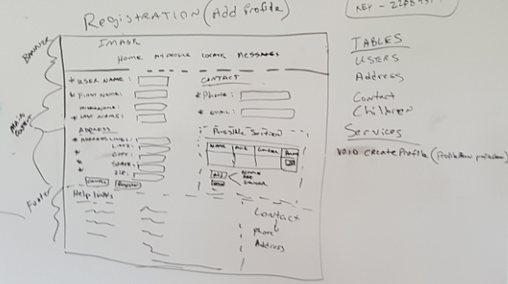

The Whiteboard Wireframe for edit profile is below.

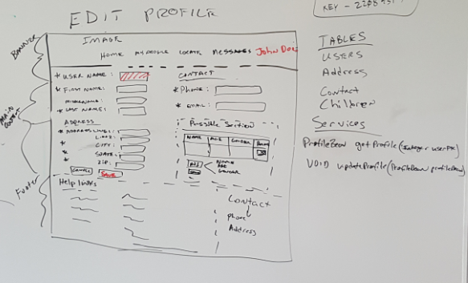

During the design session, we also did a quick tech/implementation rundown so that we could have a general inventory of the backend and datamodel activities.

1. Services

|  |  |
| --- | --- |
| **Service** | **Operation** |
| ProfileWebService | void createProfile (ProfileBean profilebean) |
| ProfileWebService | ProfileBean getProfile (Integer userNamePK) |
| ProfileWebService | void udpateProfile (ProfileBean profilebean) |

1. Data Model

|  |  |
| --- | --- |
|  | **Table** |
|  | USERS |
|  | ADDRESS |
|  | CONTACT |
|  | CHILDREN |

1. Usability testing results

See Pivotal Tracker for Enhancements and defects from usability testing