**OncoreCHHS Search Design Specification**

**Story: The Foster Parent needs to search for facilities by zipcode**

**URL :: https://www.pivotaltracker.com/story/show/119701383**

05/18/2016

1. Page description narrative:

This page will support the search by zip code against the HHS API. No security is required for this page. We also are considering the integration to Google Maps for additional richness

1. Page interactions:

|  |  |  |
| --- | --- | --- |
| **Control** | **Action** | **Response** |
| Search | Click | Calls the search service and renders search results table |
| Cancel | Click | Go to homepage |
| Results Table | Table | Display results of search based on the relevant columns returned from the API call. |

1. The Whiteboard Wireframe

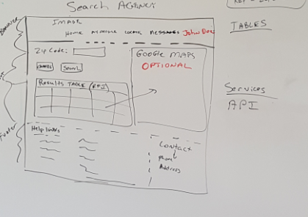

1. Services

|  |  |
| --- | --- |
| **Service** | **Operation** |
| AgencySearchWebService | AgencyResults searchAgencyByZipCode (String zipcode) |

1. Data Model

No tables should be needed for this page

1. Usability testing results
2. See Pivotal Tracker for Enhancements and defects from usability testing