ONCORE LLC, CHHS PROTOTYPE UBUNTU DEVELOPMENT VM

**General Information**

* The user is oncore
* The password for the oncore user and all other installed software, MySQL etc, is “Passw0rd”
* The latest Java JDK is installed under /home/oncore/java
* Netbeans and Glassfish are installed in /home/oncore
* All code is under the /home/oncore/workspaces directory
* All necessary tools have been installed but you can install others as needed
* The VM is configured with a basic configuration of 4GB or RAM and 2 CPUs. You can adjust this to your host’s capabilities by adding more memory or cpus as needed.

**Setting up your workspace**

1. Open Netbeans
2. Under the “Team” menu select Git->Clone

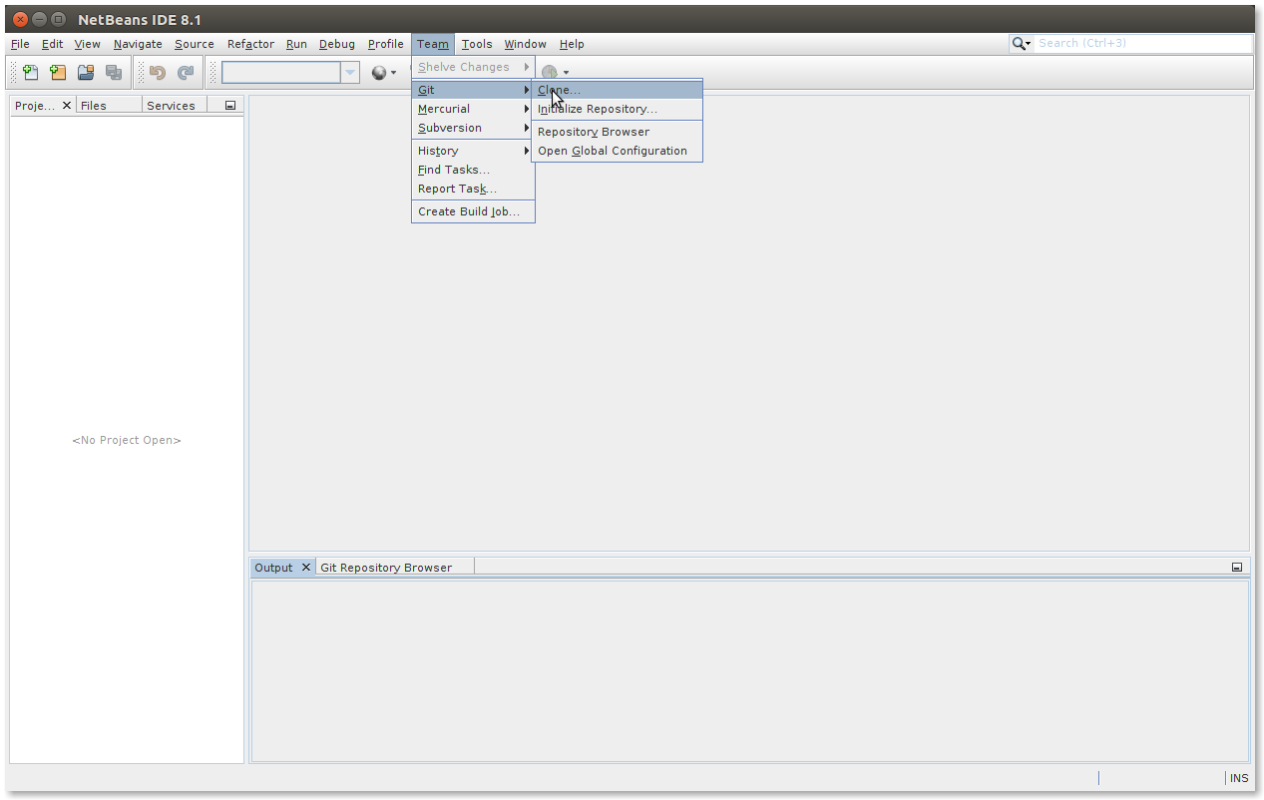

1. Fill in your GitHub credentials
2. Follow the wizard as follows

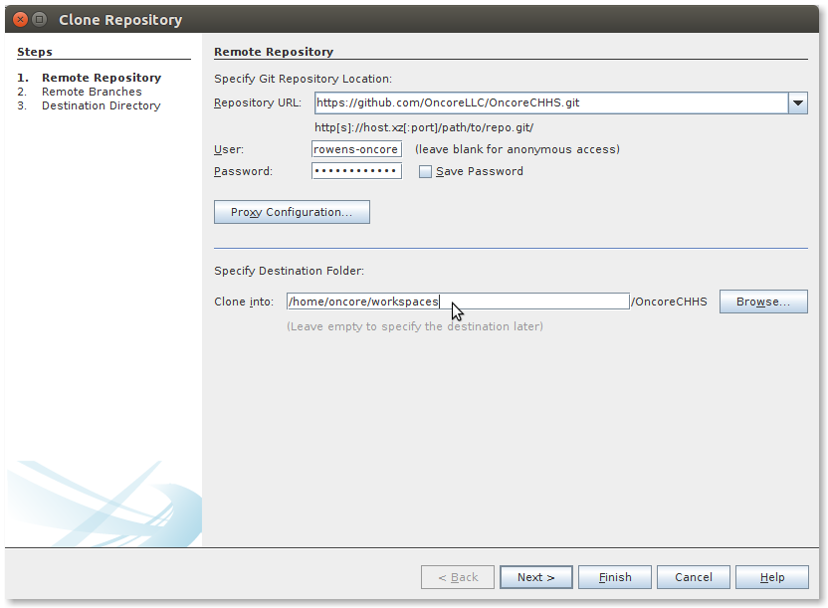

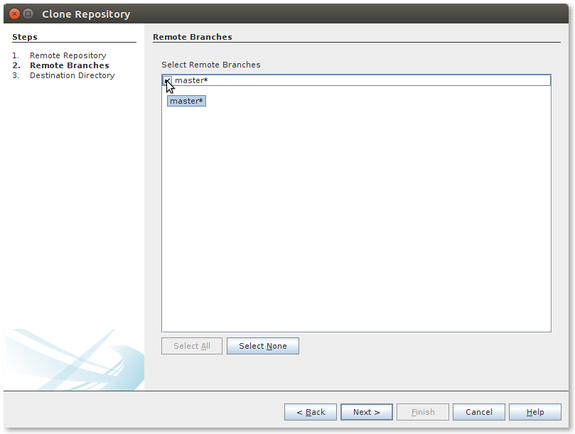

1. Make sure you select scan for Netbeans projects

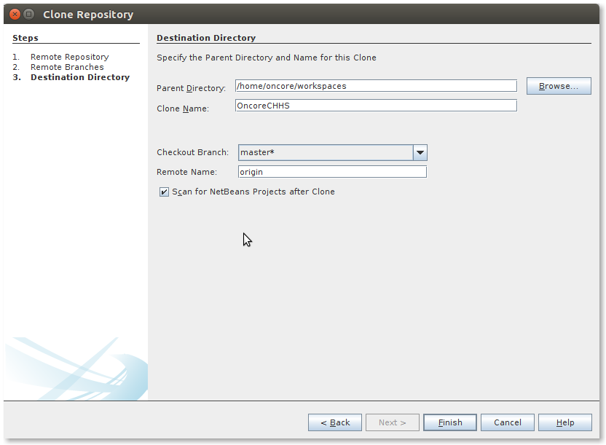

1. Click the Open Project Button

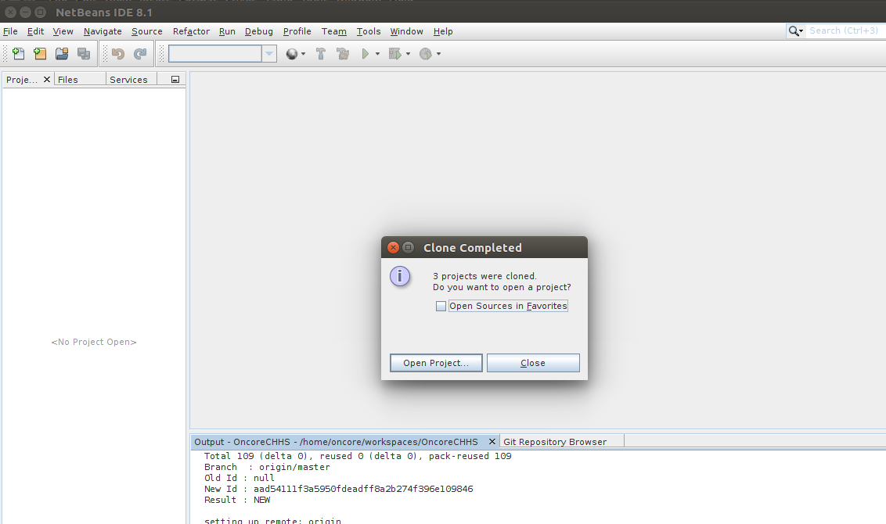

1. VERY IMPORTANT, make sure you select all the sub projects in OncoreCHHS and OncoreCHHSServices before clicking the open button

