Kendall Pollard

HW1 Attempt 2

This attempt took a lot of time for me in trying to convert it to a PDF from Quarto. I ended up not removing (with the rm function) some of the read rds stuff of the huge files, so it brought that over to my HW1_workspace. When I pushed changes to GitHub, it broke. The files were too big, and then I couldn’t go back and unstage those changes. So I had to start completely over.

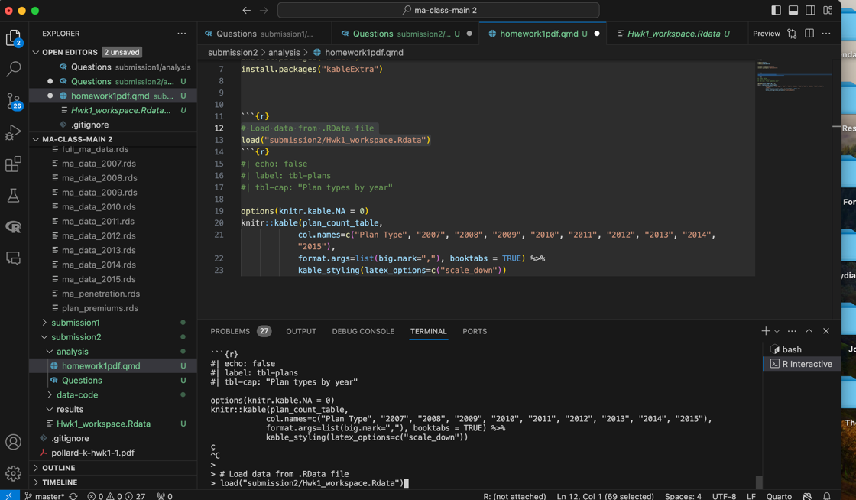

Here is my new repository: <https://github.com/kpollard8/Homework1>. (that period is included)

Note: I didn’t have question 4 in my initial submission done, but in this one it looks like I did. Sorry about this – I copied and pasted my code from where I currently was today, not where I was before class on Monday.

So for Submission 2:

* I worked for a long time on trying to get Quarto to then create a PDF and remove everything that would cause GitHub breaking issue
* I opened the Quarto file and started trying to make a pretty-looking table, but I couldn’t get past the first loading
* Finished question 4,
* started on 5 and a little of 6.

Here are my answers to most of the questions so far:

Questions 1 – 3

1. How many observations exist in your current dataset?
   1. 19126783
2. How many different *plan_types* exist in the data?
   1. 27
3. Provide a table of the count of plans under each plan type in each year.

1. A screen shot of a computer

   Description automatically generated
2. Can merge with inner_join
3. Again use the inner_join
4. Couldn’t do because I couldn’t do 6
5. Why did we drop the “800-series” plans?
   1. I think 800 series plans are extensions of eghps. According to MA, employers engage with a third party, which assumes the insurance risk and operates as the plan sponsor. The designation "800 series" commonly encompasses the majority of EGWPs. Therefore, it’s similar to a eghp, so we dropped it because we were already dropping the rest.
6. Why do so many plans charge a $0 premium? What does that really mean to a beneficiary?
   1. A $0 premium is attractive to beneficiaries because that means they don't have to pay an additional premium beyond their standard Medicare Part B premium. So I think it means that they still have to pay a premium, just not an additional
7. Briefly describe your experience working with these data (just a few sentences). Tell me one thing you learned and one thing that really aggravated you.
   1. Figuring out how to link it to a GitHub repository was incredibly exhausting – I had to start over 8x. The .gitignore wasn’t working, so it would try to push all of the data files along with the code. I met with people in the class 4x this weekend. The thing that took the longest was setting up how to even start answering the questions. I ran out of time for 5, 6, 7 for that reason.
   2. I learned how to connect it to GitHub eventually and ignore the data files after multiple trial and error
   3. In the second attempt, I learned how to use a .qdm file, I learned how to create a “_workspace” file that only has my answers, and I started trying to make it a PDF – this was really time consuming