Homework 5

1a.

65

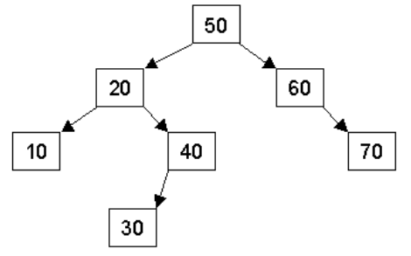

80

74

15

36

65

25

1b.

In-Order Traversal: 10,15,20,25,30,36,40,50,60,65,70,74,80

Pre-Order Traversal: 50, 20,10,15,40,30,25,36,60,70,65,80,74

Post-Order Traversal: 15,10,25,36,30,40,20,65,74,80,70,60,50

65



80

74

15

1c.

65

25

40

36

After removing 30 and then node 20.

2a.

struct Node {

int val;

Node* left;

Node* right;

Node* parent;

};

**//CHECK**

2b. //pseudocode to insert a new node

insert (val, root) {

if the root is null

make the parent the node before

if the value is bigger than the root

if there is no child on the right, insert node with parent as current node, right child of root as this new node

otherwise, recursively pass the right node with the insert function

if the value is smaller than the root

if there is no child on the left, insert node with parent as current node, left child of root as this new node

otherwise, recursively pass the left node with the insert function

}

8

3a.

6

3

4

0

2

3

4

2

0

6

8

3b.

0

2

4

3

6

3c.

4.

a. O(C+S)

b. O(logC + S)

c. O(logC+logS)

d. O(logS)

e. O(1)

f. O(logC+S)

g. O(S)

h. O(ClogS)