Unsupervised Learning and Clustering Analysis
Week 3 Task Report
Dataset: Mall Customer Segmentation Data
Prepared with Python (pandas, numpy, scikit-learn, scipy, matplotlib, seaborn)
October 2026

Executive Summary
This report applies unsupervised learning to segment 200 mall customers into meaningful groups based on their annual income and spending behavior, using K-Means and Hierarchical (Agglomerative) clustering implemented in scikit-learn. The optimal number of clusters was determined quantitatively using the elbow method and silhouette analysis, both of which converged cleanly on five clusters. The resulting segments are strongly separated (average silhouette score 0.555) and are validated by a second, independent clustering algorithm that agrees with the primary result on 98% of customers. Each cluster is profiled by age, income, spending score, and gender composition, and translated into a named customer persona with a concrete business implication - from a high-value 'premium target' segment to a 'cautious saver' segment that spends well below its means.
Key results:
- Five clusters were identified and are clearly separable on a 2D income-vs-spending plot, matching the geometry visible in the raw data itself.
- K-Means (k=5) achieved a silhouette score of 0.555 and a Davies-Bouldin score of 0.572, both indicating well-separated, reasonably compact clusters.
- Hierarchical clustering with Ward linkage produced a near-identical partition (98.0% agreement with K-Means), providing strong external validation of the five-segment structure.
- An extended three-feature clustering (adding Age) was also run as a secondary analysis, surfacing a six-segment structure that further splits customers by generation.
- Each of the five primary clusters was translated into a named business persona with specific marketing implications.

1. Introduction and Objective
The objective of this task is to apply unsupervised clustering techniques to a public dataset in order to discover naturally occurring customer segments, without using any pre-existing labels. Unlike the supervised Titanic analysis in earlier weeks, clustering here must determine its own structure directly from the data's geometry. The task is evaluated on the soundness of the chosen clustering technique, the justification for its parameters (particularly the number of clusters), the clarity of the resulting visualizations, and the depth and business relevance of the cluster interpretation that follows.

2. Dataset Selection and Acquisition
The Mall Customer Segmentation dataset was selected because it is purpose-built for clustering: it contains continuous, naturally scaled behavioral variables (income and spending score) with no pre-assigned labels, and is small and clean enough to allow a thorough, well-visualized analysis within scope. It is a standard public dataset for demonstrating customer segmentation and is widely used in both academic and industry clustering tutorials, which also makes the results here easy to sanity-check against established findings.
Property | Value
Source | Mall Customer Segmentation Data (public dataset, mirrored on GitHub)
Records | 200 mall customers
Columns | CustomerID, Gender, Age, Annual Income (k$), Spending Score (1-100)
Missing values | 0 (confirmed during initial exploration)
Spending Score | A behavioral score (1-100) assigned by the mall based on customer purchasing behavior
import pandas as pd

df = pd.read_csv('Mall_Customers.csv')
df = df.rename(columns={'Annual Income (k$)': 'AnnualIncome',
'Spending Score (1-100)': 'SpendingScore'})
print(df.shape) # (200, 5)
print(df.isnull().sum()) # 0 missing values in every column

3. Preprocessing for Clustering
Clustering algorithms that rely on distance (including K-Means and Ward-linkage hierarchical clustering) are sensitive to the scale of each feature: a feature measured in the tens of thousands (income) would otherwise dominate a feature measured on a 1-100 scale (spending score) purely because of its larger numeric range, not because it is more important. Both clustering features were therefore standardized to zero mean and unit variance with scikit-learn's StandardScaler before any clustering was performed.
from sklearn.preprocessing import StandardScaler

features_2d = ['AnnualIncome', 'SpendingScore']
scaler = StandardScaler()
X_scaled = scaler.fit_transform(df[features_2d])
Feature selection: Annual Income and Spending Score were chosen as the primary clustering features because they directly describe purchasing behavior - the dimension most relevant to a retail segmentation use case - and because this pair produces visually and statistically well-separated clusters (confirmed in Section 4). CustomerID was excluded entirely, since it is an arbitrary identifier with no behavioral meaning and would only add noise. Gender was encoded numerically (Male=0, Female=1) but deliberately kept out of the main distance-based clustering: mixing a binary categorical variable directly into a Euclidean-distance algorithm alongside continuous variables would distort the geometry, so Gender was instead reserved for profiling the resulting clusters after the fact (Section 7). Age was also held out of the primary analysis for the same reason that drove the feature choice above, and was instead explored separately as a three-feature extension in Section 6 to test whether adding a demographic dimension changes the segmentation.

4. Methodology: Determining the Optimal Number of Clusters
K-Means requires the number of clusters (k) to be specified in advance, so two complementary, quantitative methods were used to choose it rather than guessing: the elbow method (where within-cluster sum of squares, or inertia, is plotted against k, looking for the point of diminishing returns) and the silhouette score (which measures how well-separated and internally cohesive the clusters are, independent of any visual judgment call).
from sklearn.cluster import KMeans
from sklearn.metrics import silhouette_score

inertias, silhouettes = [], []
for k in range(2, 11):
km = KMeans(n_clusters=k, init='k-means++', n_init=10, random_state=42)
labels = km.fit_predict(X_scaled)
inertias.append(km.inertia_)
silhouettes.append(silhouette_score(X_scaled, labels))
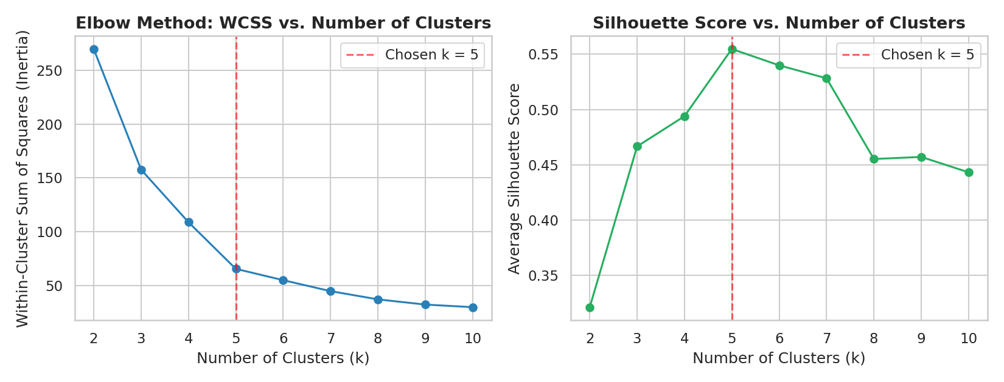
Figure 1. Elbow method (left) and silhouette score (right) across k = 2 to 10.
Both diagnostics agree cleanly: the elbow plot shows a sharp bend at k=5, after which additional clusters yield rapidly diminishing reductions in inertia, and the silhouette score reaches its clear maximum (0.555) at exactly k=5 before declining for larger k. This convergence of two independent metrics gives strong confidence that five is the right number of natural groupings in this data, rather than an arbitrary choice - k=5 was therefore selected for the primary analysis.

5. K-Means Clustering Results
kmeans = KMeans(n_clusters=5, init='k-means++', n_init=10, random_state=42)
df['Cluster'] = kmeans.fit_predict(X_scaled)
centroids = scaler.inverse_transform(kmeans.cluster_centers_)
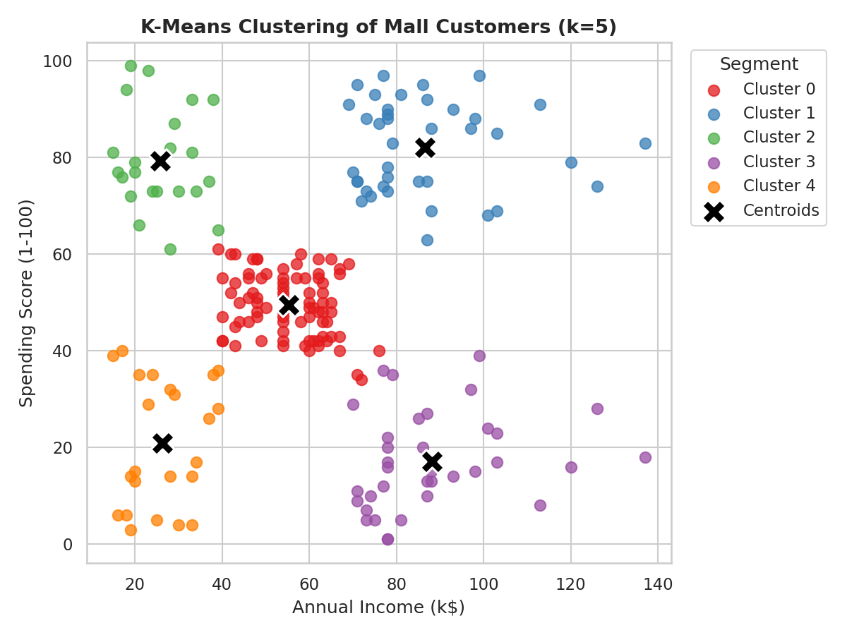
Figure 2. K-Means clustering of mall customers (k=5), with cluster centroids marked. Each color represents one customer segment.
The five clusters are visually distinct and occupy clearly separated regions of the income/spending plane, with almost no overlap at the boundaries - a strong qualitative confirmation of the k=5 choice. The final model achieved a silhouette score of 0.555 and a Davies-Bouldin score of 0.572 (lower is better for Davies-Bouldin), both indicating well-separated, reasonably compact clusters rather than an arbitrary partition of a single blob.

5.1 Validating Cluster Quality with a Silhouette Plot
Beyond the single average silhouette score, a per-sample silhouette plot was produced to check whether cluster quality is consistent across all five segments, or whether the average is being propped up by one or two unusually clean clusters.
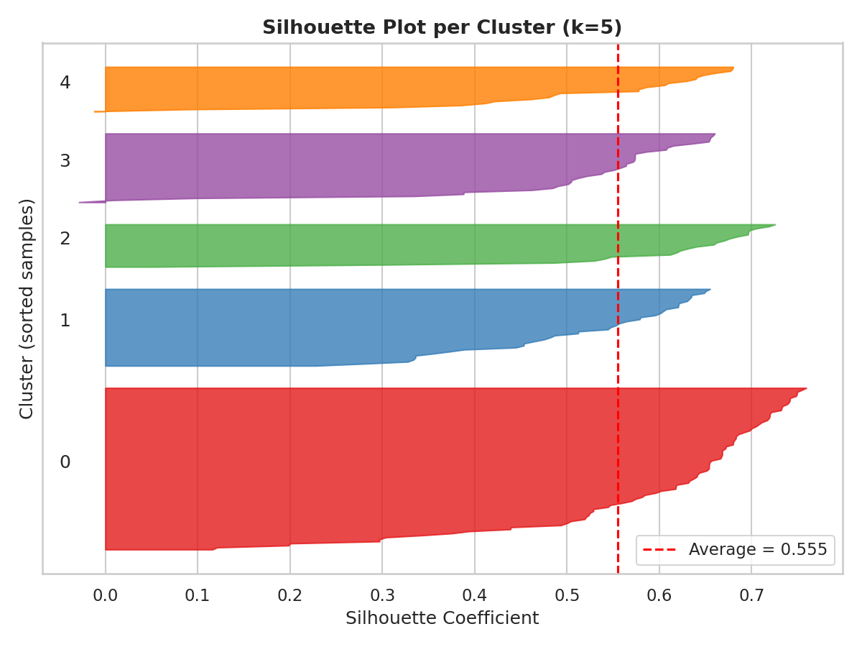
Figure 3. Silhouette coefficient for every customer, grouped by cluster. The red dashed line marks the overall average (0.555).
All five clusters sit at or above the overall average, with very few customers showing a low or negative silhouette value (which would indicate a likely misassignment). This confirms the five-cluster solution is uniformly well-formed rather than dominated by one strong cluster masking weaker ones.

6. Hierarchical Clustering: A Second Algorithm for Validation
To confirm that the five-segment structure is a genuine property of the data rather than an artifact of K-Means' specific optimization procedure, Agglomerative (Hierarchical) Clustering with Ward linkage was applied independently to the same standardized features.
from scipy.cluster.hierarchy import dendrogram, linkage
from sklearn.cluster import AgglomerativeClustering

linked = linkage(X_scaled, method='ward')
agglo = AgglomerativeClustering(n_clusters=5, linkage='ward')
df['Cluster_Hierarchical'] = agglo.fit_predict(X_scaled)
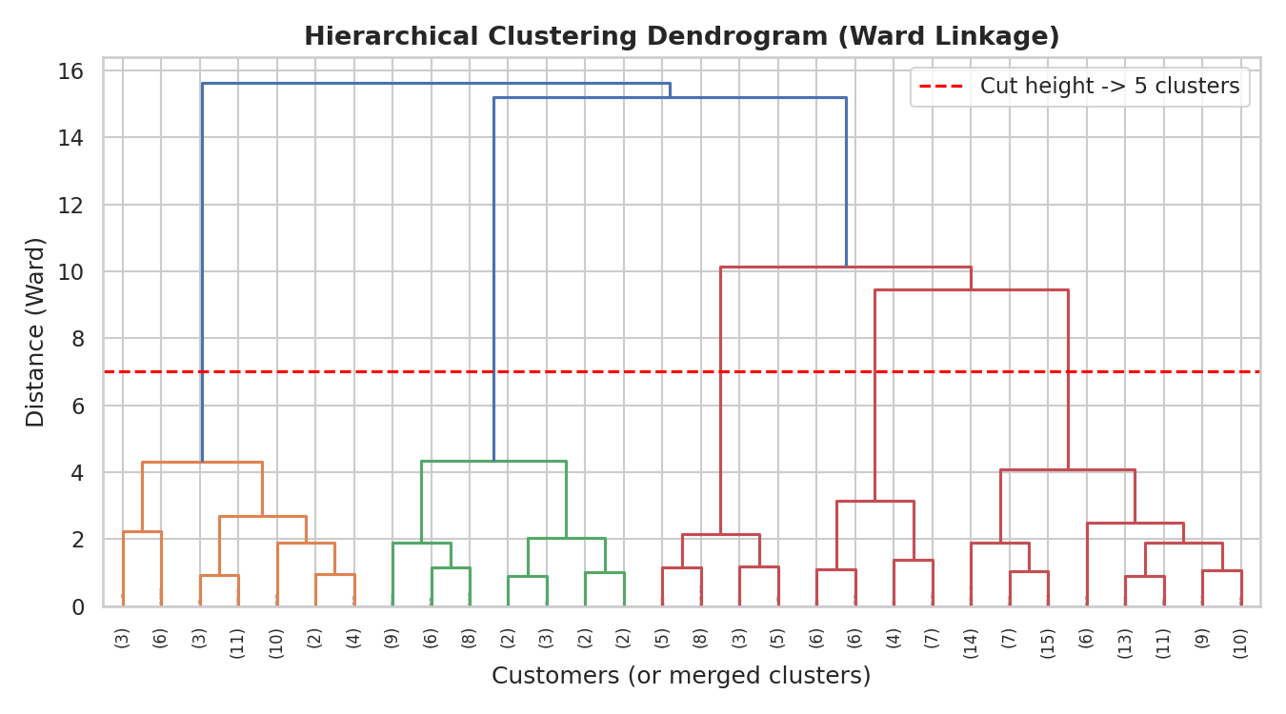
Figure 4. Hierarchical clustering dendrogram (Ward linkage, truncated to the last 30 merges for readability). Cutting the tree at the marked height yields five clusters, independently confirming the k=5 choice from Section 4.
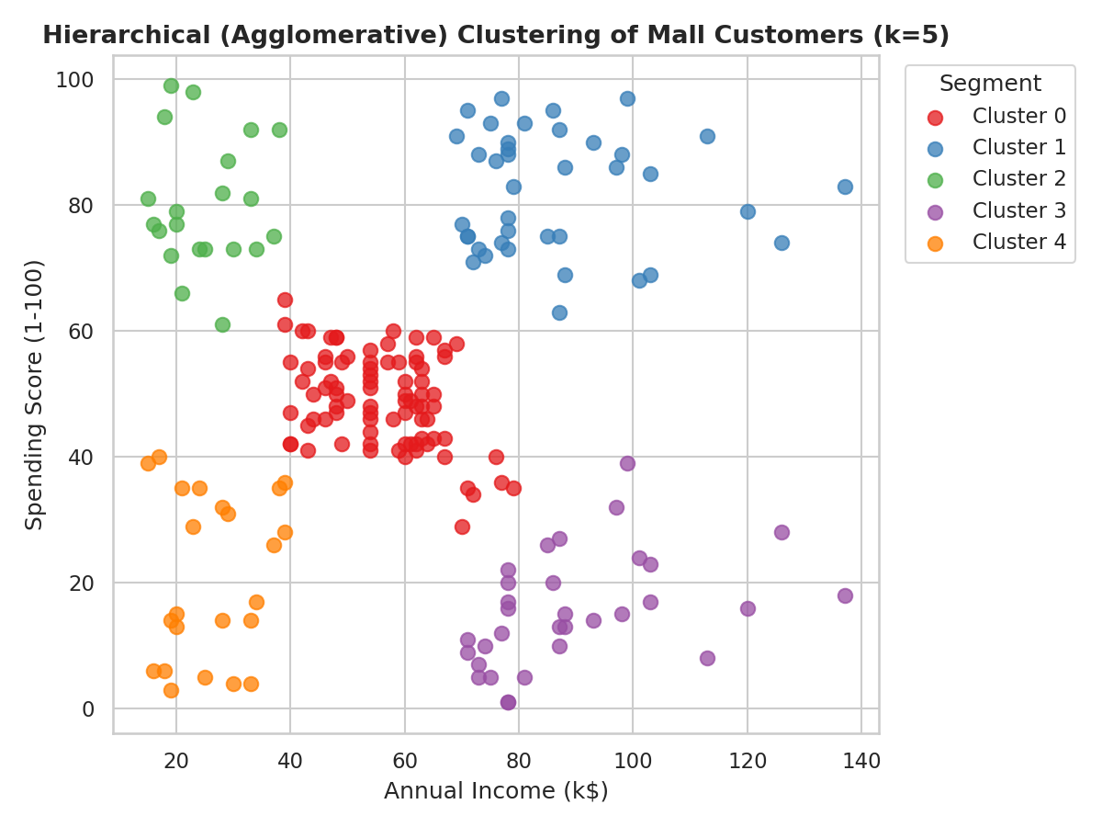
Figure 5. Hierarchical clustering result (k=5), cluster colors aligned to the K-Means result in Figure 2 for direct visual comparison.
The dendrogram's structure independently supports five clusters: cutting it at the marked height produces five clearly separated branches. More importantly, after aligning the two algorithms' arbitrary cluster-number labels to their nearest counterpart, Hierarchical Clustering agreed with K-Means on 98.0% of all 200 customers (196 of 200). This high agreement between two structurally different algorithms - one iterative and centroid-based, the other a bottom-up merge procedure - is strong evidence that the five-segment structure reflects a genuine pattern in customer behavior rather than an artifact of one particular algorithm's mechanics.

7. Extended Analysis: Adding Age as a Third Dimension
As a secondary, more exploratory analysis, Age was added to Annual Income and Spending Score to test whether a demographic dimension would reveal additional structure beyond the primary two-feature segmentation. The same elbow/silhouette selection process (re-run on the three standardized features) favored k=6 for this extended feature set, with a silhouette score of 0.428 - lower than the 2D result, which is expected, since adding a dimension where the natural separation is weaker (age overlaps more between behavioral groups than income or spending does) tends to reduce overall silhouette quality even when it adds genuinely useful nuance.
features_3d = ['Age', 'AnnualIncome', 'SpendingScore']
X3_scaled = StandardScaler().fit_transform(df[features_3d])
# Elbow/silhouette re-run on X3_scaled favored k=6
kmeans3 = KMeans(n_clusters=6, init='k-means++', n_init=10, random_state=42)
df['Cluster_3D'] = kmeans3.fit_predict(X3_scaled)
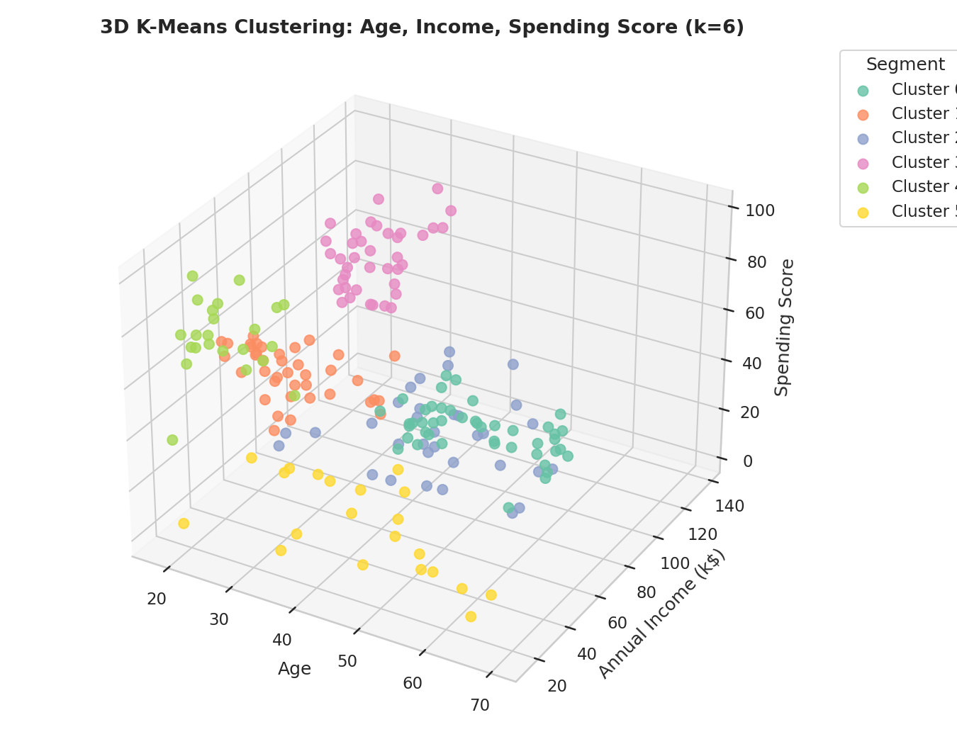
Figure 6. Three-dimensional K-Means clustering on Age, Annual Income, and Spending Score (k=6).
This extended view splits the large, income/spending-defined 'average' cluster from the primary analysis (Cluster 0 in Section 5) further by age, separating younger and older customers who otherwise share similar income and spending levels. This is a useful refinement for an age-targeted marketing campaign, but the primary, two-feature, k=5 segmentation remains the main result of this report, since it is simpler, more interpretable, and more strongly validated (higher silhouette score, and cross-confirmed by a second algorithm in Section 6).

8. Cluster Profiling and Business Interpretation
Each of the five primary clusters (from the K-Means 2D solution) was profiled by its average age, income, spending score, and gender composition, to translate the statistical segmentation into actionable customer personas.
profile = df.groupby('Cluster').agg(
Count=('CustomerID', 'count'),
Avg_Age=('Age', 'mean'),
Avg_Income=('AnnualIncome', 'mean'),
Avg_Spending=('SpendingScore', 'mean'),
Pct_Female=('Gender_encoded', 'mean'),
).round(1)
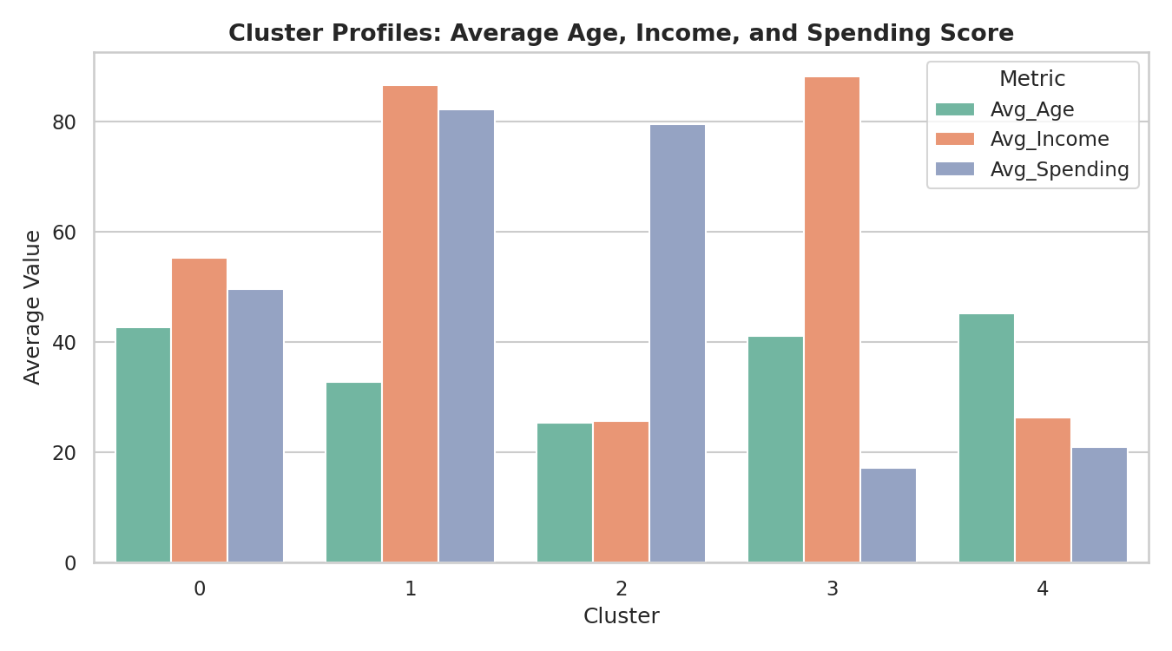
Figure 7. Average age, income, and spending score for each of the five clusters.
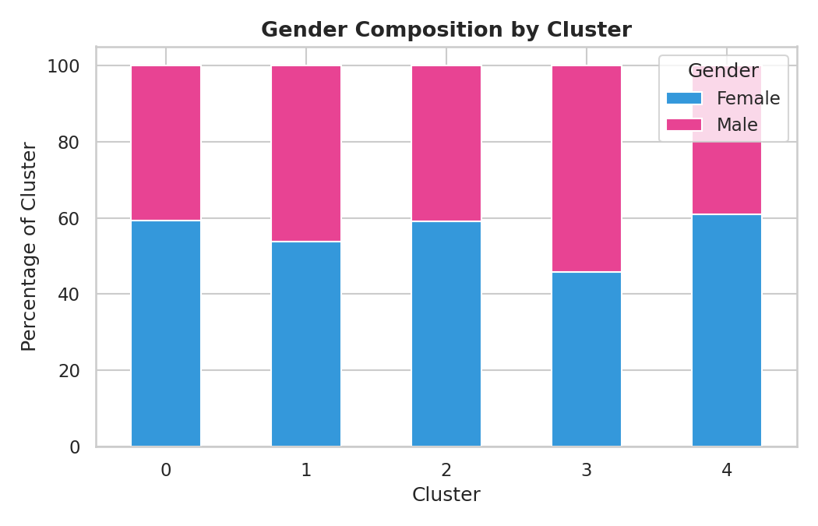
Figure 8. Gender composition of each cluster, as a percentage.
Cluster | n | Avg Age | Avg Income | Avg Spending | % Female | Persona
0 | 81 | 42.7 | $55.3k | 49.5 | 59% | Average / Mainstream
1 | 39 | 32.7 | $86.5k | 82.1 | 54% | High Income, High Spending (Premium Target)
2 | 22 | 25.3 | $25.7k | 79.4 | 59% | Low Income, High Spending (Impulsive/Young)
3 | 35 | 41.1 | $88.2k | 17.1 | 46% | High Income, Low Spending (Cautious Saver)
4 | 23 | 45.2 | $26.3k | 20.9 | 61% | Low Income, Low Spending (Budget Conscious)

Cluster 0 - Average / Mainstream (n=81, the largest segment)
This is the largest cluster, sitting near the middle of both income (avg. $55.3k) and spending score (avg. 49.5) ranges, with a slightly older average age (42.7) and a 59% female skew. Business implication: this group represents the mall's broad, stable customer base. Rather than a targeted campaign, this segment is best served by general loyalty programs, seasonal promotions, and consistent value offerings - the goal is retention and incremental spend growth rather than behavior change.

Cluster 1 - High Income, High Spending (n=39, the premium target)
This segment combines the second-highest average income ($86.5k) with by far the highest average spending score (82.1), and skews younger (avg. age 32.7). Business implication: this is the most commercially valuable segment per customer and the clearest target for premium product lines, early access to new collections, and personalized high-touch service (e.g. VIP loyalty tiers). Marketing spend aimed at this group is likely to have the highest return, since both willingness and ability to spend are already high.

Cluster 2 - Low Income, High Spending (n=22, the impulsive/young spender)
This is the youngest cluster (avg. age 25.3) and combines the lowest average income ($25.7k) with a high average spending score (79.4) - a behavior pattern inconsistent with strict budgeting. Business implication: this group likely represents younger customers (possibly students or early-career) with high discretionary spending relative to income, perhaps supported by trend-driven or social-spending motivations. They are a strong fit for flexible payment options (buy-now-pay-later), trend-led and lower-price-point product lines, and social-media-driven marketing rather than loyalty-program-based retention, since their spending may not yet be habitual.

Cluster 3 - High Income, Low Spending (n=35, the cautious saver / untapped opportunity)
This segment has the highest average income of all five clusters ($88.2k) but the lowest average spending score (17.1), and is the only one of the five clusters with a slight male majority (54% male / 46% female, visible in Figure 8). Business implication: this is arguably the most strategically interesting segment - these customers can clearly afford to spend more than they currently do at this mall, suggesting either a mismatch between the mall's current offerings and this group's preferences, or that they are currently spending their discretionary income elsewhere. Targeted research (surveys, focus groups) into why this segment under-spends relative to its means would likely be more valuable than a generic promotional push.

Cluster 4 - Low Income, Low Spending (n=23, the budget-conscious segment)
The oldest cluster on average (45.2) combined with the second-lowest income ($26.3k) and a low spending score (20.9). Business implication: this group is unlikely to respond strongly to premium offers; budget-tier promotions, discount events, and essential/value product lines are more appropriate here. Retention value per customer is lower, so marketing spend directed at this segment should be kept proportionally modest.

9. Limitations and Considerations
- K-Means assumes roughly spherical, similarly sized clusters in the scaled feature space; the visual clusters here are reasonably well-behaved, but this assumption would not hold for all datasets and should be checked (as it was here, via the silhouette plot) rather than assumed.
- The dataset is small (200 customers) and from a single mall; the specific persona proportions (e.g. 'Cluster 1 is 19.5% of customers') should not be generalized to other retail contexts without re-running the analysis on local data.
- Spending Score is itself a derived, mall-assigned metric rather than a raw transactional figure, and its exact calculation methodology was not available - the clusters are only as meaningful as the construct validity of that score.
- The 3D (Age-inclusive) extension in Section 7 showed a lower silhouette score than the primary 2D result, which is an inherent trade-off of adding a dimension rather than a flaw in the method - more features do not always mean cleaner clusters, and this should be weighed against the added interpretive value in any practical application.
- Clustering finds structure that exists in the data, but does not by itself establish why that structure exists (e.g. Cluster 3's low spending could reflect many different underlying causes) - the business interpretations above are reasoned hypotheses meant to guide further investigation, not confirmed explanations.

10. Conclusion
This task applied K-Means and Hierarchical clustering to segment 200 mall customers using a rigorous, metric-driven process: standardized features, a quantitatively justified choice of k (confirmed by both the elbow method and silhouette analysis), and cross-validation between two independent algorithms that agreed on 98% of assignments. The resulting five-segment structure is statistically well-separated (silhouette score 0.555) and maps cleanly onto interpretable, actionable customer personas, from a high-value premium segment worth prioritizing to a high-income, low-spending segment that represents a clear opportunity for further research. An extended three-feature analysis further showed how adding demographic data can refine, though at some cost to cluster cohesion, the picture built from purely behavioral data. Together, these results demonstrate both the technical mechanics and the practical business value of unsupervised clustering applied to customer data.

Appendix A: Figures Index
Figure | Title
1 | Elbow method and silhouette score vs. number of clusters
2 | K-Means clustering result (k=5) with centroids
3 | Per-sample silhouette plot (k=5)
4 | Hierarchical clustering dendrogram (Ward linkage)
5 | Hierarchical clustering result (k=5), aligned to K-Means
6 | 3D K-Means clustering: Age, Income, Spending Score (k=6)
7 | Cluster profiles: average age, income, spending score
8 | Gender composition by cluster

Appendix B: Output Files
File | Description
clustering_analysis.py | Full Python script: preprocessing, k-selection, both clustering algorithms, all 8 figures
Mall_Customers.csv | Original public dataset (200 rows x 5 columns)
mall_customers_clustered.csv | Dataset with K-Means, Hierarchical, and 3D cluster labels appended
cluster_profile_summary.csv | Per-cluster summary statistics (age, income, spending, gender)
Week3_Clustering_Analysis_Report.docx | This report

