Data Acquisition, Cleaning, and Preprocessing
Week 1 Task Report
Dataset: Titanic Passenger Records
Prepared with Python (pandas, numpy, seaborn, matplotlib, scikit-learn)
September 2026

Executive Summary
This report documents the end-to-end process of acquiring a public dataset, exploring it, and cleaning and preprocessing it for downstream analysis. The dataset used is the classic Titanic passenger dataset (891 passengers, 15 original fields), sourced from a public, versioned GitHub mirror commonly used for teaching data-cleaning workflows. The raw data contains three data-quality problems typical of real-world tabular data: missing values (in three columns, ranging from 0.2% to 77.2% of rows), a right-skewed numeric field with statistical outliers (fare), and several fully redundant columns that duplicate information already captured elsewhere. This report walks through how each issue was identified, the reasoning behind the chosen remedy, and the code used to implement it, and closes with a discussion of how these choices could influence any analysis built on top of the cleaned data.
Key results after cleaning and preprocessing:
- 0 missing values remain in the cleaned dataset (891 rows x 17 columns), down from 867 missing cells across 3 columns in the raw data.
- 116 statistical outliers in fare (1.5xIQR rule) were capped rather than deleted, preserving all 891 passenger records.
- 3 fully redundant columns (alive, class, embark_town) were removed; 2 new engineered features (family_size, has_cabin_record) were added.
- A fully encoded, scaled, model-ready version of the dataset (22 columns) was produced for direct use in downstream machine-learning workflows.

1. Introduction and Objective
The objective of this task is to demonstrate a complete, defensible data-cleaning and preprocessing workflow: acquiring a real public dataset, exploring its structure and quality, identifying missing values, outliers, and erroneous or redundant entries, and resolving each issue with a documented, reasoned approach. The emphasis throughout is not simply on running cleaning code, but on explaining why a particular technique was chosen over its alternatives, and what trade-offs that choice implies for later analysis.

2. Data Acquisition
The Titanic passenger dataset was selected because it is small enough to explore thoroughly within the scope of this task, but realistic enough to contain genuine missing-data and outlier problems - unlike a fully pre-cleaned toy dataset. The version used here is the seaborn-data project's mirror of the dataset, a stable, publicly accessible CSV hosted on GitHub, distinct from an internal or private source.
Property | Value
Source | mwaskom/seaborn-data (GitHub, public repository)
File | titanic.csv
URL | raw.githubusercontent.com/mwaskom/seaborn-data/master/titanic.csv
Rows | 891 passenger records
Columns (raw) | 15 fields (demographic, ticket, and survival-outcome data)
Format | Comma-separated values (CSV)
License / usage | Public teaching dataset derived from the original 1912 Titanic passenger manifest
The data was loaded directly with pandas:
import pandas as pd

df = pd.read_csv('titanic.csv')
print(df.shape) # (891, 15)
print(df.dtypes)

3. Initial Data Exploration
Before making any changes, the raw data was profiled to understand its structure, data types, value ranges, and quality issues. This step used pandas' built-in inspection methods plus manual cross-tabulations to check for hidden redundancy between columns.
print(df.info())
print(df.describe()) # numeric summary
print(df.describe(include='object')) # categorical summary
print(df.isnull().sum()) # missing value counts per column
print(df.duplicated().sum()) # fully-duplicated rows
print(df.nunique()) # cardinality per column
Raw dataset shape: 891 rows x 15 columns. The 15 original columns were:
- survived, pclass, sex, age, sibsp, parch, fare, embarked, class, who, adult_male, deck, embark_town, alive, alone
The missing-value counts by column were:
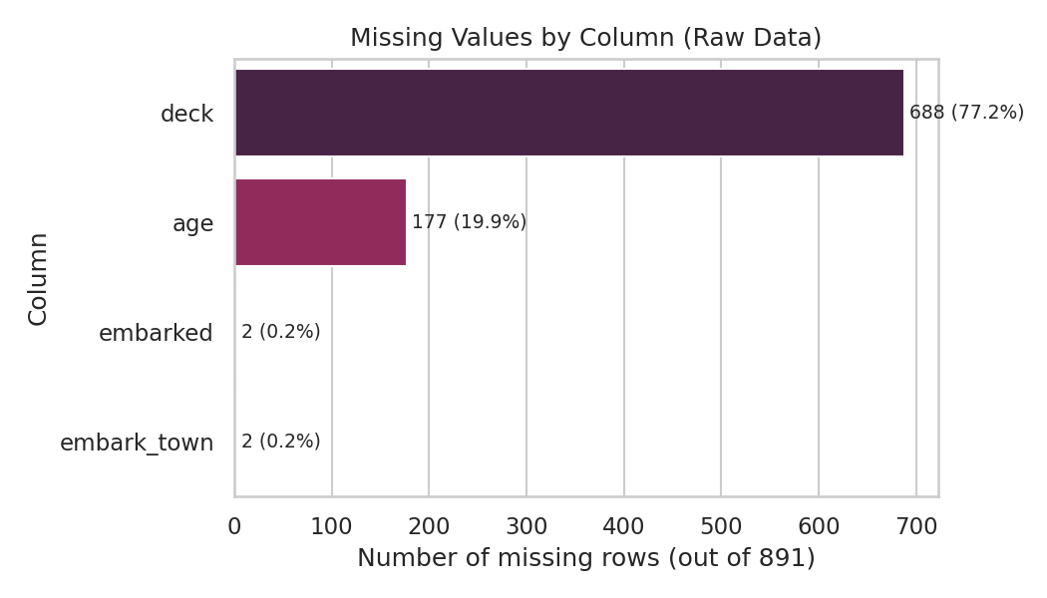
Figure 1. Missing values by column in the raw dataset.
Column | Missing Count | Missing % | Notes
deck | 688 | 77.2% | Cabin/deck letter; only recorded for passengers whose cabin survived in the historical record
age | 177 | 19.9% | Age at time of voyage; unrecorded for many steerage passengers
embarked | 2 | 0.2% | Port of embarkation code (S/C/Q)
embark_town | 2 | 0.2% | Full name of the same port - same 2 rows as 'embarked'
A cross-tabulation check also revealed that three columns carry no information beyond what another column already encodes:
- alive (yes/no) is a perfect string mirror of survived (1/0) - every combination in the cross-tab falls on the diagonal.
- class (First/Second/Third) is a perfect string mirror of pclass (1/2/3).
- embark_town (Southampton/Cherbourg/Queenstown) is a perfect string mirror of embarked (S/C/Q).
Finally, df.duplicated() flagged 107 fully identical rows (160 rows involved in some duplicate group). This dataset has no passenger-name or ticket-ID column, so this was investigated further before deciding how to treat it (see Section 5.4).

4. Data Quality Issues Identified
The exploration phase surfaced four categories of data-quality issue, summarized below before each is addressed in turn:
- Missing values - in deck (77.2%), age (19.9%), and embarked/embark_town (0.2%).
- Redundant columns - alive, class, and embark_town duplicate information already present in other columns.
- Outliers and special values - fare is heavily right-skewed with 116 statistical outliers (1.5xIQR rule); 15 rows have fare = 0.00.
- Coincidental duplicate rows - 107 rows are fully identical to another row, but the dataset lacks a unique passenger identifier to confirm whether these represent true duplicate records or distinct passengers who happen to share every recorded attribute.

5. Cleaning Procedures

5.1 Removing Redundant Columns
alive, class, and embark_town were dropped. Keeping duplicate encodings of the same information adds no analytical value, can silently double-count a variable's influence in some modeling techniques, and increases the chance that the two encodings drift out of sync after future edits.
redundant_cols = ['alive', 'class', 'embark_town']
df = df.drop(columns=redundant_cols)

5.2 Handling the 'deck' Column (77.2% Missing)
With over three-quarters of values missing, any imputation method (mode, model-based, or otherwise) would be fabricating the large majority of that column's values, which risks introducing false signal rather than removing noise. Rather than impute or drop the column outright, it was converted into a binary indicator - has_cabin_record - that preserves the one genuinely informative signal the column carries: whether a cabin was recorded for that passenger at all (which itself correlates with class and survival in the historical record).
df['has_cabin_record'] = df['deck'].notna().astype(int)
df = df.drop(columns=['deck'])

5.3 Handling 'embarked' (0.2% Missing)
Only 2 of 891 rows were missing embarked. Given how small this share is, imputing with the column's mode (the most common port, Southampton) has negligible impact on the overall distribution and is far simpler to justify than dropping two otherwise-complete passenger records.
embarked_mode = df['embarked'].mode()[0]
df['embarked'] = df['embarked'].fillna(embarked_mode)

5.4 Handling 'age' (19.9% Missing)
Age is missing for roughly one in five passengers - too large a share to drop those rows without losing meaningful data, but also too large to impute carelessly. A single global median would ignore the fact that age is not missing at random with respect to other variables: first-class passengers, for instance, skew markedly older than third-class passengers. To preserve that structure, missing ages were imputed with the median age of each passenger's own (pclass, sex) group rather than a single dataset-wide value.
df['age'] = df.groupby(['pclass', 'sex'])['age']\
.transform(lambda s: s.fillna(s.median()))
df['age'] = df['age'].fillna(df['age'].median()) # defensive fallback
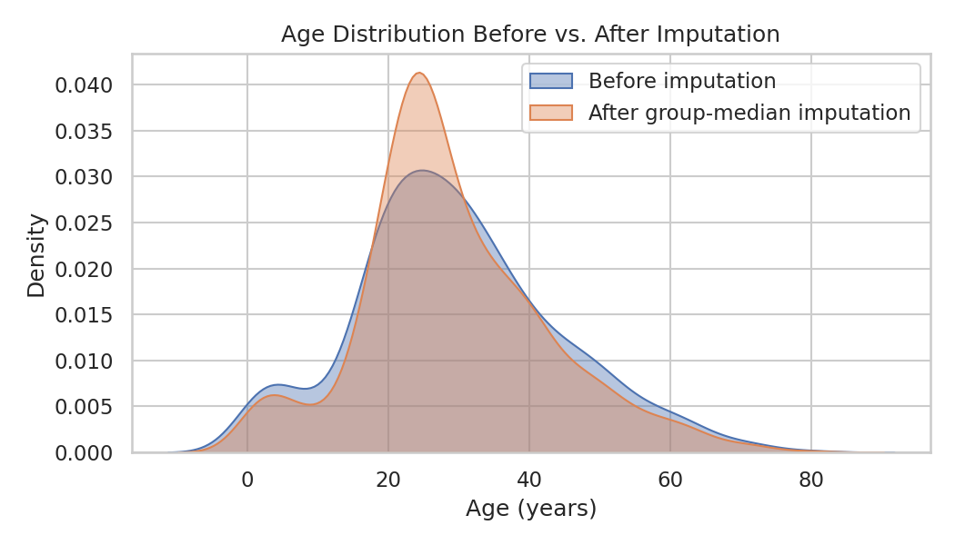
Figure 2. Age distribution before and after group-median imputation. The overall shape is preserved rather than compressed toward a single global value.

5.5 Handling the Zero-Fare Rows (Special Case, Not an Error)
15 rows have fare = 0.00. Before assuming this was a data-entry error, the affected rows were inspected: all 15 are adult men who embarked at Southampton, spread across all three passenger classes. This pattern matches known historical records of Titanic crew members and Line employees who travelled without a paid fare - a legitimate real-world condition, not corrupted data. These rows were therefore kept (not deleted or overwritten with an imputed fare) and flagged with a new zero_fare_flag column so that any downstream fare-based analysis can account for them explicitly.
df['zero_fare_flag'] = (df['fare'] == 0).astype(int)
# 15 rows flagged: all adult males, all embarked at Southampton

5.6 Coincidental Duplicate Rows - A Documented Decision Not to Drop
df.duplicated() flags 107 rows as fully identical to an earlier row. Because this version of the dataset carries no passenger name or ticket ID, a naive response would be to call df.drop_duplicates() and remove them. Inspecting the flagged rows shows they cluster around common combinations of low-cardinality fields (e.g. several 3rd-class men, no listed cabin, embarked at Southampton, sharing a common rounded age and a common rounded fare) - exactly the kind of coincidental overlap expected among 891 people described by only a handful of categorical and rounded numeric attributes, rather than evidence that the same person was recorded twice. Historical accounts confirm the Titanic carried close to 891 passengers in third and second class with many shared fares and ages. Dropping these rows would silently remove real, distinct passengers and understate the size of the dataset. The decision was therefore to keep all 891 rows and document the caveat, rather than to apply drop_duplicates() by default.
dups = df[df.duplicated(keep=False)]
print(len(dups)) # 160 rows share a value combination with at least one other row
# Inspected manually: clusters of identical low-cardinality attribute combinations,
# not a shared unique identifier -> treated as coincidental, not true duplicates.

6. Outlier Detection and Treatment
The fare column is the dataset's main outlier concern: it is heavily right-skewed, since a small number of first-class passengers paid far more than the typical fare. Outliers were detected using the standard 1.5xInterquartile-Range (IQR) rule.
q1, q3 = df['fare'].quantile([0.25, 0.75])
iqr = q3 - q1
lower_bound, upper_bound = q1 - 1.5*iqr, q3 + 1.5*iqr
n_outliers = ((df['fare'] < lower_bound) | (df['fare'] > upper_bound)).sum()
# lower_bound = -26.72 (not meaningful, fare cannot be negative)
# upper_bound = 65.63
# n_outliers = 116 (13.0% of passengers)
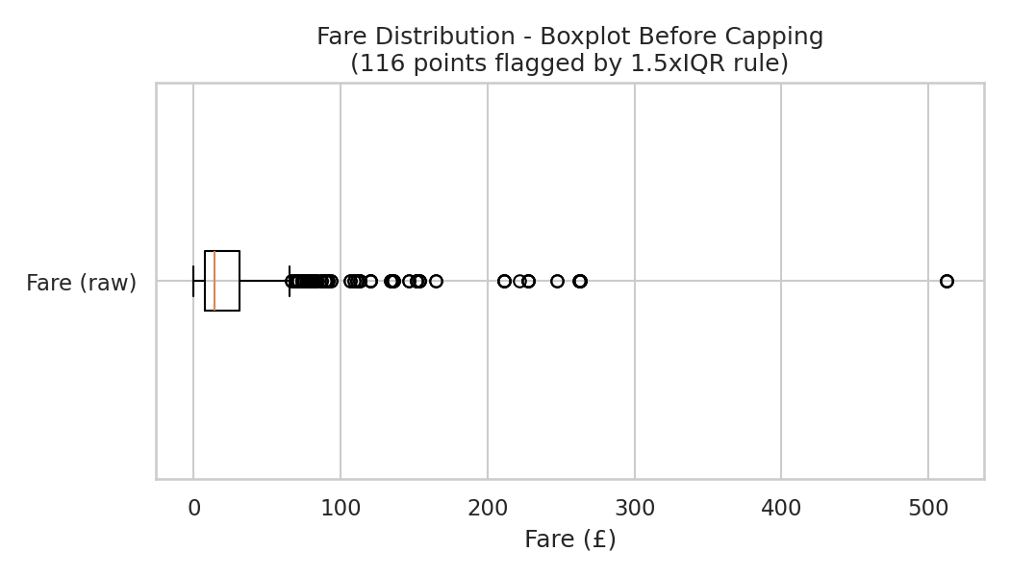
Figure 3. Fare distribution before treatment, with 116 points beyond the 1.5xIQR whiskers.
With 13% of rows flagged, deleting every outlier would discard a large and informative slice of the data - first-class fares are not errors, they are the genuine, expected result of a tiered ticketing system. Deletion was therefore rejected in favor of winsorization (capping): values above the upper IQR bound were capped at that bound, which limits the influence of extreme values on distance-based or variance-sensitive downstream methods while keeping every passenger record in the dataset.
df['fare_capped'] = df['fare'].clip(lower=max(lower_bound, 0), upper=upper_bound)
df['fare_log'] = np.log1p(df['fare_capped']) # reduce residual right-skew
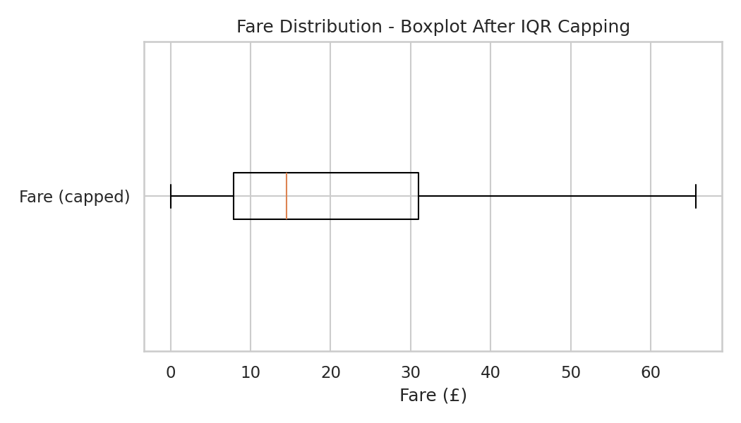
Figure 4. Fare distribution after capping at the upper IQR bound.
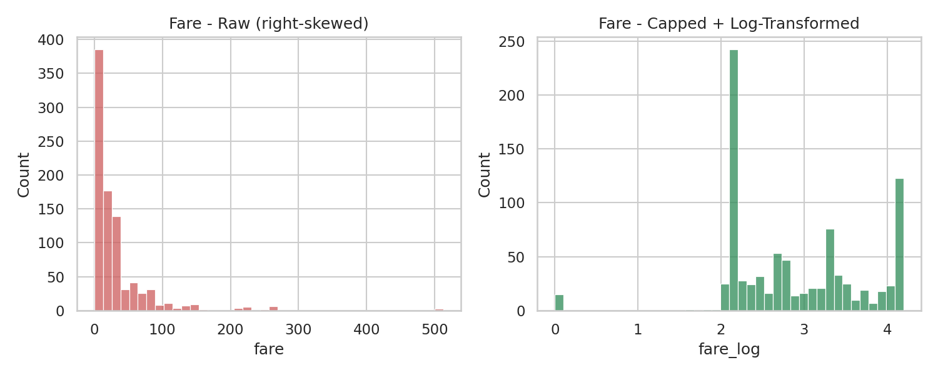
Figure 5. Raw fare (left) versus capped and log-transformed fare (right). The log transform further reduces skew for models that assume roughly symmetric numeric inputs.
Age was also checked with the same rule (bounds approximately -6.7 to 64.8), which flagged 11 rows, mostly elderly passengers. Because these are plausible, valid ages rather than data-entry problems, and the affected share is very small (1.2%), no capping was applied to age; the values were left untouched, again in preference to discarding real passenger records.

7. Feature Engineering and Preprocessing for Modeling
Beyond cleaning, several steps were applied to make the dataset directly usable by common downstream modeling techniques (e.g. logistic regression, k-nearest neighbors, gradient boosting).

7.1 New Engineered Features
- family_size = sibsp + parch + 1, combining siblings/spouses and parents/children aboard into a single household-size measure.
- is_alone, a binary flag for family_size == 1, since travelling alone showed a distinct pattern from travelling with family in the exploratory cross-tabs.
- has_cabin_record and zero_fare_flag, described above in Sections 5.2 and 5.5, retained as engineered signals rather than raw problematic columns.
df['family_size'] = df['sibsp'] + df['parch'] + 1
df['is_alone'] = (df['family_size'] == 1).astype(int)

7.2 Encoding Categorical Variables
The remaining categorical columns (sex, embarked, who) were one-hot encoded with drop_first=True to avoid the dummy-variable trap (perfect multicollinearity between the dropped category and the others).
df_model = pd.get_dummies(df, columns=['sex', 'embarked', 'who'], drop_first=True)

7.3 Scaling Numeric Features
age, fare_log, and family_size were standardized (zero mean, unit variance) with scikit-learn's StandardScaler. Scaling matters for any distance-based or gradient-based algorithm (e.g. k-NN, SVM, logistic regression with regularization), where unscaled features on very different numeric ranges (age in years vs. fare in pounds) would otherwise dominate the objective function disproportionately. Tree-based models do not require this step, so both the pre-scaling and post-scaling columns were retained side by side rather than overwritten, leaving the choice to whoever uses the dataset next.
from sklearn.preprocessing import StandardScaler

numeric_cols_to_scale = ['age', 'fare_log', 'family_size']
scaler = StandardScaler()
df_model[[c + '_scaled' for c in numeric_cols_to_scale]] = \
scaler.fit_transform(df_model[numeric_cols_to_scale])

7.4 Final Correlation Check
As a last validation step, a correlation heatmap over the cleaned numeric features was produced to sanity-check the pipeline: pclass and fare_log show a strong negative correlation (higher-numbered, cheaper classes paid less), and pclass and survived are negatively correlated, consistent with well-documented Titanic survival patterns. This gave confidence that the cleaning steps had not distorted the data's underlying relationships.
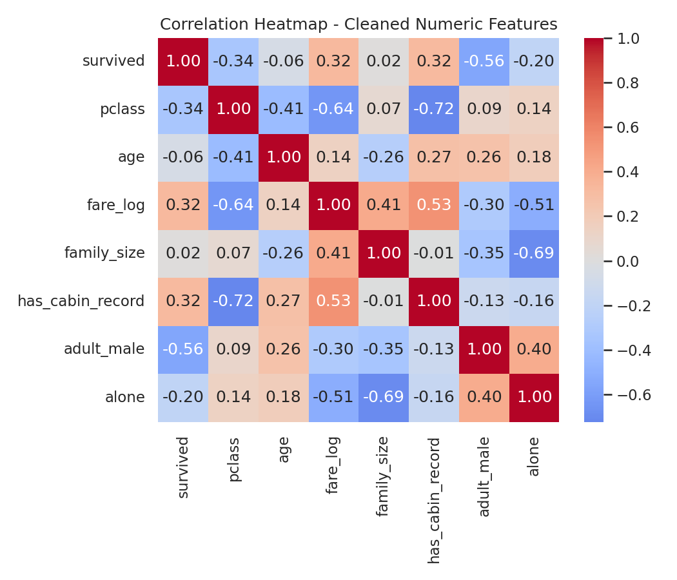
Figure 6. Correlation heatmap of key cleaned numeric features.

8. Before / After Summary
Metric | Raw Data | Cleaned Data
Rows | 891 | 891 (no rows dropped)
Columns | 15 | 17 (pre-encoding) / 22 (model-ready, post-encoding)
Missing cells | 867 (across 3 columns) | 0
Redundant columns | 3 (alive, class, embark_town) | 0
Fare outliers beyond 1.5xIQR | 116 uncapped | 0 (capped at upper bound)
Zero-fare rows | 15, unflagged | 15, explicitly flagged
Deck data usability | 688 raw NaNs, unusable as-is | Converted to has_cabin_record binary flag

9. Challenges Faced and How They Were Overcome
- Deciding what to do with 77% missing 'deck' data: imputing that many values risked fabricating information, so the column was reframed as a lower-information but reliable binary indicator instead of forcing a full imputation.
- Distinguishing real duplicate rows from coincidental ones: the dataset's lack of a unique passenger ID made drop_duplicates() unsafe to apply blindly. This was resolved by manually inspecting the flagged rows and reasoning about the dataset's cardinality rather than trusting the duplicate flag at face value.
- Choosing between deleting and capping fare outliers: with 13% of rows flagged, deletion would have removed a meaningful and legitimate part of the population (first-class passengers). Capping (winsorization) combined with a log transform was chosen to control the outliers' influence while keeping every record.
- Confirming that 'fare = 0' was not corrupted data: this required cross-checking the affected rows against passenger attributes (sex, class, port) and comparing that pattern against known historical context about Titanic crew, rather than assuming it was an entry error and imputing over it.

10. Potential Impact of Preprocessing on Subsequent Analyses
Every cleaning and preprocessing decision made here shapes what a later analysis can and cannot conclude, and it is worth being explicit about that:
- Group-median age imputation preserves the pclass/sex-conditioned age structure, but it also means ~20% of age values are not truly observed. Any model or statistic that treats age as fully reliable (e.g. a precise age-based survival cutoff) should be interpreted with that caveat in mind.
- Capping fare at the upper IQR bound compresses the very top of the fare distribution. This reduces the leverage of extreme first-class fares on models sensitive to scale (e.g. linear regression, k-NN), which is desirable for robustness, but it also means the very richest passengers' fares are understated in the capped column - fare_log should be preferred over the raw fare column for most modeling uses, and analyses specifically about the wealthiest passengers should use the uncapped fare column instead.
- Converting deck into a binary has_cabin_record flag discards the specific deck letter. This is a deliberate loss of granularity: any future analysis that needs deck-level detail (e.g. distance to lifeboats) would need to return to the raw data and accept a much smaller, less representative sample (only 203 of 891 rows have a deck value).
- Choosing not to drop the 107 flagged duplicate rows keeps the sample size at its full 891, but if even a handful of those rows are, in fact, true duplicates, downstream survival-rate estimates could be marginally biased toward whatever pattern those repeated rows share. This risk was judged smaller than the risk of wrongly discarding real passengers, but it is a genuine, disclosed trade-off rather than a certainty.
- One-hot encoding and standard scaling are reversible, well-understood transformations, but they do assume a linear or distance-based downstream model; tree-based models do not need scaling and can use the unscaled columns retained alongside the scaled ones.

11. Conclusion
This task walked through a complete, reasoned data-cleaning and preprocessing pipeline on the Titanic passenger dataset: profiling the raw data, identifying missing values, redundant columns, statistical outliers, and a special-case zero-fare pattern, and resolving each with an explicit, documented rationale rather than a default one-size-fits-all rule. The resulting cleaned dataset (titanic_cleaned.csv) retains all 891 original passenger records with zero missing values, and a further model-ready version (titanic_model_ready.csv) provides an encoded, scaled feature set suitable for direct use in classification or survival-analysis tasks. Throughout, the guiding principle was to prefer transformations that preserve information and disclose uncertainty (flags, group-aware imputation, capping) over transformations that silently discard or fabricate data (blanket deletion, naive global imputation).

Appendix A: Output Files
File | Description
titanic.csv | Original, unmodified raw dataset (891 x 15)
titanic_cleaned.csv | Cleaned dataset after missing-value handling, outlier capping, and feature engineering (891 x 17)
titanic_model_ready.csv | Cleaned dataset after one-hot encoding and feature scaling, ready for modeling (891 x 22)

Appendix B: Full Column Reference (Cleaned Dataset)
Column | Type | Description
survived | int (0/1) | Target variable: did the passenger survive
pclass | int (1-3) | Ticket class (proxy for socio-economic status)
sex | category | Passenger sex
age | float | Age in years (missing values group-median imputed)
sibsp | int | Number of siblings/spouses aboard
parch | int | Number of parents/children aboard
fare | float | Original ticket fare (uncapped, for reference)
embarked | category | Port of embarkation (S/C/Q)
who | category | man / woman / child classification
adult_male | int (0/1) | Whether passenger is an adult male
alone | int (0/1) | Whether passenger had zero family aboard
has_cabin_record | int (0/1) | Engineered: whether a deck/cabin was recorded
zero_fare_flag | int (0/1) | Engineered: whether fare was 0 (crew/employee)
fare_capped | float | Fare after 1.5xIQR winsorization
fare_log | float | log1p of fare_capped, for reduced skew
family_size | int | Engineered: sibsp + parch + 1
is_alone | int (0/1) | Engineered: whether family_size == 1

