Exploratory Data Analysis and Visualization
Week 2 Task Report
Dataset: Titanic Passenger Records (cleaned dataset carried forward from Week 1)
Prepared with Python (pandas, numpy, matplotlib, seaborn)
October 2026

Executive Summary
This report presents an exploratory data analysis (EDA) and visualization study of the Titanic passenger dataset, building on the cleaned dataset produced in the Week 1 task (891 passengers, 0 missing values). The analysis moves through univariate, bivariate, and multivariate exploration using pandas for aggregation and matplotlib/seaborn for visualization, with every chart annotated with titles, axis labels, and legends. The goal is not simply to produce charts, but to extract and critically interpret patterns in who survived the disaster and why, and to be explicit about the data transformations (grouping, binning, pivoting) behind each view.
Headline findings:
- Overall survival rate was 38.4% (342 of 891 passengers).
- Sex was the single strongest predictor explored: women survived at 74.2% versus 18.9% for men.
- Ticket class compounded this effect: 1st-class women survived at 96.8%, while 3rd-class men survived at only 13.5%.
- Fare and class are closely related (higher fare, better class), and both correlate with survival, but age shows only a weak linear correlation with survival overall - its effect is concentrated at the extremes (children) rather than across the full range.
- Moderate family size (2-4 people) was associated with meaningfully higher survival than travelling alone or in very large family groups.

1. Introduction and Objective
The objective of this task is to perform a structured exploratory data analysis on a public dataset and communicate the findings through well-annotated visualizations. EDA sits between data cleaning and formal modeling: its purpose is to let the data reveal its own structure - distributions, relationships, and anomalies - before any hypothesis or model is imposed on it. This report follows a standard EDA progression: univariate analysis (one variable at a time), bivariate analysis (pairs of variables, usually against the target), and multivariate analysis (three or more variables at once), followed by a critical discussion of what the patterns do and do not prove.

2. Dataset Recap
This task reuses the cleaned Titanic dataset (titanic_cleaned.csv) produced in the Week 1 task, rather than re-cleaning the raw data from scratch. The dataset contains 891 passenger records and 17 columns after cleaning, with zero missing values, fare outliers capped via the IQR method, and engineered fields such as family_size and has_cabin_record. Using an already-cleaned, well-understood dataset lets this report focus entirely on exploration and visualization rather than repeating data-quality work.
import pandas as pd

df = pd.read_csv('titanic_cleaned.csv')
print(df.shape) # (891, 17)
print(df.dtypes)

3. Initial Analysis: Summary Statistics
Before building visualizations, descriptive statistics were computed for the key numeric fields to establish a baseline understanding of scale and spread.
print(df[['age','fare','family_size','sibsp','parch']].describe().round(2))
print(df['survived'].mean()) # overall survival rate
Statistic | Age | Fare (£) | Family Size
Mean | 29.11 | 32.20 | 1.90
Std. Dev. | 13.30 | 49.69 | 1.61
Min | 0.42 | 0.00 | 1
25th pct. | 21.50 | 7.91 | 1
Median | 26.00 | 14.45 | 1
75th pct. | 36.00 | 31.00 | 2
Max | 80.00 | 512.33 | 11
The overall survival rate was 38.4% (342 survived of 891). Fare's mean (£32.20) sitting well above its median (£14.45) confirms the right-skew already identified and treated in Week 1. Family size is similarly skewed, with most passengers (median = 1) travelling alone.

4. Univariate Analysis
Univariate analysis examines each variable of interest in isolation, to understand its own shape before relating it to anything else.

4.1 Survival Overview
sns.countplot(data=df, x='Survived_Label')
plt.pie(df['survived'].value_counts(), autopct='%1.1f%%', ...)
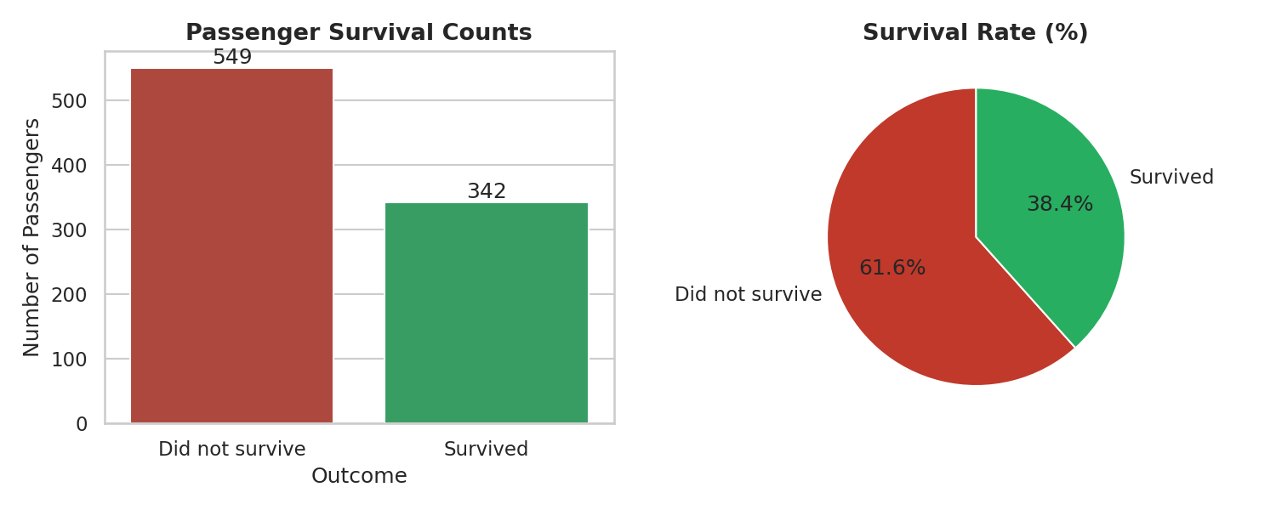
Figure 1. Passenger survival counts (left) and survival rate (right).
549 of 891 passengers (61.6%) did not survive, making this a moderately imbalanced target variable - a consideration worth noting for anyone building a predictive model on this data later, since accuracy alone can be a misleading metric under this level of imbalance.

4.2 Age and Fare Distributions
sns.histplot(df['age'], bins=30, kde=True)
sns.histplot(df['fare'], bins=30, kde=True)
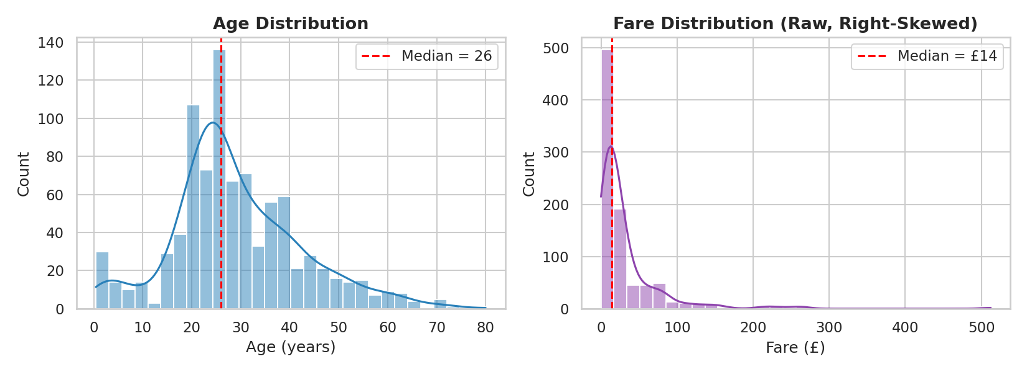
Figure 2. Age distribution (left, roughly bell-shaped, median 26) and fare distribution (right, strongly right-skewed, median £14.45).
Age is roughly unimodal and only mildly skewed, consistent with a general adult population with a tail of children and elderly passengers. Fare, by contrast, is heavily right-skewed: most tickets were inexpensive, with a long tail of high-value 1st-class fares pulling the mean well above the median - the same pattern that motivated capping and log-transforming fare in the Week 1 preprocessing.

4.3 Class and Embarkation Composition
sns.countplot(data=df, x='Pclass_Label', order=['1st Class','2nd Class','3rd Class'])
sns.countplot(data=df, x='Embarked_Label')
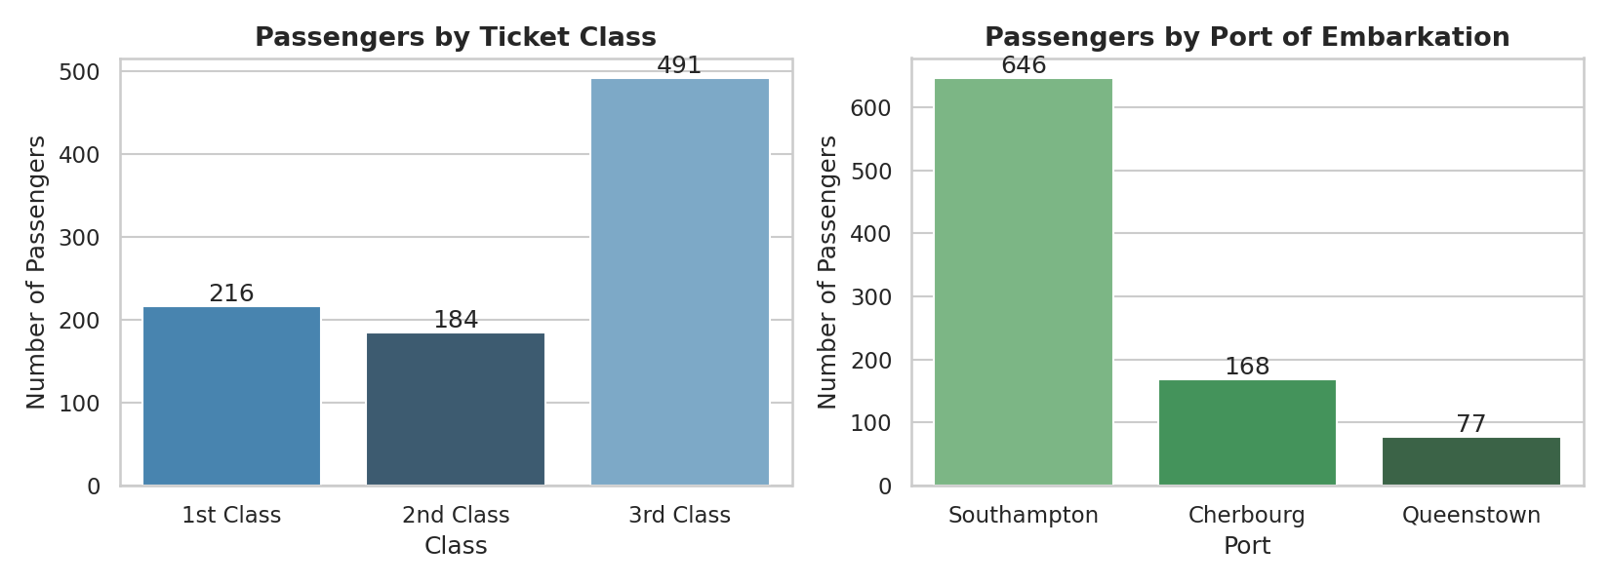
Figure 3. Passenger counts by ticket class (left) and port of embarkation (right).
Just under half the passengers travelled 3rd class (491 of 891), reflecting the Titanic's large steerage capacity. The large majority of passengers embarked at Southampton, with smaller groups boarding at Cherbourg and Queenstown - a composition that becomes relevant in Section 6.5, where embarkation port shows a notable (if partly confounded) relationship with survival.

5. Bivariate Analysis
Bivariate analysis relates each variable to the outcome of interest - survival - one relationship at a time, using grouped aggregation (pandas groupby) paired with a chart.

5.1 Survival Rate by Sex and by Class
sex_rate = df.groupby('Sex_Label')['survived'].mean()
class_rate = df.groupby('Pclass_Label')['survived'].mean()
# Female: 74.2% Male: 18.9%
# 1st: 63.0% 2nd: 47.3% 3rd: 24.2%
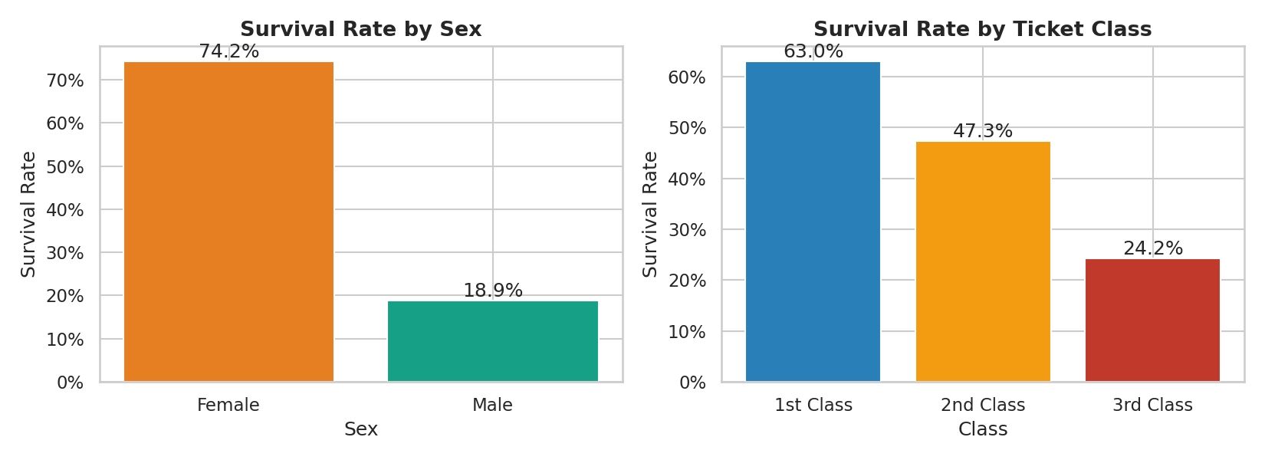
Figure 4. Survival rate by sex (left) and by ticket class (right).
Both variables show a strong, monotonic relationship with survival. Sex shows the largest single-variable gap found anywhere in this analysis - a nearly 4x difference in survival odds between women and men - consistent with the historical 'women and children first' evacuation protocol. Class shows a clear step-down in survival from 1st to 3rd class, plausibly driven by a mix of cabin location (proximity to lifeboats), and socio-economic priority during evacuation.

5.2 Age Distribution by Survival Outcome
sns.kdeplot(data=df[df.survived==0], x='age', fill=True, label='Did not survive')
sns.kdeplot(data=df[df.survived==1], x='age', fill=True, label='Survived')
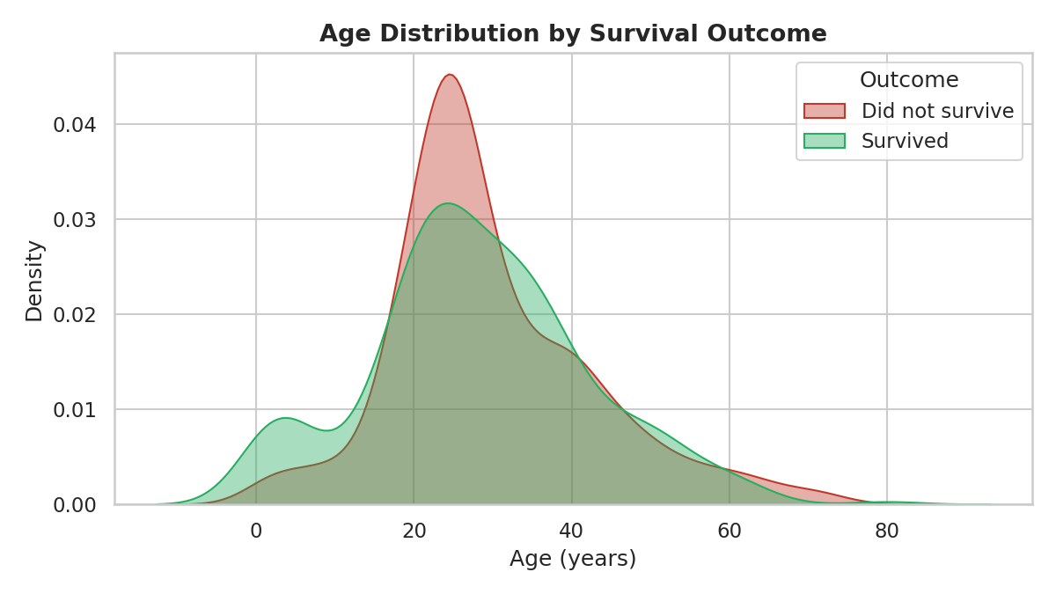
Figure 5. Age density curves for passengers who survived vs. did not survive.
The two curves largely overlap, which is why age alone correlates only weakly with survival in the correlation matrix (Section 6.3). The clearest visible difference is at the youngest ages: the 'survived' curve is noticeably higher below roughly age 10, matching the historical priority given to children, an effect explored further with explicit age bins in Section 7.

5.3 Fare by Ticket Class
sns.boxplot(data=df, x='Pclass_Label', y='fare', order=['1st Class','2nd Class','3rd Class'])
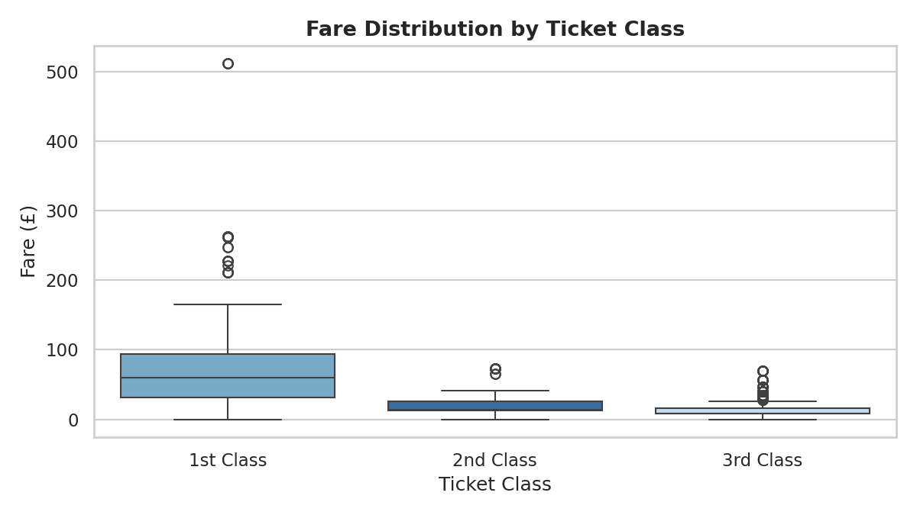
Figure 6. Fare distribution by ticket class, showing both the expected class/price relationship and within-class variability.
Fare increases sharply and monotonically with class, as expected, but with wide within-class variation (especially 1st class, where family-sized multi-berth tickets could cost far more than a single berth). This confirms fare and class carry overlapping but not identical information, which is why both were retained as separate features in Week 1 rather than treating one as redundant.

5.4 Family Size and Survival
family_rate = df.groupby('family_size')['survived'].agg(['mean','count'])
family_rate = family_rate[family_rate['count'] >= 5]
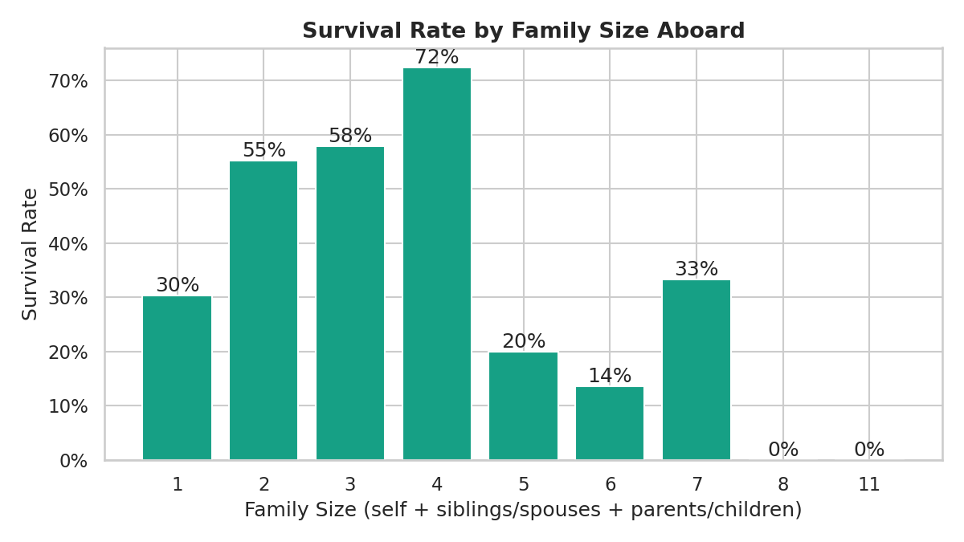
Figure 7. Survival rate by family size aboard (groups with fewer than 5 passengers excluded as too sparse to be reliable).
Survival rises from travelling alone (30.4%) to a peak at a family size of 4 (72.4%), then falls sharply for large families (6+ members, survival at or near 0%). A plausible reading is that small family groups could coordinate and assist one another during evacuation, while very large families may have been harder to keep together and evacuate as a unit, and lone travellers had no one to help them react quickly. This is a pattern, not a proven causal mechanism - the largest-family groups are also a very small sample (6-7 passengers per group), so those extreme rates should be treated cautiously.

5.5 Survival by Port of Embarkation
embark_rate = df.groupby('Embarked_Label')['survived'].mean().sort_values(ascending=False)
# Cherbourg: 55.4% Queenstown: 39.0% Southampton: 33.9%
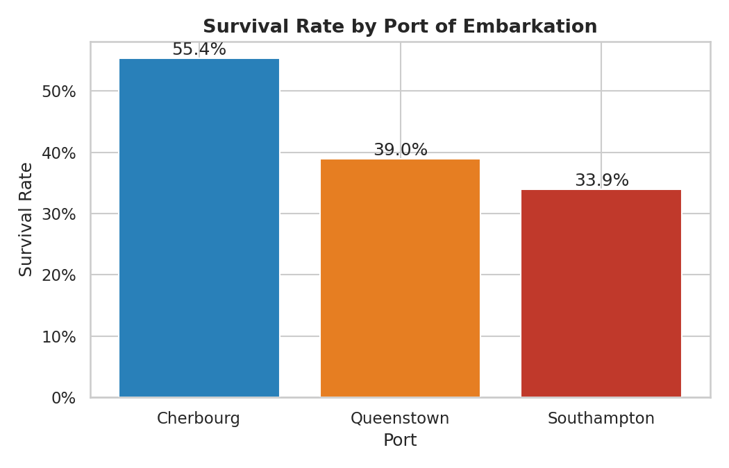
Figure 8. Survival rate by port of embarkation.
Cherbourg passengers survived at a notably higher rate than those who boarded at Southampton or Queenstown. Embarkation port itself has no plausible direct causal effect on survival; the more likely explanation is confounding with class - Cherbourg had a higher proportion of 1st-class passengers than the other two ports. This is flagged explicitly as a case where a visible pattern should not be over-interpreted without controlling for the confounding variable, which the multivariate view in Section 6 helps address.

6. Multivariate Analysis
Multivariate analysis layers a third (or more) variable onto a relationship, which is often necessary to avoid the kind of confounding noted in Section 5.5.

6.1 Survival by Class and Sex Combined
pivot = df.pivot_table(index='Pclass_Label', columns='Sex_Label',
values='survived', aggfunc='mean')
sns.heatmap(pivot, annot=True, fmt='.1%', cmap='RdYlGn')
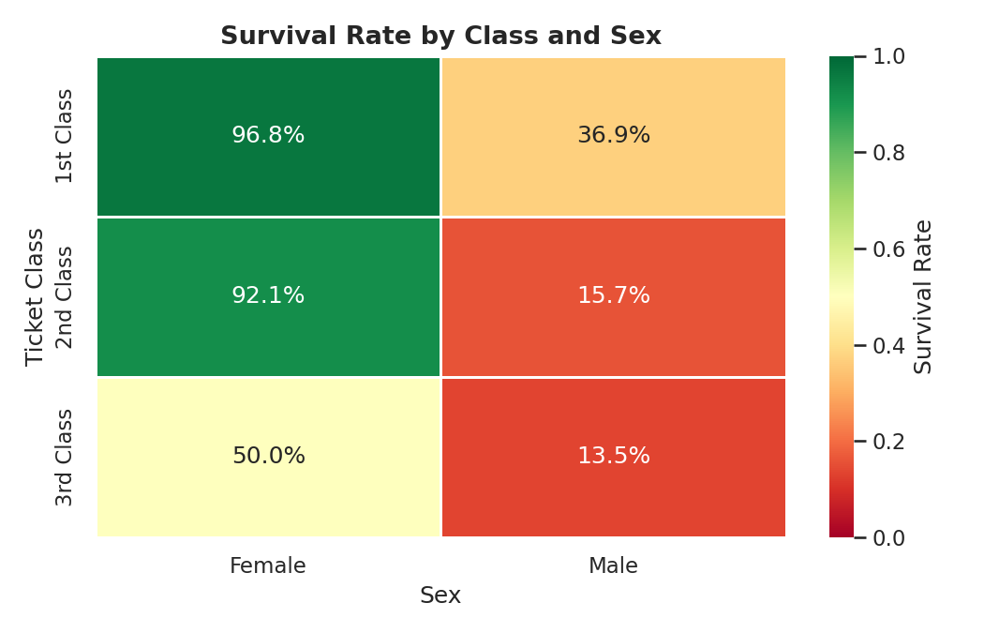
Figure 9. Survival rate by class and sex combined.
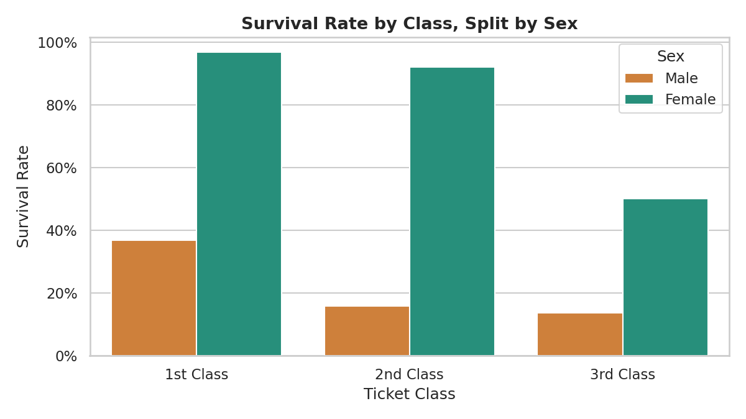
Figure 10. The same class-by-sex survival rates as a grouped bar chart, for easier side-by-side comparison of exact values.
Splitting survival by both class and sex at once reveals that sex dominates even within class: 1st-class men (36.9%) survived at a lower rate than 3rd-class women (50.0%). This is the clearest example in the dataset of why single-variable (bivariate) views can be misleading on their own - class alone suggested a moderate, steady effect, but the combined view shows sex is the stronger driver throughout, and the class effect is far more pronounced among women (96.8% to 50.0%) than among men (36.9% to 13.5%).

6.2 Age vs. Fare, Colored by Survival and Styled by Class
sns.scatterplot(data=df, x='age', y='fare', hue='Survived_Label',
style='Pclass_Label', alpha=0.7)
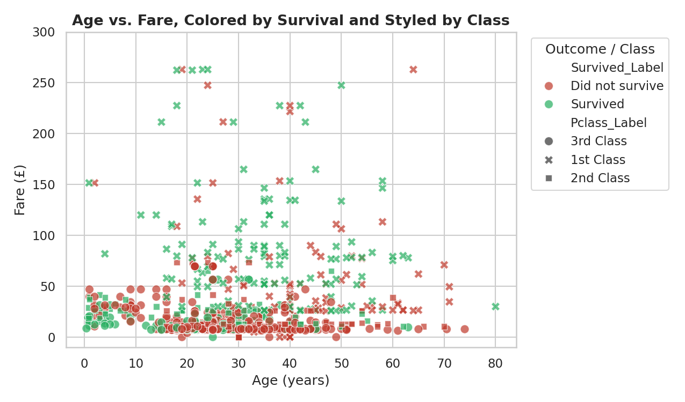
Figure 11. Age vs. fare, colored by survival outcome and styled by ticket class (fare axis limited to £300 to keep the bulk of points readable).
This view confirms the class/fare relationship visually (circle markers for 3rd class cluster at low fares, X markers for 1st class spread across higher fares) and shows that green (survived) points are denser at higher fare levels across all ages, reinforcing the class-and-wealth effect on survival found elsewhere in this analysis, rather than revealing a new age-specific pattern.

6.3 Correlation Heatmap of Numeric Features
numeric_cols = ['survived','pclass','age','fare','sibsp','parch','family_size','has_cabin_record']
sns.heatmap(df[numeric_cols].corr(), annot=True, fmt='.2f', cmap='coolwarm', center=0)
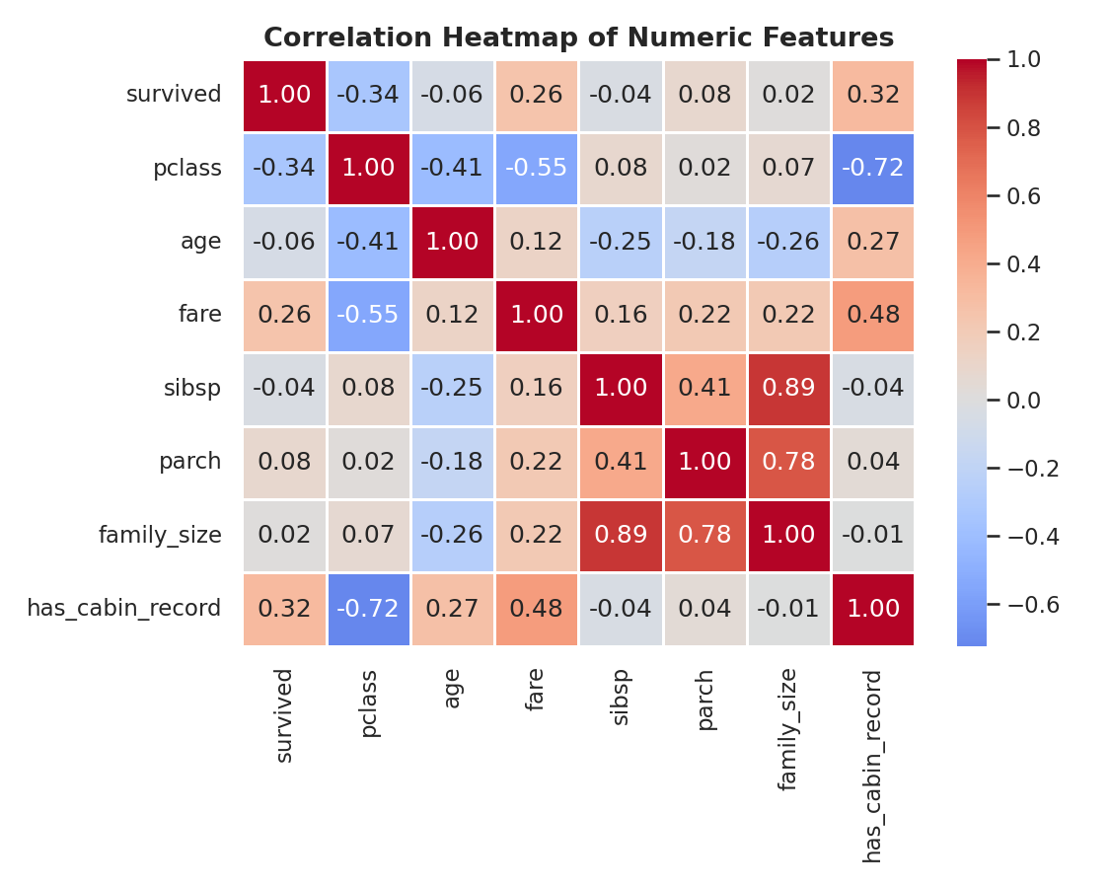
Figure 12. Pearson correlation matrix of key numeric features.
Survived correlates most strongly (negatively) with pclass (-0.34) and has_cabin_record correlates positively (0.32) - largely the same underlying signal, since having a recorded cabin is itself far more common among 1st-class passengers. Fare correlates positively with survival (0.27) for the same reason. Age's correlation with survival is weak (-0.08) in this linear measure, which matches the heavily overlapping KDE curves in Figure 5 - a reminder that Pearson correlation captures linear relationships only, and can understate an effect that is concentrated in a sub-group (young children) rather than spread linearly across the whole age range.

7. Data Transformations and Aggregations Used
Several transformations were applied purely for this analysis stage (on top of the cleaning already done in Week 1), each chosen to make a pattern visible that the raw column would not show on its own.
- groupby().mean() aggregations - used throughout Section 5 and 6 to collapse 891 individual rows into interpretable rate-per-group summaries (e.g. survival rate per sex, per class, per port).
- pivot_table() - used in Section 6.1 to cross two categorical variables (class and sex) against the mean of a third (survival), which a simple groupby on one column cannot show.
- Sparse-group filtering - in the family-size analysis (Section 5.4), groups with fewer than 5 passengers were excluded from the chart, since a 'rate' computed from 1-2 people is not a reliable estimate and would visually exaggerate noise as signal.
- Age binning (pd.cut) - continuous age was grouped into five bands (Child, Teen, Young Adult, Adult, Senior) to test the 'children first' hypothesis directly, since the earlier KDE and correlation views could only hint at an age effect without isolating it.
bins = [0, 12, 18, 35, 60, 100]
labels = ['Child (0-12)', 'Teen (13-18)', 'Young Adult (19-35)', 'Adult (36-60)', 'Senior (60+)']
df['age_group'] = pd.cut(df['age'], bins=bins, labels=labels)
age_group_rate = df.groupby('age_group', observed=True)['survived'].mean()
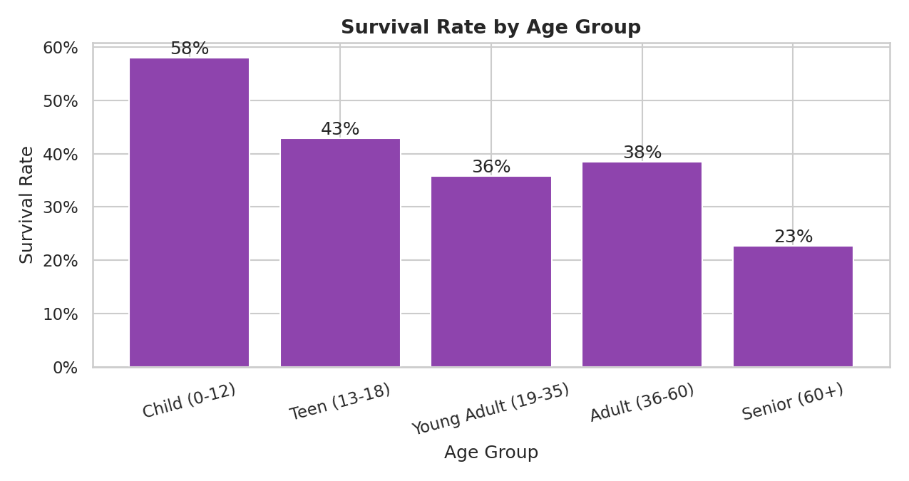
Figure 13. Survival rate by binned age group.
Binning confirms what the overlapping KDE curves in Figure 5 only hinted at: children (0-12) survived at 58.0%, well above every other age band, while seniors (60+) survived at just 22.7% - the lowest of any group. This is a case where a deliberate transformation (binning a continuous variable into meaningful categories) surfaced a clearer, more actionable pattern than the raw continuous variable did on its own, and illustrates why the weak linear correlation computed in Section 6.3 undersold age's real, concentrated effect at the youngest ages.

8. Summary of Key Insights
- Sex was the single strongest factor in survival: women survived at roughly 4x the rate of men (74.2% vs. 18.9%).
- Ticket class was the second-strongest factor, and its effect was far more pronounced for women (96.8% in 1st class vs. 50.0% in 3rd) than for men (36.9% vs. 13.5%), showing the two variables interact rather than act independently.
- Children (age 0-12) had a clear survival advantage (58.0%) over every other age band, consistent with evacuation priority; this effect is concentrated at the youngest ages rather than spread across the age range, so it is easy to miss in a simple correlation coefficient.
- Moderate family size (2-4) was associated with better outcomes than travelling alone or in very large groups, though the largest-family estimates rest on very small sample sizes and should be treated as suggestive rather than conclusive.
- Port of embarkation showed a visible survival gap (Cherbourg highest), but this is most plausibly explained by that port's higher share of 1st-class passengers rather than any direct effect of the port itself - a reminder to check for confounding before reading a bivariate pattern as causal.

9. Critical Discussion and Limitations
A few caveats are worth stating plainly. First, every relationship described here is observational and historical - none of it implies that, say, boarding at Cherbourg caused higher survival; apparent effects can and do stem from confounding variables, as shown directly in Sections 5.5 and 6.1. Second, several groupings used in this analysis (large families, seniors, Queenstown passengers) rest on relatively small sample sizes within an already modest 891-row dataset, so their exact percentages should be read as indicative rather than statistically precise. Third, age itself is partly imputed (as documented in the Week 1 report, ~20% of age values were filled using group medians), so age-based patterns - including the children's-survival finding in Section 7 - carry a degree of uncertainty inherited from that imputation. Finally, Pearson correlation (Section 6.3) only captures linear relationships and will understate the importance of a variable like age whose effect is concentrated at one end of its range rather than spread evenly; non-linear or sub-group-aware methods would be needed to fully quantify such effects.

10. Conclusion
This exploratory analysis moved systematically from single-variable summaries through paired relationships to combined, multi-variable views, using annotated matplotlib/seaborn visualizations and pandas aggregations at each stage. The analysis confirmed well-documented historical patterns in the Titanic disaster - the dominant role of sex and class, and a meaningful but concentrated age effect - while also demonstrating, through the embarkation-port example, why a bivariate pattern should always be checked against plausible confounders before being treated as a real driver. The resulting set of 13 figures and accompanying aggregation tables give a thorough, critically-interpreted picture of the dataset and would form a solid foundation for any subsequent predictive modeling task.

Appendix A: Figures Index
Figure | Title
1 | Passenger survival counts and rate
2 | Age and fare distributions
3 | Class and embarkation composition
4 | Survival rate by sex and by class
5 | Age distribution by survival outcome (KDE)
6 | Fare distribution by ticket class (boxplot)
7 | Survival rate by family size
8 | Survival rate by port of embarkation
9 | Survival rate by class and sex (heatmap)
10 | Survival rate by class and sex (grouped bar)
11 | Age vs. fare scatter, colored by survival, styled by class
12 | Correlation heatmap of numeric features
13 | Survival rate by binned age group

Appendix B: Output Files
File | Description
eda_analysis.py | Full Python script producing all statistics and all 13 figures
titanic_cleaned.csv | Input dataset (cleaned in Week 1), carried forward unchanged
chart_01.png ... chart_13.png | Individual figure files, embedded in this report
Week2_EDA_Visualization_Report.docx | This report

