Supervised Learning Model Implementation
Week 4 Task Report
Problem: Binary Classification - Predicting Titanic Passenger Survival
Prepared with Python (pandas, numpy, scikit-learn, matplotlib, seaborn)
October 2026

Executive Summary
This report designs, trains, and evaluates a supervised classification model to predict whether a Titanic passenger survived, using the cleaned dataset produced in Week 1 of this project series. Four candidate algorithms - Logistic Regression, Random Forest, Gradient Boosting, and Support Vector Machine - were compared using 5-fold stratified cross-validation. A Random Forest was selected as the primary model, tuned via grid search, and evaluated on a held-out test set with a full suite of classification metrics, a confusion matrix, ROC and precision-recall curves, and feature-importance analysis. The tuned model achieved 77.7% test accuracy and an ROC-AUC of 0.842, correctly identifying the dominant role of sex, fare, and age in survival - consistent with, and a natural extension of, the exploratory findings from Week 2.
Key results:
- All four candidate models scored within a narrow band (80.2%-82.2% cross-validated accuracy), with Gradient Boosting and SVM marginally ahead of Logistic Regression and Random Forest.
- The tuned Random Forest (max_depth=None, min_samples_leaf=2, n_estimators=400) achieved 77.7% accuracy, 0.738 precision, 0.652 recall, and 0.842 ROC-AUC on the untouched test set.
- Logistic Regression, a far simpler model, achieved a nearly identical ROC-AUC (0.841) on the same test set - a result discussed explicitly in Section 8.
- sex, fare, and age were the three most important predictors, accounting for roughly 69% of total feature importance combined.
- A validation curve and learning curve both indicate the model has modest overfitting and would likely benefit from more training data or stronger regularization, discussed in Section 7.

1. Problem Definition
This task frames survival prediction as a binary classification problem: given a passenger's demographic and ticket information (class, sex, age, fare, family composition, port of embarkation, and whether a cabin record exists), predict whether they survived (1) or did not survive (0). This is a natural and well-studied choice for the Titanic dataset, and one with genuine real-world analogues - the same modeling pattern (predicting a binary outcome from a mix of categorical and continuous features) underlies many practical classification problems, such as credit default prediction or customer churn.

2. Data Preparation and Feature Engineering
The modeling pipeline begins from the cleaned Titanic dataset produced in Week 1 (891 rows, 17 columns, zero missing values), rather than re-cleaning the raw data. On top of that cleaning, several feature-engineering and feature-selection decisions were made specifically for the modeling task:
- who and adult_male were dropped. Both are derived almost entirely from sex and age (who is 'man'/'woman'/'child', adult_male is a near-deterministic function of sex and age >= 18). Keeping them alongside sex and age would let the model exploit a near-duplicate of information already present in other columns, inflating apparent performance without adding genuine signal - a subtle form of data leakage.
- alone was dropped in favor of the equivalent is_alone (both encode family_size == 1); keeping both would be redundant.
- fare and fare_capped were dropped in favor of fare_log alone, since all three are highly collinear representations of the same underlying ticket price, and fare_log (capped and log-transformed) is the best-behaved version for a model sensitive to extreme values.
- sex and embarked were one-hot encoded (drop_first=True), producing sex_male, embarked_Q, and embarked_S as binary features.
drop_cols = ['who', 'adult_male', 'alone', 'fare', 'fare_capped']
model_df = df.drop(columns=drop_cols)
model_df = pd.get_dummies(model_df, columns=['sex', 'embarked'], drop_first=True)

X = model_df.drop(columns=['survived'])
y = model_df['survived']
# Final feature set: pclass, age, sibsp, parch, has_cabin_record,
# zero_fare_flag, fare_log, family_size, is_alone, sex_male,
# embarked_Q, embarked_S (12 features)
The target variable is moderately imbalanced (61.6% did not survive, 38.4% survived), a point carried over from the Week 2 EDA and one that shapes which evaluation metrics matter most in Section 6 - accuracy alone would be a misleading measure of model quality at this level of imbalance.

2.1 Train/Test Split and a Note on Avoiding Data Leakage
The data was split into training (80%, 712 rows) and test (20%, 179 rows) sets before any scaling was applied, using stratified sampling to preserve the 61.6%/38.4% class balance in both sets. This is a stricter standard than the Week 1 preprocessing, where the full dataset was scaled once for descriptive/exploratory purposes - appropriate for that context, but not appropriate here, since fitting a scaler on data that includes the test set would leak test-set statistics into the training process and produce an optimistic, unrealistic estimate of real-world performance. The StandardScaler used for age, fare_log, and family_size was therefore fit only on the training set and then applied (transform only, no re-fitting) to the test set.
X_train, X_test, y_train, y_test = train_test_split(
X, y, test_size=0.2, random_state=42, stratify=y)

scaler = StandardScaler()
X_train_scaled[scale_cols] = scaler.fit_transform(X_train[scale_cols])
X_test_scaled[scale_cols] = scaler.transform(X_test[scale_cols]) # transform only

3. Model Selection Rationale
Four candidate algorithms were chosen to span a deliberate range of complexity and inductive bias:
- Logistic Regression - a linear, highly interpretable baseline. Its coefficients directly show the direction and relative strength of each feature's association with survival (Section 8), and it is cheap to train and hard to overfit on a dataset this size.
- Random Forest - an ensemble of decision trees that can capture non-linear relationships and feature interactions (e.g. the class-by-sex interaction found in Week 2) without requiring them to be manually specified, while still offering a built-in, interpretable feature-importance measure.
- Gradient Boosting - a sequential ensemble method that often achieves strong performance on small-to-medium tabular datasets by iteratively correcting previous models' errors.
- Support Vector Machine (RBF kernel) - included as a non-tree-based non-linear method, to check whether a fundamentally different algorithm family would substantially outperform the tree-based approaches.

4. Model Comparison via Cross-Validation
All four models were compared using 5-fold stratified cross-validation on the training set only (the test set was held out entirely until final evaluation in Section 6), scored on accuracy, precision, recall, F1, and ROC-AUC.
cv = StratifiedKFold(n_splits=5, shuffle=True, random_state=42)
scoring = ['accuracy', 'precision', 'recall', 'f1', 'roc_auc']

for name, model in models.items():
res = cross_validate(model, X_train_scaled, y_train, cv=cv, scoring=scoring)
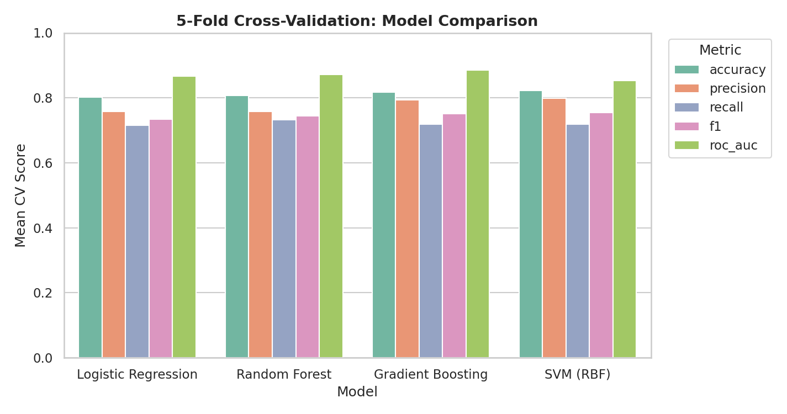
Figure 1. Five-fold cross-validation scores for all four candidate models.
Model | Accuracy | Precision | Recall | F1 | ROC-AUC
Logistic Regression | 0.802 | 0.759 | 0.714 | 0.734 | 0.866
Random Forest | 0.808 | 0.759 | 0.733 | 0.745 | 0.872
Gradient Boosting | 0.817 | 0.794 | 0.718 | 0.752 | 0.886
SVM (RBF) | 0.822 | 0.798 | 0.718 | 0.755 | 0.854
All four models perform within a narrow band of each other (80.2%-82.2% CV accuracy), suggesting the dataset's signal is largely linear and well-captured even by the simplest model. Random Forest was selected to carry forward as the primary model for the remainder of this report, not because it was the top scorer (Gradient Boosting and SVM were marginally ahead on several metrics), but because it offers a strong balance of competitive performance, straightforward hyperparameter tuning, and - critically for a report meant to explain its findings - directly interpretable feature importances, which Section 8 uses to connect the model's behavior back to the exploratory findings from Week 2.

5. Hyperparameter Tuning
A grid search over n_estimators, max_depth, and min_samples_leaf was performed with 5-fold cross-validation, optimizing for F1 score (a more informative target than accuracy given the class imbalance noted in Section 2).
param_grid = {
'n_estimators': [100, 200, 400],
'max_depth': [4, 6, 8, None],
'min_samples_leaf': [1, 2, 4],
}
grid = GridSearchCV(RandomForestClassifier(random_state=42), param_grid,
cv=cv, scoring='f1', n_jobs=-1)
grid.fit(X_train_scaled, y_train)
# Best params: {'max_depth': None, 'min_samples_leaf': 2, 'n_estimators': 400}
# Best CV F1 score: 0.771
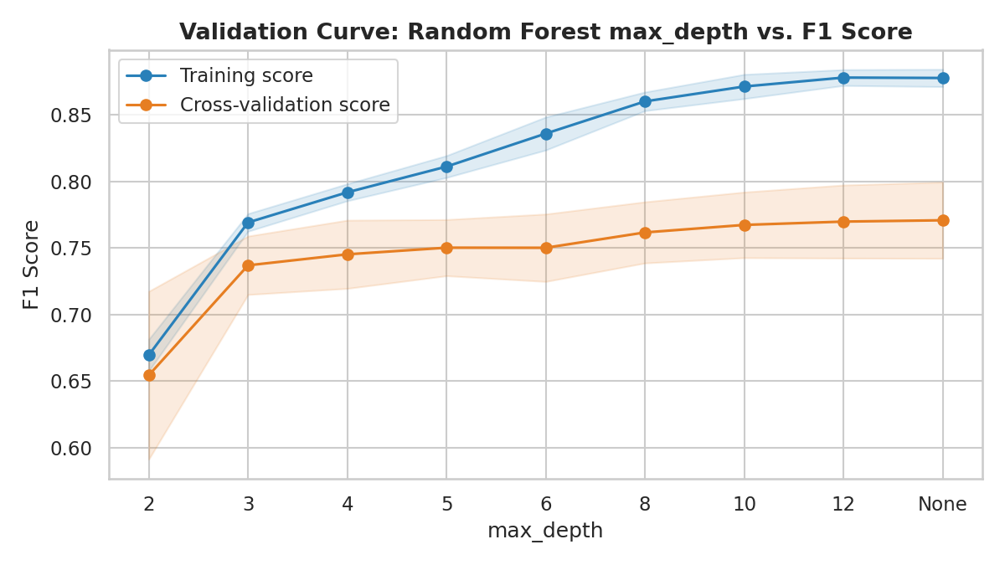
Figure 2. Validation curve for max_depth, holding the other tuned parameters fixed.
The validation curve makes the bias/variance trade-off explicit: training F1 climbs steadily as trees are allowed to grow deeper (effectively memorizing more of the training data), while the cross-validation score rises much more slowly and plateaus around max_depth=8-10. The widening gap between the two curves at greater depths is a textbook signature of overfitting - the grid search's choice of max_depth=None (unlimited) is only safe here because it was paired with min_samples_leaf=2, which constrains how finely individual trees can split regardless of depth. This trade-off is revisited in Section 7's discussion of limitations.

6. Final Model Evaluation on the Held-Out Test Set
The tuned Random Forest was evaluated once, on the 179-row test set that had not been used in any cross-validation fold or hyperparameter search, giving an unbiased estimate of real-world performance.
Metric | Score | Interpretation
Accuracy | 0.777 | 78% of test passengers correctly classified
Precision (Survived) | 0.738 | Of passengers predicted to survive, 73.8% actually did
Recall (Survived) | 0.652 | Of passengers who actually survived, 65.2% were identified
F1 Score | 0.692 | Harmonic mean of precision and recall
ROC-AUC | 0.842 | Strong ranking ability between the two classes
Recall for the 'Survived' class (0.652) is noticeably lower than precision (0.738), meaning the model is more conservative about predicting survival than it should ideally be - it misses more true survivors than it falsely flags. This asymmetry is consistent with the class imbalance (only 38.4% of passengers survived): without explicit class-weighting, a model trained on imbalanced data tends to favor the majority class ('did not survive') when uncertain, which is worth flagging as a concrete improvement opportunity (Section 7).
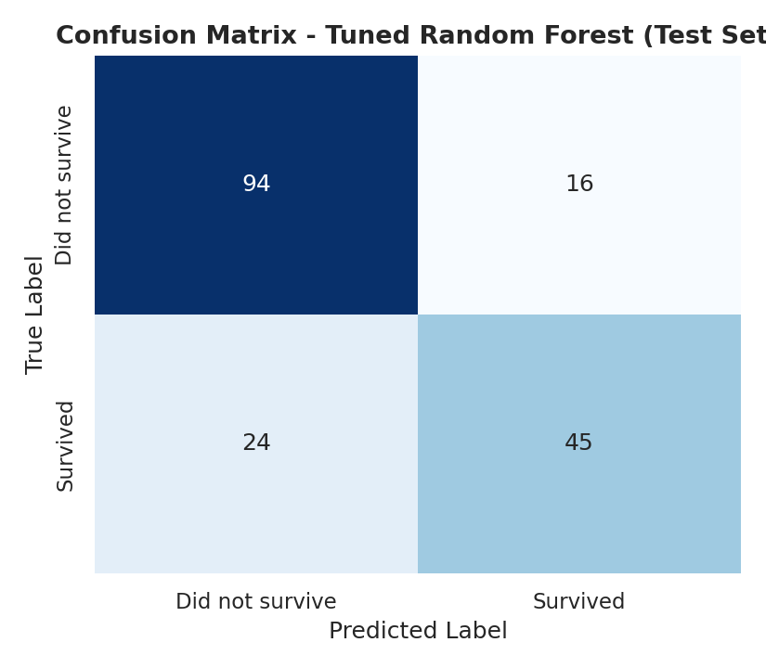
Figure 3. Confusion matrix on the test set.
The confusion matrix shows the model is considerably more accurate on the majority class (94 of 110 'did not survive' passengers correctly identified, 85.5%) than the minority class (45 of 69 'survived' passengers correctly identified, 65.2%) - the same imbalance effect described above, made concrete.
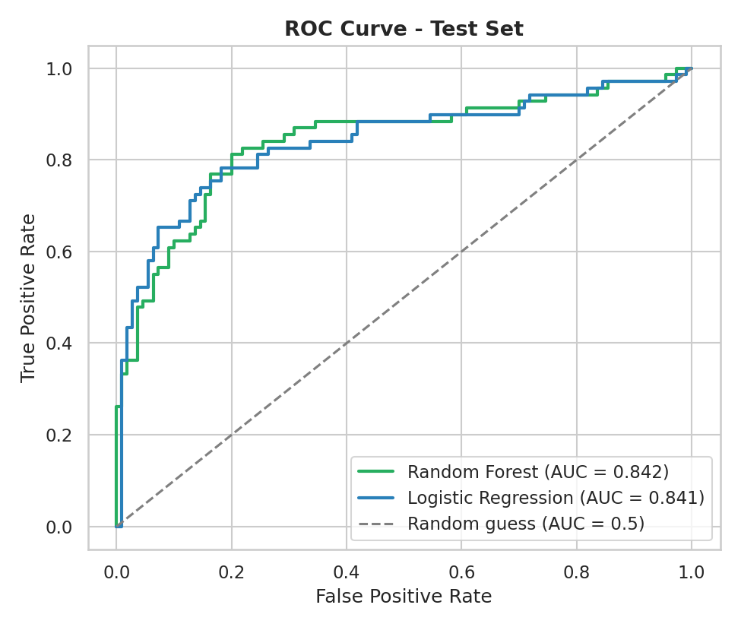
Figure 4. ROC curve comparing the tuned Random Forest and the Logistic Regression baseline on the test set.
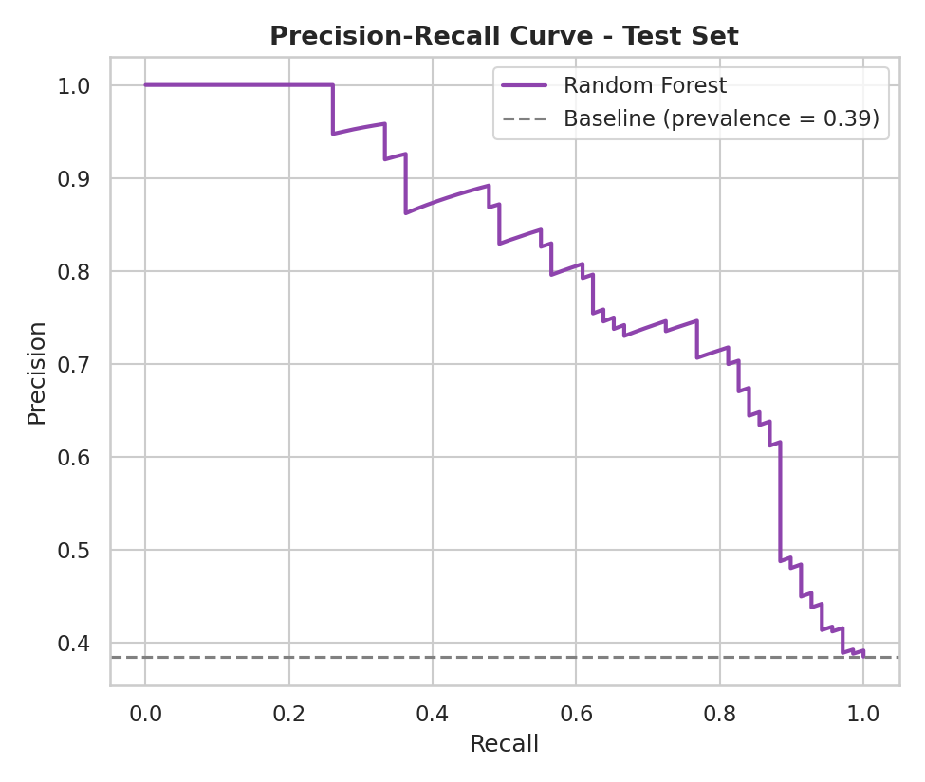
Figure 5. Precision-recall curve for the tuned Random Forest, compared against the no-skill baseline (the dataset's survival prevalence).
Both curves sit well above their respective baselines (the diagonal for ROC, the prevalence line for precision-recall), confirming the model has learned a genuinely useful ranking of survival likelihood rather than approximating random guessing. The ROC-AUC of 0.842 indicates that, for a randomly chosen survivor and non-survivor pair, the model assigns the survivor a higher predicted probability roughly 84% of the time.

7. Discussion: Strengths, Limitations, and Possible Improvements

7.1 Strengths
- The model's most important features (sex, fare, age) align closely with, and quantitatively confirm, the patterns already identified qualitatively in the Week 2 exploratory analysis - a useful form of cross-validation between two independent analytical approaches on the same data.
- The modeling pipeline avoids data leakage at every stage: redundant/derived columns were dropped (Section 2), and all preprocessing (scaling) was fit on the training set only.
- ROC-AUC (0.842) indicates strong discriminative ability well beyond chance, and is robust to the class imbalance in a way that raw accuracy is not.

7.2 Limitations
- Class imbalance (61.6%/38.4%) biases the model toward higher precision and lower recall on the minority ('Survived') class, as shown directly in the confusion matrix (Section 6).
- The validation curve (Figure 2) shows a persistent, widening gap between training and cross-validation performance as model complexity increases - a sign of mild overfitting inherent to tree-based ensembles on a dataset this size.
- The learning curve (below) shows the cross-validation score is still rising, even at the full training-set size, suggesting the model has not yet reached a performance plateau and more data would likely help.
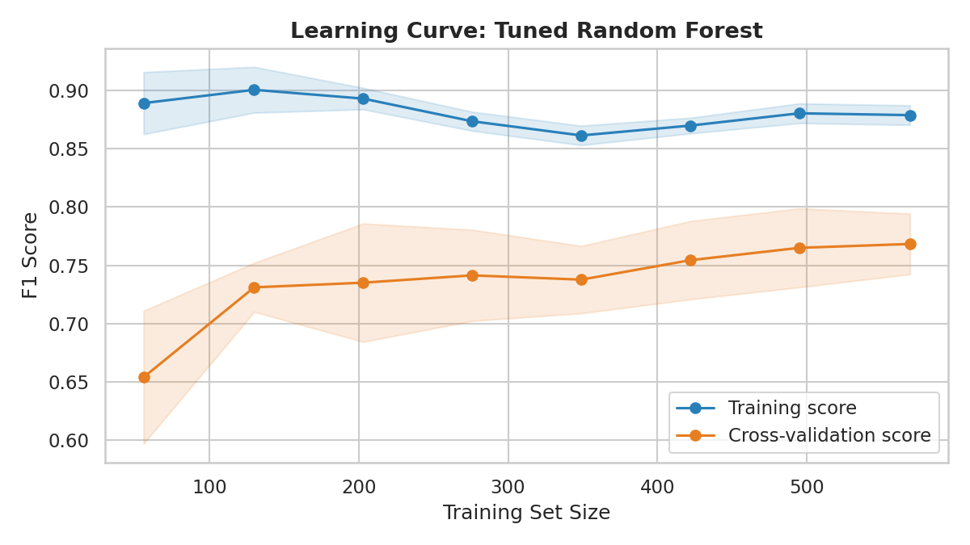
Figure 6. Learning curve for the tuned Random Forest.
- The dataset itself is small (891 total passengers) and historical, limiting how confidently any model's exact performance figures would generalize to a differently composed population.
- Age was partially imputed in Week 1 (group-median imputation for ~20% of values); since age is the third most important feature here, some of the model's apparent precision rests on imputed rather than observed values.

7.3 Possible Improvements
- Address class imbalance directly, e.g. via class_weight='balanced' in the Random Forest/Logistic Regression, or resampling techniques (SMOTE), to improve recall on the minority class.
- Engineer interaction features explicitly (e.g. pclass x sex, which Week 2's multivariate analysis showed to be a stronger joint predictor than either variable alone) to help the simpler, linear Logistic Regression model close the gap with the tree-based ensembles.
- Try stacking or blending the four candidate models, since their cross-validation scores (Section 4) are close but not identical, suggesting they may make partially independent errors that an ensemble could correct.
- Collect or merge in additional historical data (e.g. full names/titles, which the original Kaggle version of this dataset contains and which are known to be a strong Titanic survival predictor) to add genuinely new signal rather than re-deriving it from existing columns.

8. Feature Importance and Model Interpretability
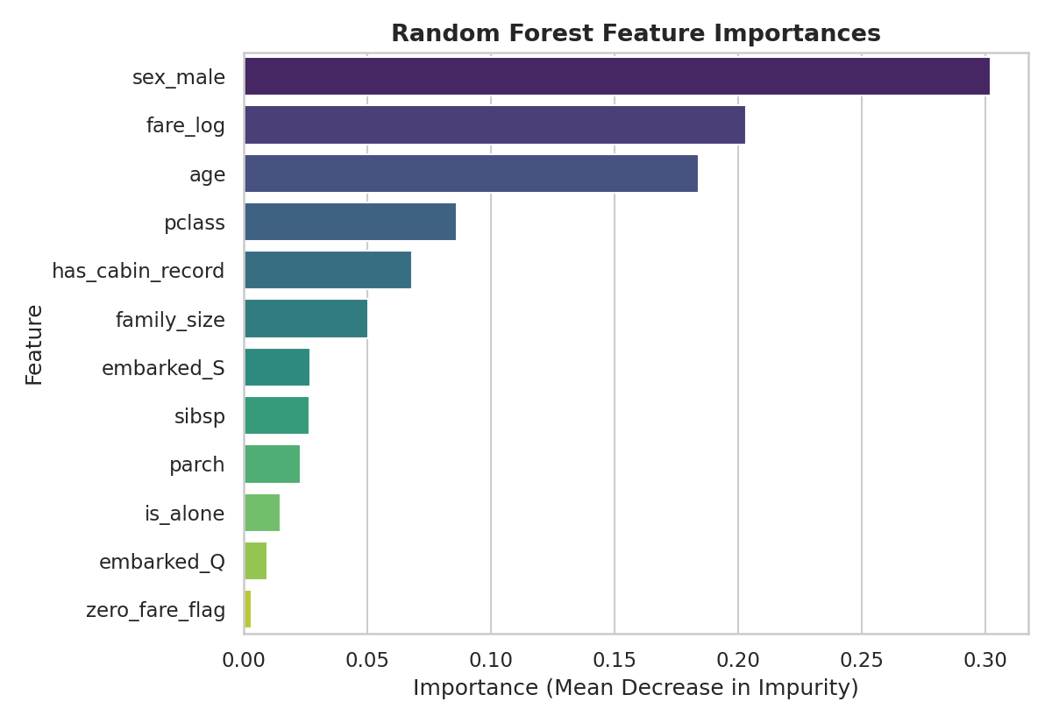
Figure 7. Random Forest feature importances (mean decrease in impurity).
sex_male (0.302), fare_log (0.203), and age (0.184) together account for roughly 69% of the Random Forest's total feature importance. This directly corroborates the Week 2 exploratory finding that sex was the single strongest driver of survival, with class/fare and age as secondary factors - the supervised model has independently 're-discovered' the same structure the EDA surfaced through visualization and group aggregation, which is a reassuring form of validation across two different analytical methods.
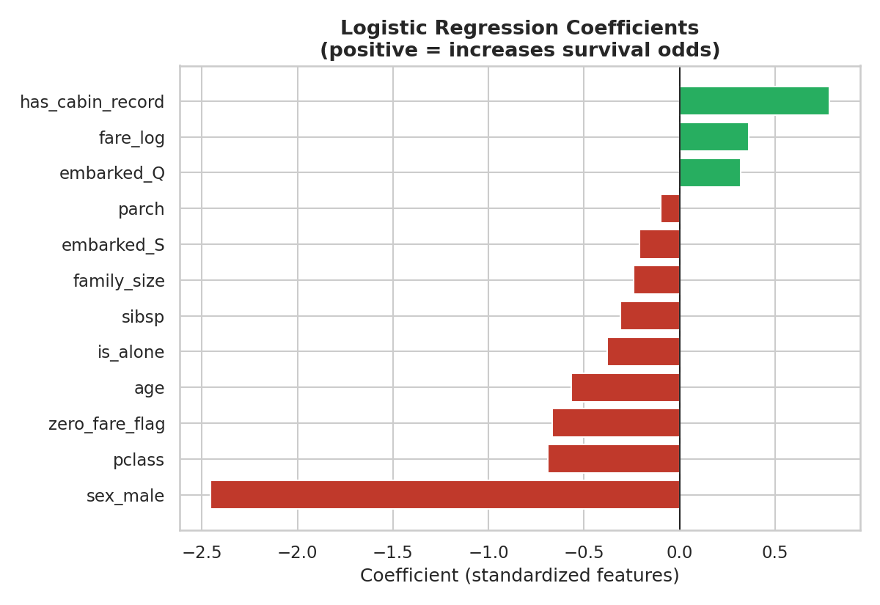
Figure 8. Logistic Regression coefficients (on standardized features); positive values increase predicted survival odds.
The Logistic Regression coefficients tell the same story from a different angle: sex_male has by far the largest negative coefficient (being male sharply reduces predicted survival odds), while fare_log and has_cabin_record carry positive coefficients (higher fare and a recorded cabin both increase predicted odds), and pclass carries a negative coefficient (higher-numbered, cheaper classes reduce odds). Because Logistic Regression's coefficients are directly interpretable as log-odds, and because this model's ROC-AUC (0.841) was nearly identical to the tuned Random Forest's (0.842, Figure 4), this is a case worth noting explicitly: the added complexity of an ensemble model bought almost no additional predictive power over a simple, fully transparent linear model on this particular dataset. For an application where interpretability or auditability matters (e.g. explaining individual predictions to a non-technical stakeholder), Logistic Regression would be a defensible, and arguably preferable, choice over the Random Forest carried forward as the primary model in this report.

9. Conclusion
This task implemented a complete supervised learning pipeline: leakage-aware feature engineering, a train/test split with correctly isolated preprocessing, a principled comparison of four classification algorithms via cross-validation, hyperparameter tuning with an explicit bias/variance analysis, and a thorough final evaluation on a held-out test set using metrics appropriate to an imbalanced target. The resulting Random Forest model achieves solid, honestly-reported performance (77.7% accuracy, 0.842 ROC-AUC) without overstating its reliability, and its feature-importance results independently confirm the exploratory patterns found in Week 2, tying this project's four weeks of work into a single coherent analytical narrative: from raw data, through cleaning and exploration, to a validated predictive model whose behavior can be explained in the same terms the data itself first suggested.

Appendix A: Figures Index
Figure | Title
1 | 5-fold cross-validation scores for all four candidate models
2 | Validation curve: Random Forest max_depth vs. F1 score
3 | Confusion matrix (test set)
4 | ROC curve: Random Forest vs. Logistic Regression (test set)
5 | Precision-recall curve (test set)
6 | Learning curve: tuned Random Forest
7 | Random Forest feature importances
8 | Logistic Regression coefficients

Appendix B: Output Files
File | Description
model_training.py | Full pipeline: feature engineering, CV comparison, tuning, evaluation, all 8 figures
titanic_cleaned.csv | Input dataset (cleaned in Week 1)
final_model_results.csv | Test-set metrics for Logistic Regression and the tuned Random Forest
cv_model_comparison.csv | 5-fold CV metrics for all four candidate models
feature_importances.csv | Random Forest feature importance values
Week4_Supervised_Learning_Report.docx | This report

