**1. what is jQuery?**

jQuery is a lightweight, "write less, do more", JavaScript library.The purpose of jQuery is to make it much easier to use JavaScript on your website.

jQuery takes a lot of common tasks that require many lines of JavaScript code to accomplish, and wraps them into methods that you can call with a single line of code.

jQuery also simplifies a lot of the complicated things from JavaScript, like AJAX calls and DOM manipulation.

The jQuery library contains the following features:

1. HTML/DOM manipulation

2. CSS manipulation

3. HTML event methods

4. Effects and animations

5. AJAX

**2. How to Apply CSS Using JQuery, How to Add Class and Remove Class in Jquery , JQuery Animation?**

1. addClass() - Adds one or more classes to the selected elements

2. removeClass() - Removes one or more classes from the selected elements

3. toggleClass() - Toggles between adding/removing classes from the selected elements

4. css() – Sets or returns the style attribute

**3.** **How to create slider with animation?**

Step 1: Come up with a strategy for the slider.

Step 2: Update the background image in each slide.

Step 3: Update the text layers in each slide.

Step 4: Edit the button text and design in each slide.

Step 5: Edit the slider navigation.

**4.** **Event bubbling tickling example.**

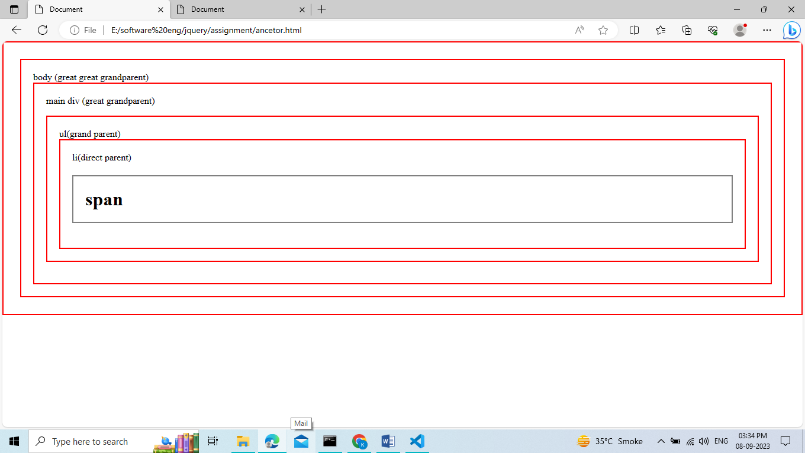

<!DOCTYPE html>

<html lang="en">

<head>

    <meta charset="UTF-8">

    <meta name="viewport" content="width=device-width, initial-scale=1.0">

    <title>Document</title>

    <style>

    .main{

        border: 2px solid gray;

        padding: 20px;

    }

    ul{

        border: 2px solid gray;

        padding: 20px;

    }

    li{

        border: 2px solid gray;

        padding: 20px;

        list-style: none;

    }

    h1{

        border: 2px solid gray;

        padding: 20px;

    }

    .changecss{

        border: 2px solid red;

        padding: 20px;

    }

    </style>

</head>

<body>

   body (great great grandparent)

    <div class="main">main div (great grandparent)

      <ul>ul(grand parent)

        <li>li(direct parent)

            <h1>span</h1>

        </li>

      </ul>

    </div>

    <script src="./jQuery.js"></script>

    <script>

        $(document).ready(function(){

            $("h1").parents("").addClass("changecss")

        })

    </script>

</body>

</html>