**1. What do you understand By Database?**

Database defined

A database is an organized collection of structured information, or data, typically stored electronically in a computer system. A database is usually controlled by a database management system (DBMS).

**2. What is Normalization?**

As an SQL Developer, you often work with enormous amounts of data stored in different tables that are present inside multiple databases. It often becomes strenuous to extract the data if it is not organized correctly. Using Normalization, you can solve the problem of data redundancy and organize the data using different forms. This tutorial will help you get to know the concept of Normalization in SQL.

**3. What is Difference between DBMS and RDBMS?**

|  |  |
| --- | --- |
| **RDBMS** | **DBMS** |
| Data stored is in table format | Data stored is in the file format |
| Multiple data elements are accessible together | Individual access of data elements |
| Data in the form of a table are linked together | No connection between data |
| Normalisation is not achievable | There is normalisation |
| Support distributed database | No support for distributed database |
| Data is stored in a large amount | Data stored is a small quantity |
| Here, redundancy of data is reduced with the help of key and indexes in RDBMS | Data redundancy is common |
| RDBMS supports multiple users | DBMS supports a single user |
| It features multiple layers of security while handling data | There is only low security while handling data |
| The software and hardware requirements are higher | The software and hardware requirements are low |
| Oracle, SQL Server. | XML, Microsoft Access. |

**4. What is MF Cod Rule of RDBMS Systems?**

Codd’s rule in DBMS also known as Codd's 12 rules/commandments is a set of thirteen rules (numbered 0 to 12) that define a database to be a correct Relational Database Management System (RDBMS). If a database follows Codd's 12 rules, it is called a True relational database management system.These rules were originally set out in 1970 by Edgar F. Codd and were developed further by him in 1985.

**5. What do you understand By Data Redundancy?**

**Possible data inconsistency :-**

Data redundancy occurs when the same piece of data exists in multiple places, whereas data inconsistency is when the same data exists in different formats in multiple tables. Unfortunately, data redundancy can cause data inconsistency, which can provide a company with unreliable and/or meaningless information.

**Increase in data corruption :-**

Data corruption is when data becomes damaged as a result of errors in writing, reading, storage, or processing. When the same data fields are repeated in a database or file storage system, data corruption arises. If a file gets corrupted, for example, and an employee tries to open it, they may get an error message and not be able to complete their task.

**6. What is DDL Interpreter?**DDL Interpreter DDL expands to Data Definition Language. DDL Interpreter as the name suggests interprets the DDL statements such as schema definition statements like create, delete, etc. The result of this interpretation is a set of a table that contains the meta-data which is stored in the data dictionary.

**7. What is DML Compiler in SQL?**

DML Compiler: It processes the DML statements into low level instruction (machine language), so that they can be executed. DDL Interpreter: It processes the DDL statements into a set of table containing meta data (data about data).

INSERT: command to add new or new value to the database

UPDATE: command to change or update current/existing data to a more recent value within the database

DELETE: command to delete or delete the values or data information of the current table in the database.

**8. What is SQL Key Constraints writing an Example of SQL Key Constraints?**

SQL constraints are used to specify rules for the data in a table.

Constraints are used to limit the type of data that can go into a table. This ensures the accuracy and reliability of the data in the table. If there is any violation between the constraint and the data action, the action is aborted.

Constraints can be column level or table level. Column level constraints apply to a column, and table level constraints apply to the whole table.

**9. What is save Point? How to create a save Point write a Query?**

A SAVEPOINT is a point in a transaction in which you can roll the transaction back to a certain point without rolling back the entire transaction. Syntax for Savepoint command: SAVEPOINT SAVEPOINT_NAME; This command is used only in the creation of SAVEPOINT among all the transactions.

**10. What is trigger and how to create a Trigger in SQL?**

A trigger is a special type of stored procedure that automatically runs when an event occurs in the database server. DML triggers run when a user tries to modify data through a data manipulation language (DML) event. DML events are INSERT, UPDATE, or DELETE statements on a table or view.

DDL triggers run in response to a variety of data definition language (DDL) events. These events primarily correspond to Transact-SQL CREATE, ALTER, and DROP statements, and certain system stored procedures that perform DDL-like operations.

11**. create a table student.**

1. CREATE TABLE student(roll_num int AUTO_INCREMENT,

name varchar(30),

branch varchar(30),

PRIMARY KEY (roll_num));

2. INSERT INTO student VALUES ('',"jay","computer science");

INSERT INTO student VALUES ('',"suhani","eletronic & com");

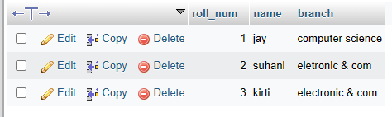

**12. Create Table Exam**

1. CREATE TABLE exam(s_code int AUTO_INCREMENT,

mark int,

p_code varchar(30),

roll_num int ,

FOREIGN KEY(roll_num) REFERENCES student(roll_num));

* INSERT INTO `exam` (`s_code`, `mark`, `p_code`, `roll_num`) VALUES ('cs11', '50', 'cs', '1');
* INSERT INTO `exam` (`s_code`, `mark`, `p_code`, `roll_num`) VALUES ('cs12', '60', 'cs', '2');
* INSERT INTO `exam` (`s_code`, `mark`, `p_code`, `roll_num`) VALUES ('ec101', '66', 'ec', '3');
* INSERT INTO `exam` (`s_code`, `mark`, `p_code`, `roll_num`) VALUES ('ec102', '70', 'ec', '1');
* INSERT INTO `exam` (`s_code`, `mark`, `p_code`, `roll_num`) VALUES ('ec101', '45', 'ec', '2');
* INSERT INTO `exam` (`s_code`, `mark`, `p_code`, `roll_num`) VALUES ('ec102', '50', 'ec', '3');

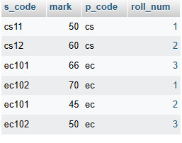

**13. create table people.**

* CREATE TABLE people(first name varchar (20),

Last name varchar(20),

Address varchar (50),

city varchar(30),

age int);

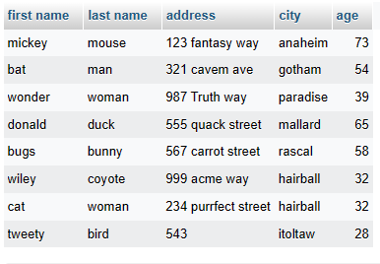

**14. create table employe**

CREATE TABLE `employe` (`emp_id` INT NOT NULL , `first name` VARCHAR(30) NOT NULL , `last name` VARCHAR(30) NOT NULL , `salary` INT NOT NULL , `joineing_date` DATE NOT NULL , `department` VARCHAR(30));

* INSERT INTO `employe` (`emp_id`, `first name`, `last name`, `salary`, `joineing_date`, `department`) VALUES ('1', 'john', 'abraham', '1000000', '2013-01-01', 'banking');
* INSERT INTO `employe` (`emp_id`, `first name`, `last name`, `salary`, `joineing_date`, `department`) VALUES ('2', 'michael', 'clarke', '800000', '2013-01-01', 'insurence');
* INSERT INTO `employe` (`emp_id`, `first name`, `last name`, `salary`, `joineing_date`, `department`) VALUES ('3', 'roy', 'thomas', '700000', '2013-01-01', 'banking');
* INSERT INTO `employe` (`emp_id`, `first name`, `last name`, `salary`, `joineing_date`, `department`) VALUES ('4', 'tom', 'jose', '600000', '2013-02-01', 'insurance');
* INSERT INTO `employe` (`emp_id`, `first name`, `last name`, `salary`, `joineing_date`, `department`) VALUES ('5', 'jery', 'pinto', '650000', '2013-02-01', 'insurence');
* INSERT INTO `employe` (`emp_id`, `first name`, `last name`, `salary`, `joineing_date`, `department`) VALUES ('6', 'philip', 'mathew', '750000', '2013-01-01', 'service');
* INSERT INTO `employe` (`emp_id`, `first name`, `last name`, `salary`, `joineing_date`, `department`) VALUES ('7', 'test name 1', '123’, '650000', '2013-01-01', service);
* INSERT INTO `employe` (`emp_id`, `first name`, `last name`, `salary`, `joineing_date`, `department`) VALUES ('8', 'test name 2', 'last name', '600000', '2013-02-01', 'insurence');

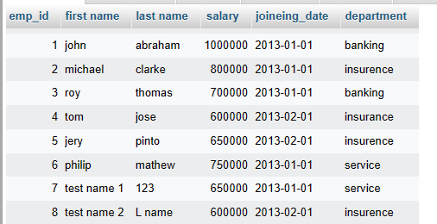

1.SELECT * FROM `employe` WHERE 'first name' ='tom’;



2. SELECT `first name`, `salary`, 'joineing_date' FROM `employe`;

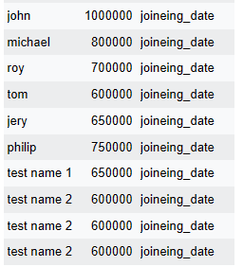

3. SELECT * FROM `employe` ORDER BY `first name` asc;

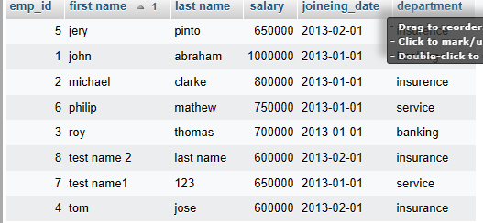

4. SELECT * FROM `employe` ORDER BY salary DESC;

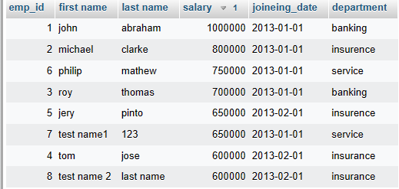

5. SELECT * FROM `employe` WHERE `first name` IN ('john','jery');

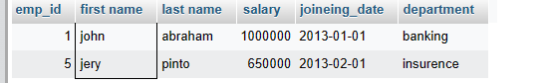

6. SELECT DEPARTMENT,MAX(SALARY) MAXSALARY FROM EMPLOYE GROUP BY DEPARTMENT ORDER BY MAXSALARY ASC;

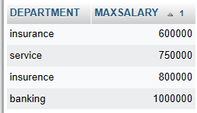

7. SELECT `FIRST NAME`,INCENTIVE_AMOUNT FROM EMPLOYE A INNER JOIN INCENTIVE B ON A.EMP_ID=B.EMP_REF_ID AND INCENTIVE_AMOUNT >3000;

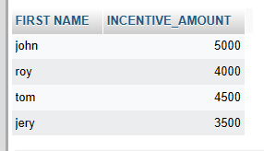

**15. create table incentive**

CREATE TABLE incentive` (`emp_ref_id` INT NOT NULL , `incentive_date` DATE NOT NULL , `incentive_amount` INT NOT NULL ) ENGINE = InnoDB;

INSERT INTO `incentive` (`emp_ref_id`, `incentive_date`, `incentive_amount`) VALUES ('1', '2013-02-01', '5000'), ('2', '2013-02-01', '3000'), ('3', '2013-02-01', '4000'), ('4', '2013-01-01', '4500'), ('5', '2013-01-01', '3500');

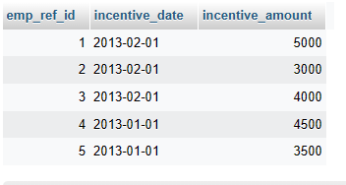

**16. create table salesman**

CREATE TABLE`salesperson` (`sno` INT NOT NULL , `sname` VARCHAR(50) NOT NULL , `city` VARCHAR(30) NOT NULL , `comm` INT NOT NULL ) ENGINE = InnoDB;

Expand Requery Edit Bookmark Database : assinment Queried time : 17:12:14

INSERT INTO `salesperson` (`sno`, `sname`, `city`, `comm`) VALUES ('1001', 'peel', 'london', '12'), ('1002', 'serres', 'san joes', '13'), ('1004', 'motika', 'london', '11'), ('1007', 'rafkin', 'barcelona', '15'), ('1003', 'axelord', 'new york', '1');

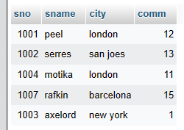

**17. create table customer.**

CREATE TABLE `customer` (`cnm` INT NOT NULL , `cname` VARCHAR(50) NOT NULL , `city` VARCHAR(30) NOT NULL , `ratting` INT NOT NULL , `sno` INT NOT NULL ) ENGINE = InnoDB;

INSERT INTO `customer` (`cnm`, `cname`, `city`, `ratting`, `sno`) VALUES ('201', 'hoffman', 'london', '100', '1001'), ('202', 'giovanee', 'roe', '200', '1003'), ('203', 'liu', 'san jose', '300', '1002'), ('204', 'grass', 'barcelona', '300', '1007'), ('205', 'pereira', 'reo', '100', '1004');

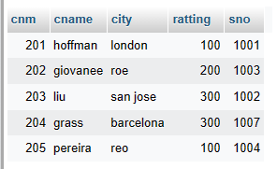

1. select * from order where amount> 1000;

2. SELECT sname,city from salesperson where city='london' and comm>0.12;

3. All salespeople either in Barcelona or in London.

SELECT * FROM salesperson WHERE city='barcelona';

SELECT * FROM salesperson WHERE city=london;

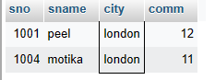

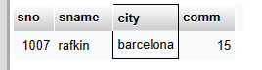

4. SELECT *FROM salesperson WHERE (comm > 10 AND comm< 12);

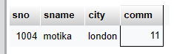

5. SELECT *FROM customer WHERE ratting>100 OR city='rome';

