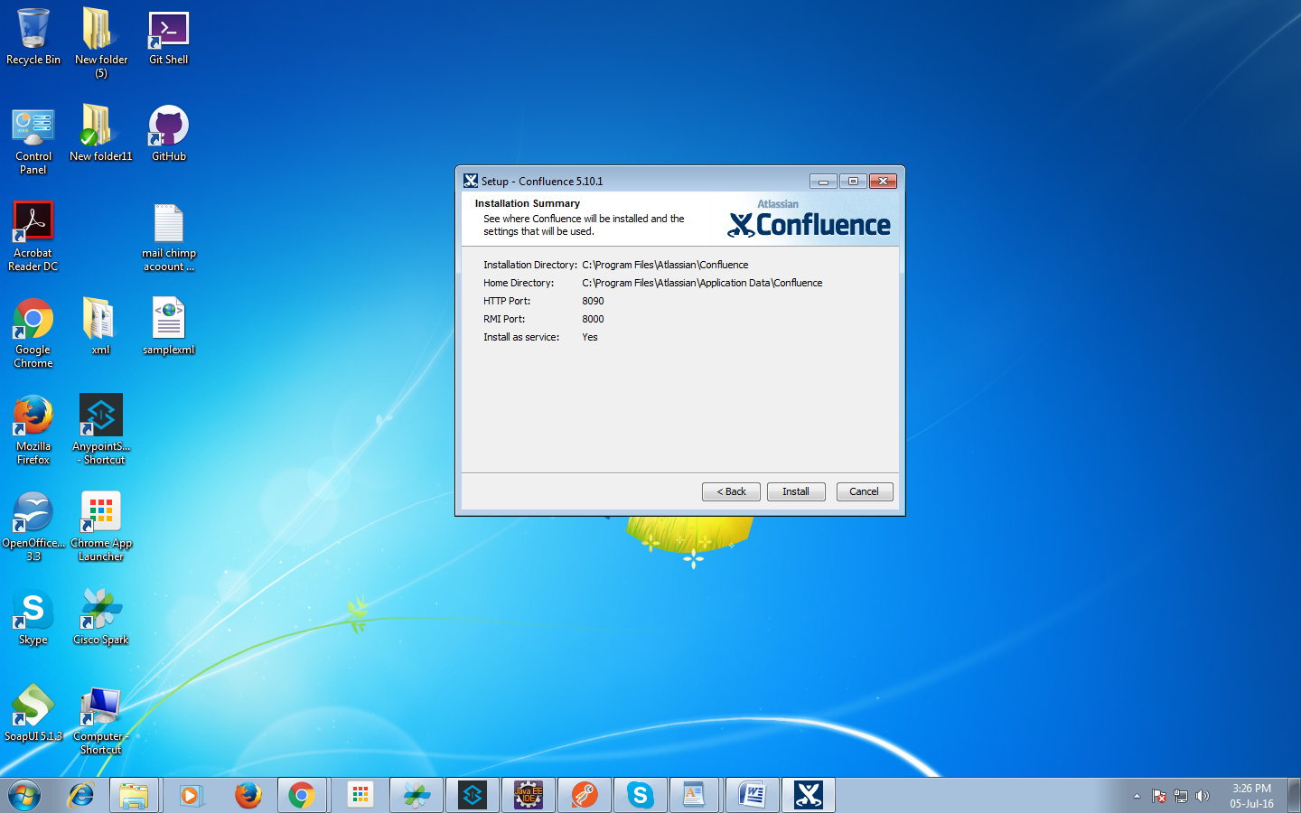

Server_Id : BW0W-I77H-ZX9G-BPP6

AAABPA0ODAoPeNptUE1Lw0AQve+vWPCihy1JNUktLGiToJH0A1utiJc1ndalySbM7pb237tpFKsIM

zDMvDfvzZwtLNAHW1IvcDH0/GFwSeNkQfueH5IEdIGyMbJWPK7VurSgCqDnc8Ad4MXbkKY7UVrRA

kiMcCwSYYC3dOZFzAtI4Yg9URi5A27QQteYG4EGkK9FqYG45cZB0rGQJW9QrACa3lYou7XKlOIG5

Epu615RV+RH8WRbLgtQGhaHBiaiAh5Px+P0Mc5uc1J2o2dA3XL6xGkoA0q4S9J9I/FwYnjAvCsyx

Y1QUnca6VGZ6oM2UNGWuUFhatSke0KW8NHSW7Isiu7Z68v1HRvNZiGZpxPukuUDP4gGYUi+HDp4n

iW/JscDJrZ6B5yun7TzyZn/jf/f4cxi8SE0/H31JxY/l/kwLAIUBA68NBwEHv1/L8j+0p1kHvbhW

A0CFHjW2MdUY9WzL4Cfl3HaCORBYPbdX02fn

http://localhost:8090/

http://localhost:8090/pages/createpage.action?useDraft=true&spaceKey=EID&draftId=1114113

docs : https://confluence.atlassian.com/alldoc/confluence-documentation-directory-12877996.html