**Pivotal Tracker Message Formats**

1. Epic Related Message Formats:

**1) Epic Created With Description:**



**2) Epic Created With Comment And Attachment:**



**3) Epic Created With Comment And Description:**



**4) Epic Name Updated:**



**5) Epic Description Updated:**

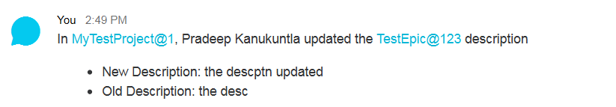

**6) Epic Deleted:**



2. Story Related Message Formats:

**7) Story Create:**

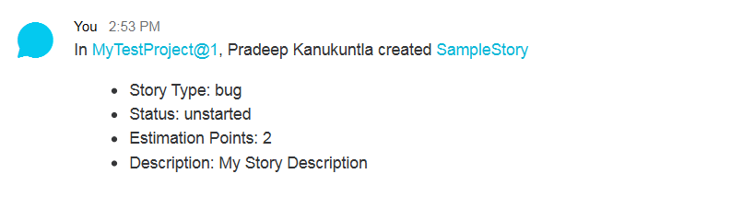

**8) Story Created with Comment:**



**9) Story Name Updated:**



**10) Story Type Updated:**



**11) Story Description Updated:**

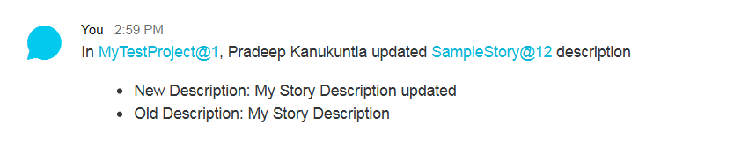

**12) Story Requester Updated:**



**13) Story Status Updated(To Started):**



**14) Story Status Updated(To Finished):**



**15) Story Status Updated(To Delivered):**



**16) Story Accepted:**



**17) Story Rejected:**



**18) Story Delete:**



**19) Story Estimation Points Updated:**



3. Blocker Related Message Formats:

**20) Blocker Created:**



**21) Blocker Name Updated:**

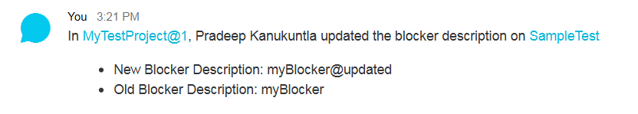

**22) Blocker Resolved:**



**23) Blocker Unblocked:**

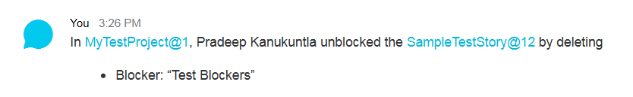

4. Task Related Message Formats:

**24) Task Created:**



**25) Task Name Updated:**



**26) Task Completed:**



**27) Task Delete:**



5. Label Related Message Formats:

**28) Label Added:**



**29) Label Deleted:**



6. Comment Related Message Formats:

**30) Comment Create:**



**31) Comment Created With Attachments:**

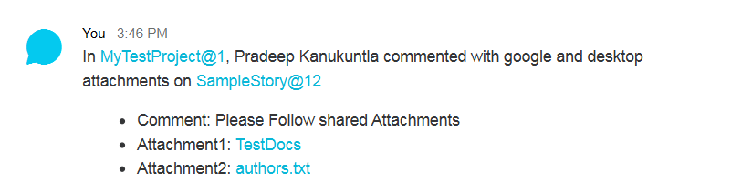

**32) Comment Updated:**



**33) Comment updated With Attachment:**

