1) He is asking following information from user's(related to xmatter's account)

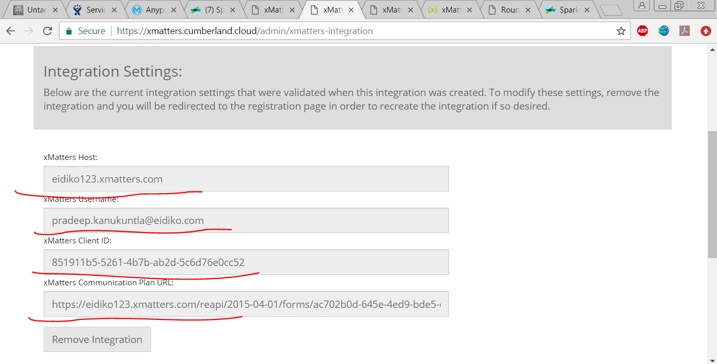

2) Here, He is inviting a group but not a perticular user(points under "Things you can try")

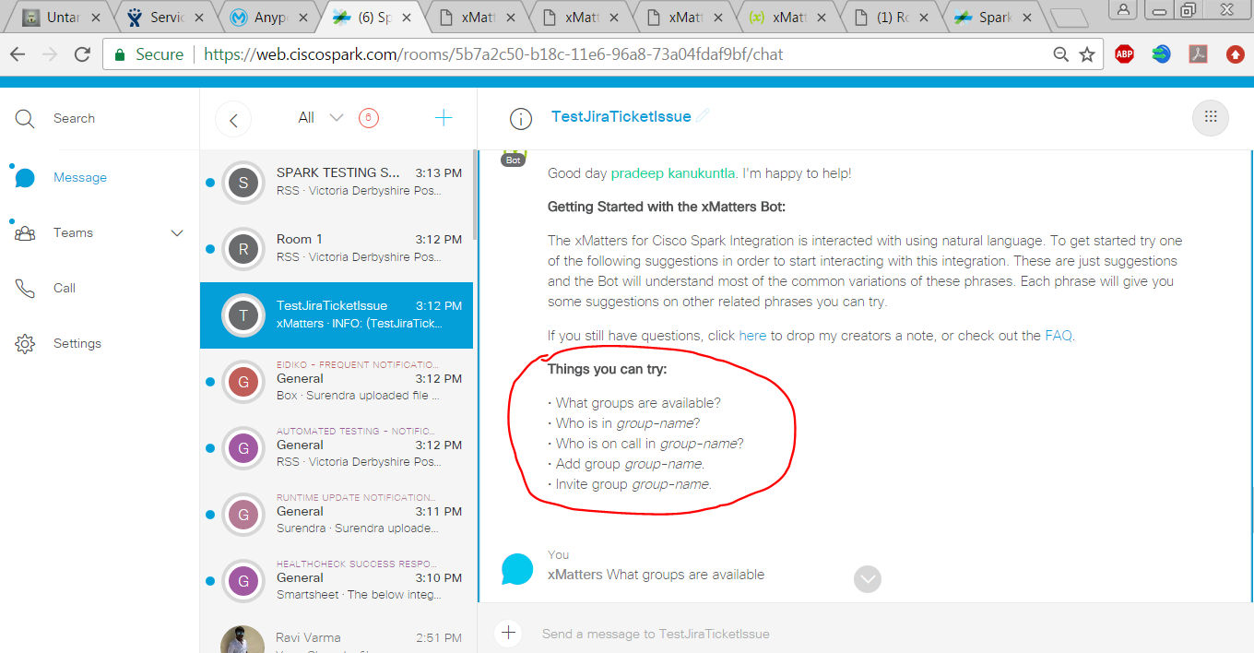

3) Group name should be same as space name(below image example for not matching group name and space name)

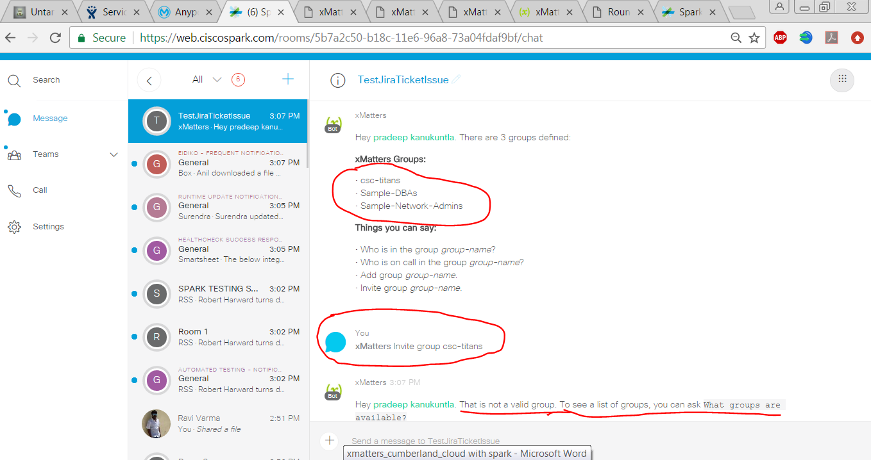

4) Below image example for group name same with space name. Inviting a group to space : event performed

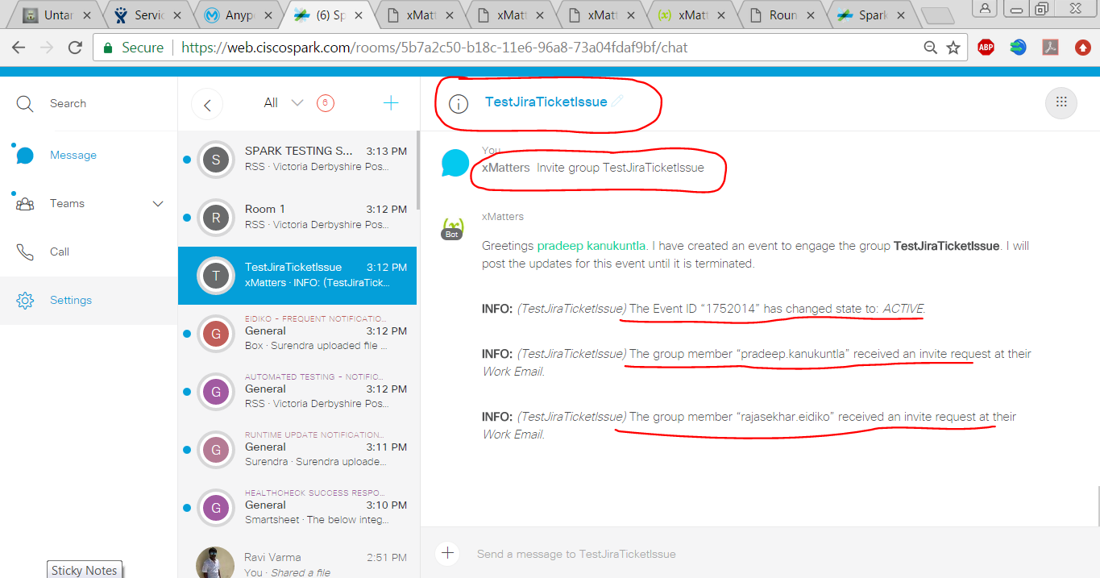

5) Email i received

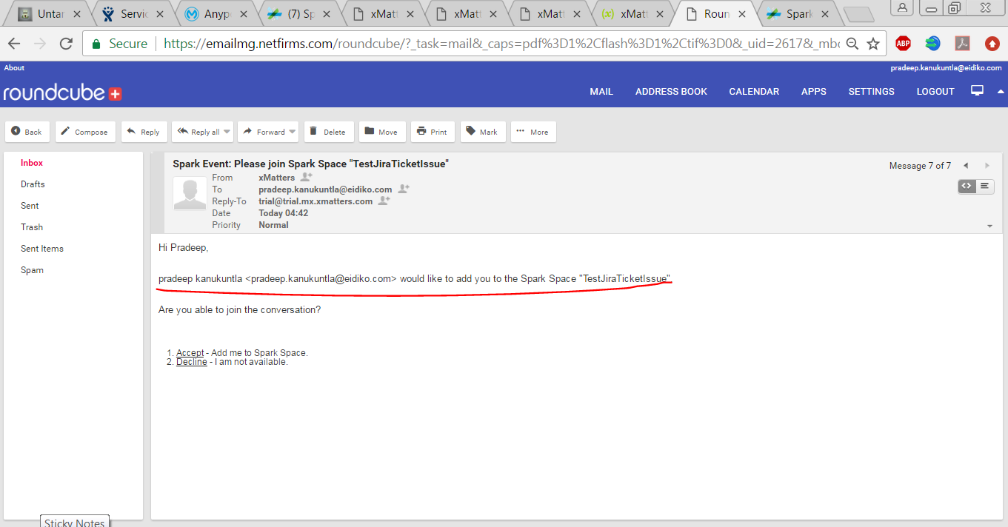

6) Notification response message in spark

