Applying SSL for wsdl

1. In search box type "crypto tools" and click on option "crypto tools" under search box.

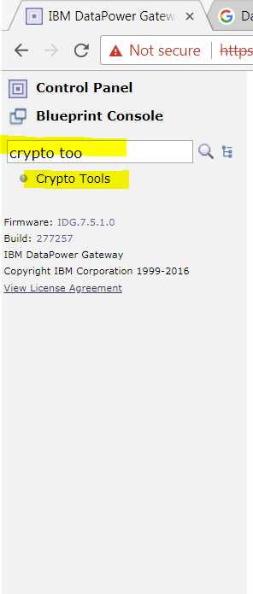

2. Under "Generate Key" section fill the details and click on "Generate key" button.

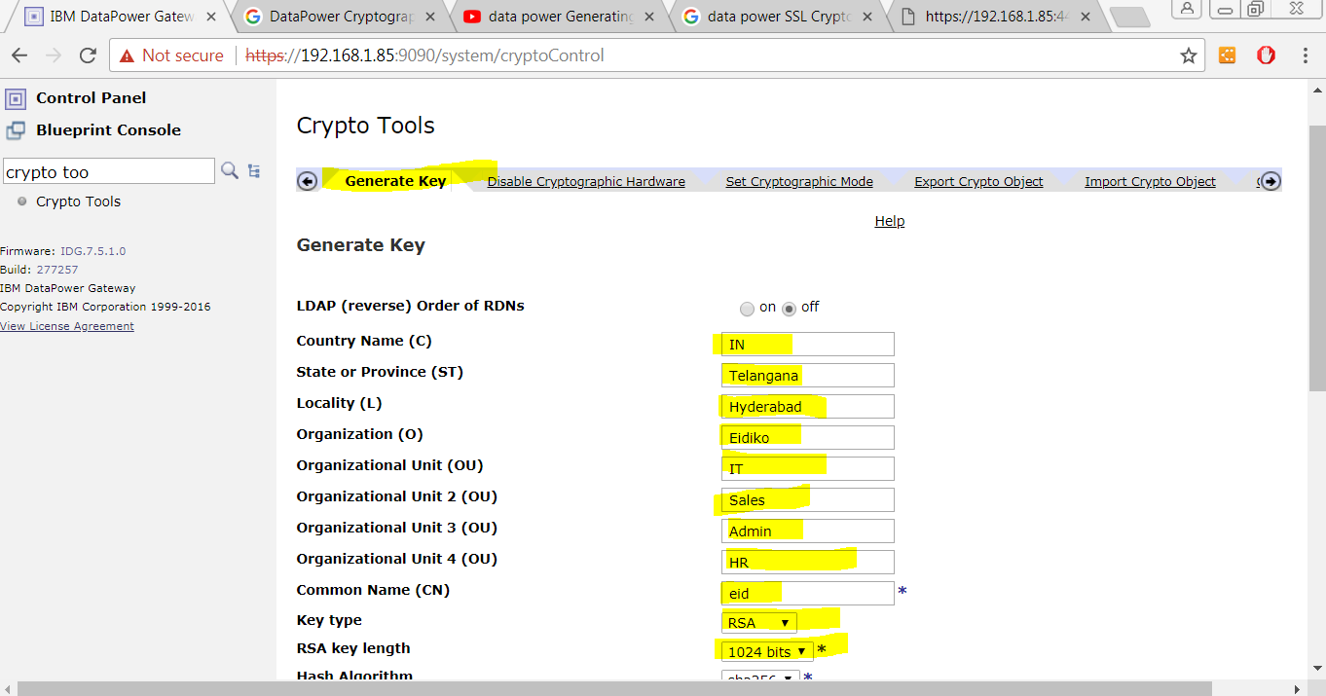

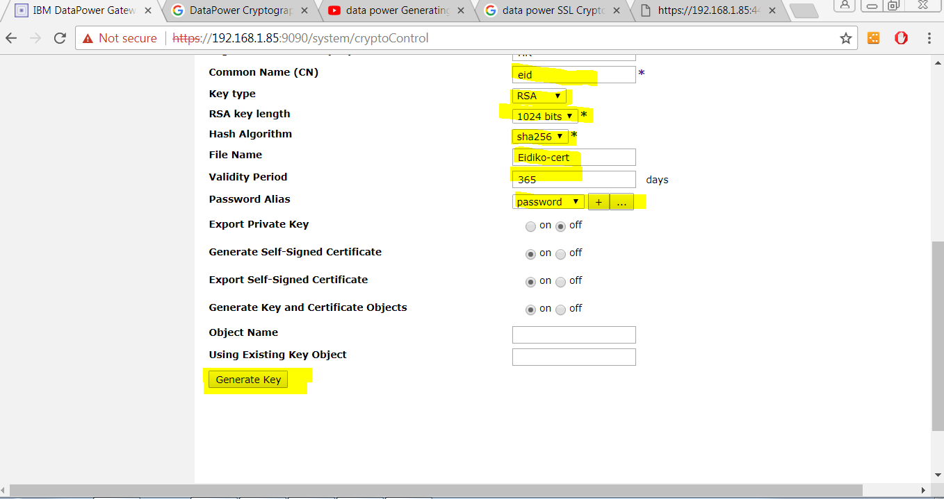

3. Now type "SSL proxy profile" in search box.

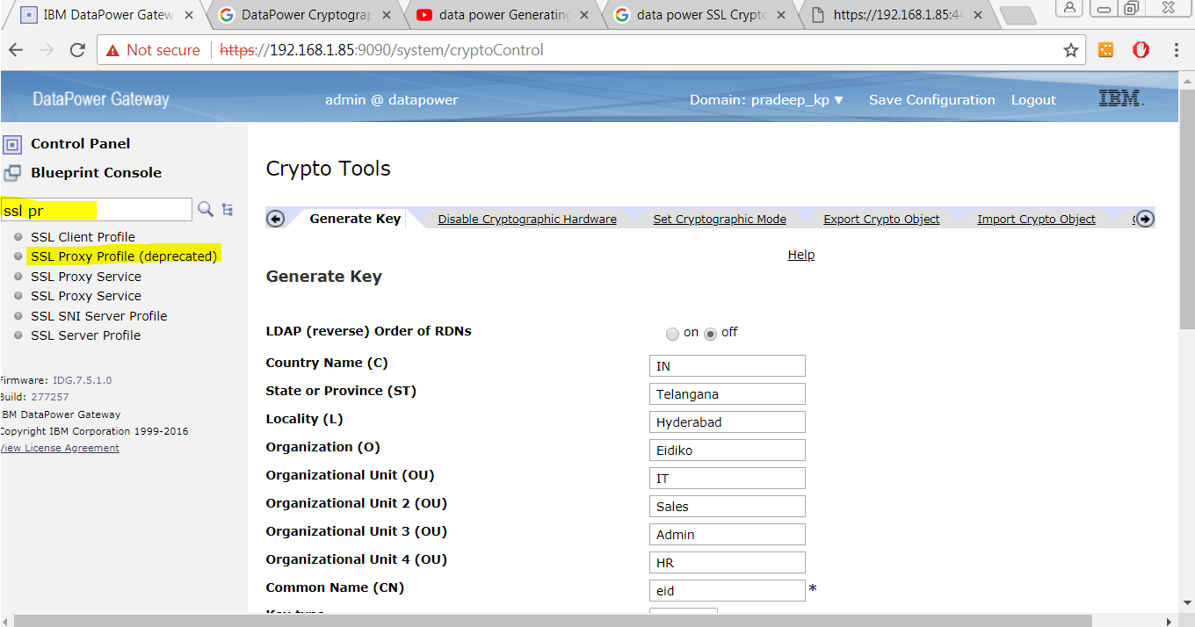

4. Give any name to it and under "SSL Direction" select "Reverse" option and click on "plus" button for "Reverse Crypto profile".

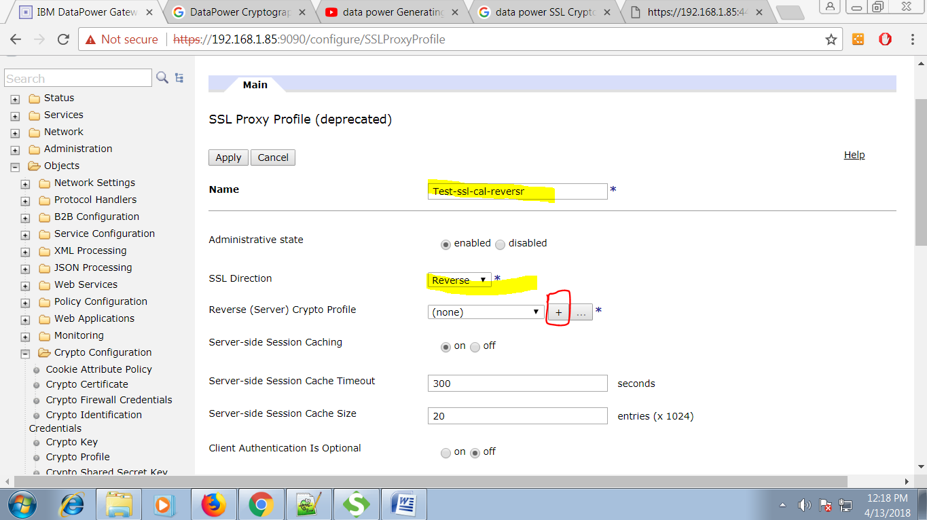

5. Give any name to it and click "plus" button for "Identification Credentials"

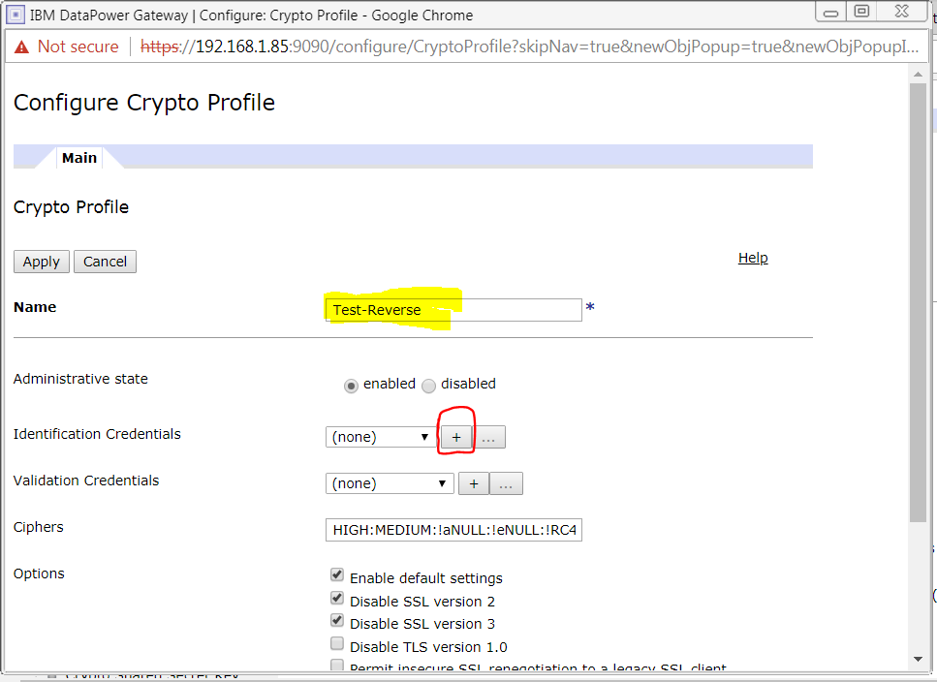

6. Give name for identity credential and select "eid" for "Crypto Key" and "Certificate".

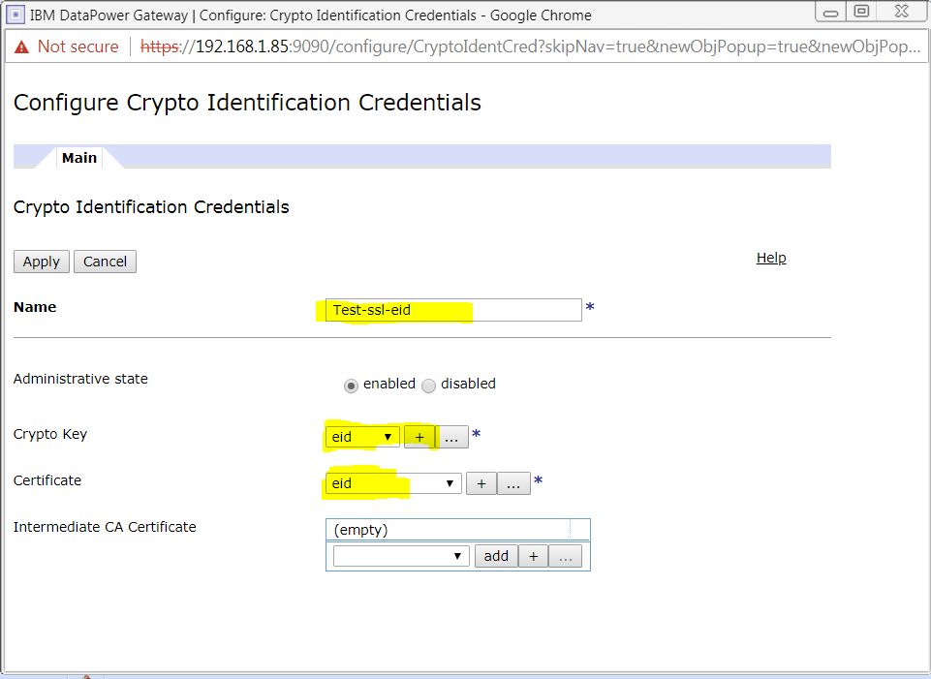

7. Open webservice proxy and click on "Add" button.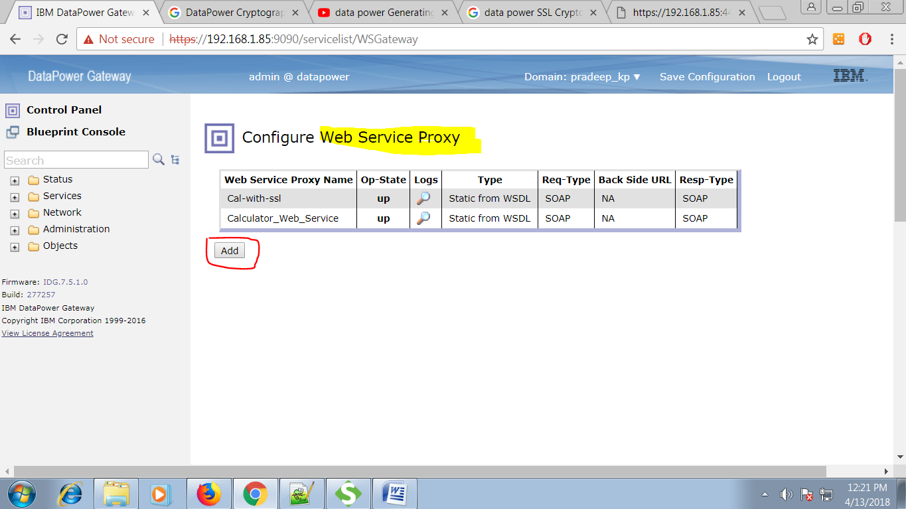

8. Give a name for your web service proxy and click on "crete web service proxy" button.

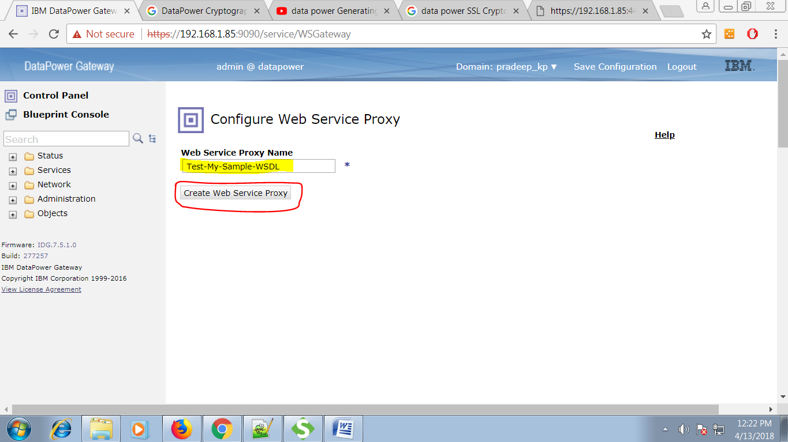

9. Give WSDL file and click on "Next" button.

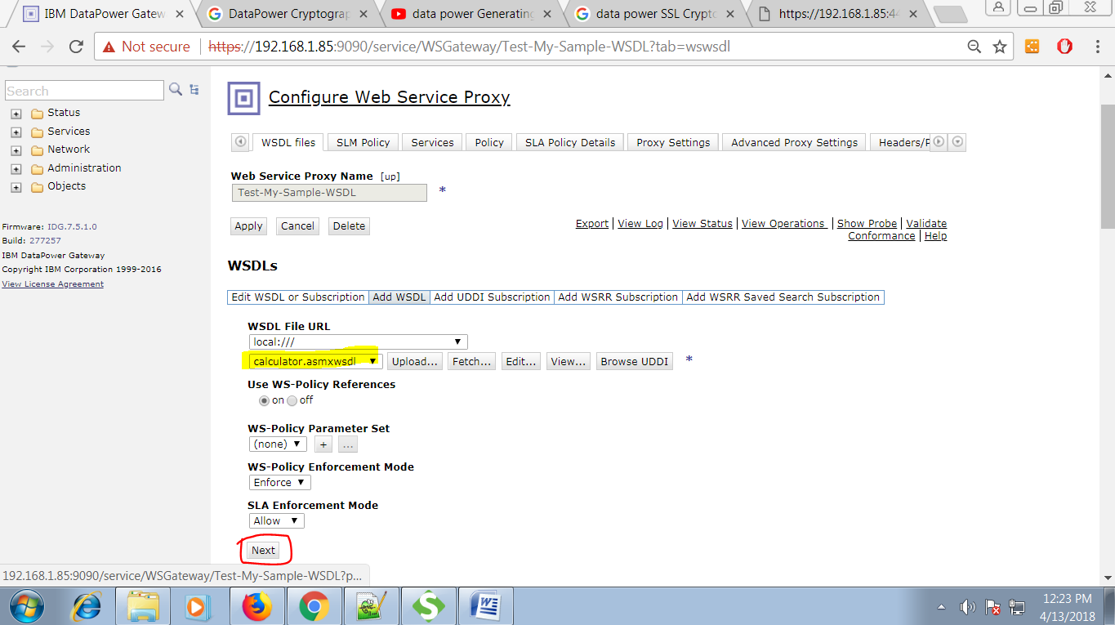

10. Select "HTTPS static handler" give any unallocated port.

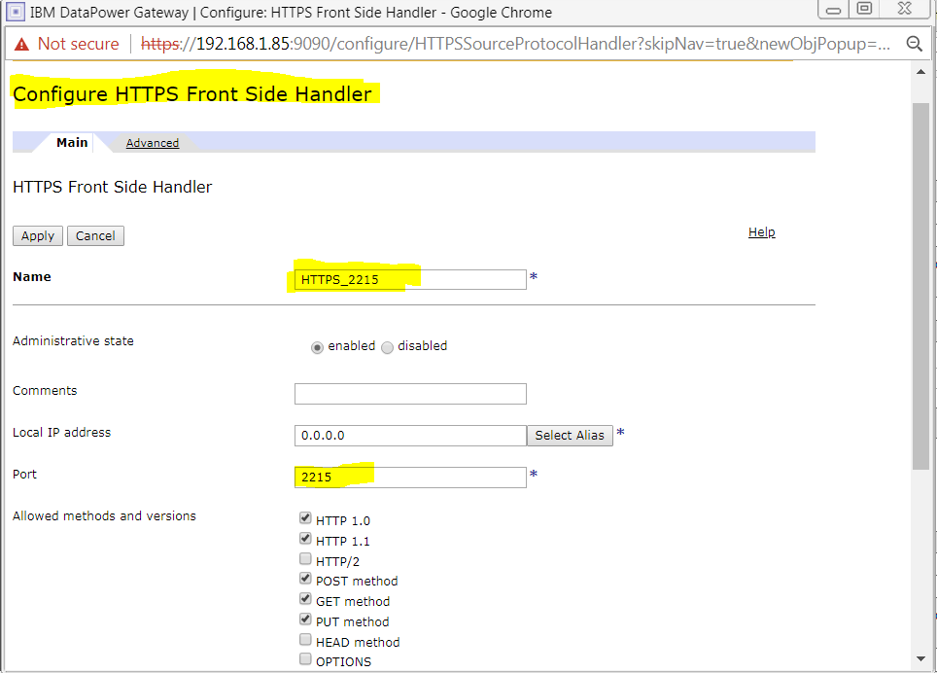

11. Select "Get method" radio button and for SSL proxy profile choose you configured file from drop-down and click on "Apply" button.

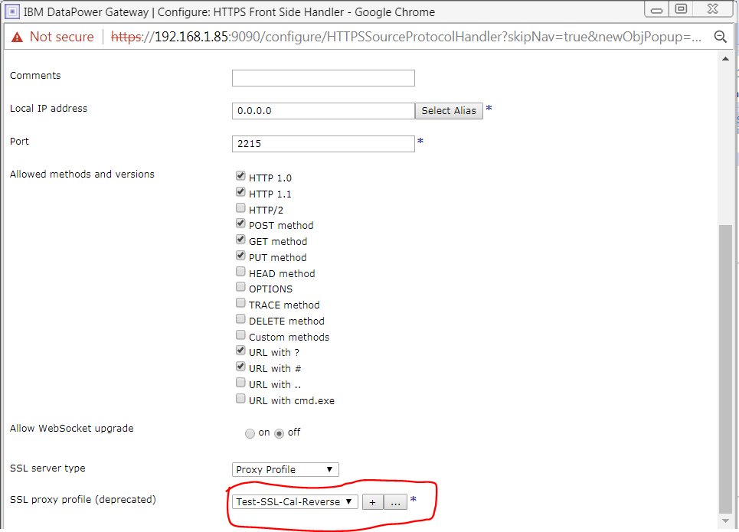

12. Now hit with HTTPS in browser.