CASE Operation

1. Click on File and select "New"=>"Application".

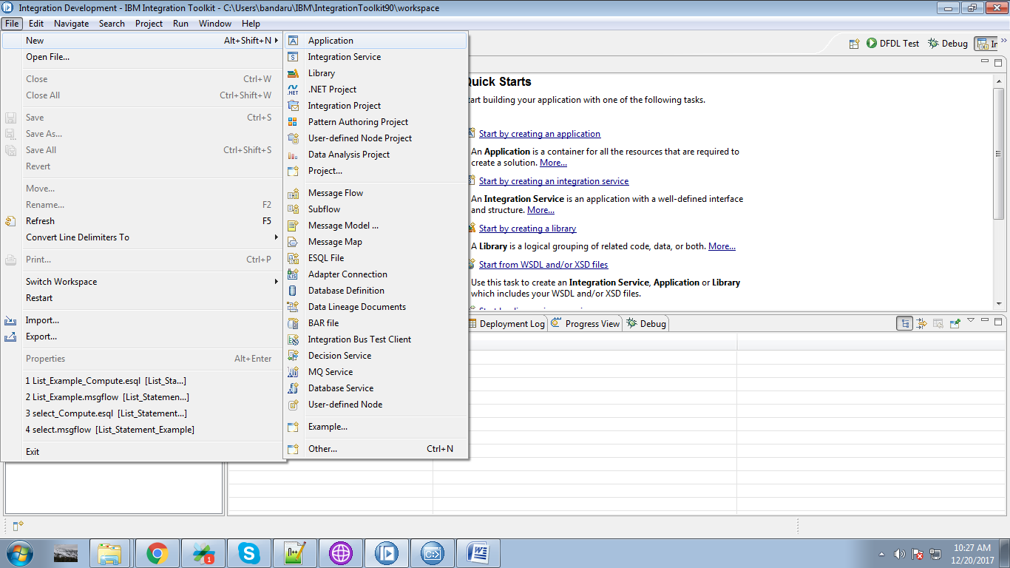

2. Give a name for your application and click on "Finish" button.

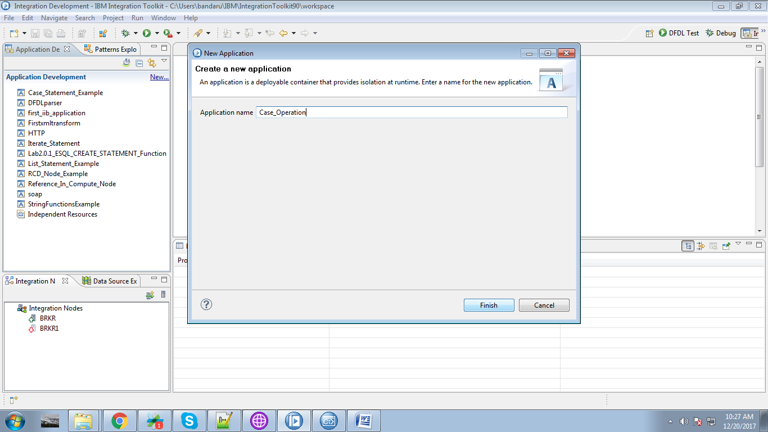

3. Under your application you can see "New" click on it.

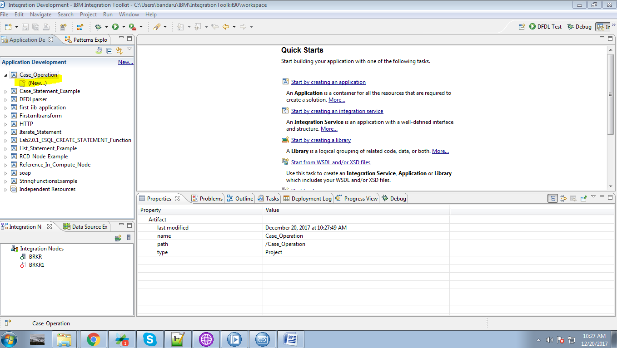

4. Select "Message Flow" from the given options.

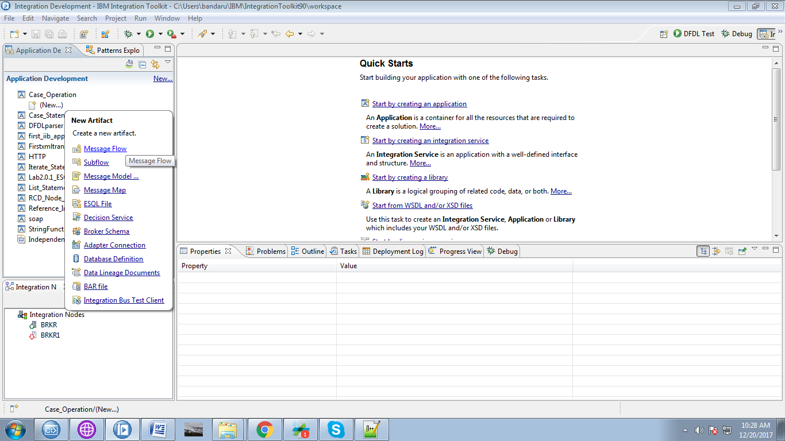

5. Give a name for your application and click "Finish" button.

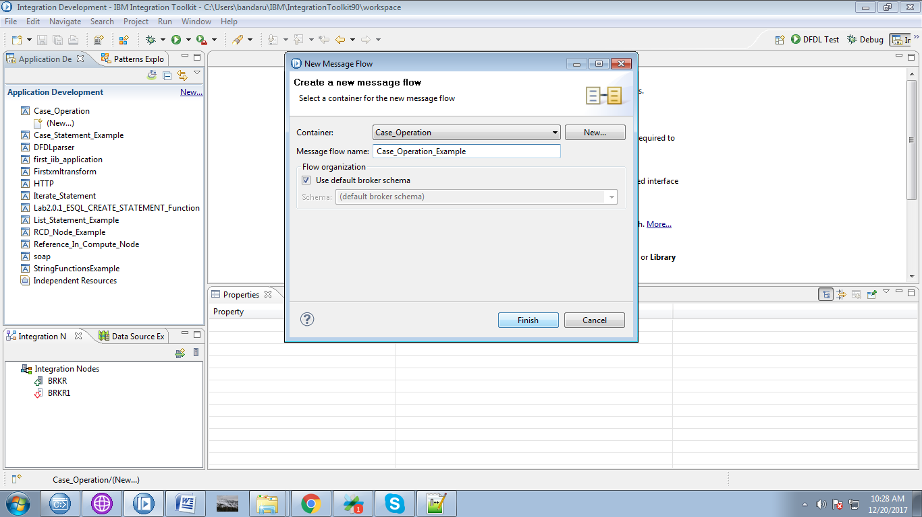

6. Drap "MQInput" from the "WebSphere MQ" and name it.

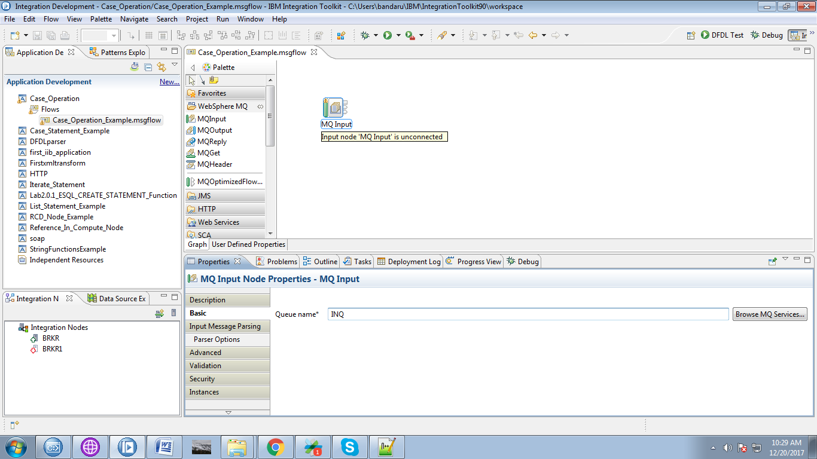

7. Drag the "compute" node from the "Transformation" section.

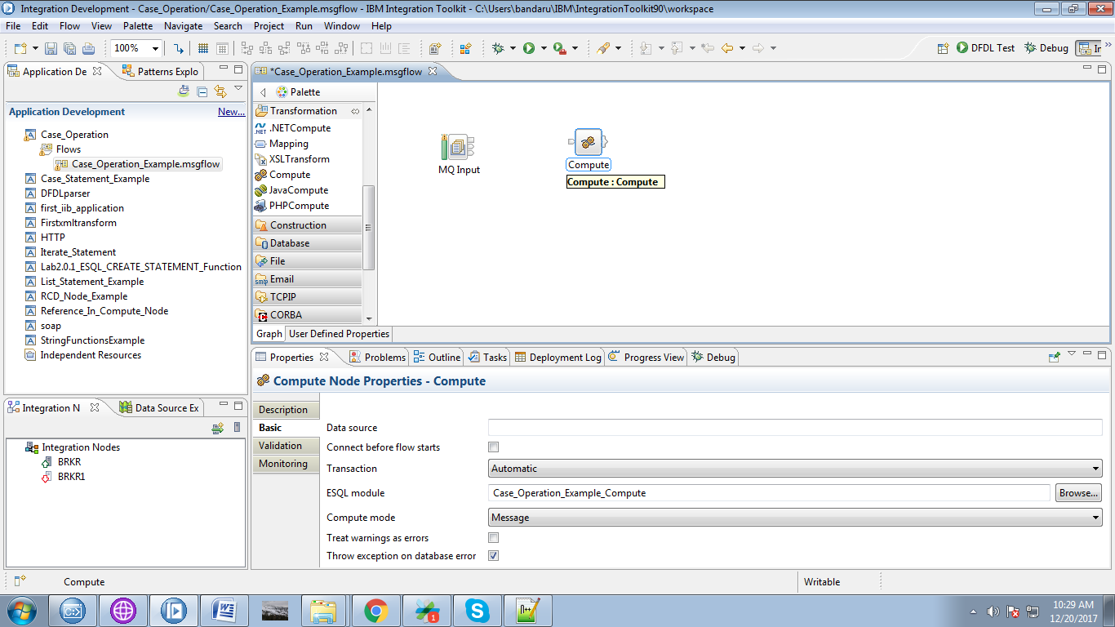

8. Connect "output" terminal of the MQInput with the "input" terminal of the compute node.

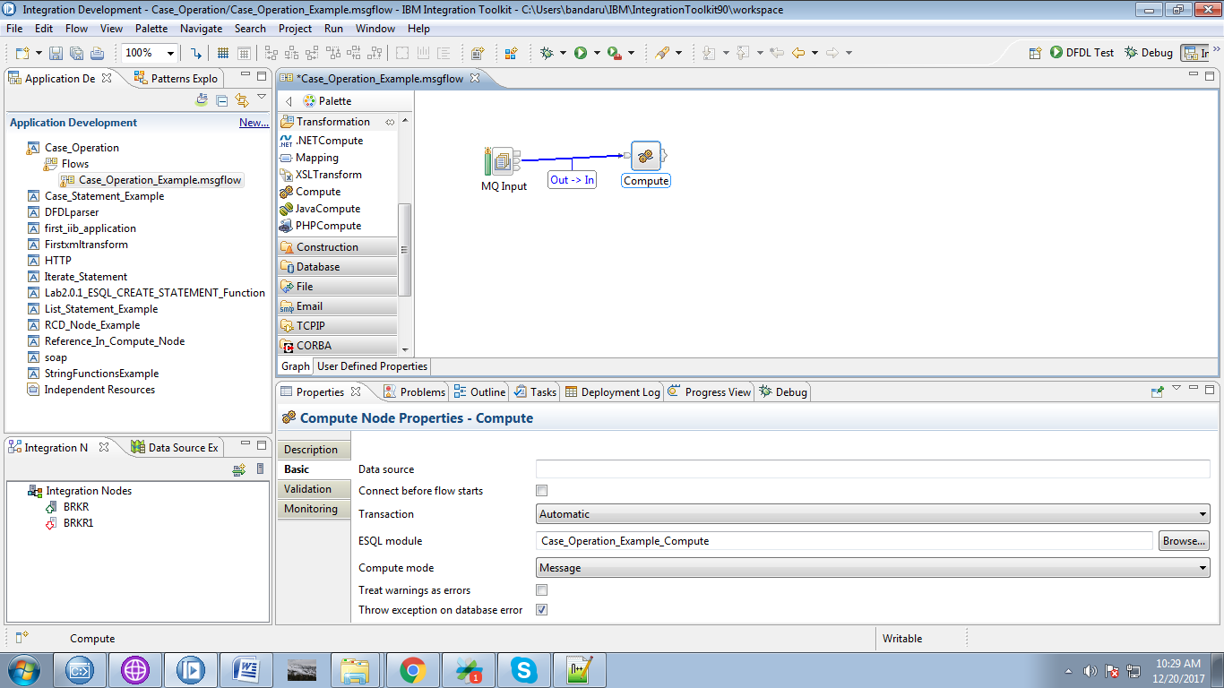

9. Drag "MQOutput" from the "WebSphere MQ" section and give it a name.

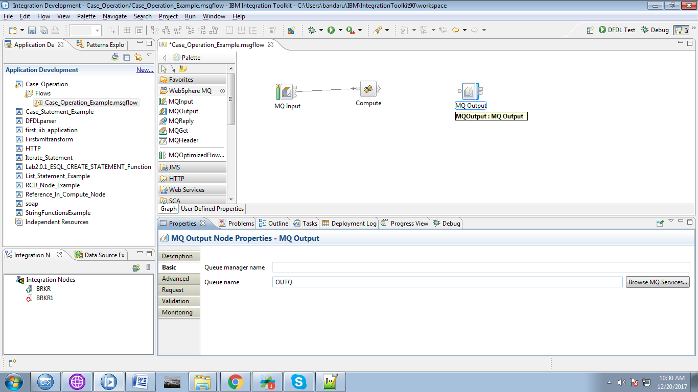

10. Click on output termial of the compute node than following pop-up will appears and select "Out" terminal and click "OK" button.

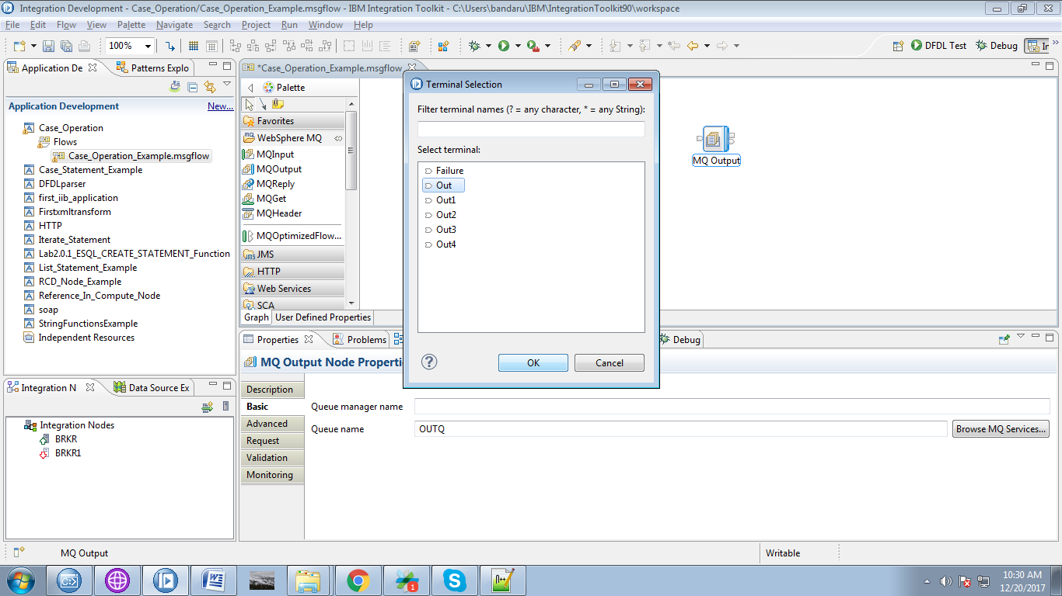

11. Connect the "output" terminal of the compute node with the "input" terminal of the MQOutput.

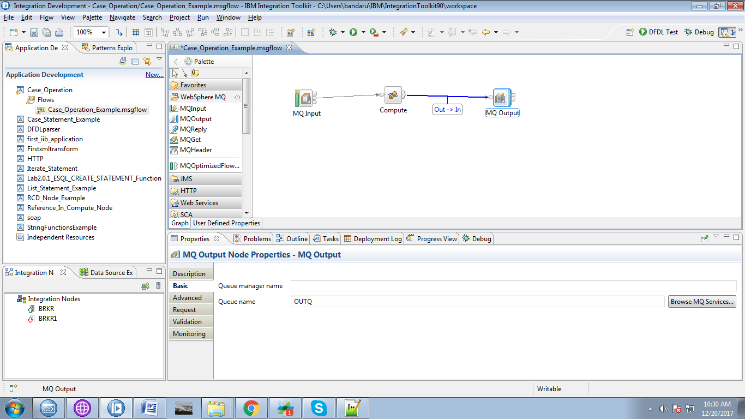

12. When you double click on compute node than following code will appears.

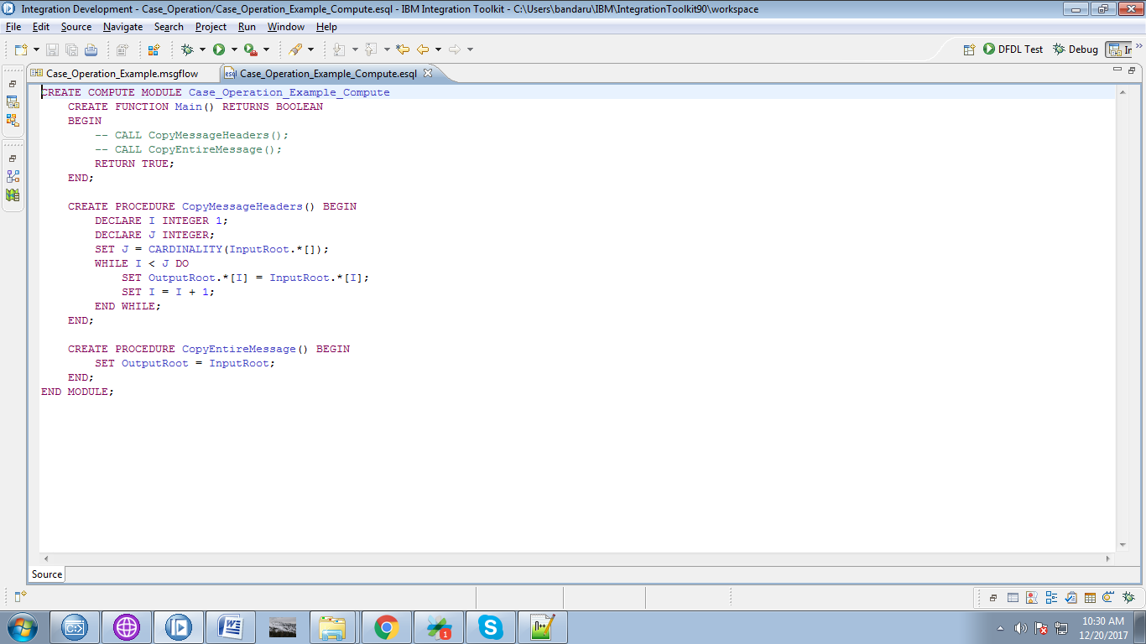

13. Override with following code.

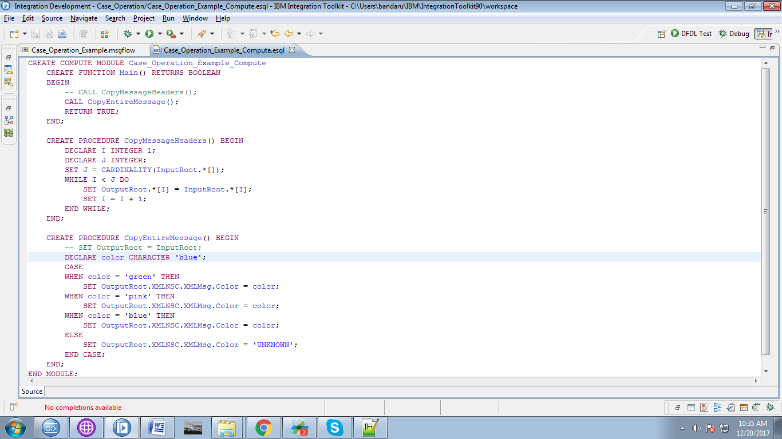

14. Create appropriate queues in "WebSphere MQ Explorer".

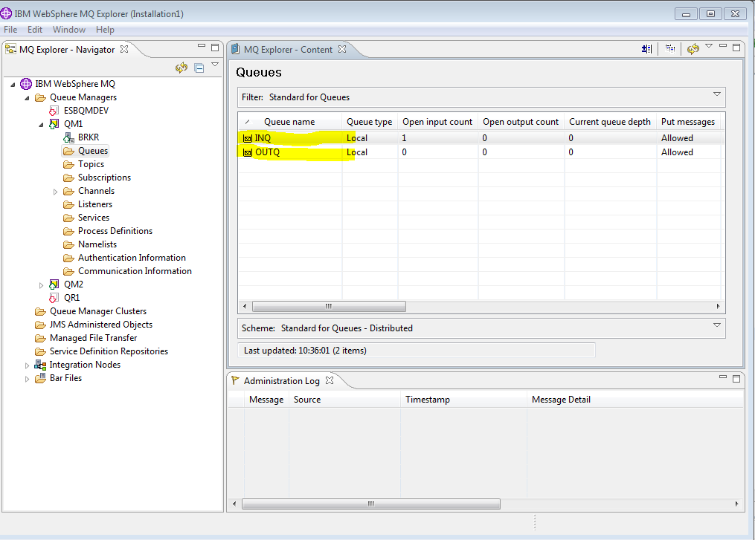

15. When you right click on application, you can see "Deploy" option click on it.

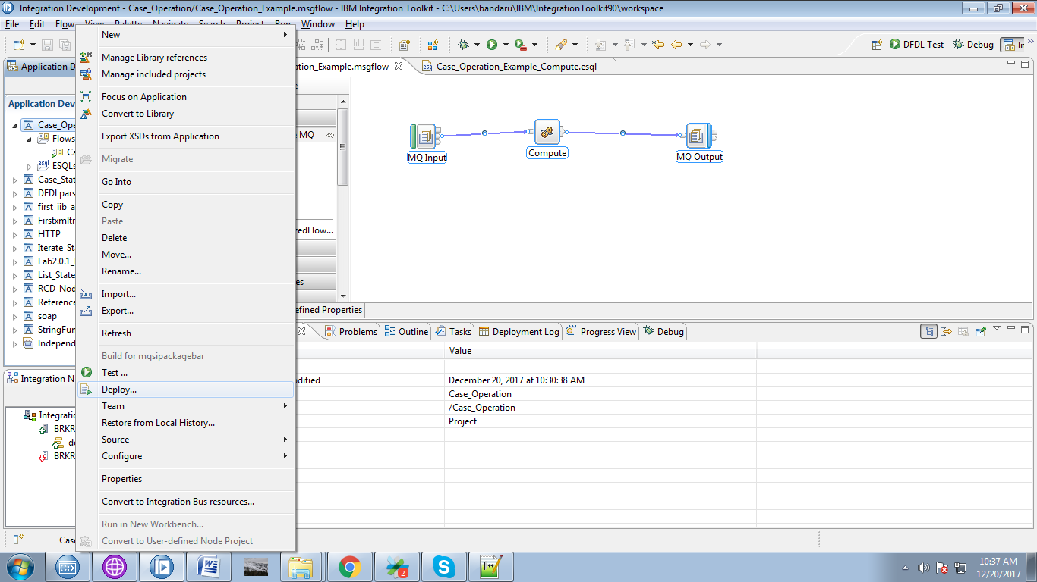

16. Select your running broker and execution group and click on "Finish" button.

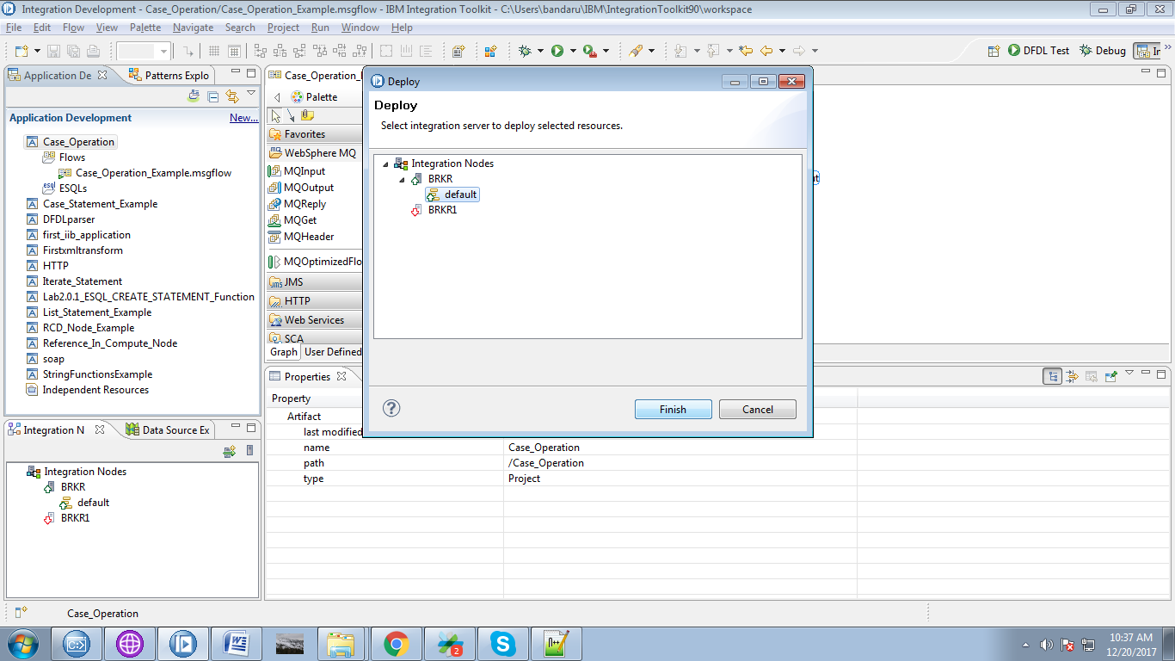

17. Right click on input queue and select "Put Text Message".

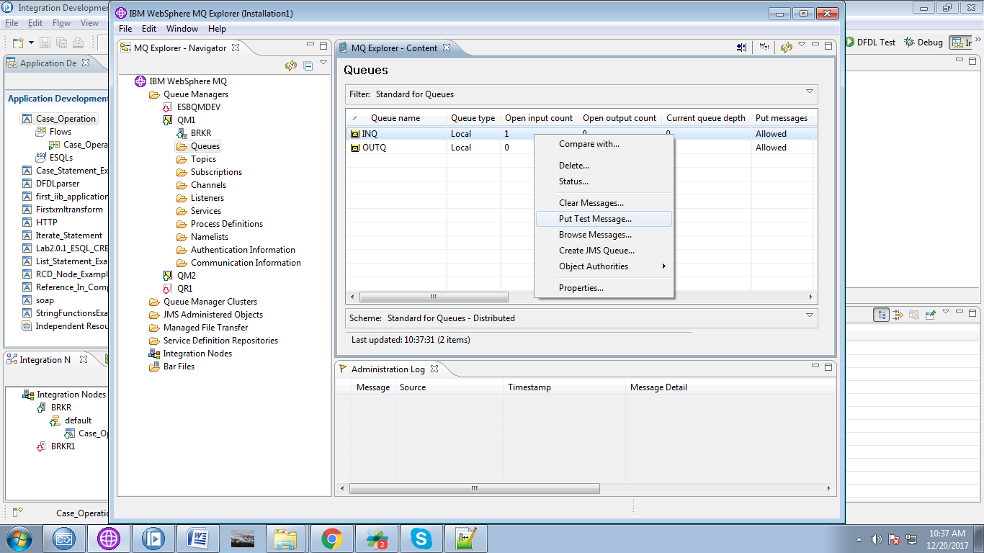

18. Give any dummy text to trigger the flow.

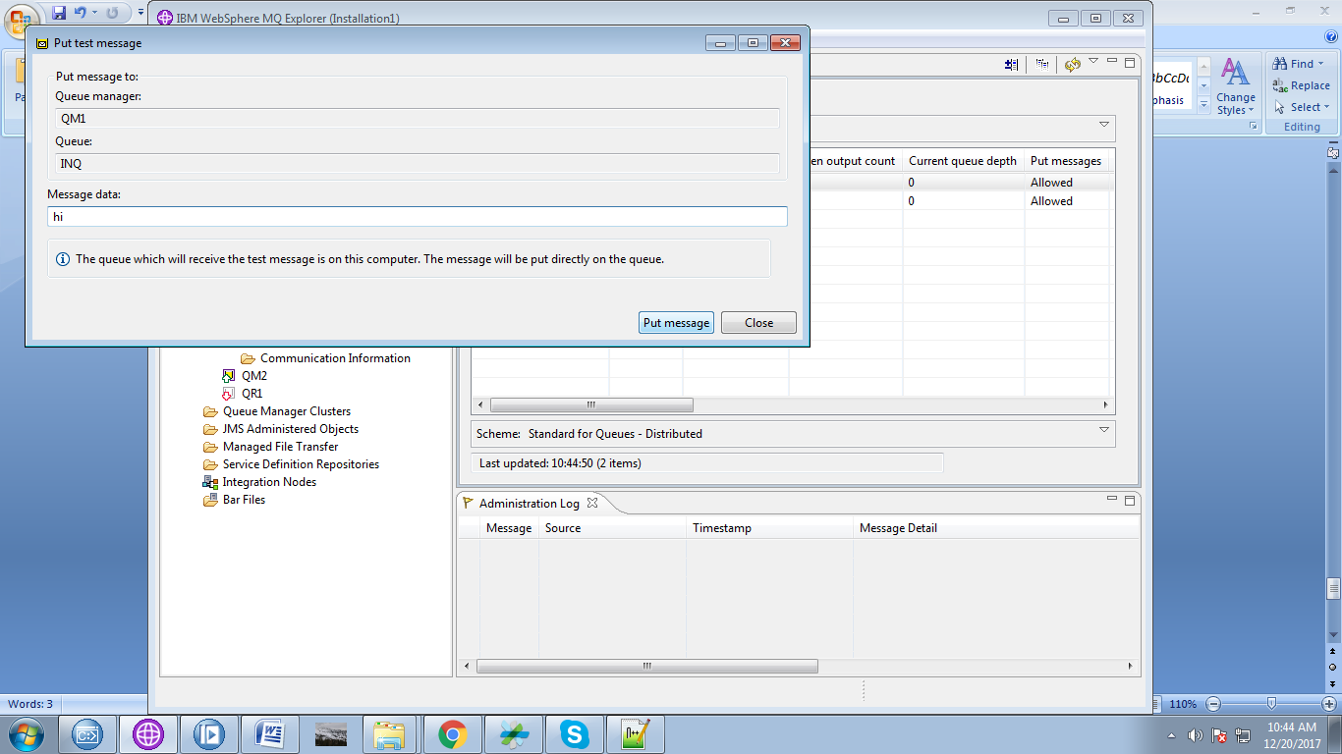

19. From the below fig the value "color" is set to "blue" before entering in to 'CASE'.

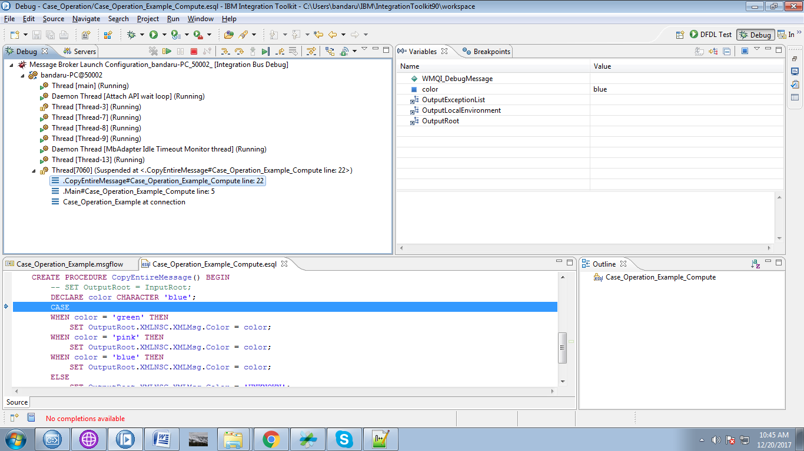

20. It directly jumps to satisfied condition as from below fig.

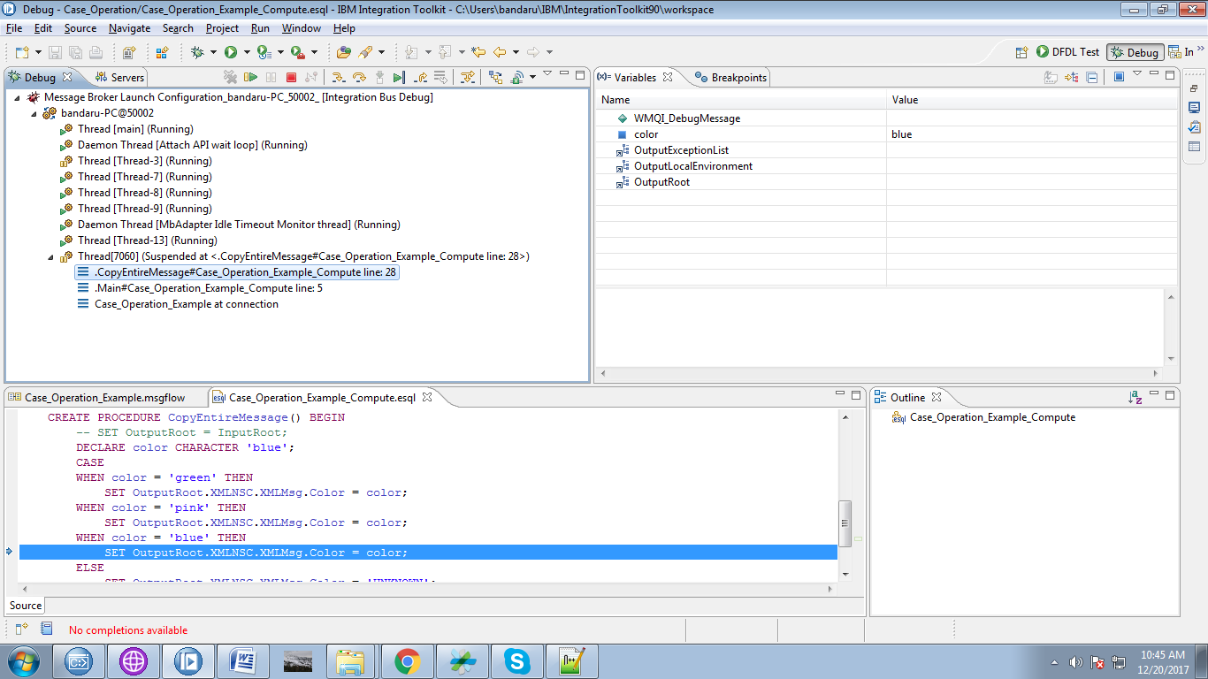

21. You can see output from compute node under "Variables" section.

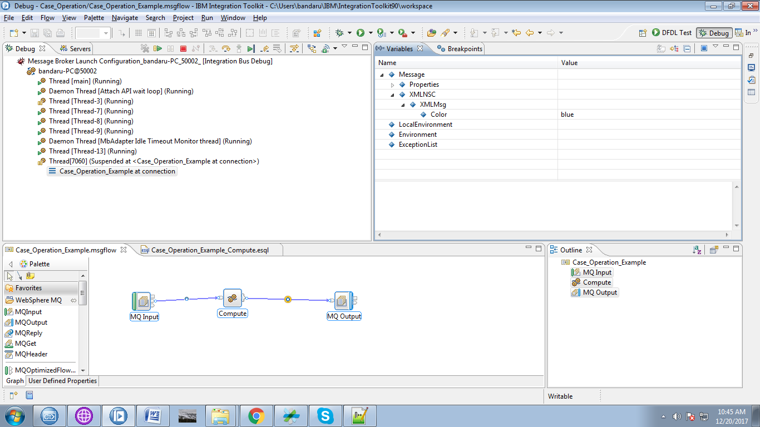

22. Right click on output queue and select "Browse Message".

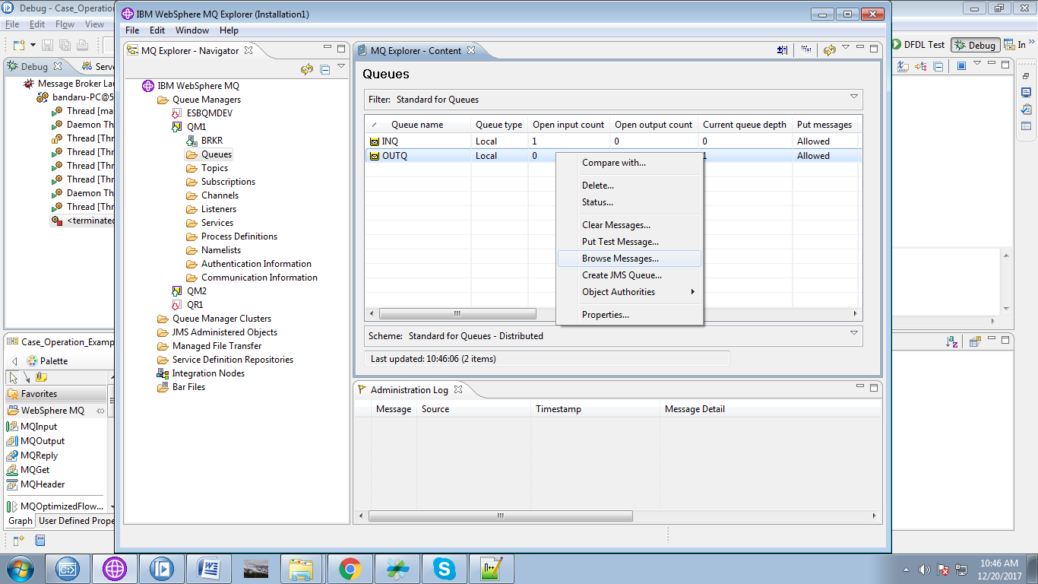

23. Right click on message and select "Properties" as from below fig.

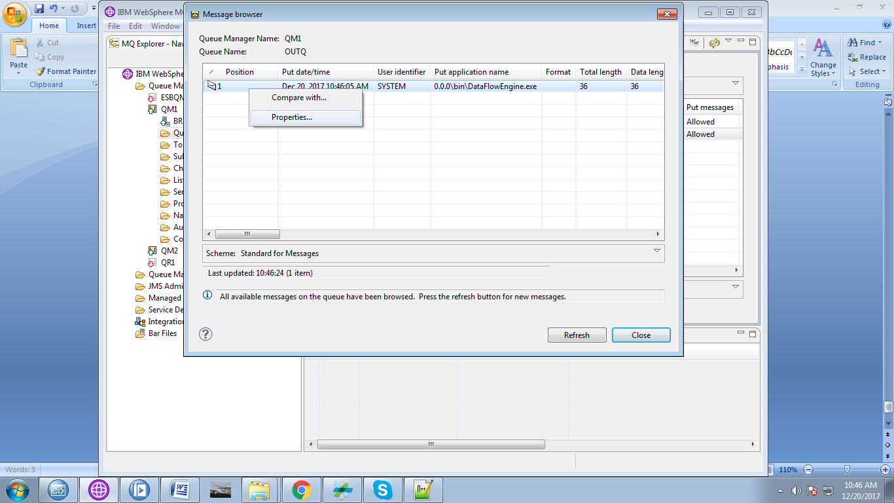

24. Now select "Data" tab.

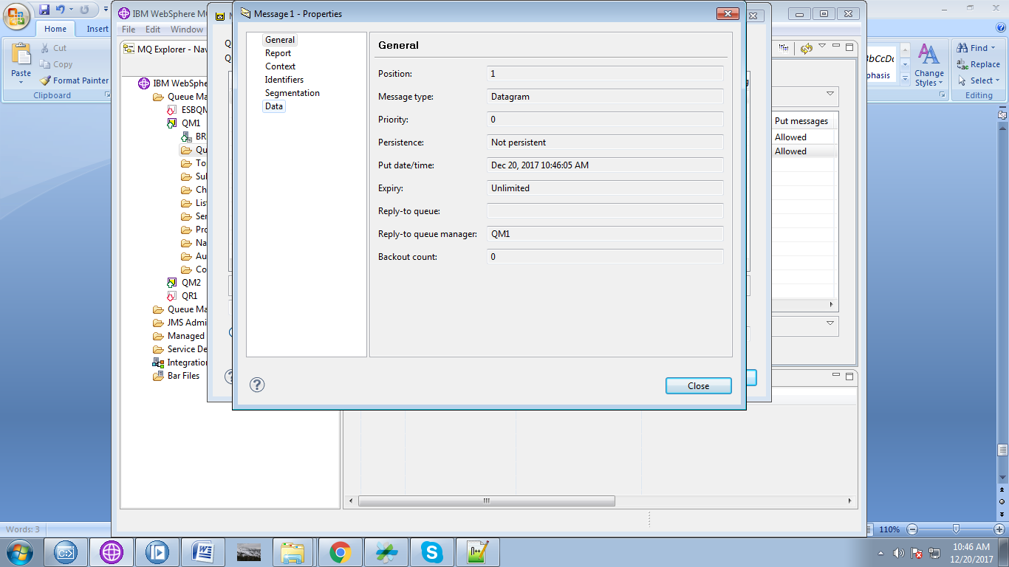

25. Final output can you see in "Data" tab.

