Case Statement

CASE Function returns a result, the value of which controls the path of subsequent processing.

1. Click on "File" and select "New"=>"Application" as shown below.

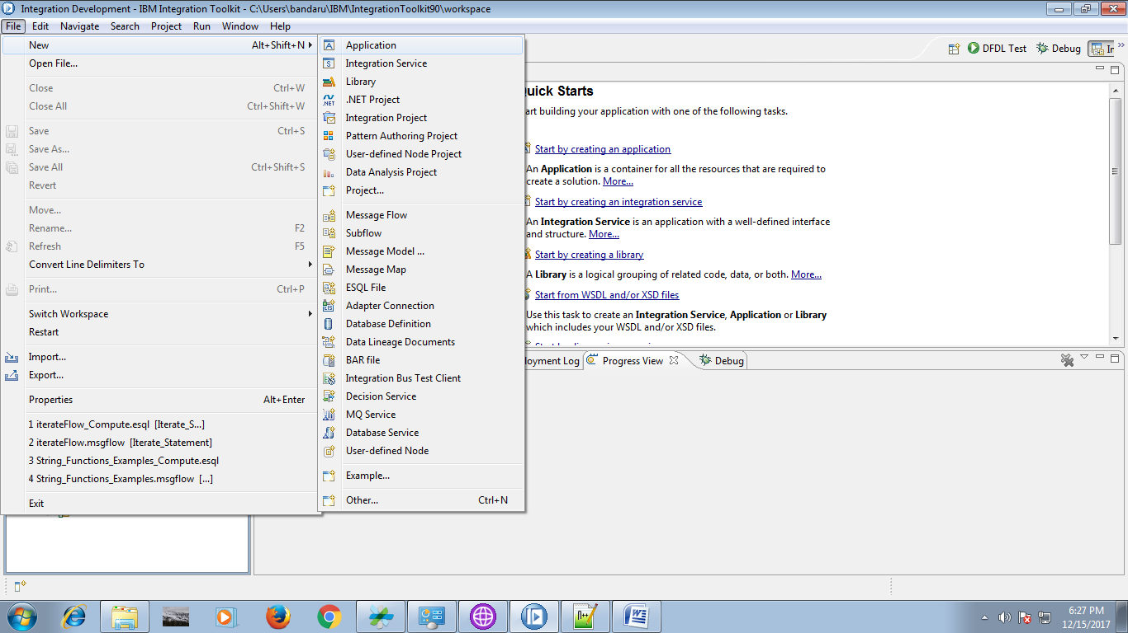

2. Give a name for your application and click "Finish" button.

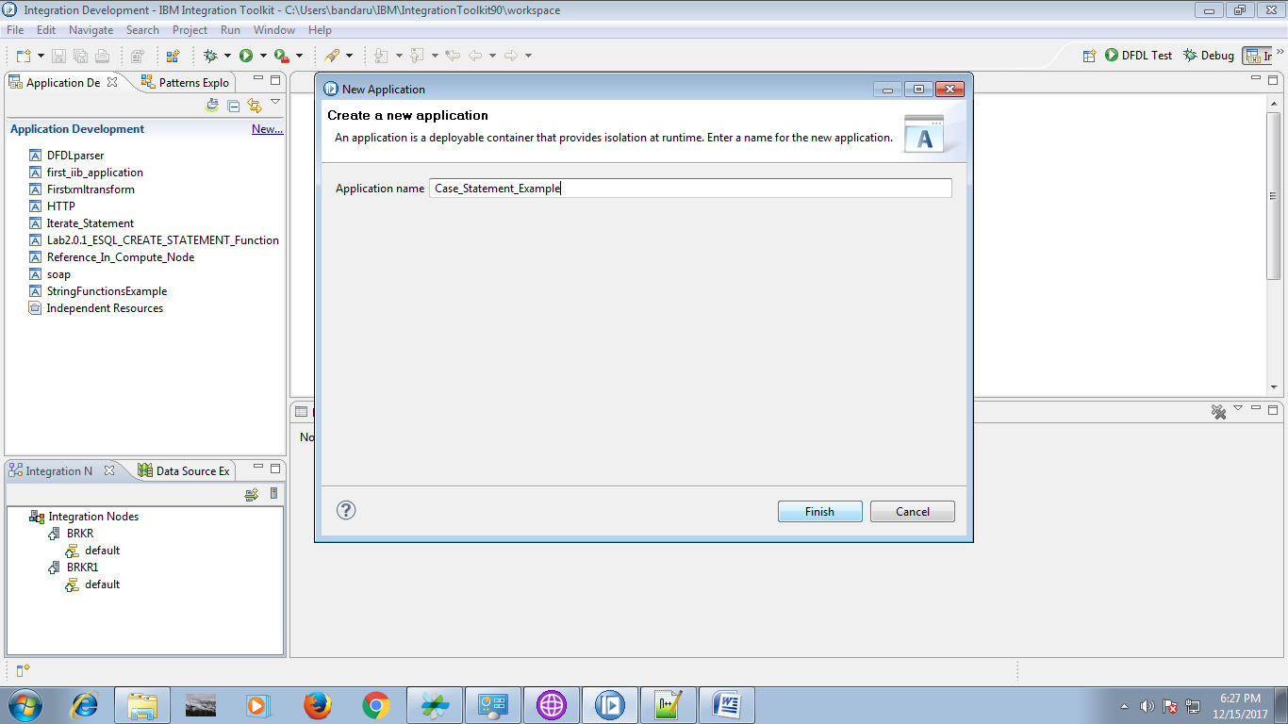

3. Under your application, you able to see "New", click on it.

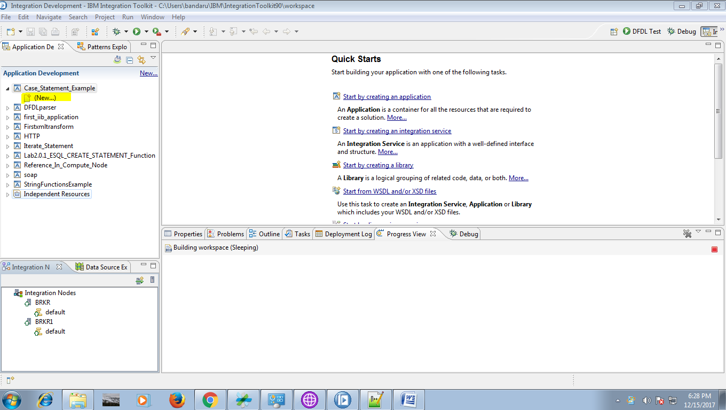

4. Select "Message Flow" from the given option.

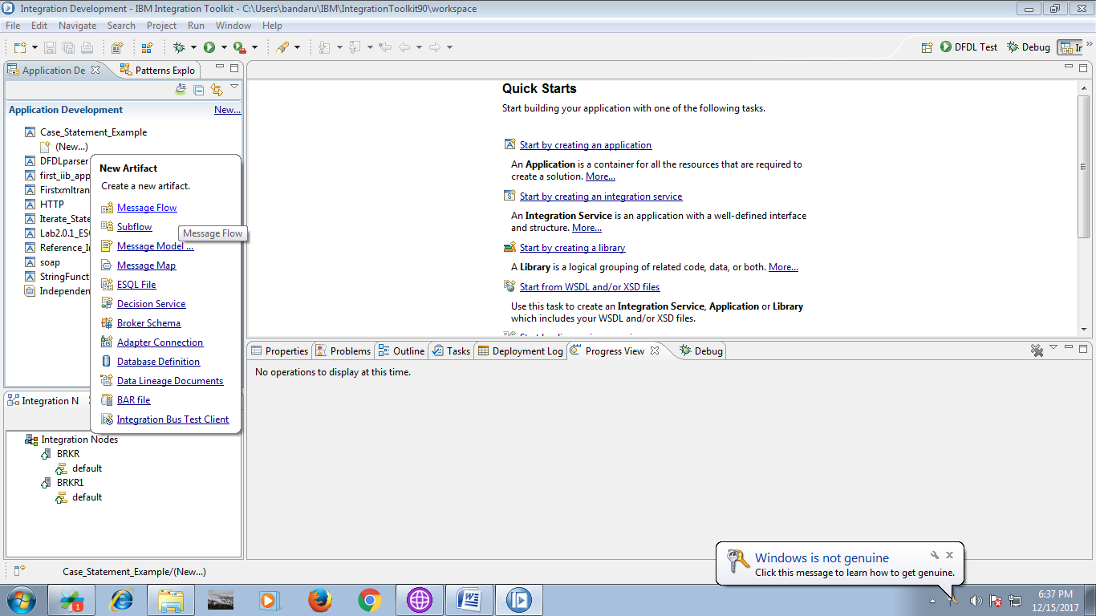

5. Name your flow and click "Finish" button.

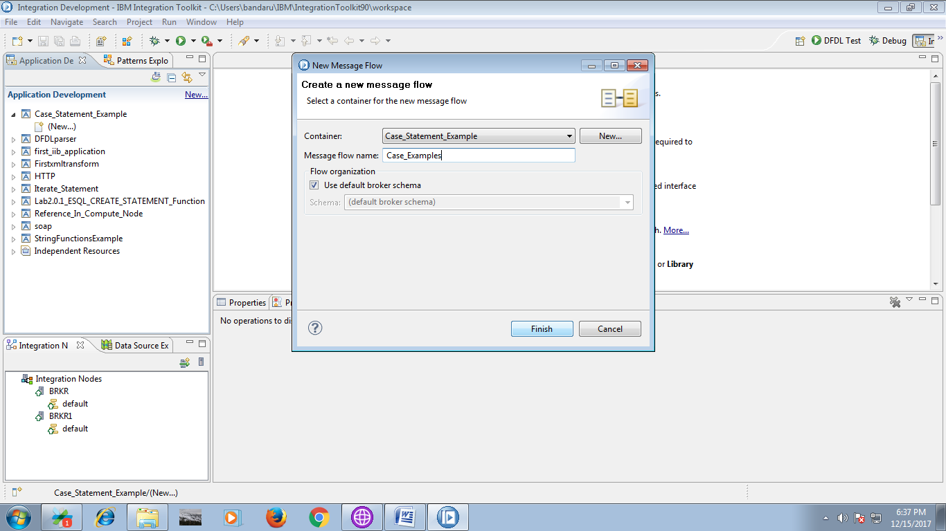

6. Drag the "MQInput" from "WebSphere MQ" section and give a name for it.

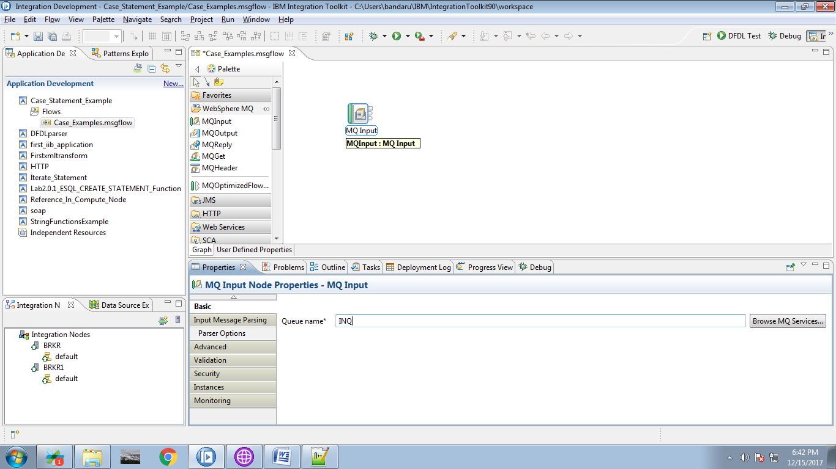

7. Drag the "Compute" node from "Transformation" section.

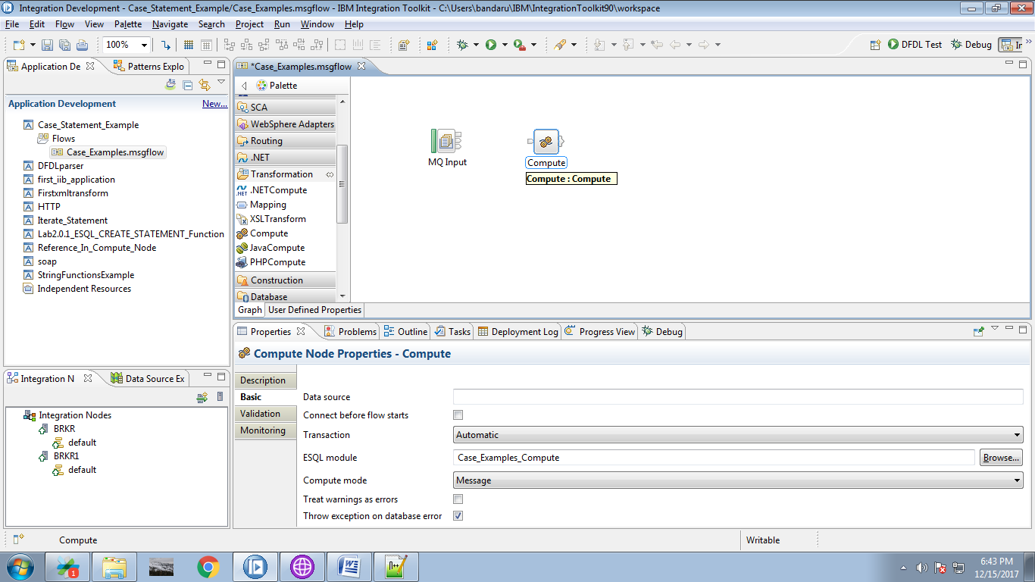

8. Connect the "output" terminal of the input queue to the "input" terminal of the compute node as shown below.

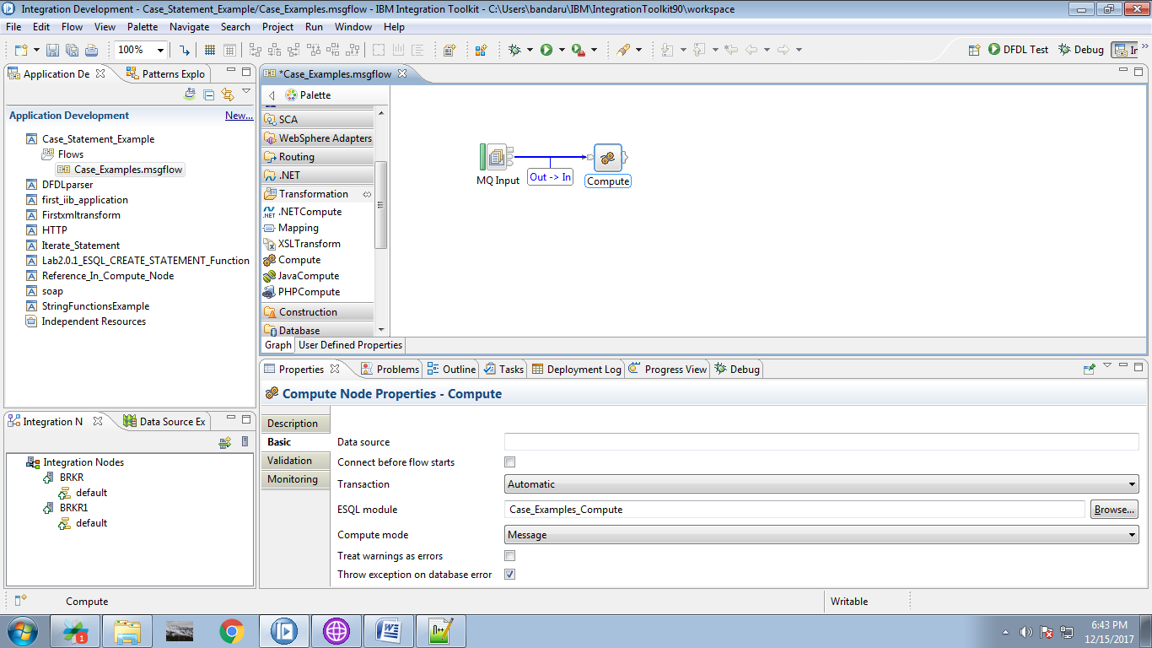

9. Drag the "MQOutput" from the "WebSphere MQ" and name it.

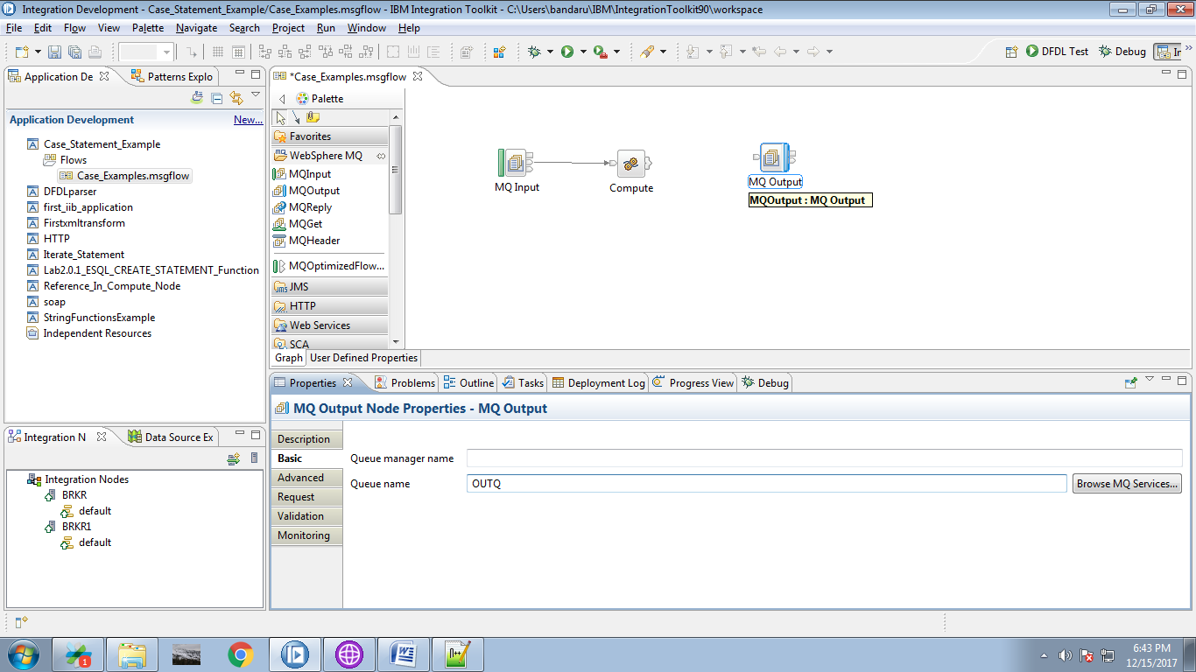

10. Click on output terminal of the compute node and select "Out" terminal.

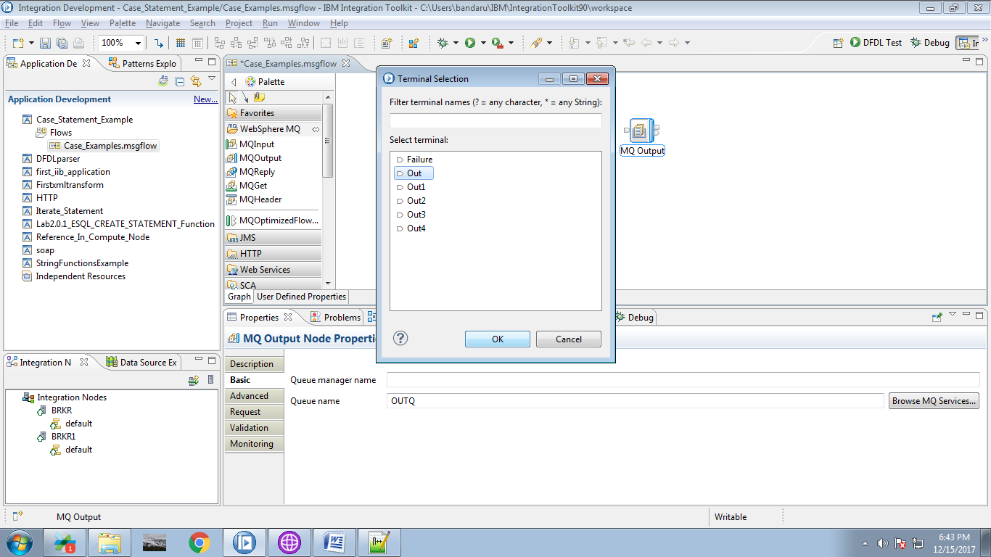

11. Connect "output" terminal of the compute node to the "input" terminal of the output queue.

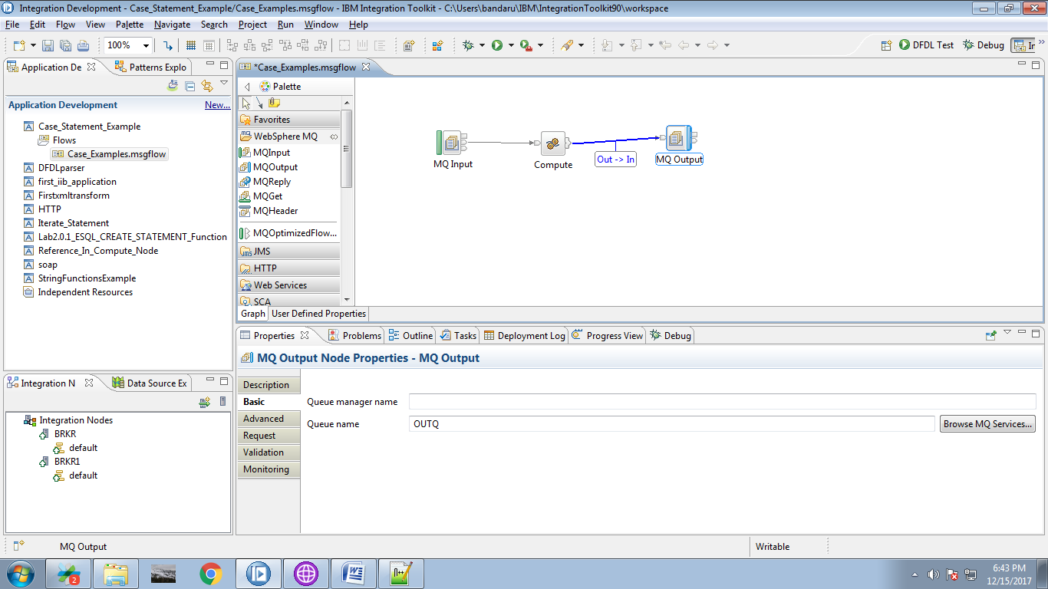

12. When you double click on the compute node, following code will appears.

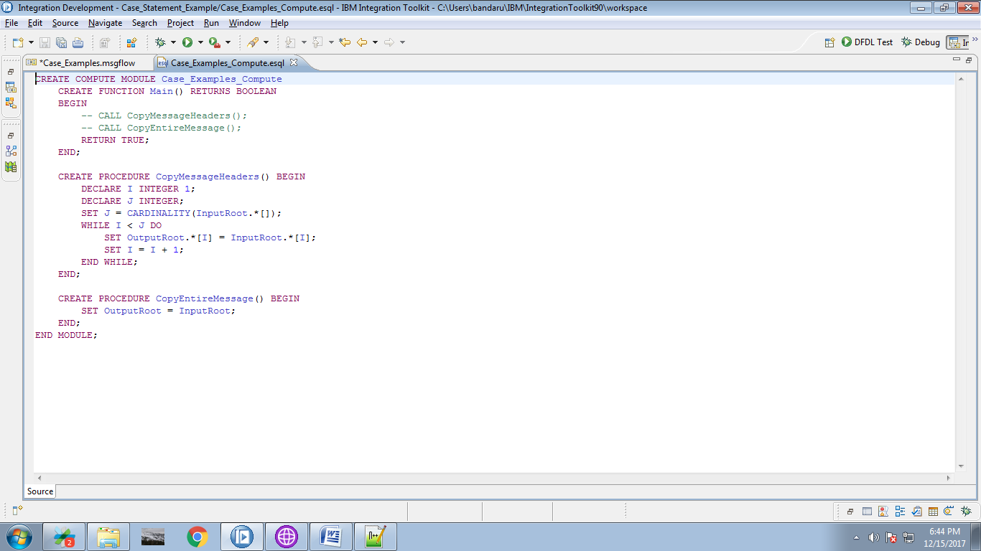

13. Replace the following code in the compute node.

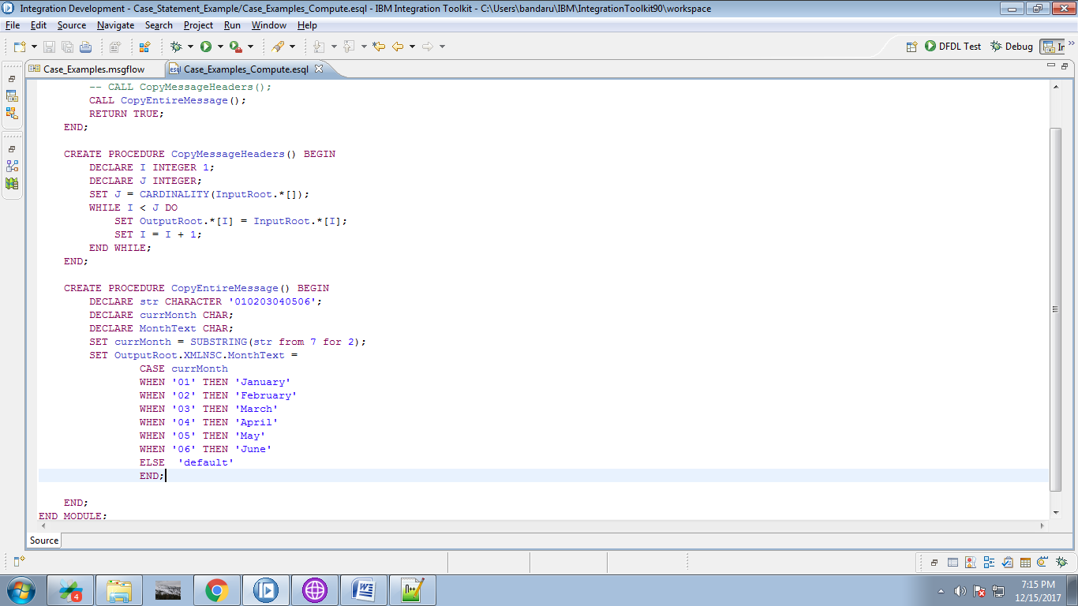

14. When you right click on the application, you able to see "Deploy" option, click on it.

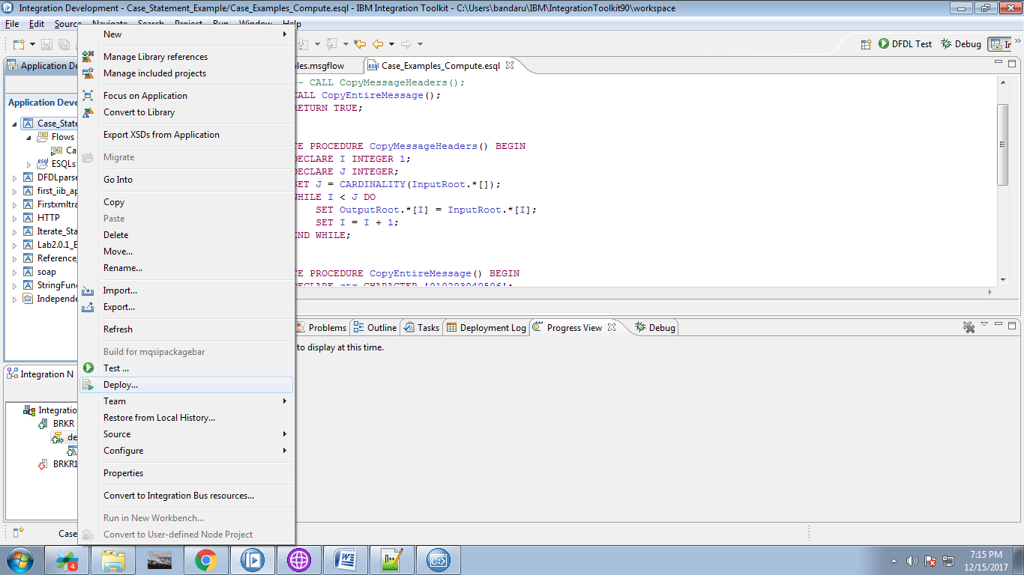

15. Select your Broker and execution group and click on "Finish" button.

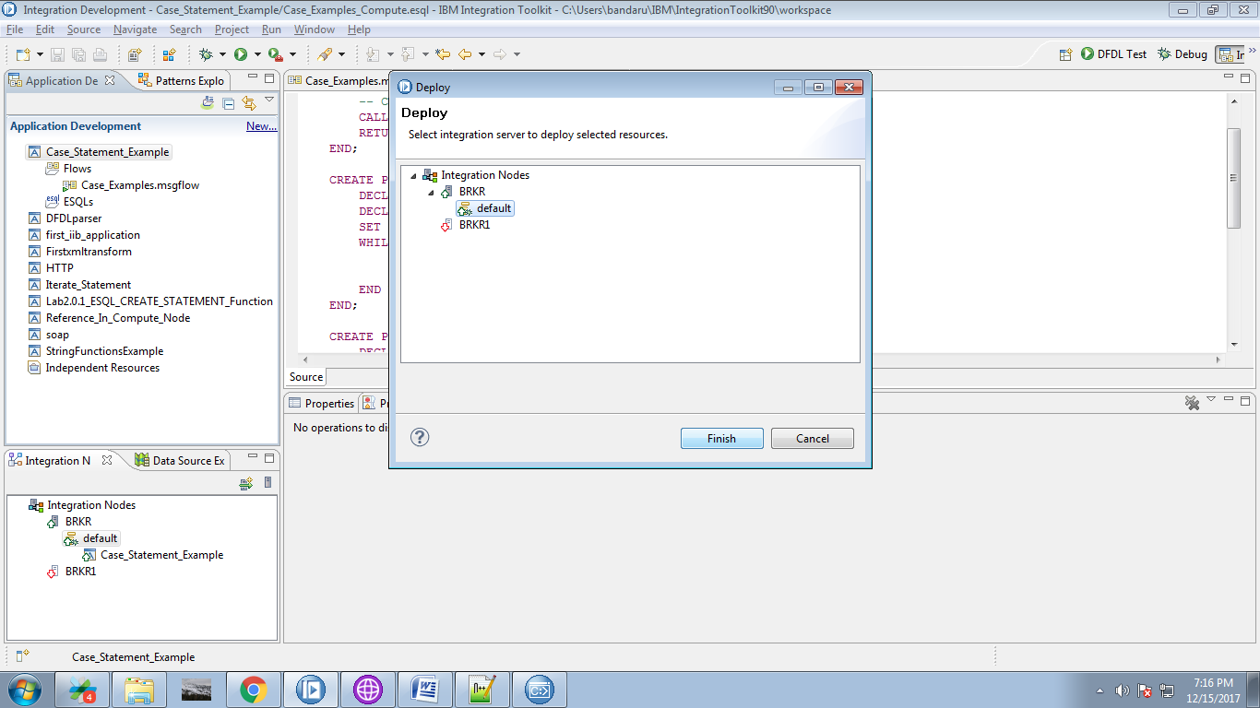

16. Create appropriate queues in "WebSphere explorer".

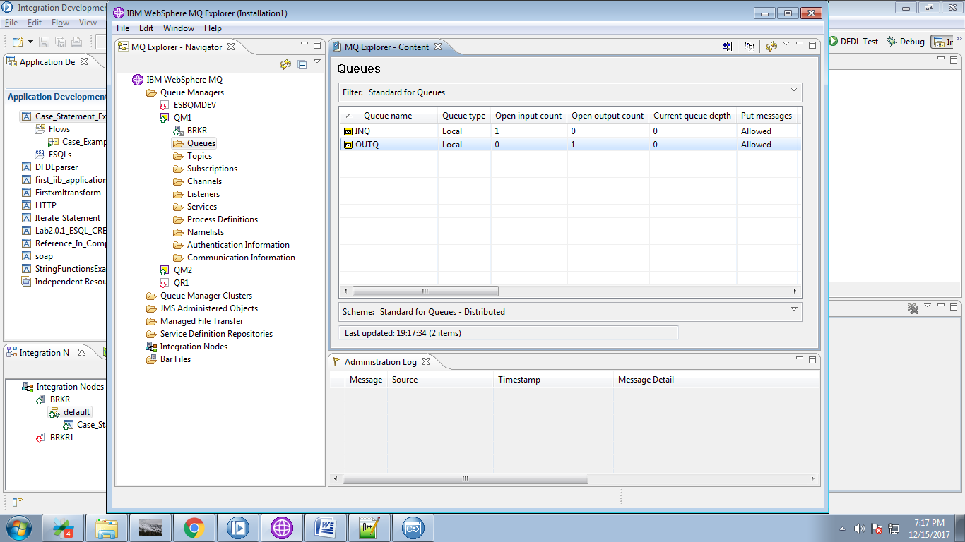

17. Right click on input queue and select "Put Test Message".

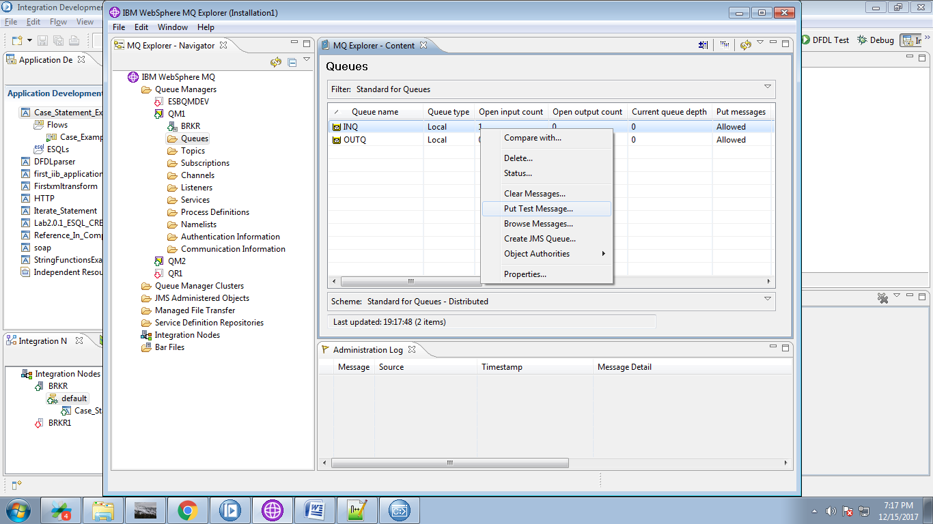

18. Give any value and click "Put Message" button to trigger your flow.

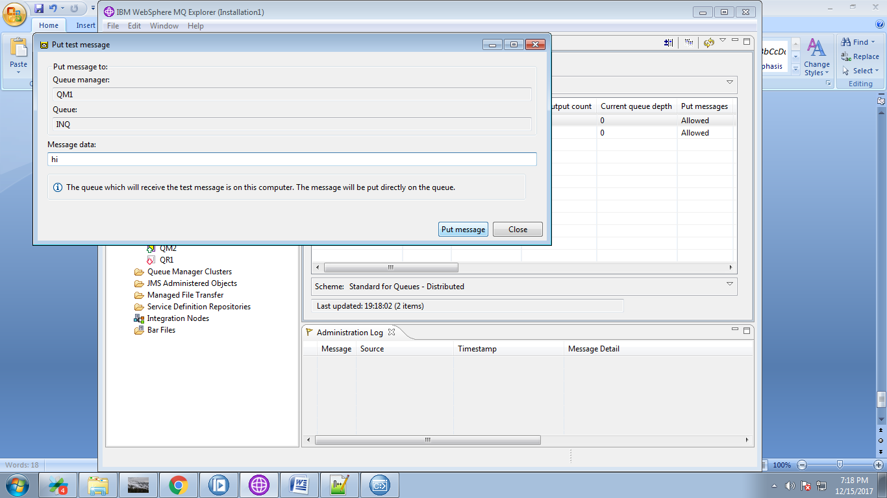

19. You can able to see respectives outputs in debug mode.

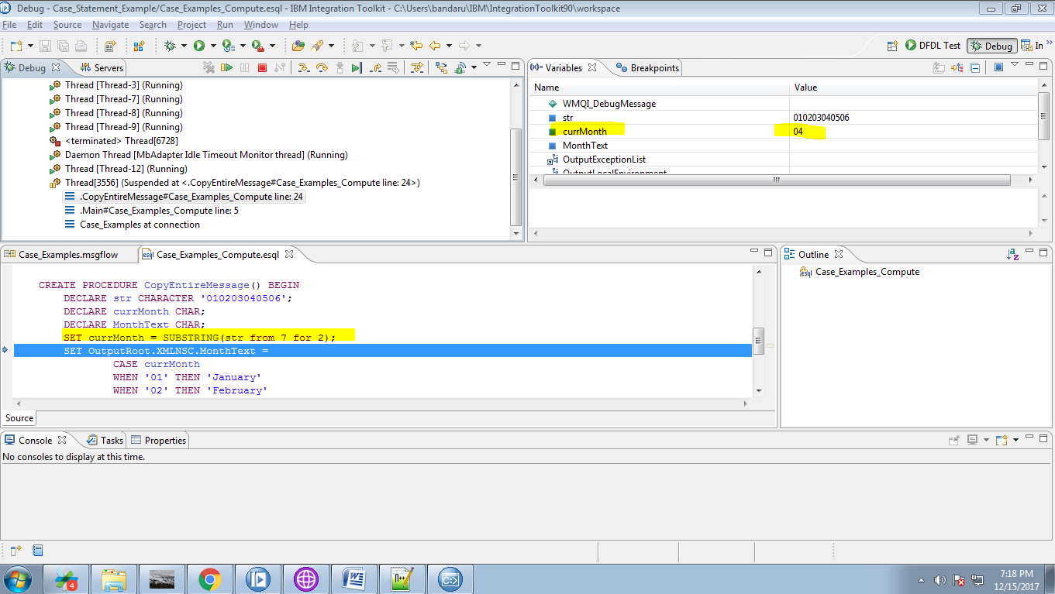

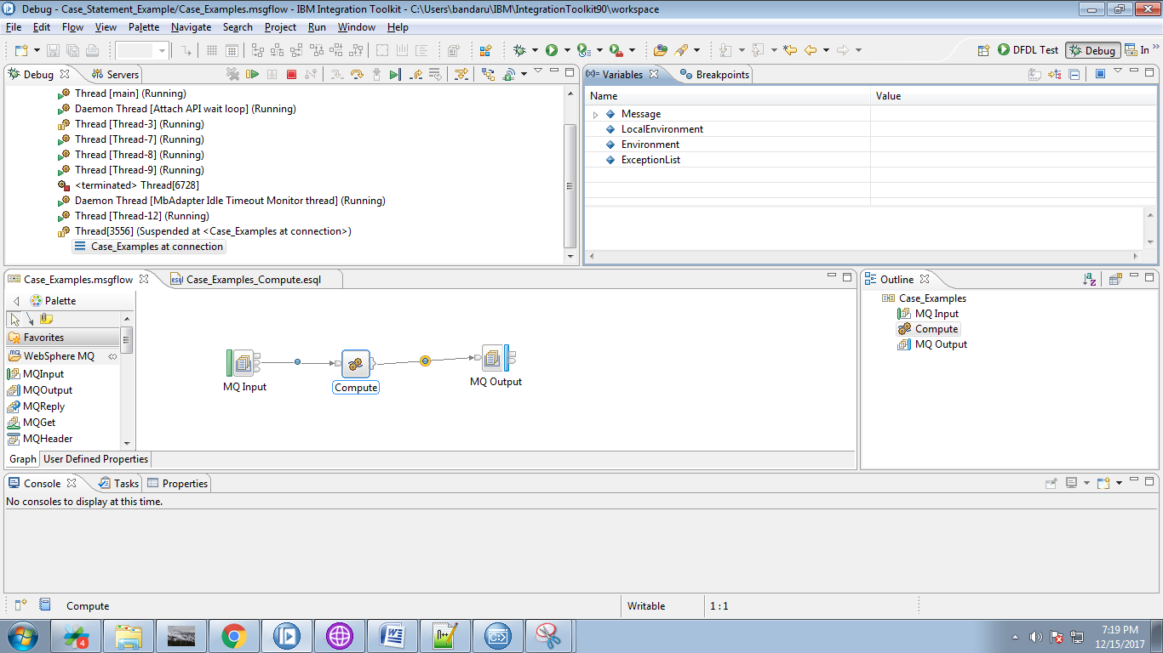

20. Now select output queue and click "Browse Q" button.

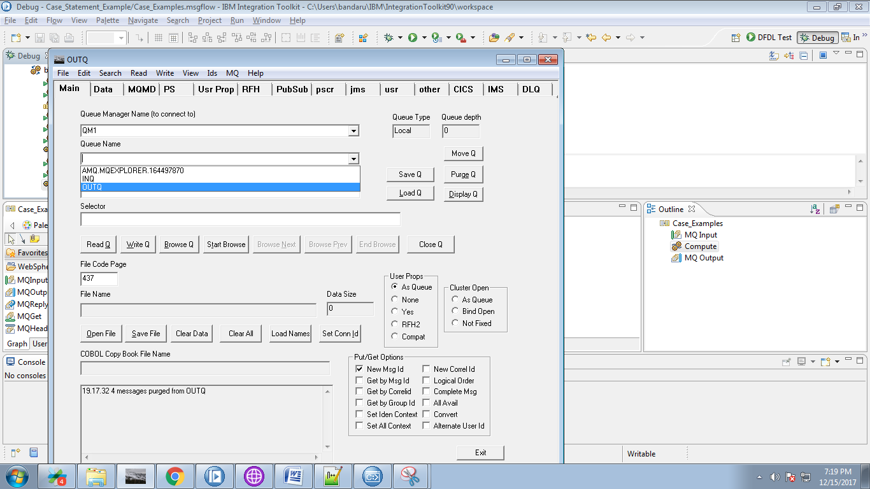

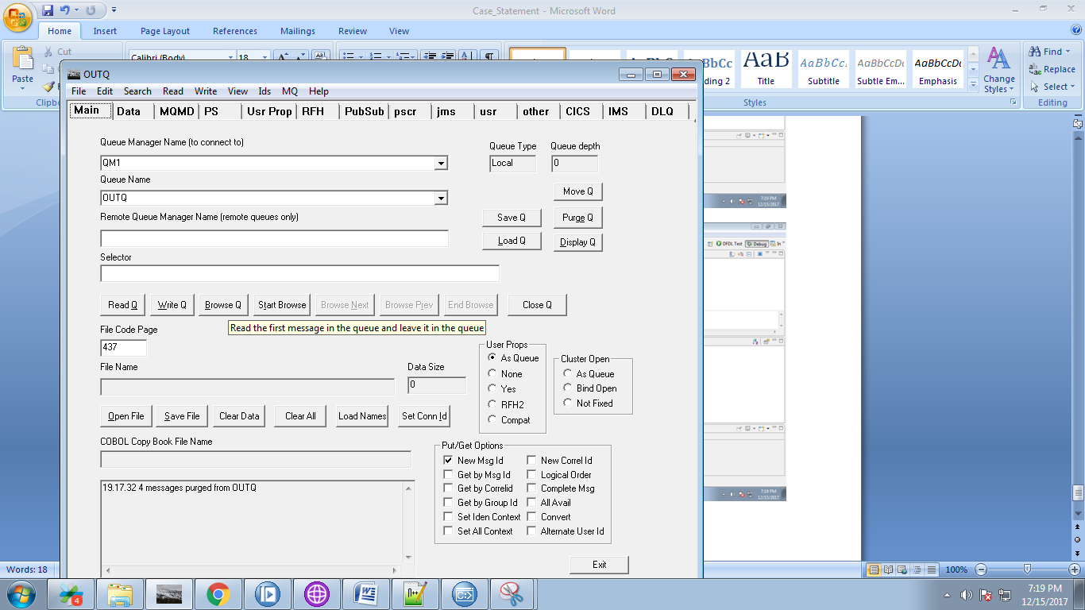

21. You can see output in "Data" tab as below fig.

