Oracle Database Connection in IIB

1. Hit windows button and type "odbc" in search box as following.

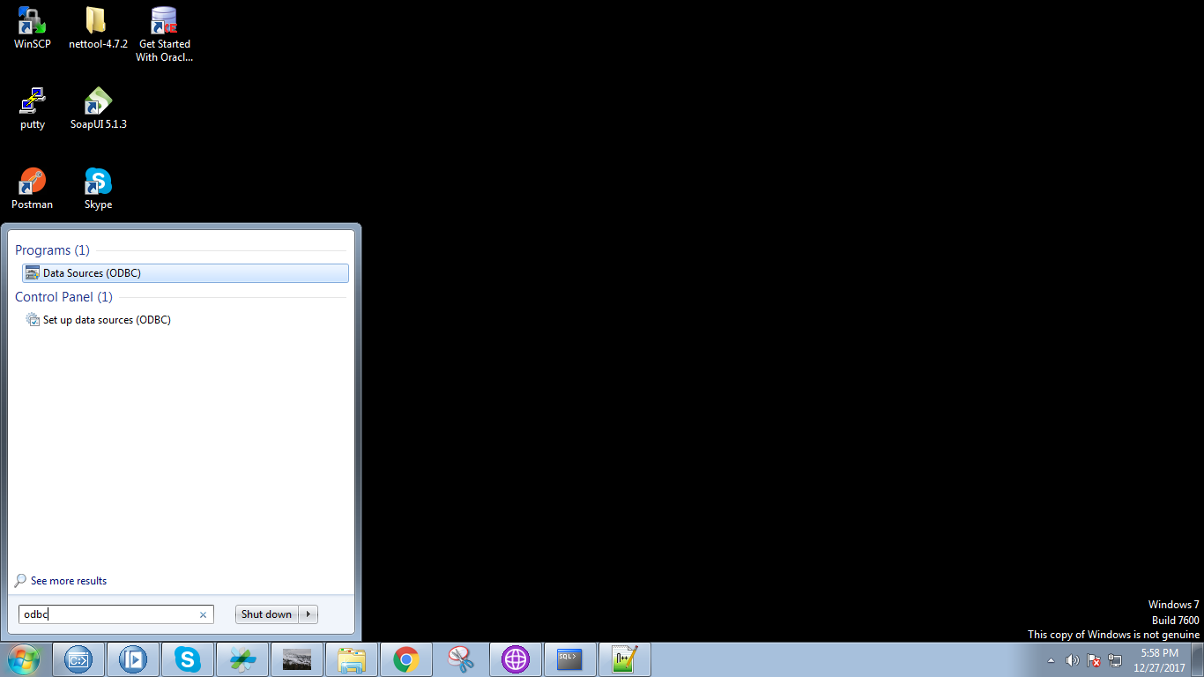

2. Under "System DSN" tab click on "Add" button.

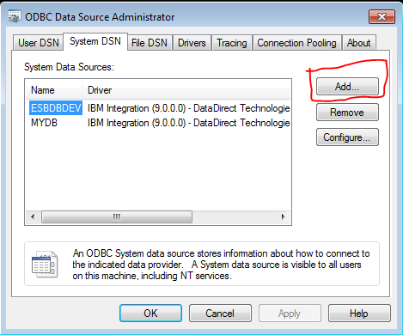

3. Following pop-up will appears and select the option which as "Oracle Wire Protocol".

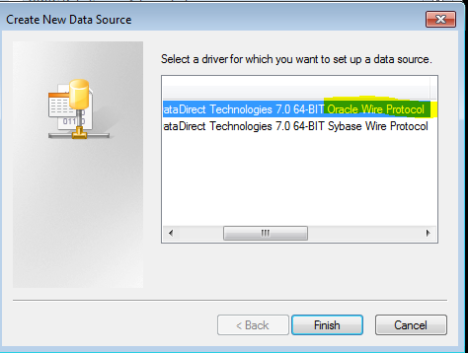

4. Give the following details in textboxes.

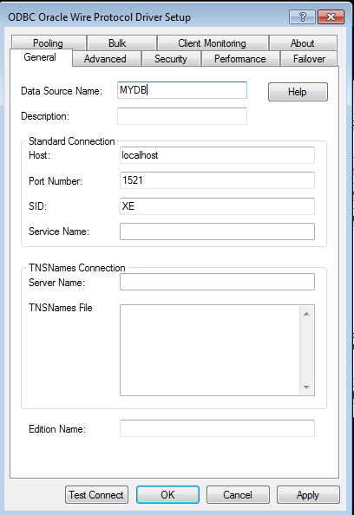

5. Under "Advanced" tab, check the all check-boxes(for oracle DB it should must).

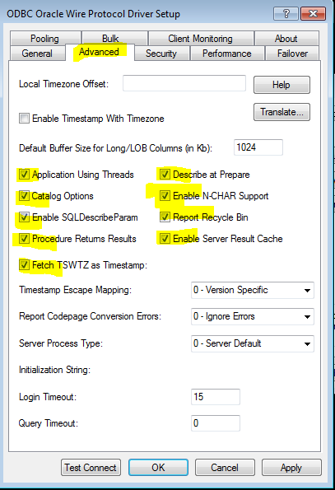

6. Click on "Test Connect", Following pop-up will appears and provide "oracle_user" name and "user_password".

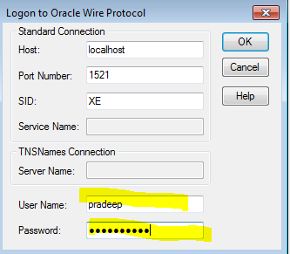

7. Your connection will successfull after performing above actions.

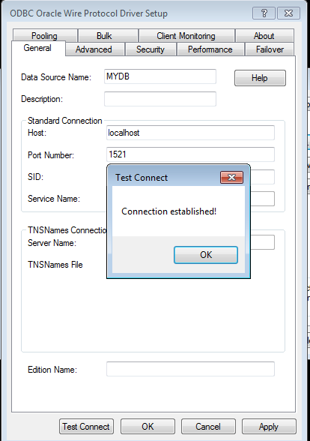

8. Open your IBM Integration Console and type the following command(markrd with yello colour).

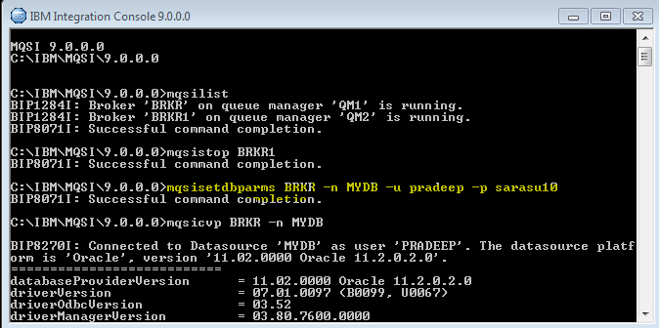

9. To check whether datasource is connected properly to your broker type following command(marked with yello colour).

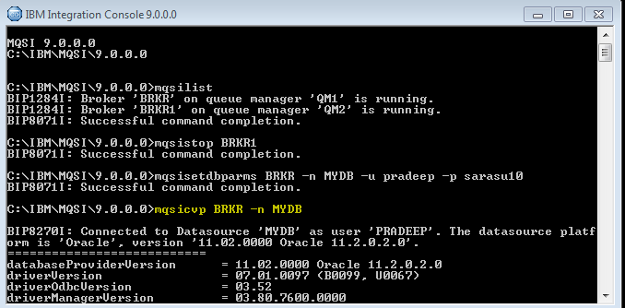

10. You will get maximum properties are set to "Yes".

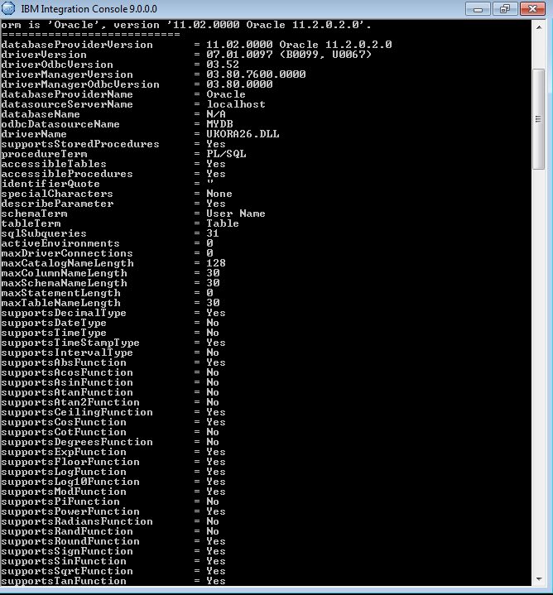

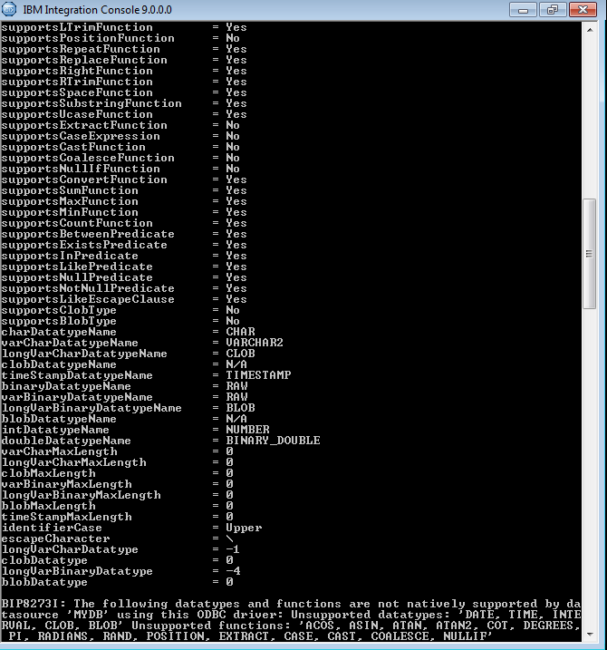

11. Now reload the broker by following command (marked with yello colour)

