LIST Statement

* LIST constructor complex function is used to explicitly generate lists of values that can be assigned to fields in an output message.
* LIST function simply create the XMLNSC message as we specified.
* Without creating LAST CHILD and LAST SIBLING it will creates the XMLNSC tree.
* For Example: If we declare, SET OutputRoot.XMLNSC.Fruit.Field[] = LIST{'Sour','Salty','Spicy'};   
    
  Than it creates following data

<Fruit>

<Field>Sour</Field>

<Field>Salty</Field>

<Field>Spicy</Field>

</Fruit>

1. Click on file and select "New"=> "Application" as shown below fig.

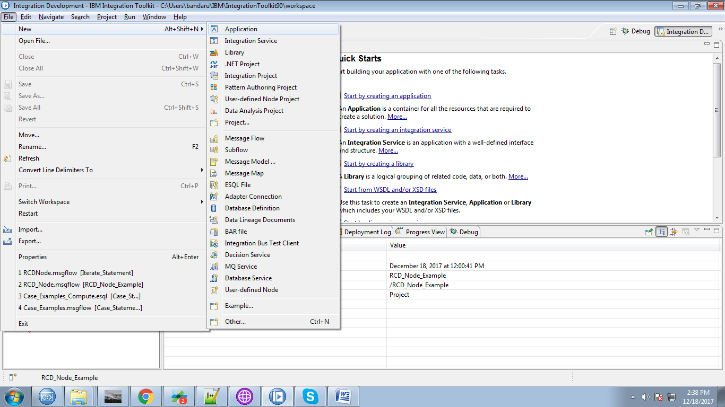

2. Give a name for your application and click "Finish" Button.

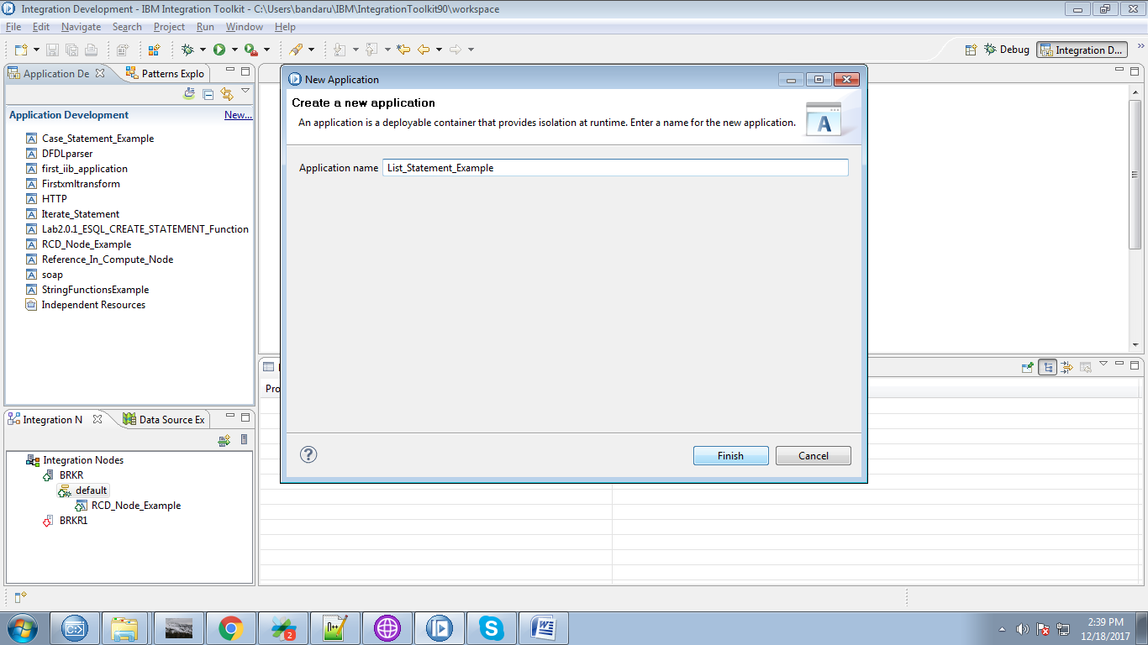

3. Under your application you can see "New", click on it.

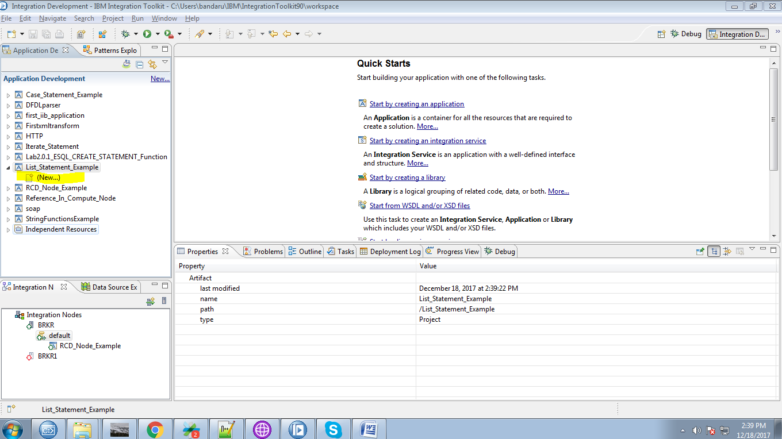

4. Select "Message Flow" from the given option.

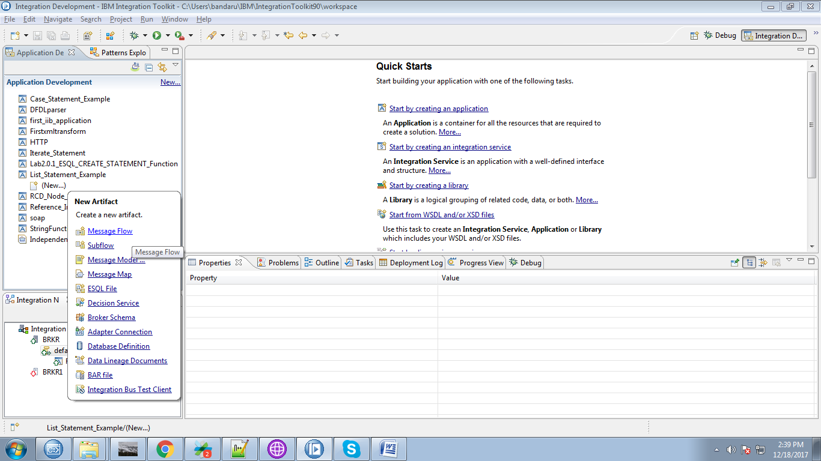

5. Give a name for your flow and click "Finish" button.

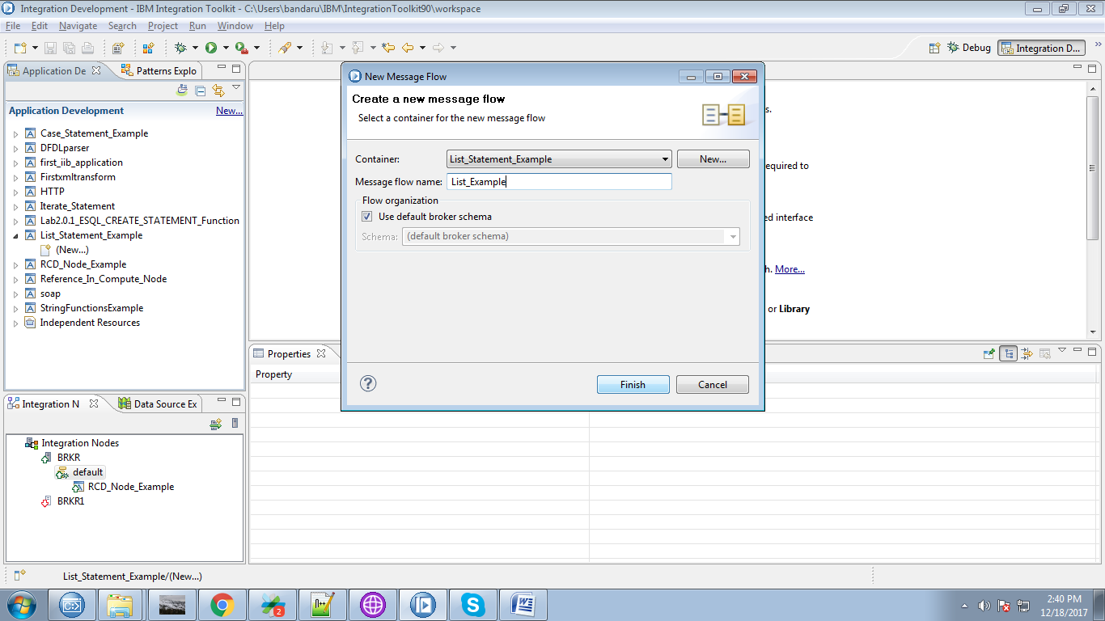

6. Drag the "MQInput" from the "WebSphere MQ" section and give a name for it.

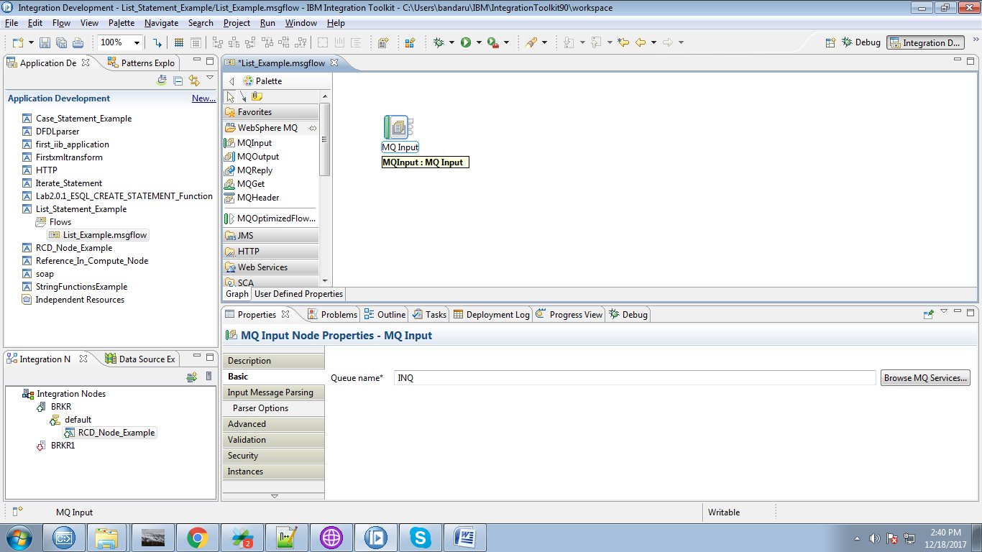

7. Select XMLNSC as message domain for the MQInput.

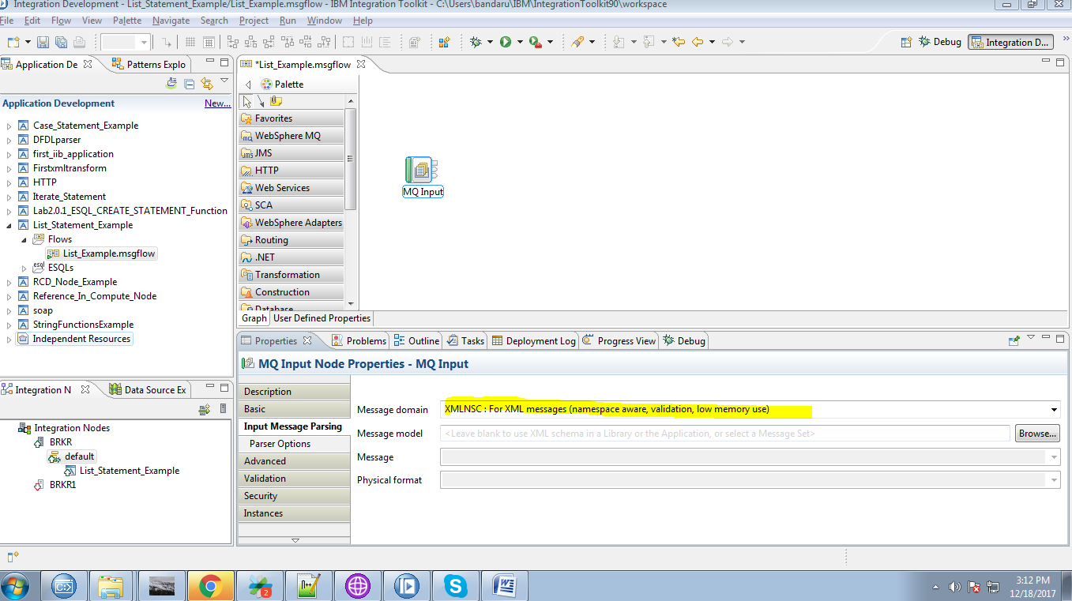

8. Drag the compute node from the "Transformation" section.

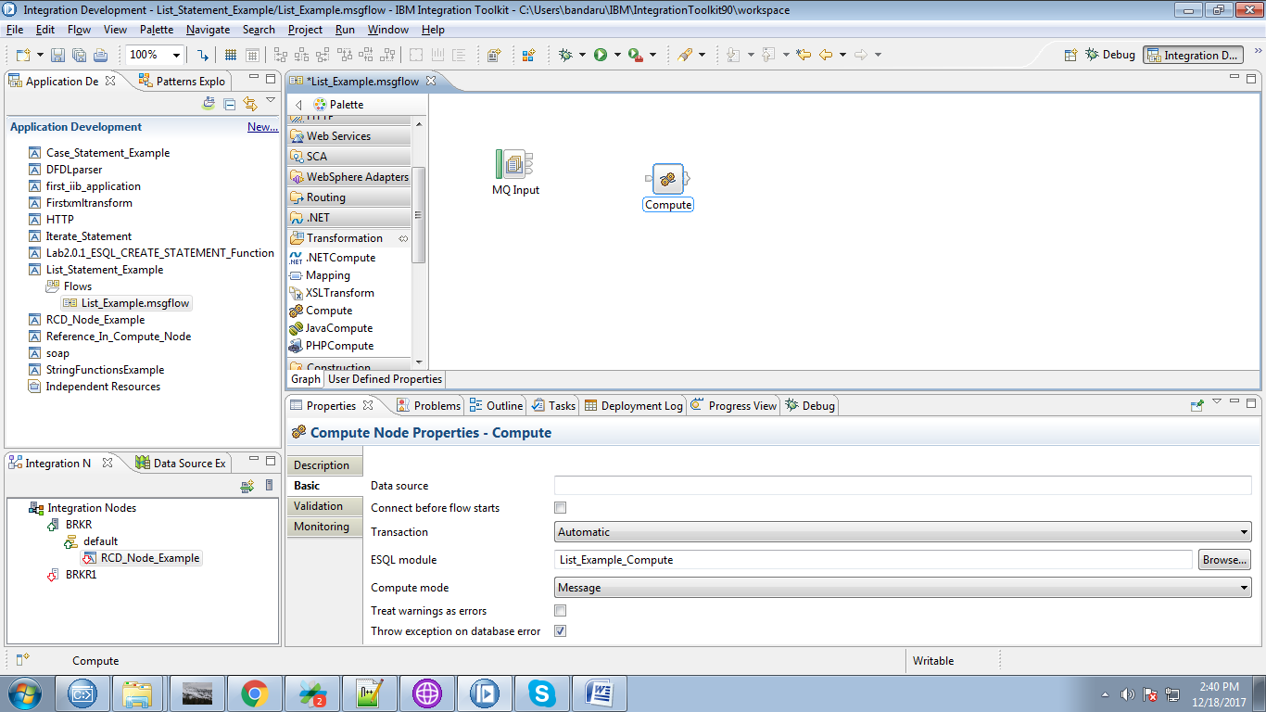

9. Connect the "output" terminal of the MQInput to the "input" terminal of the compute node.

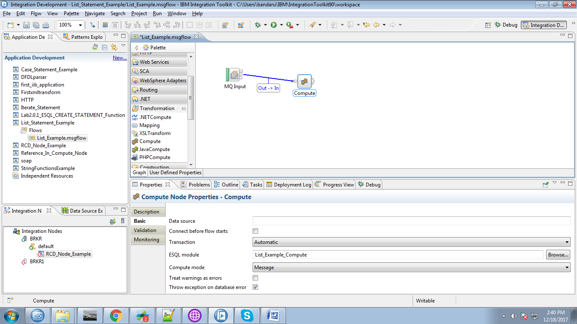

10. Drg the "MQOutput" from the "WebSphere MQ" section and give it a name.

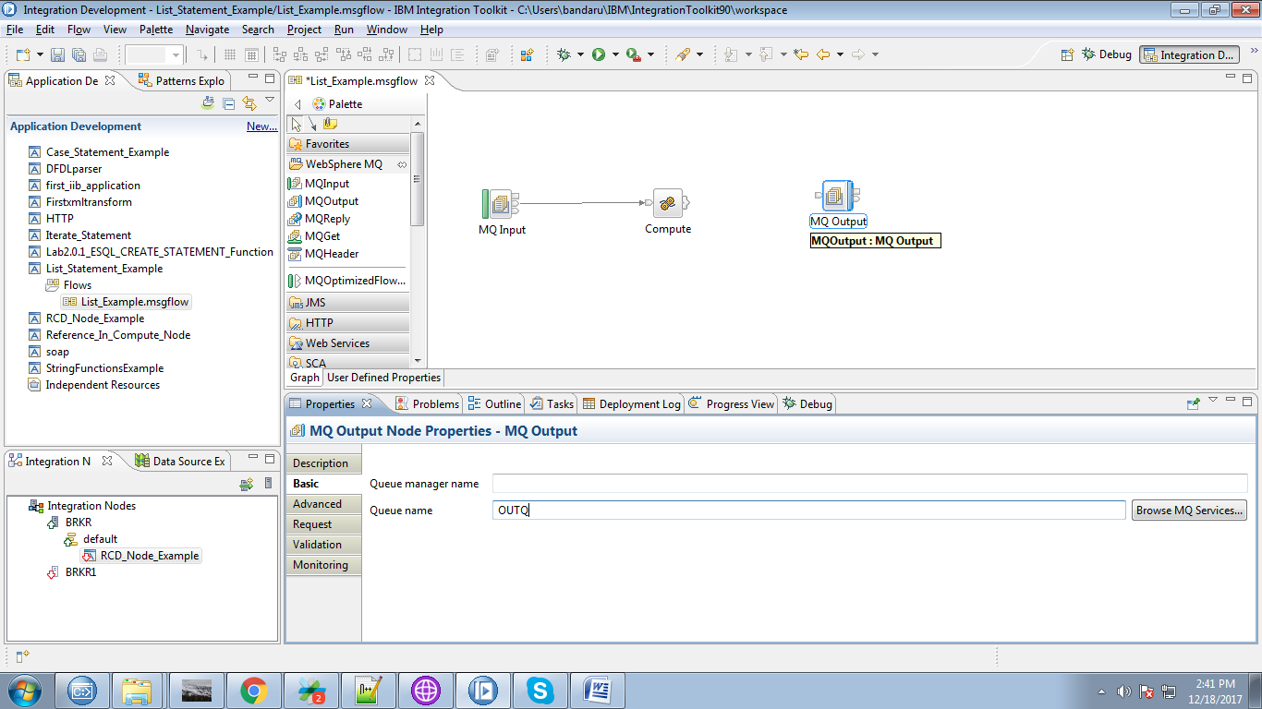

11. Click on the output terminals of the compute node and select "Out" terminal and click on "Ok" button.

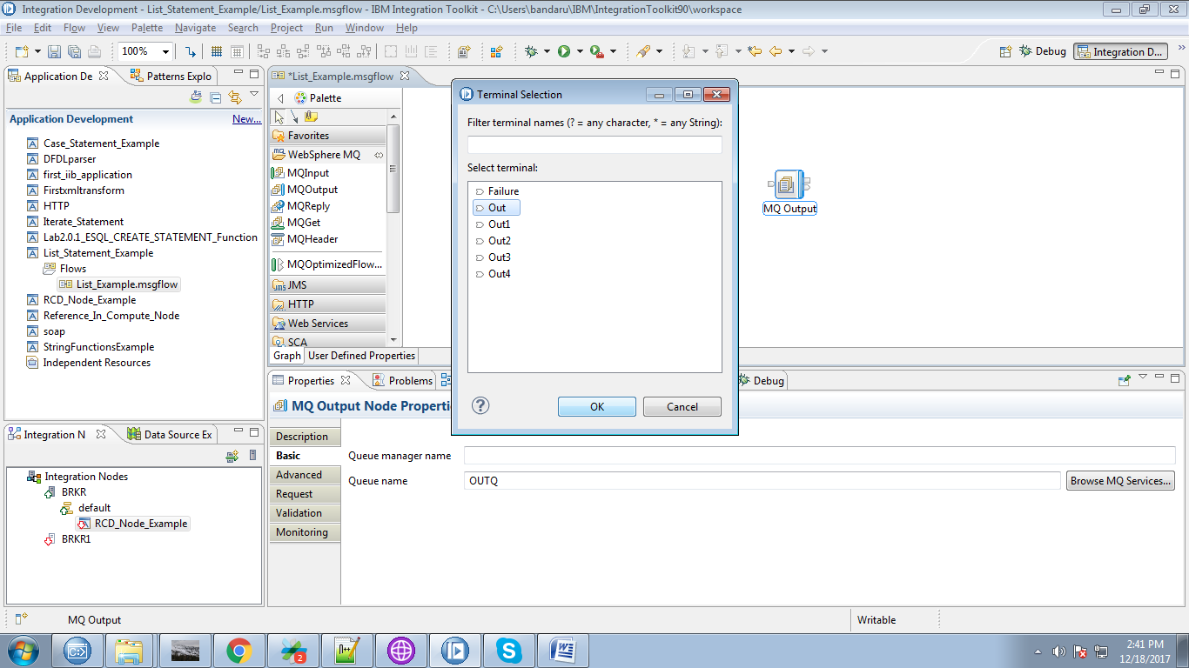

12. Connect "output" terminal of the compute node to the "input" terminal of the MQOutput.

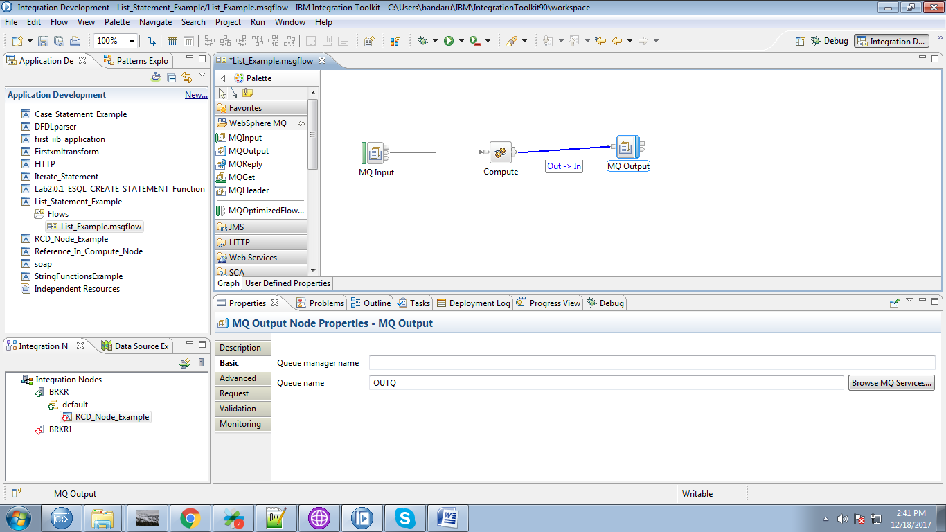

13. When you double click on compute node following(default) code will appears.

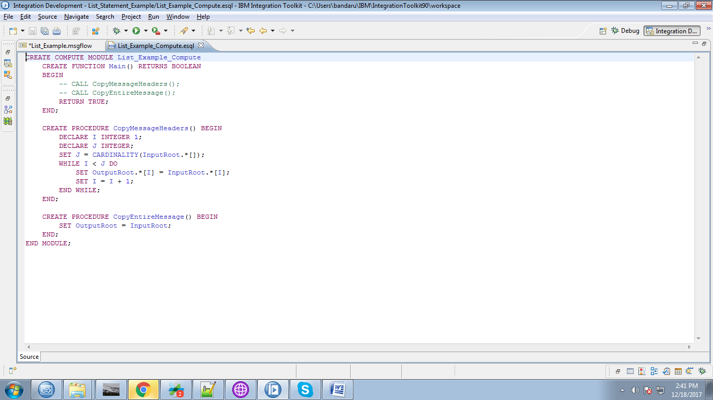

14. Override the following code.

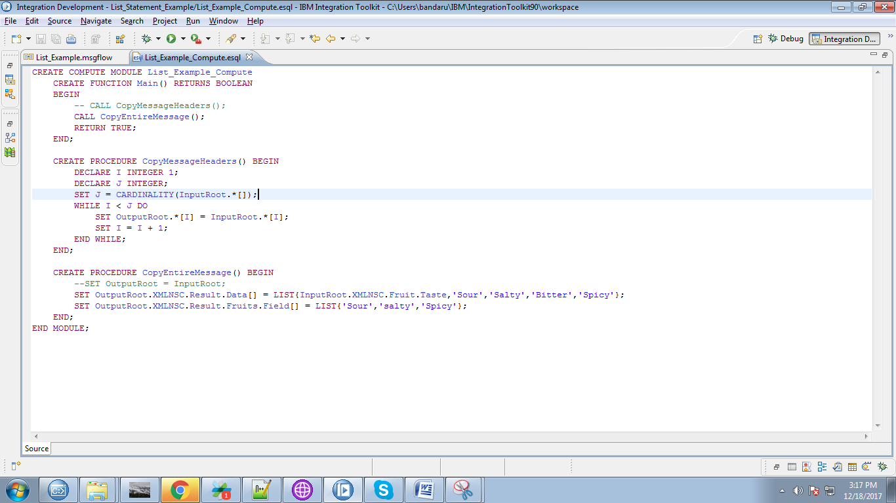

15. When you right click on application you able to see "Deploy" click on it.

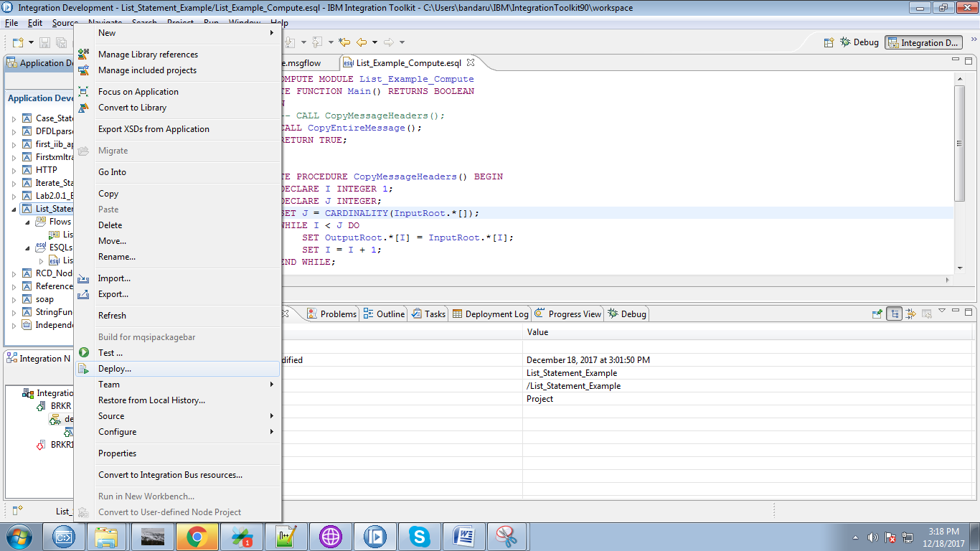

16. Select your running broker and execution group and click on "Finish" button.

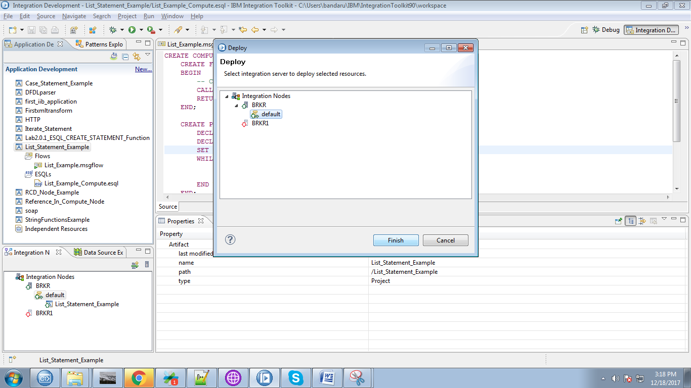

17. Create respective input and output queue in "WebSphere Explorer".

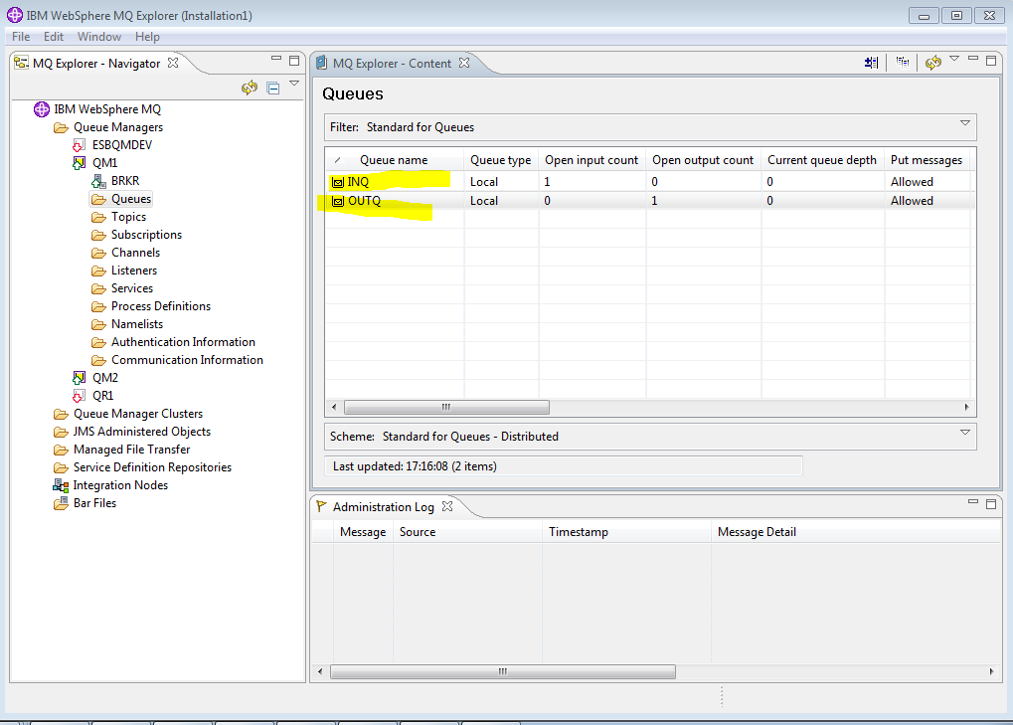

18. Open "rfhutil", select input queue and click "open file" button.

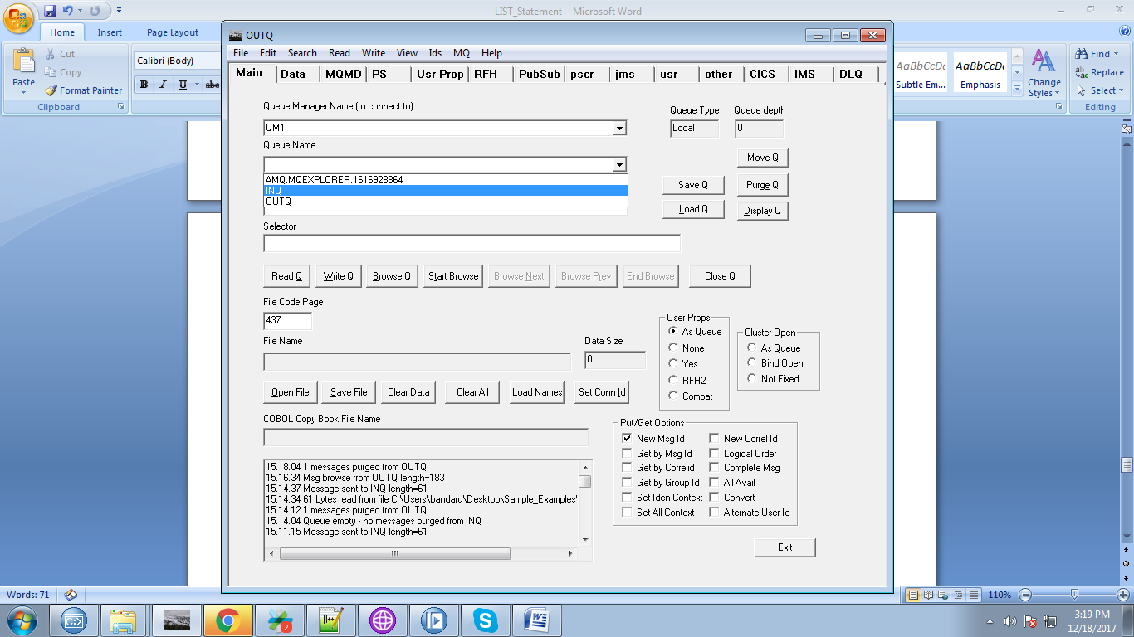

19. Browse to your file location and select your file and click "Open".

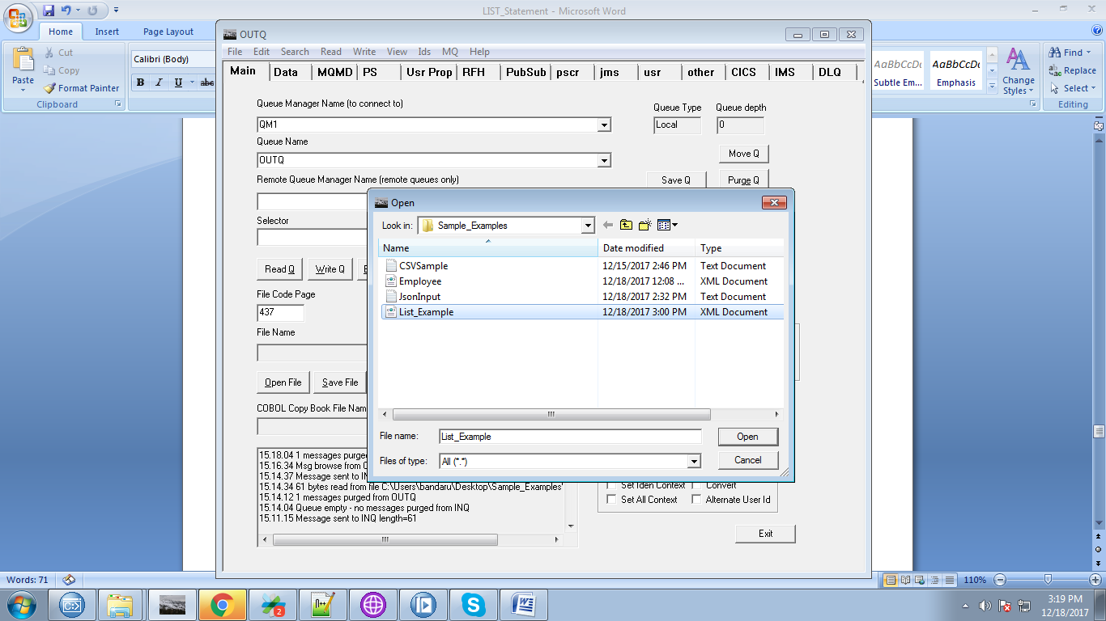

20. For this example, our file contains following data.

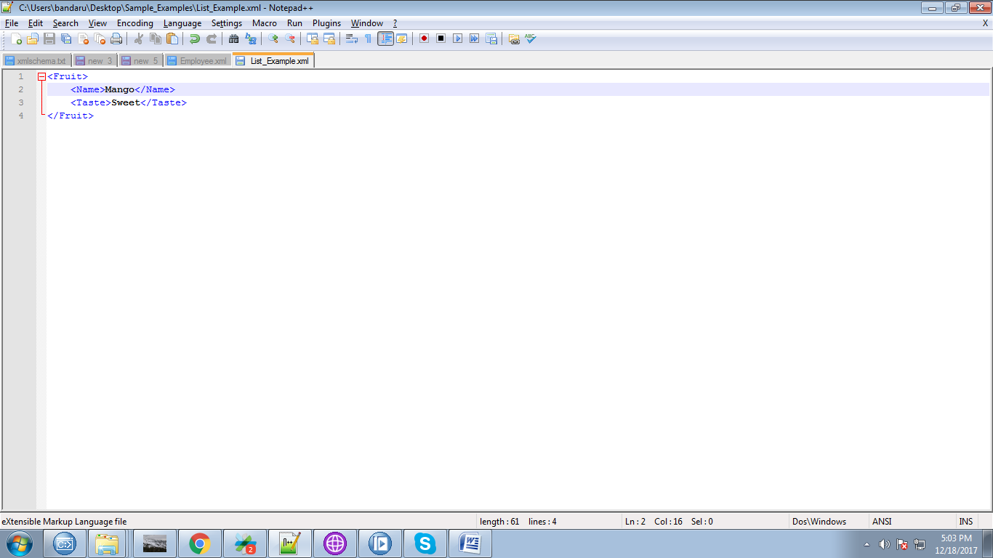

21. Now hit "Write Q" to trigger your flow.

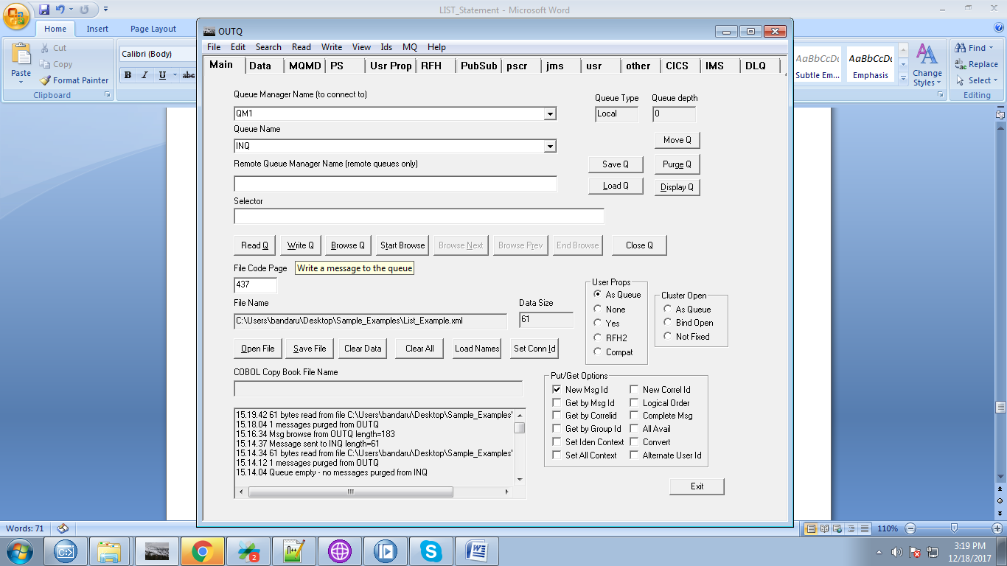

22. You can able to see output of your compute node in debug mode.

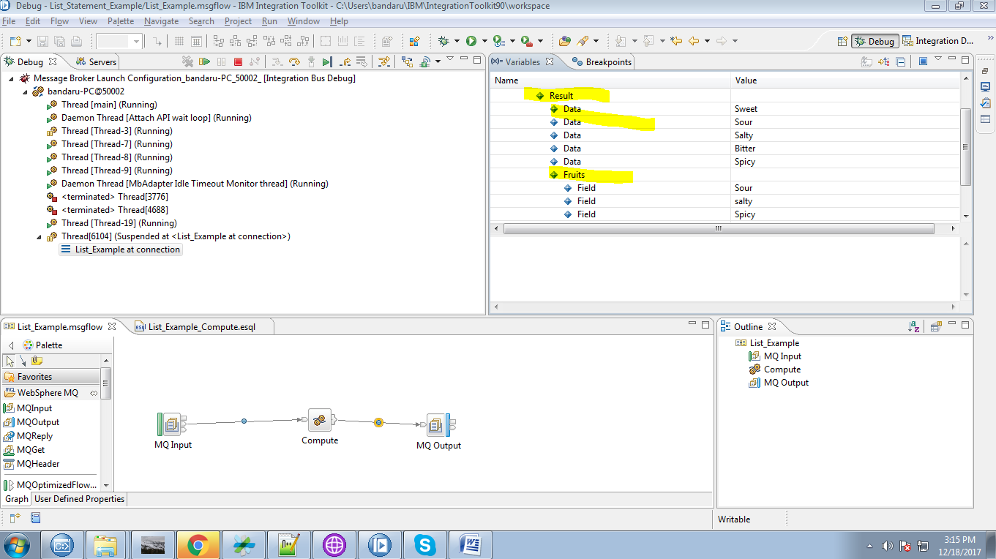

23. After completion of your flow, select your output queue.

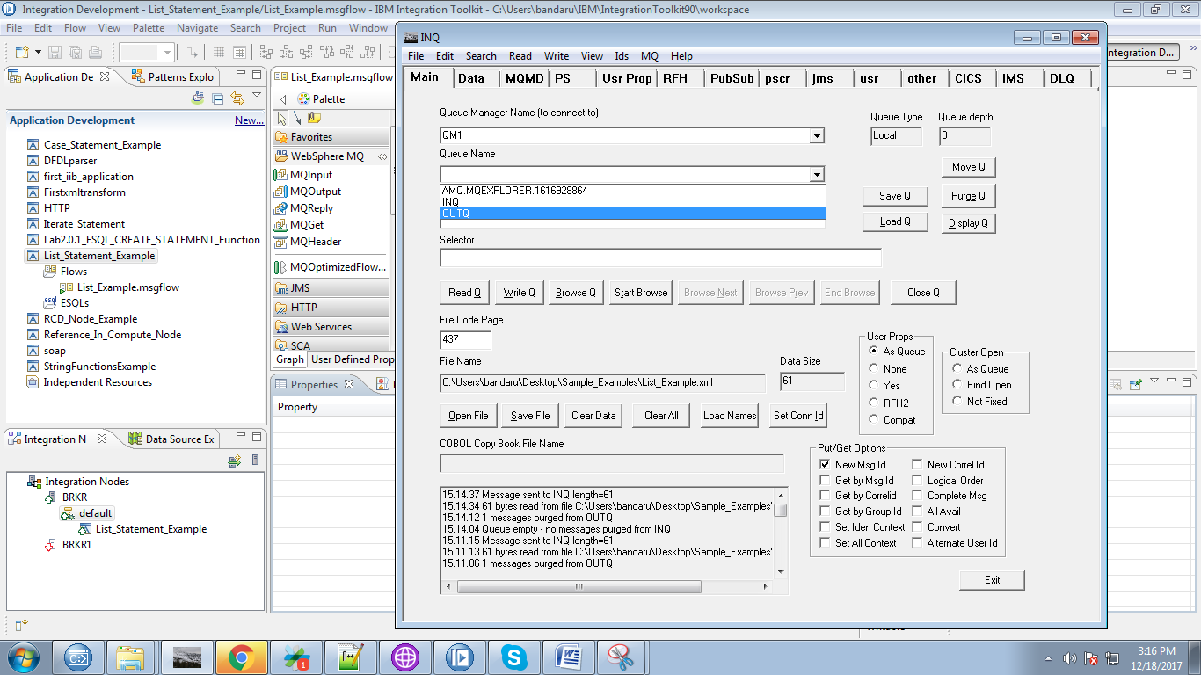

24. After selecting output queue, hit "Browse Q" button.

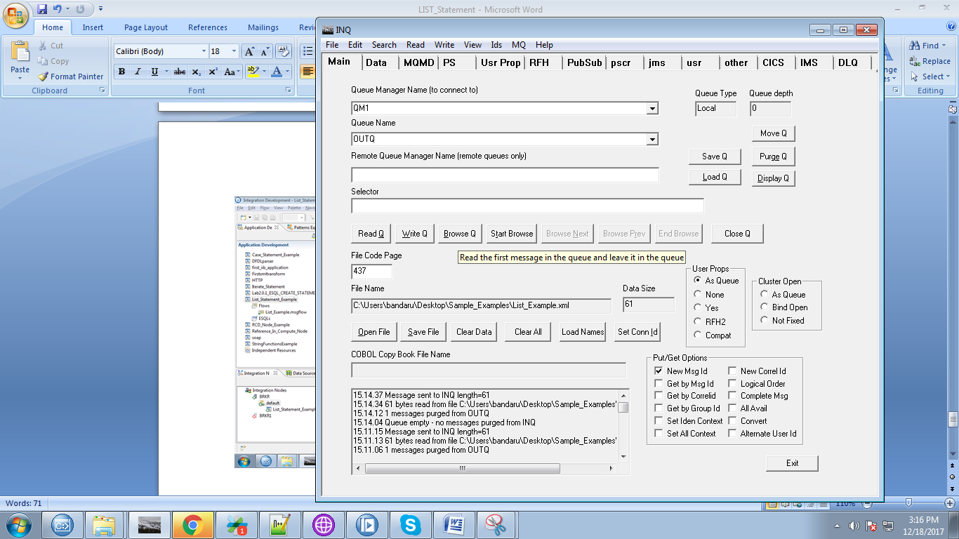

25. Resutant output queue data can able to see in "Data" tab.

