RouteToLabel Example

1. Click on File tab and select "New"=>"Application"

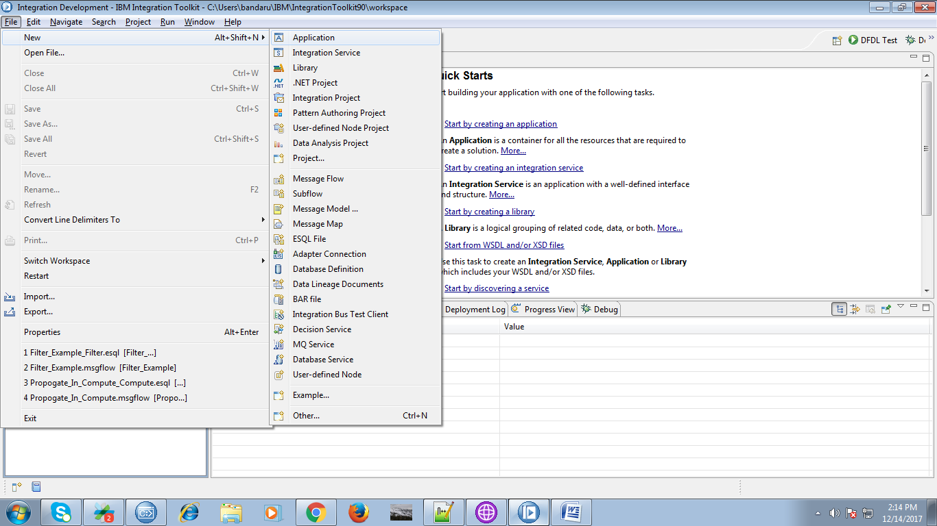

2. A pop-up will appears, give a name for your application.

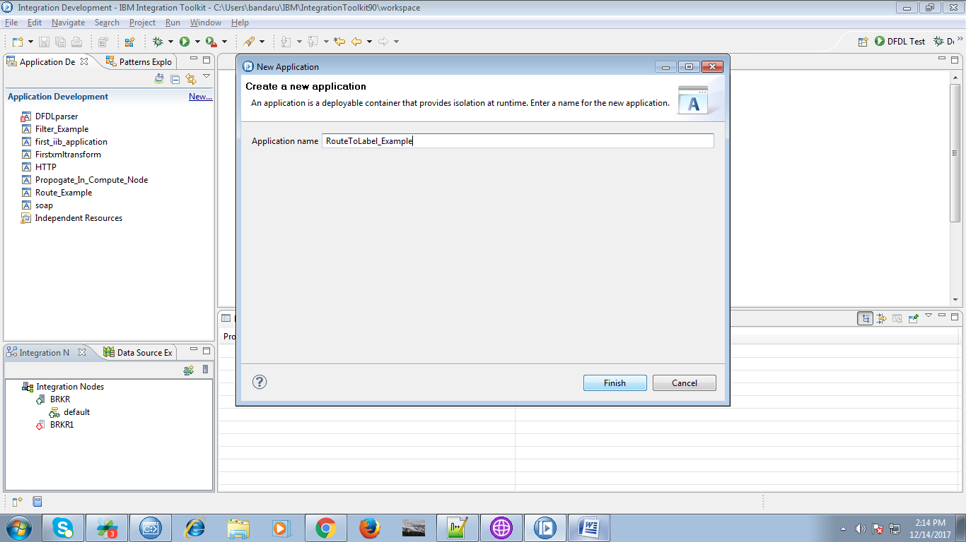

3. Under your application you can see "New" click on it.

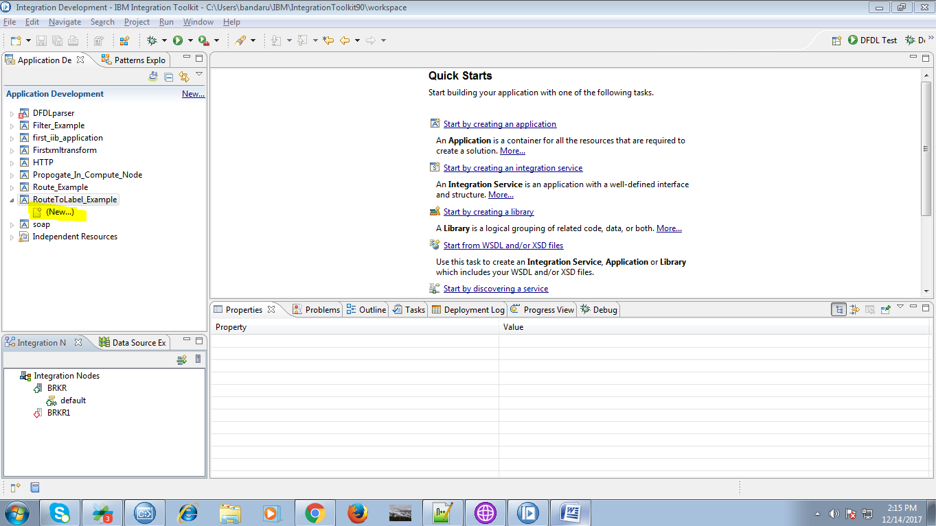

4. Select "Message Flow" from given options.

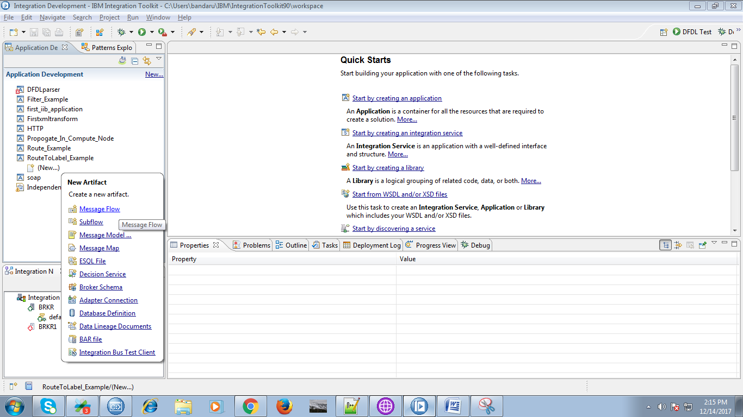

5. Now give a name for your flow and hit "Finish" button.

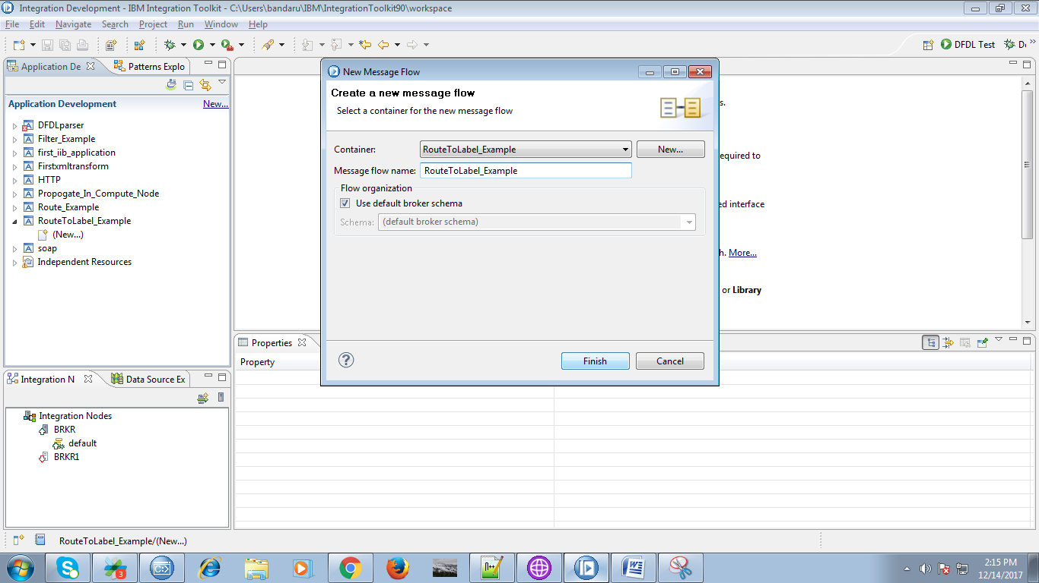

6. Drag MQInput from "WebSphere MQ" section and give it a name.

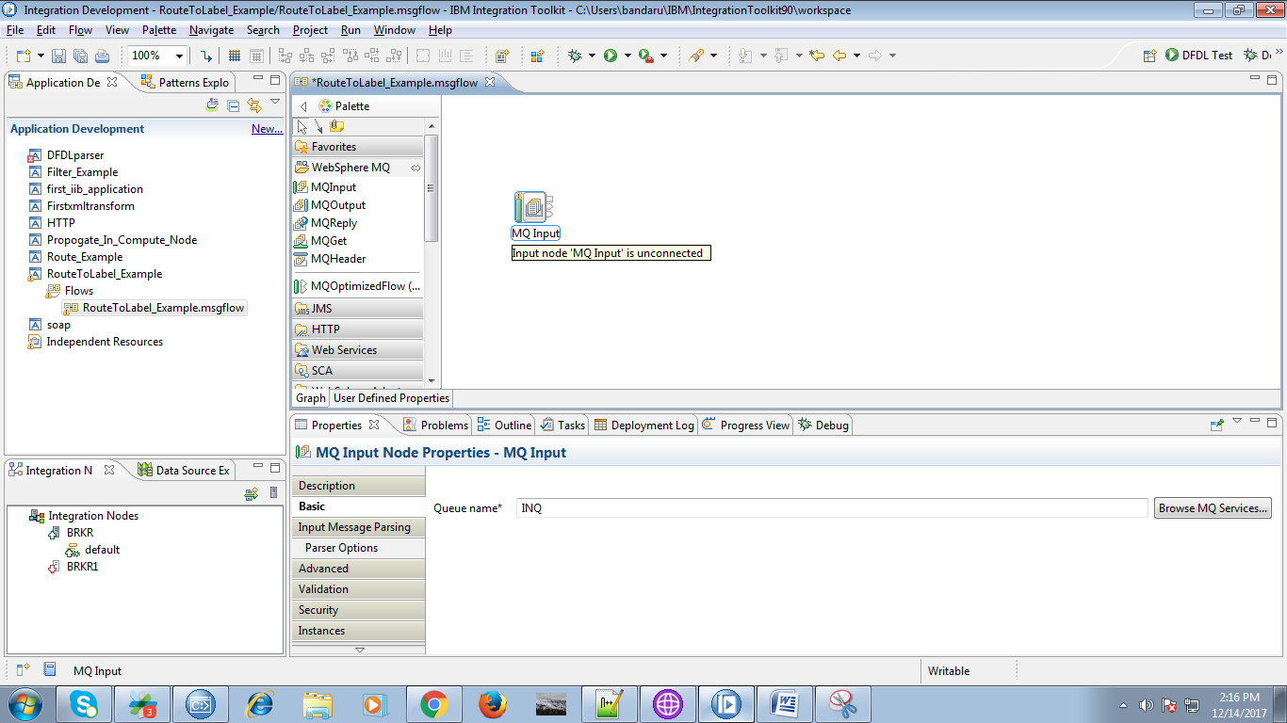

7. under "Input Message Parsing" select XMLNSC as messaging domain.

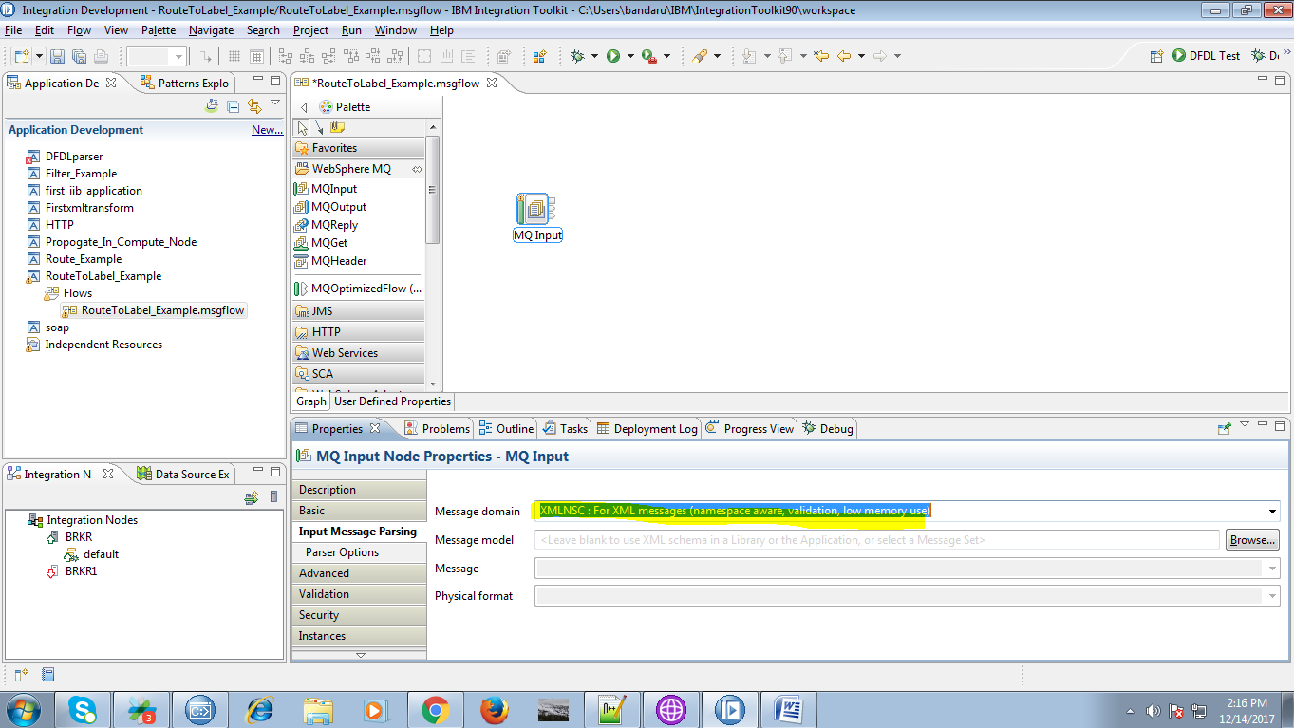

8. Drag compute node from transformation section.

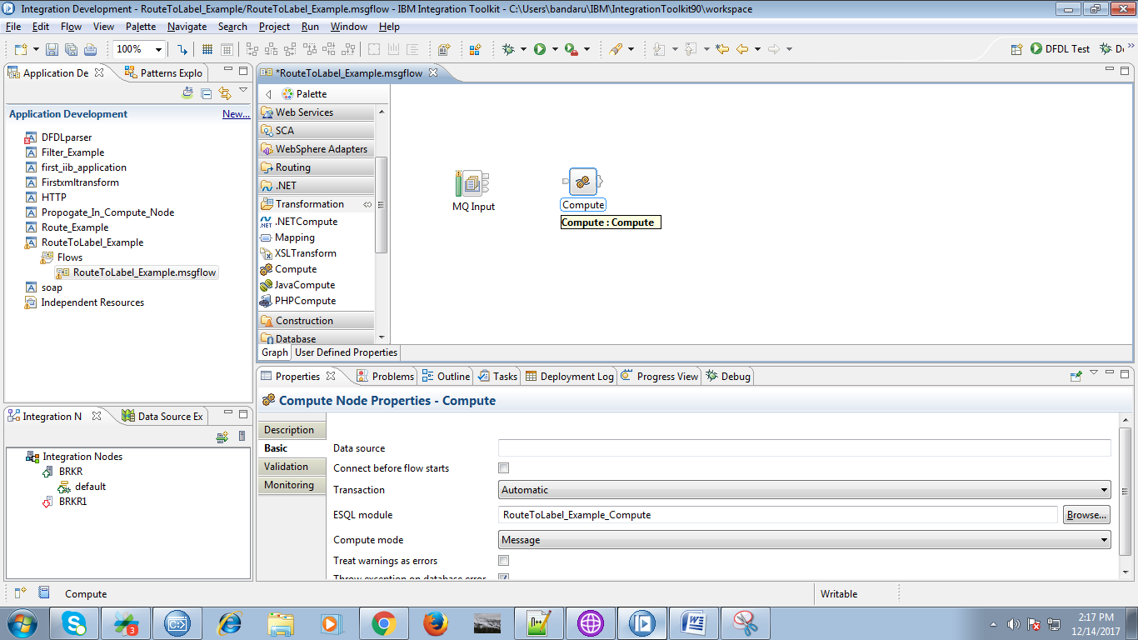

9. Connect "output" terminal of "input" queue to input terminal of compute node.

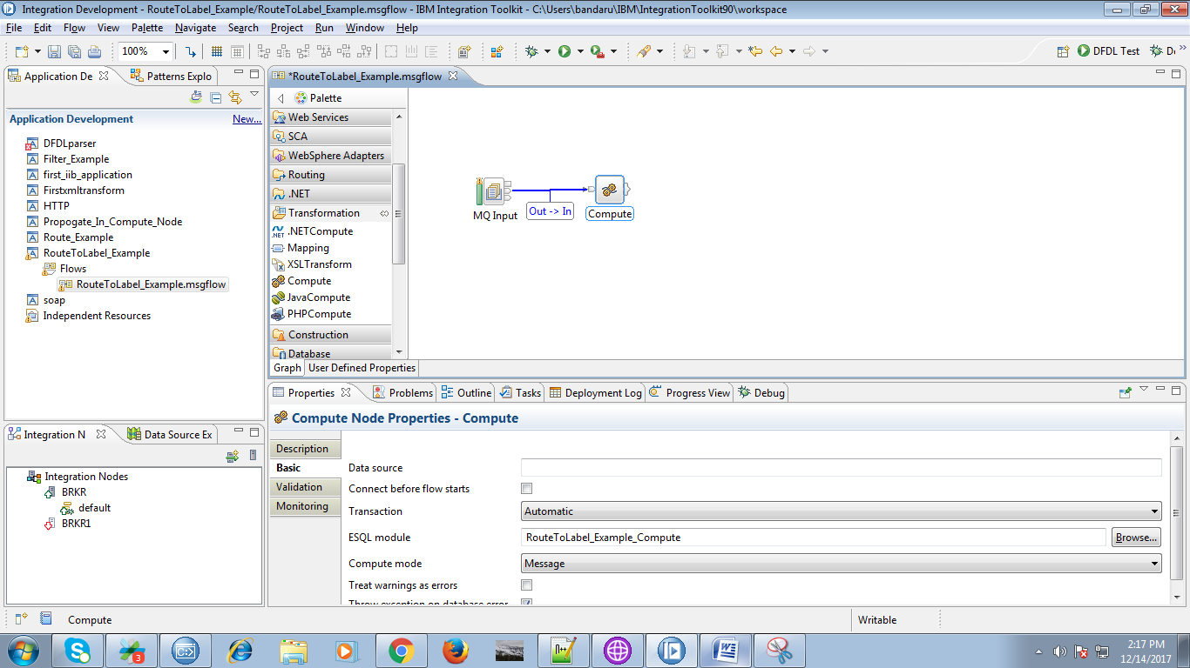

10. Drag "RouteToLabel" from "Routing" section.

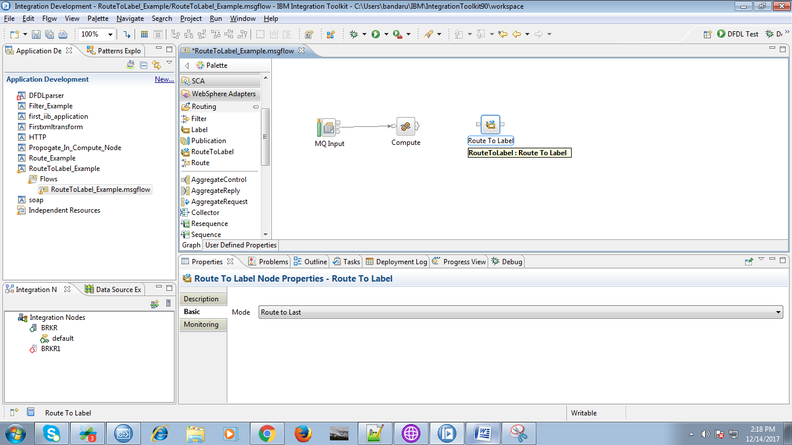

11. Select "Out" terminal from compute node.

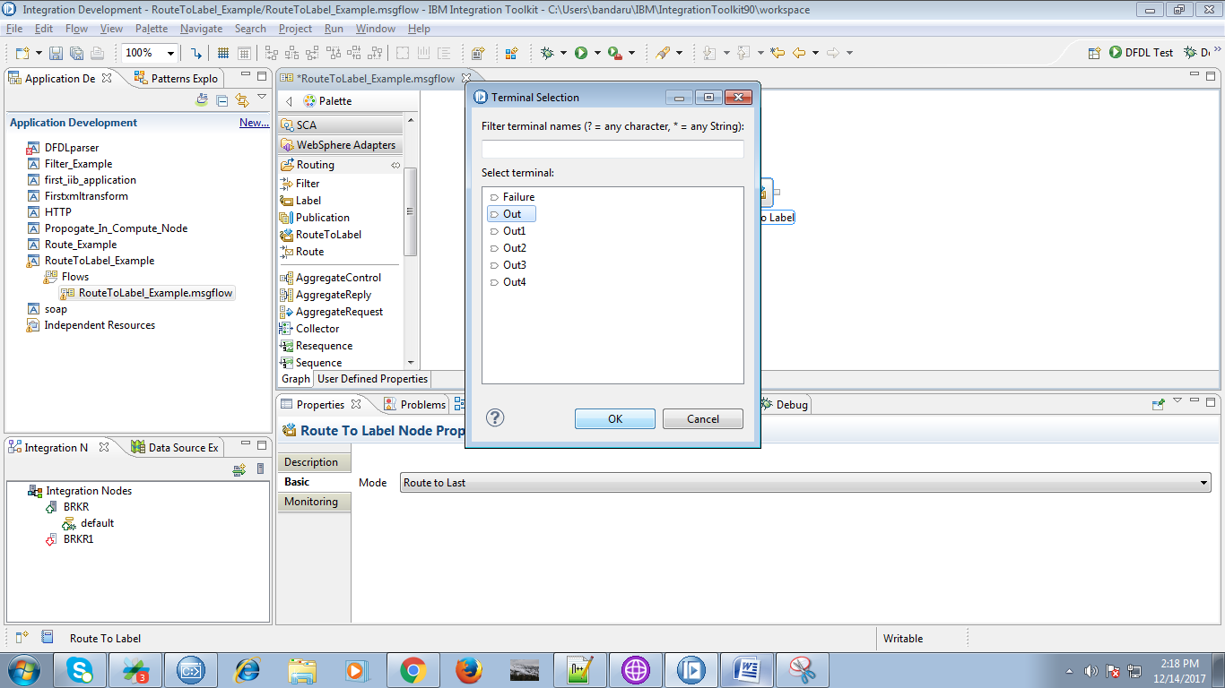

12. Connect "Out" terminal of compute to "input" terminal of RouteToLabel.

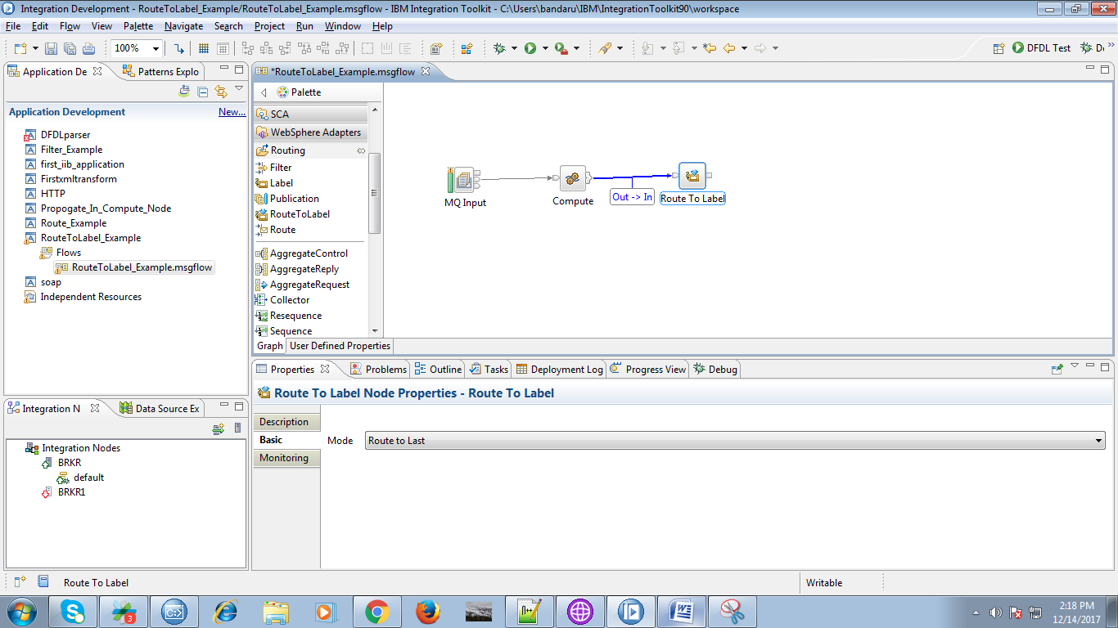

13. Drag three label nodes ang give appropriate names as given below.

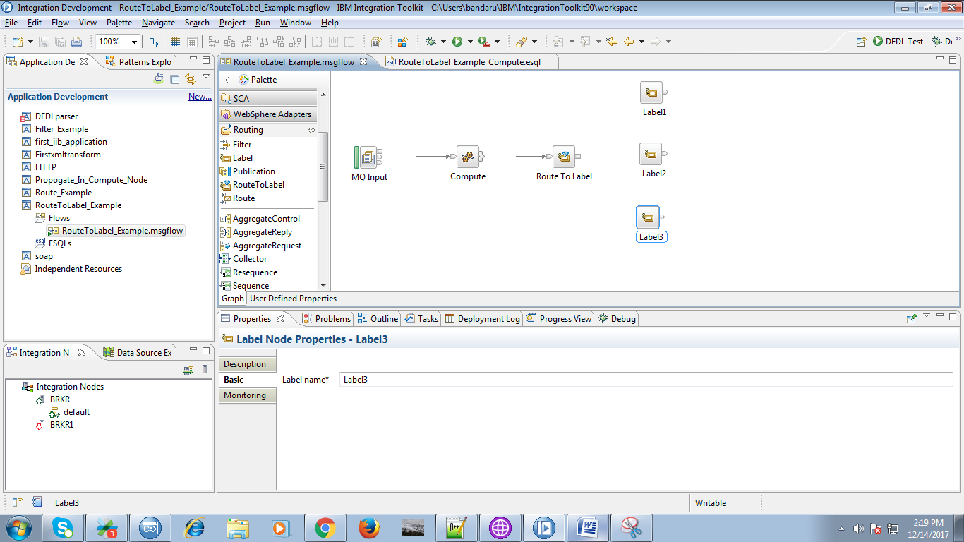

14. Drag three "MQOutput" queues and name them as given below.

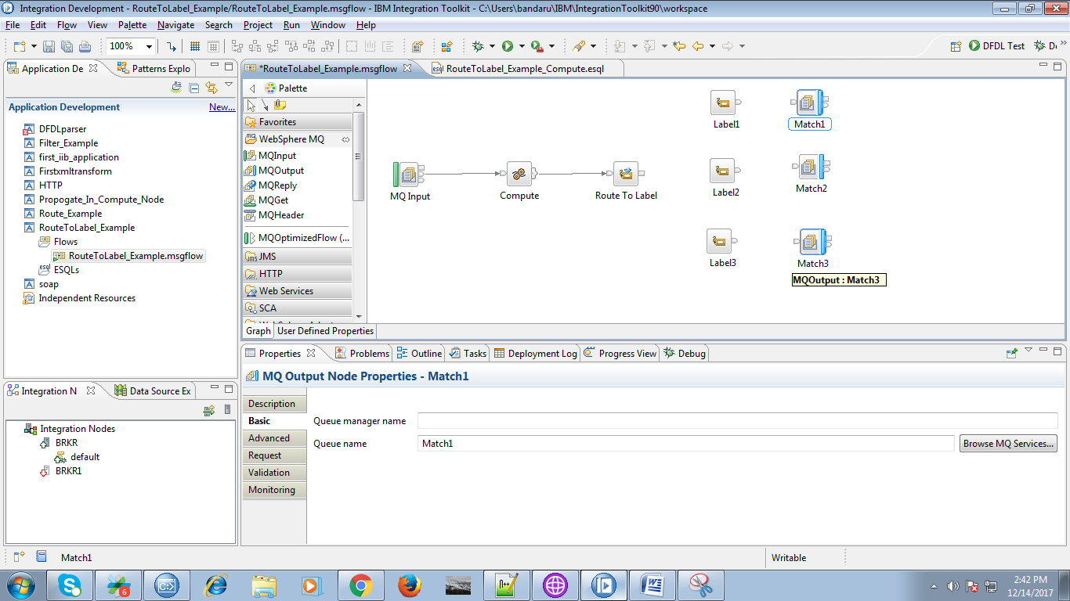

15. Match each of the "out" terminals of labels to each of the "input" terminals of "MQOutput" nodes.

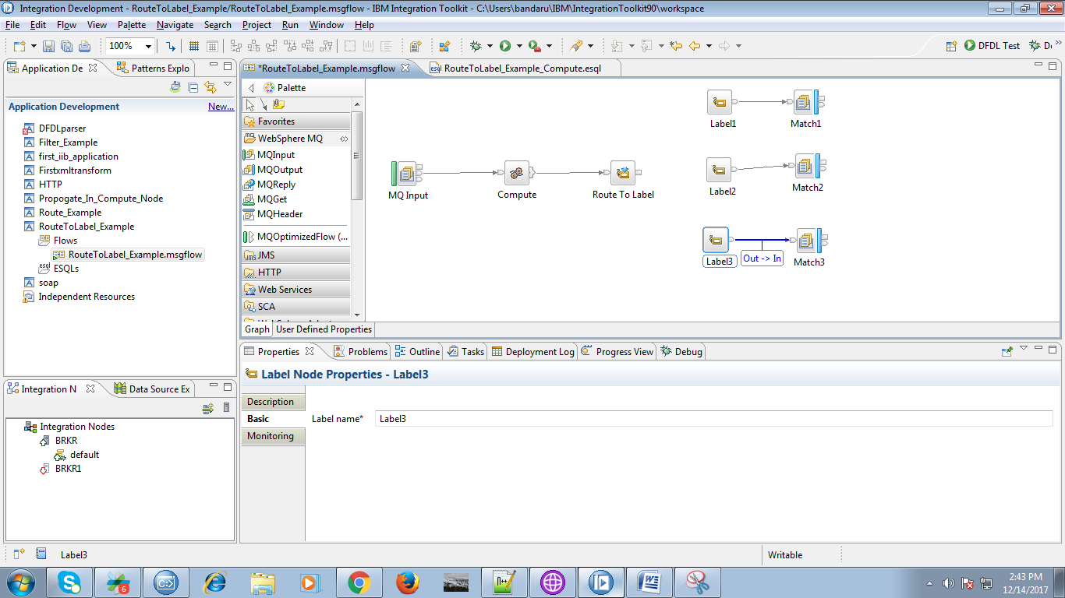

16. Change the compute node environment as given below.

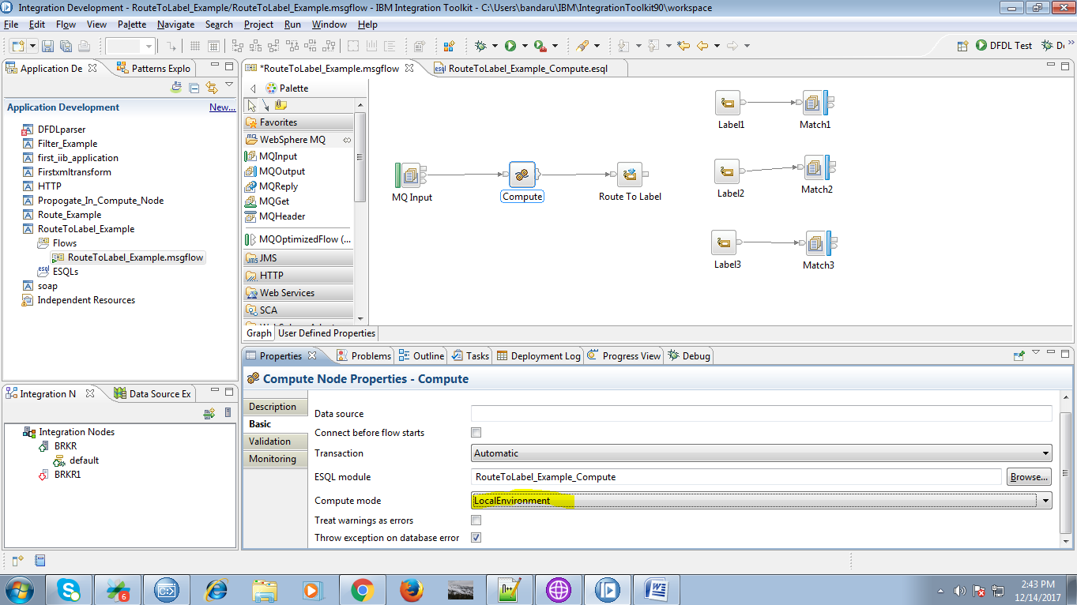

17. When you double click on compute node following code will prompts.

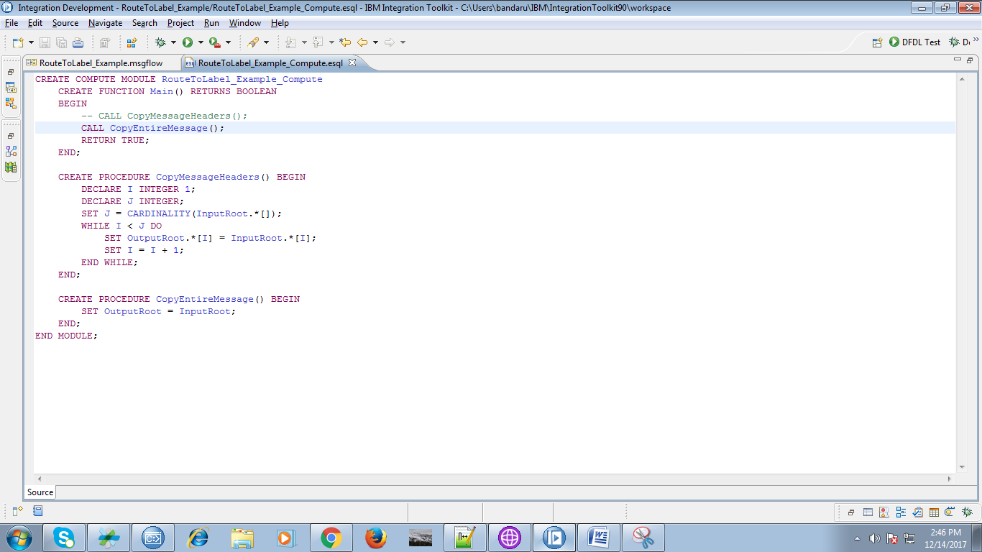

18. Override the below code.

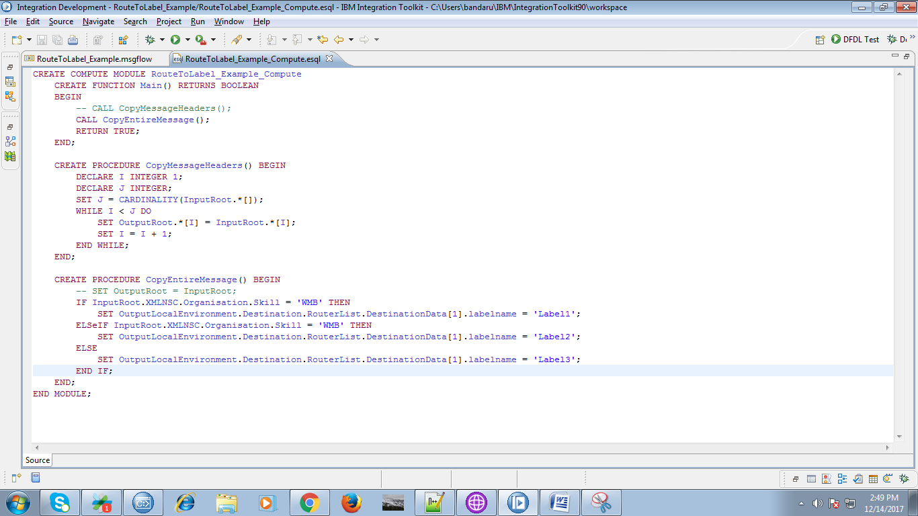

19. When you right click on application you can see "Deploy" click on it.

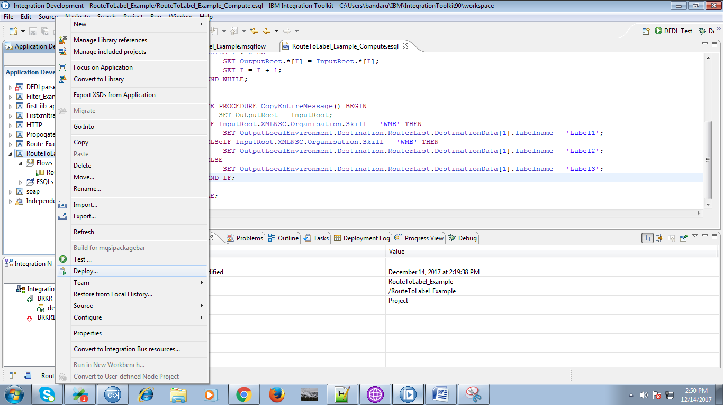

20. Select your execution group and hit "Finish" button.

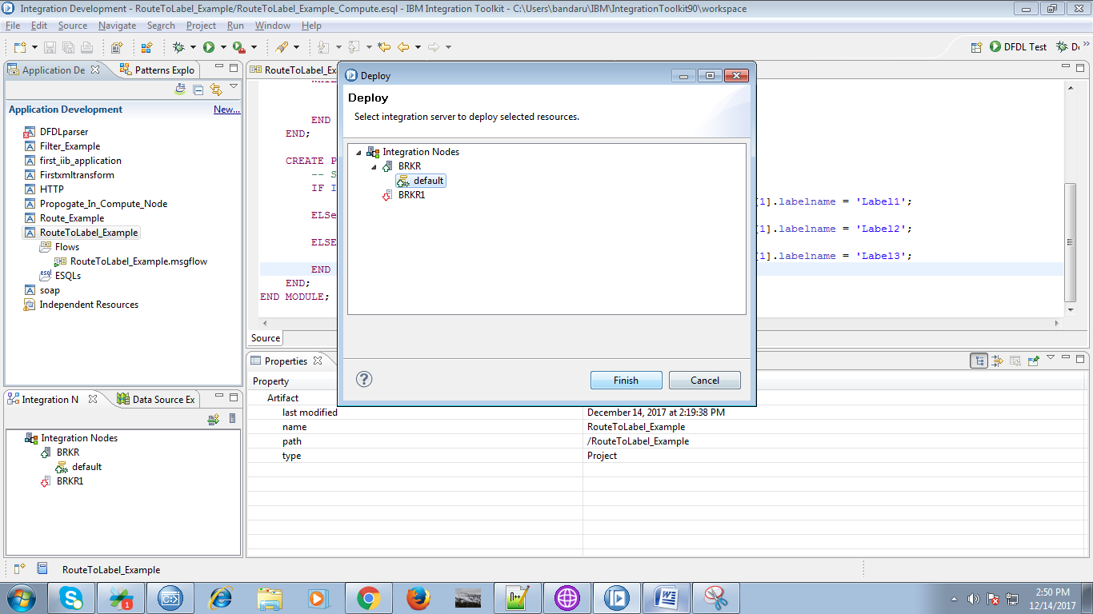

21. Create the local queues in "IIB webSphere MQ Explorer" which you were given in flow.

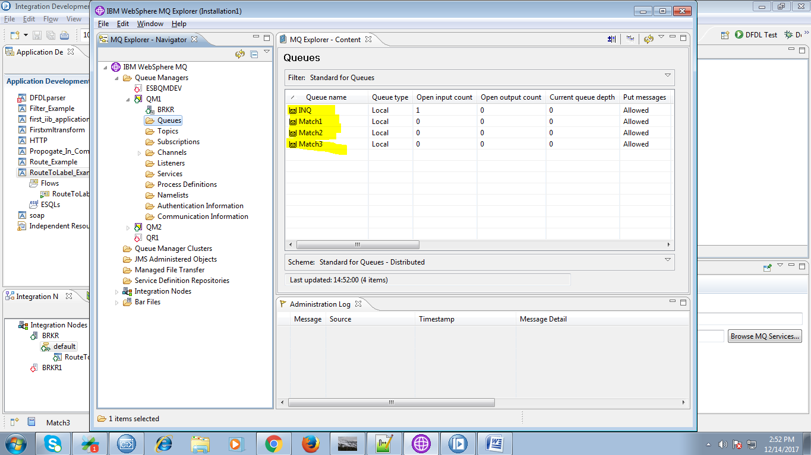

22. Open "rfhutil" and select your input queue.

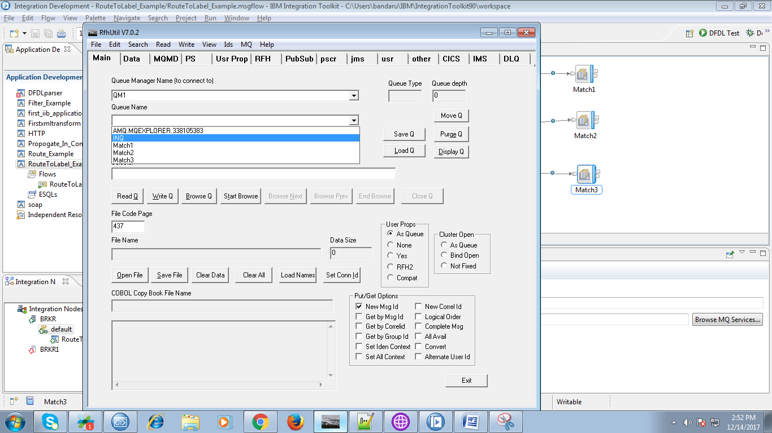

23. Click on "Open File" button and browse your file.

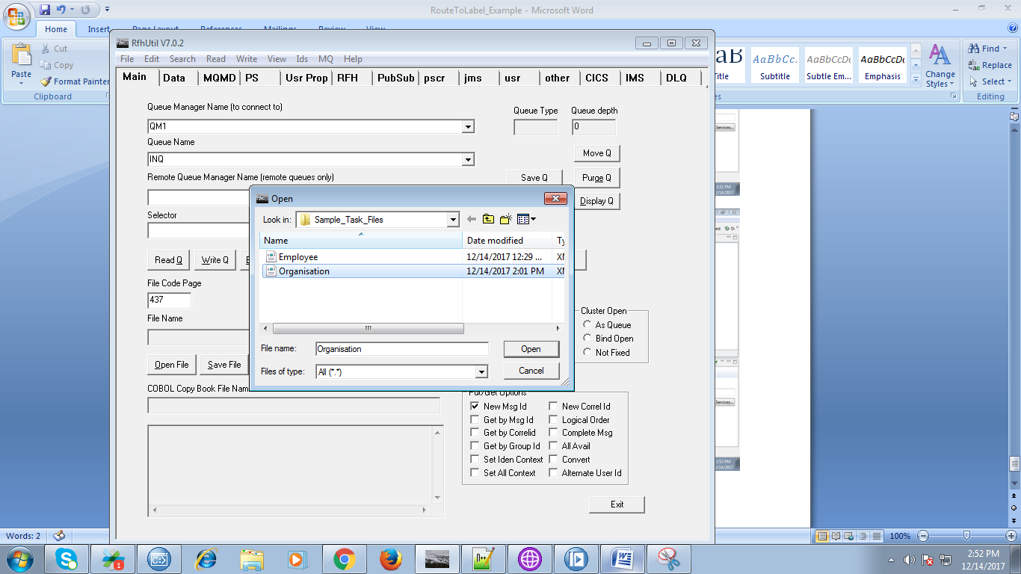

24. Now hit "Write Q" as shown in fig.

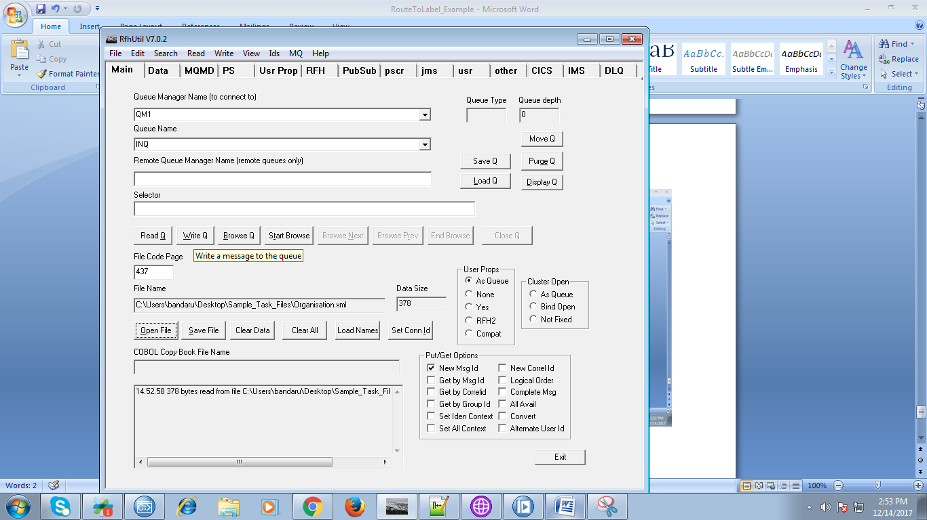

25. Following fig explains condition satisfied in compute node in debug mode.

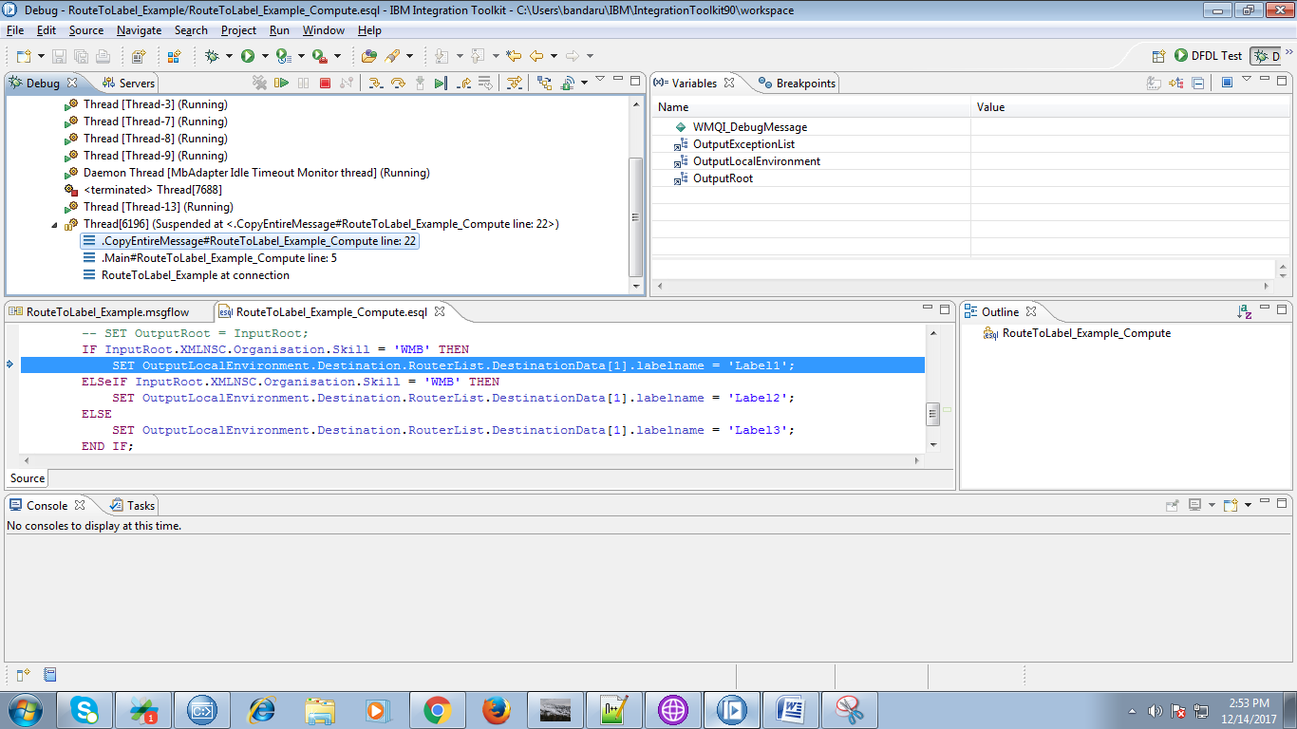

26. Output of the label shown in below fig.

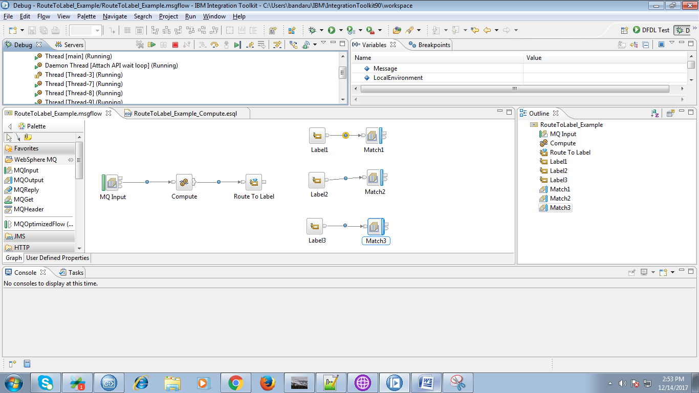

27. Now select your output queue from the list.

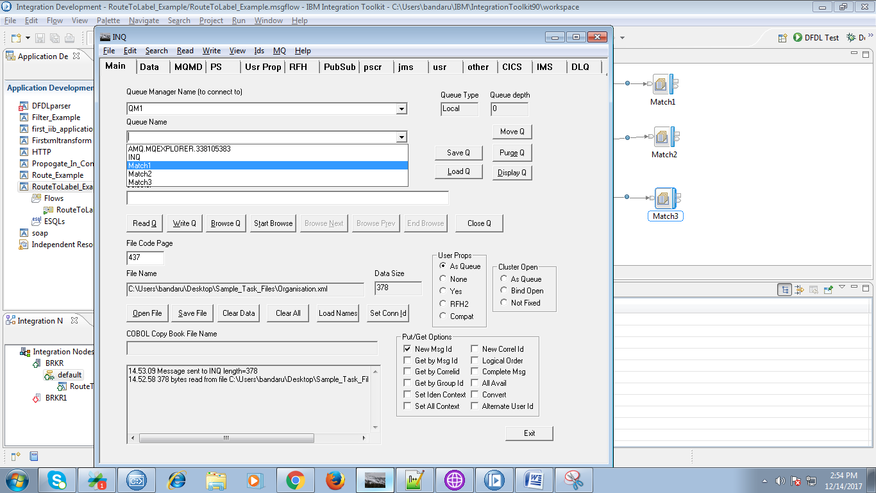

28. After selecting queue hit the "Browse Q" tab.

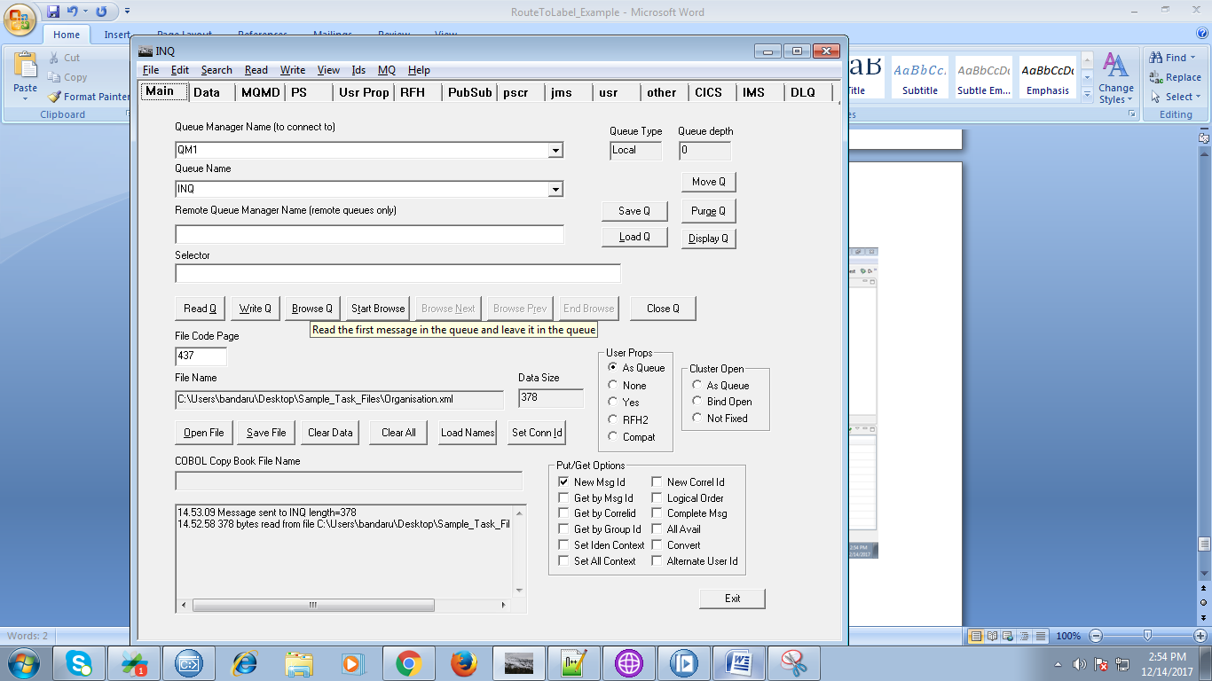

29. You can find respective output in output queue in "Data" tab.

