Route Using Compute Node(Propagate)

1. Click on file and select "New"=> "Application"

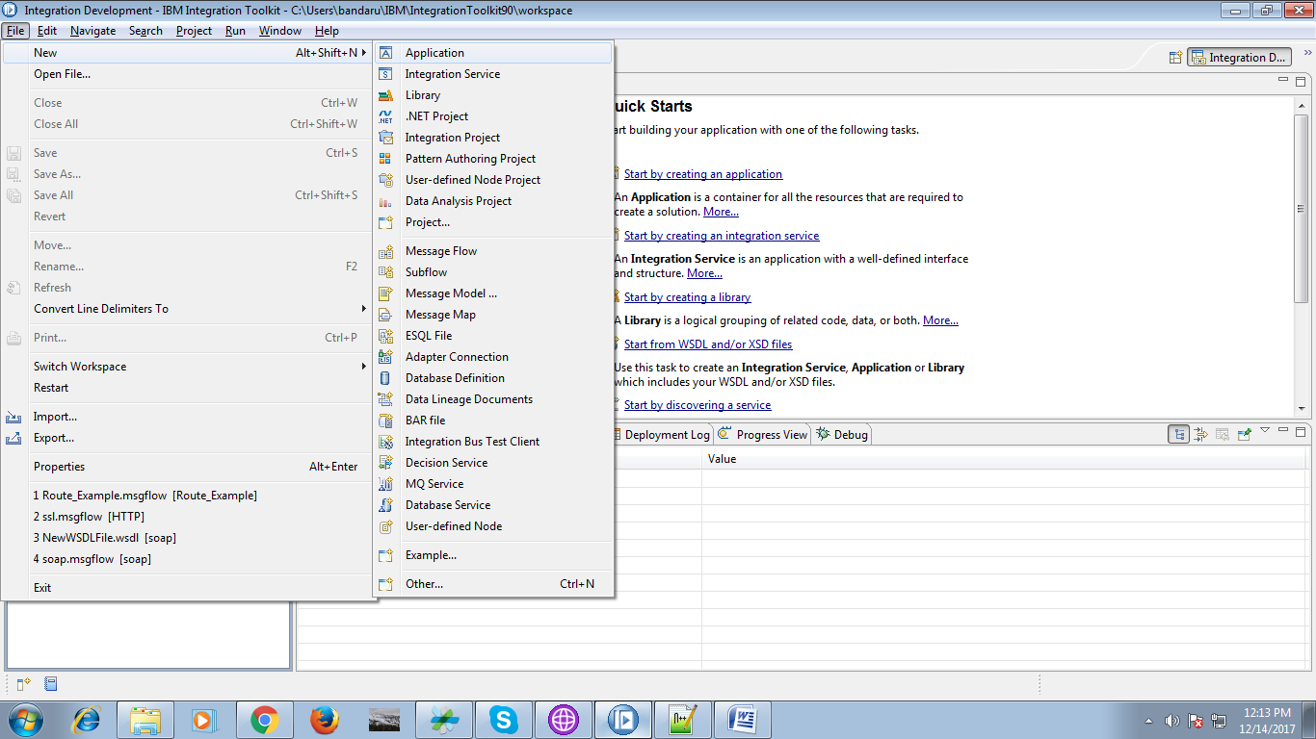

2. A pop-up will propmt and provide name for your application and click "finish" button.

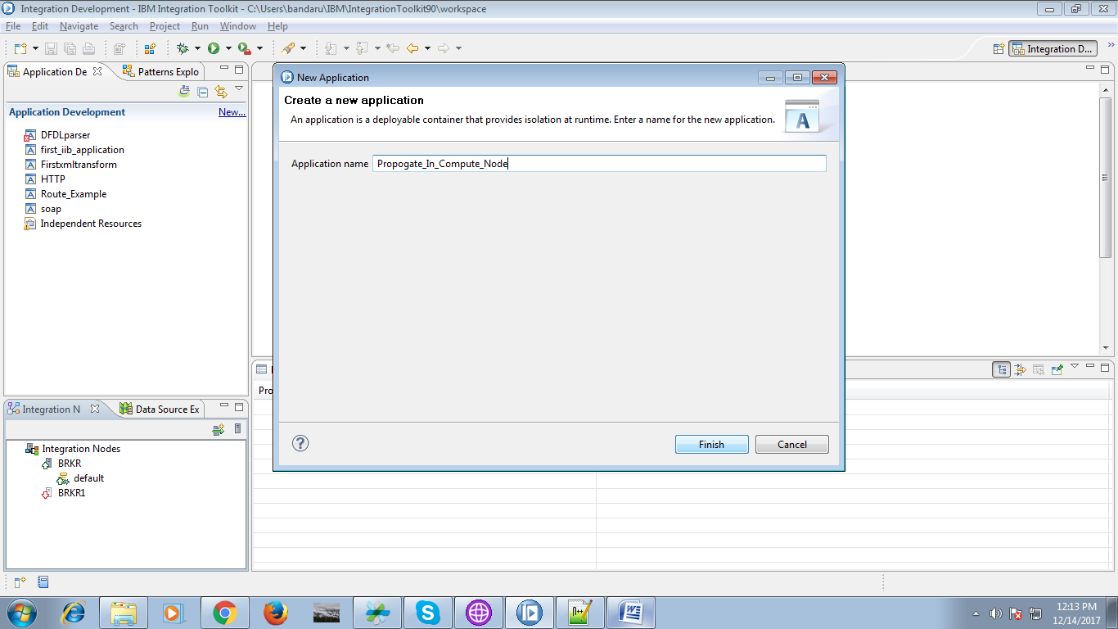

3. Under your application "New" option will appears click on it.

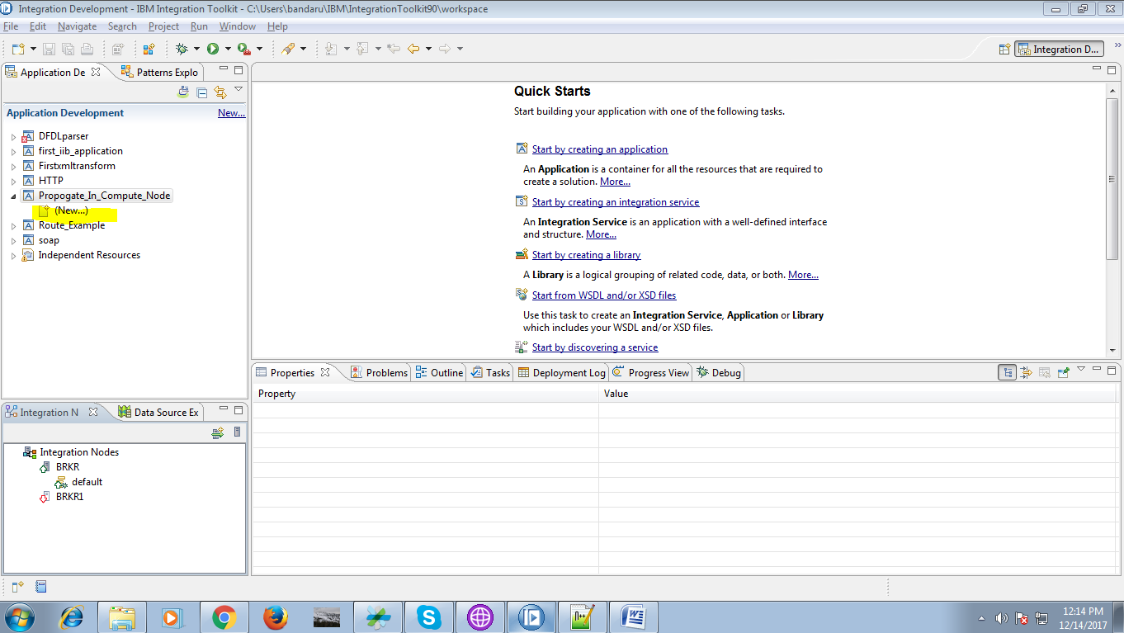

4. Than select "Message Flow" from given option.

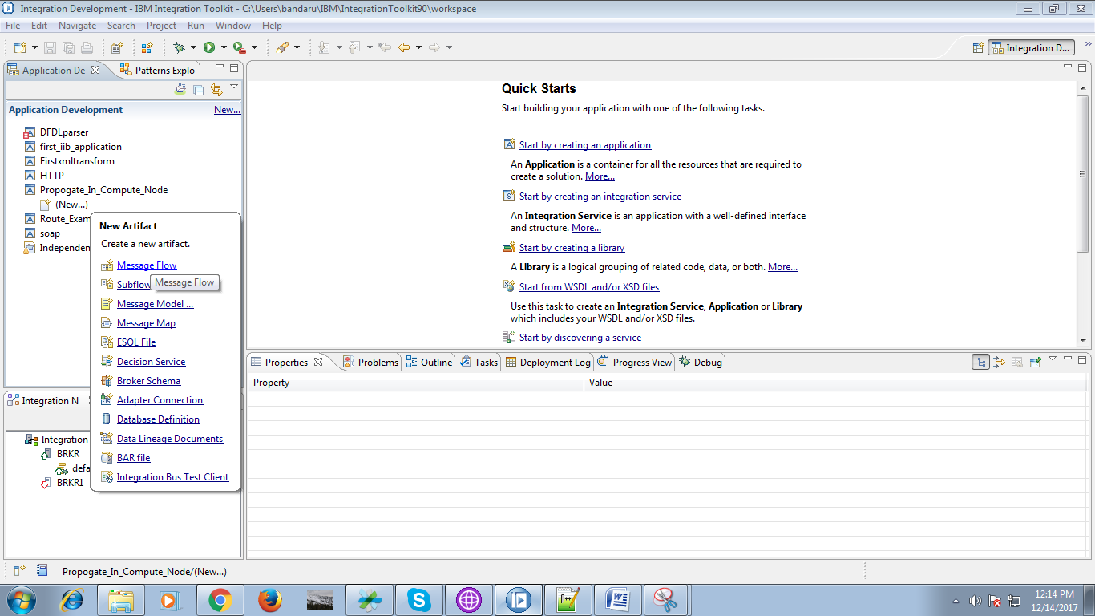

5. A pop-up will appears, give any name for your flow and click "finish" button.

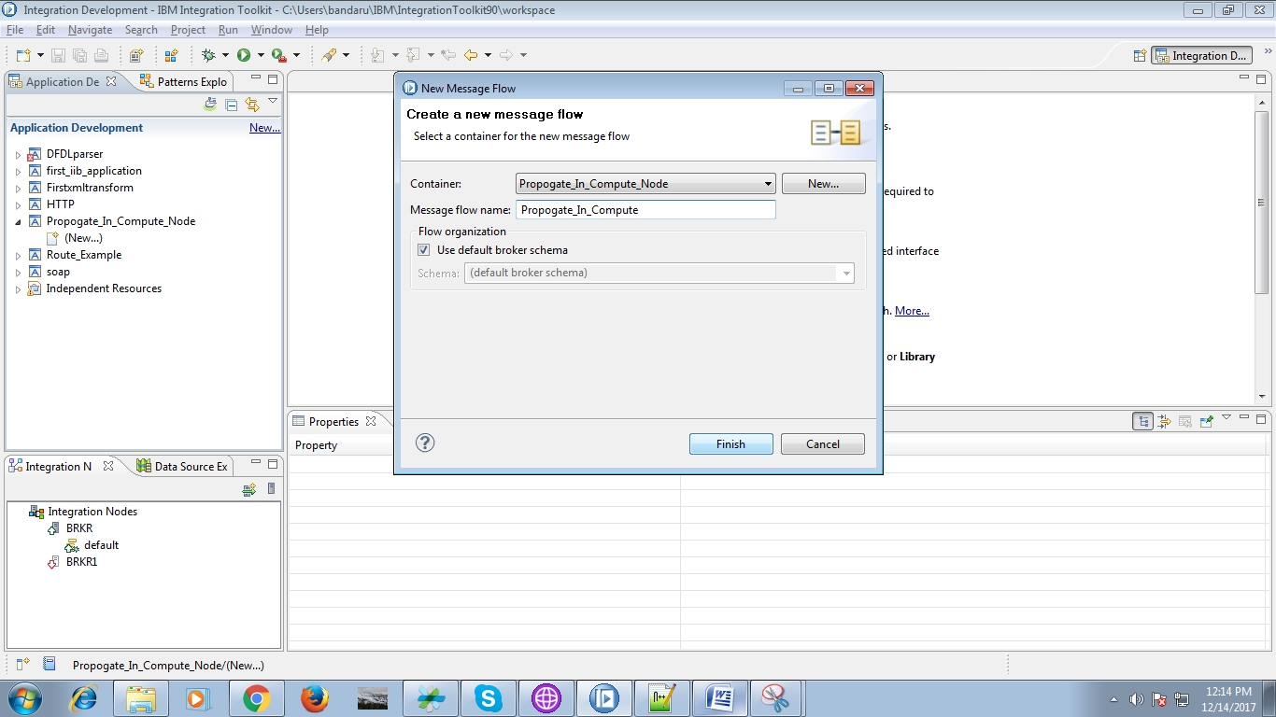

6. Drag "MQ Input" node from "WebSphere MQ" section and name the queue as shown below.

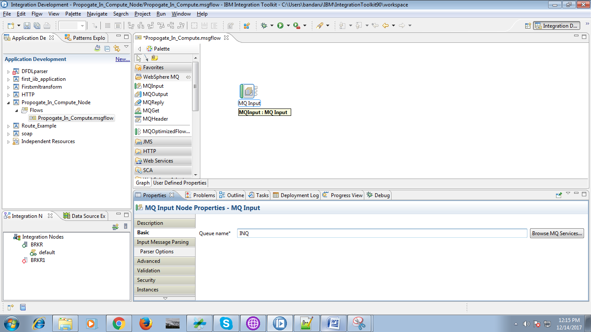

7. Now drag "Compute" node from "tranformation" section as shown below.

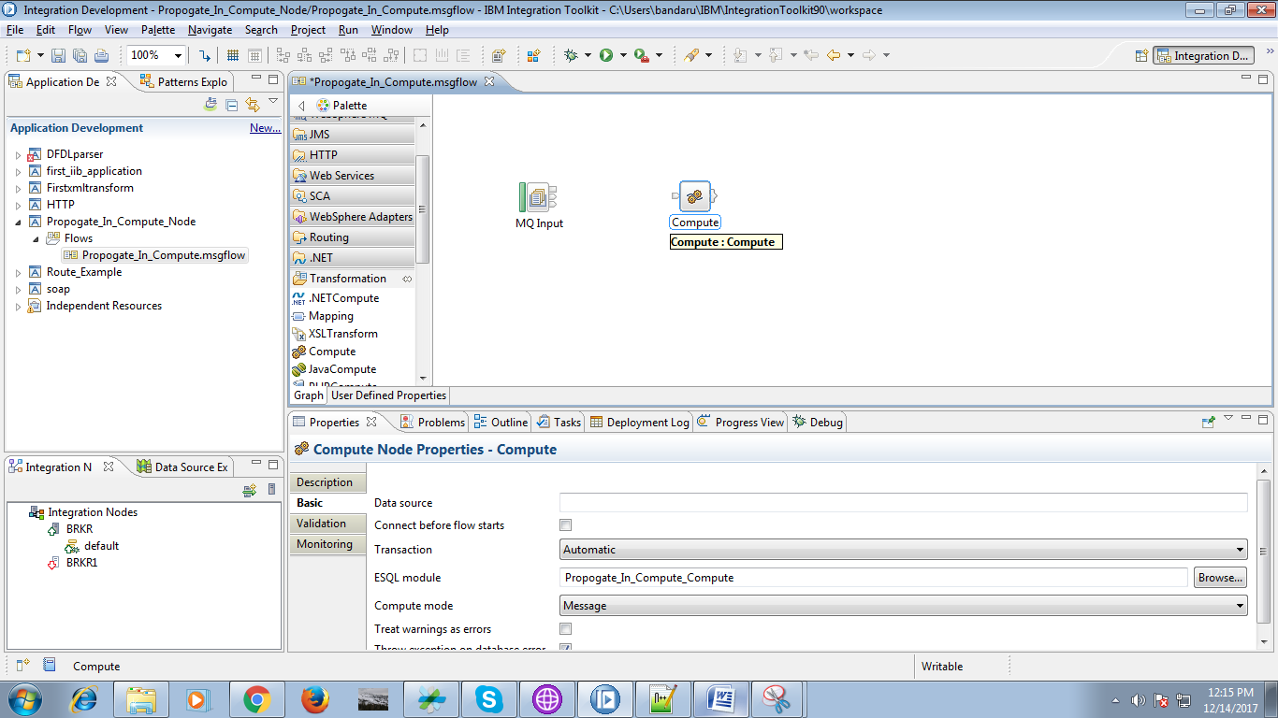

8. Connect the "out" terminal of the input queue to "In" terminal of the compute node. as shown in below fig.

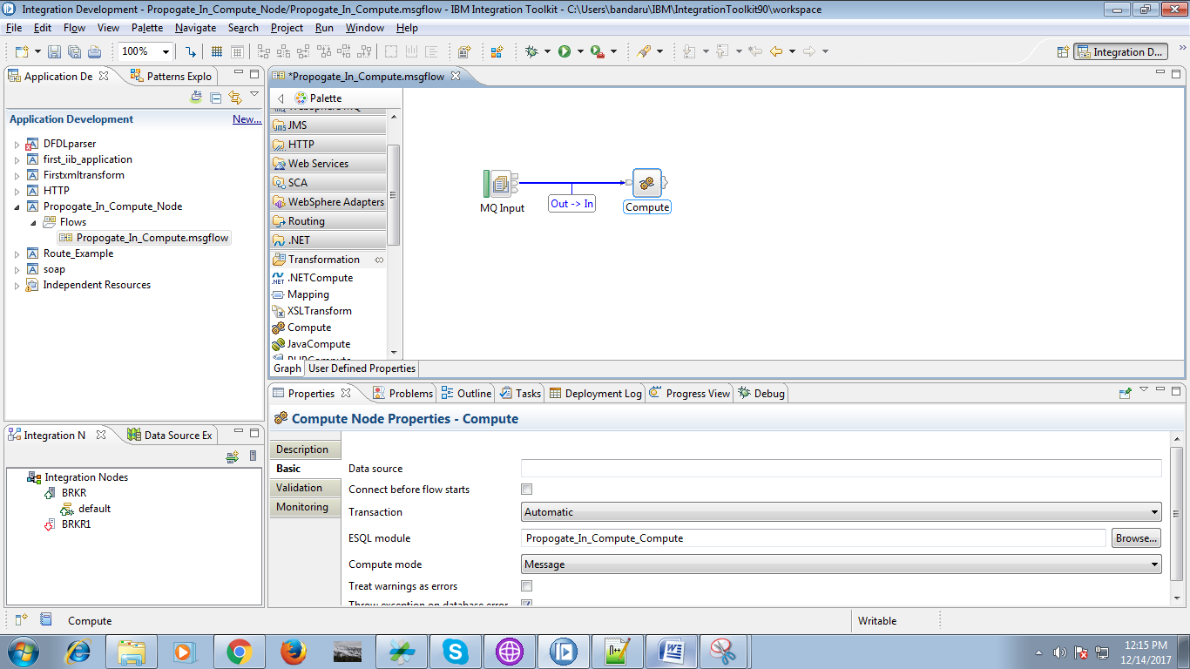

9. Now drag "MQOutput" from "WebSphere MQ" section and name the queue as shown below.

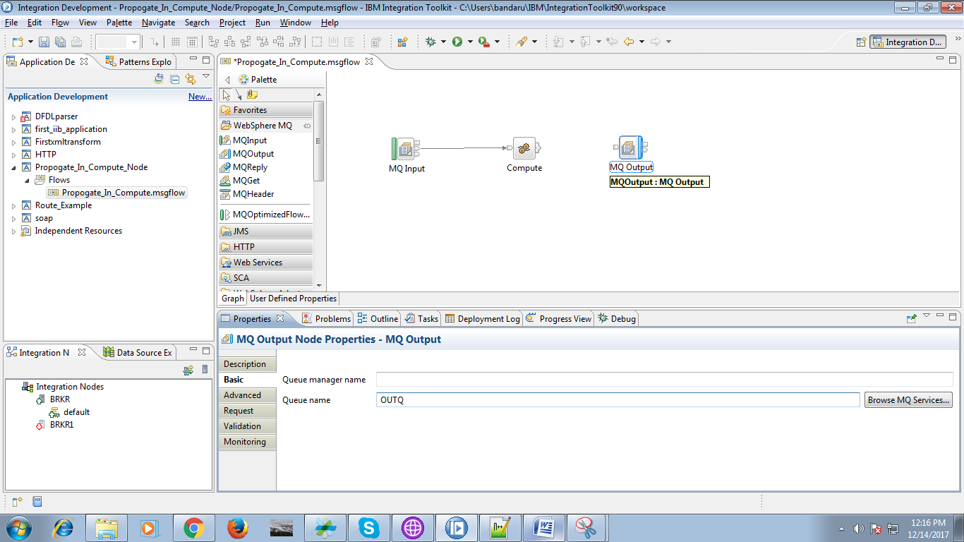

10. Connect the "Out" of compute terminal to "Input" terminal of the MQOutput queue.

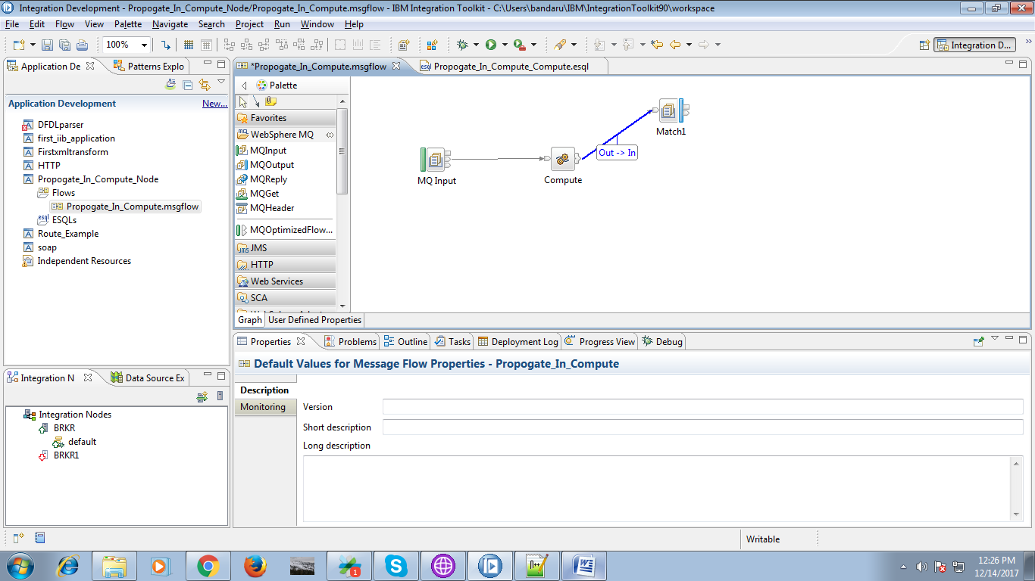

11. Drag "MQOutput" and name the queue as shown below.

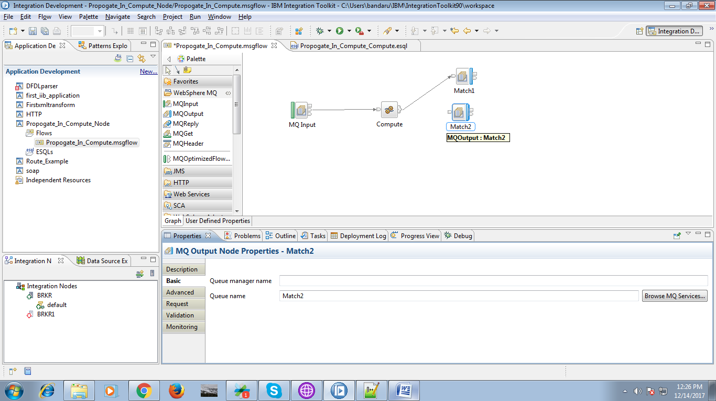

12. Select "Out1" terminal from the compute node.

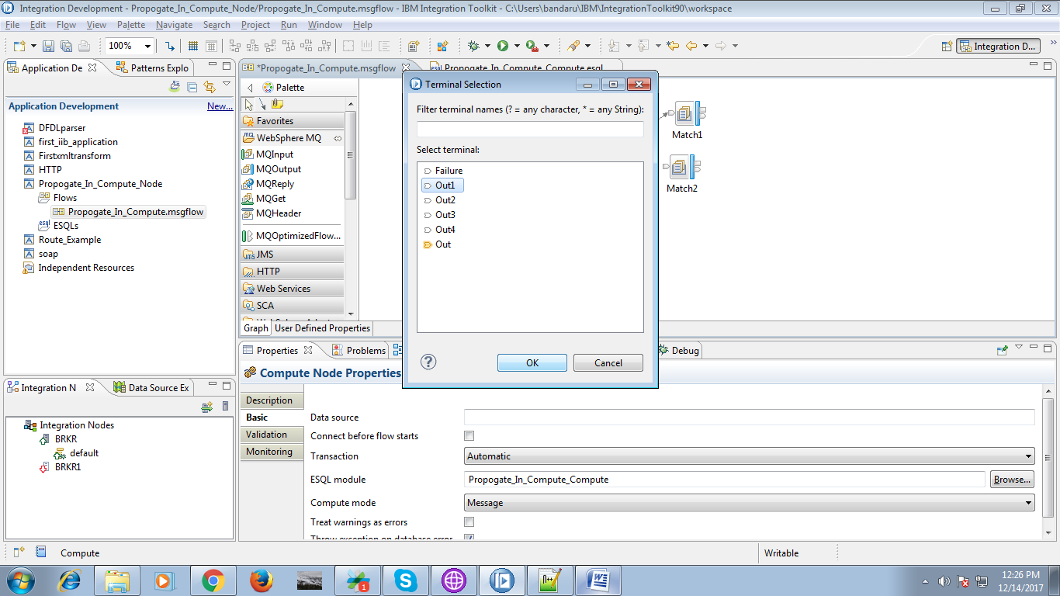

13. Connect the "Out1" terminal of compute node to "input" terminal of MQOuput as show.

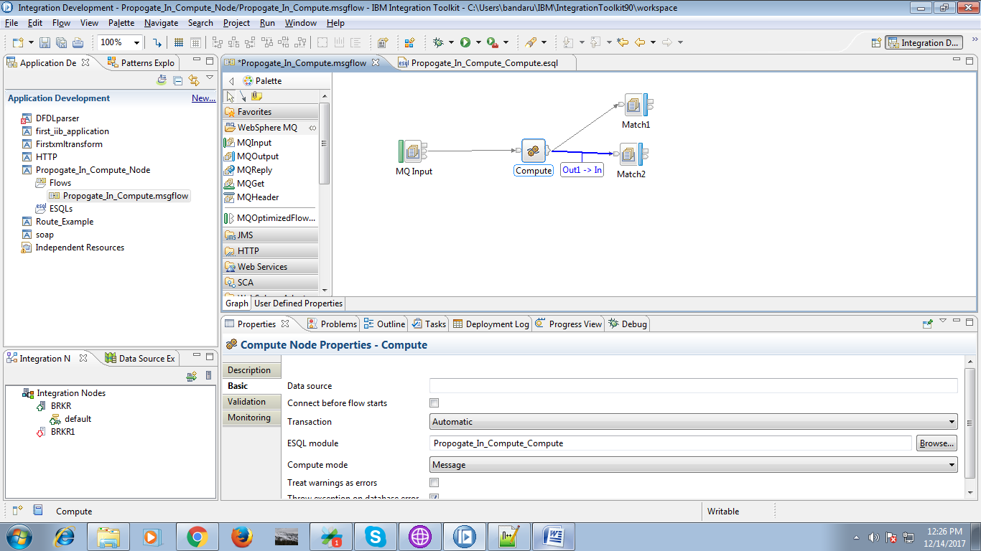

14. Drag the "MQOutput" and give the name for the queue as shown below.

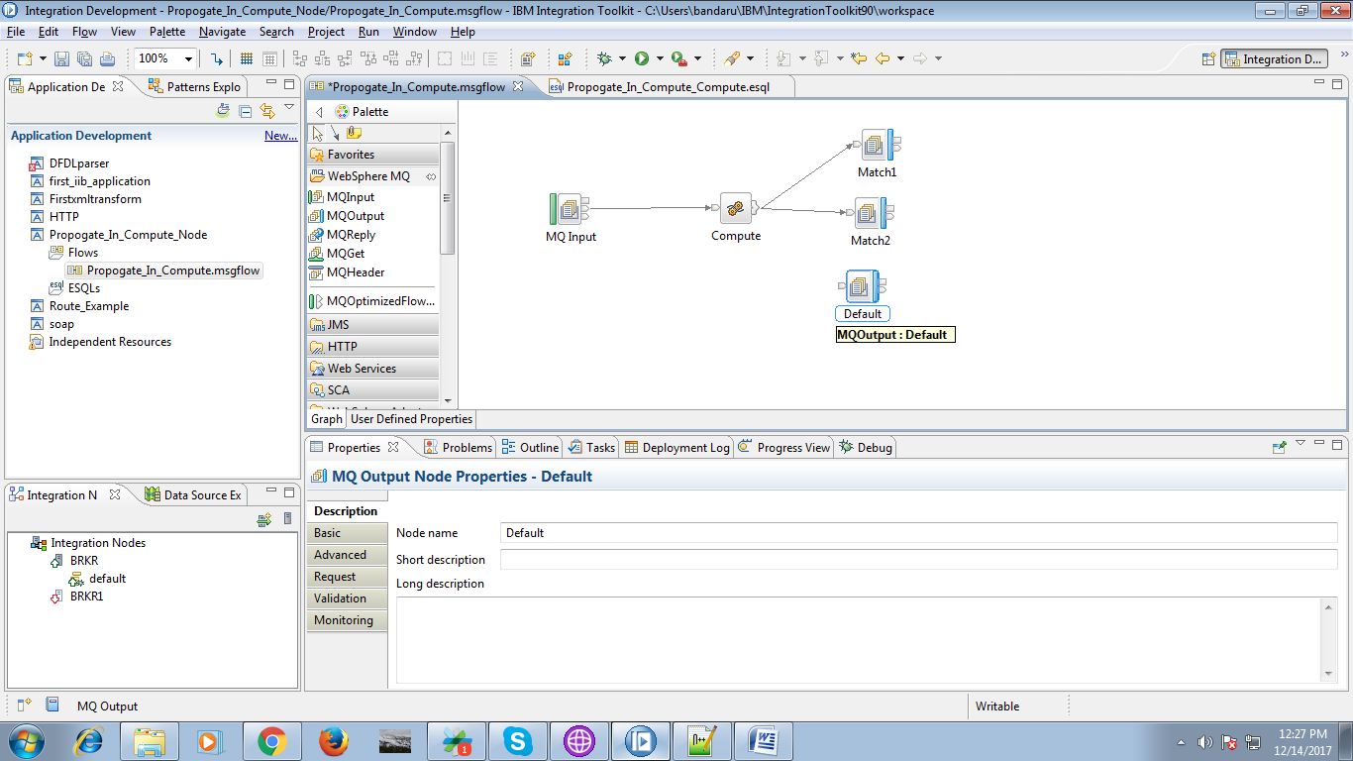

15. Connect "Out2" terminal of compute to "input" terminal of MQOutput queue.

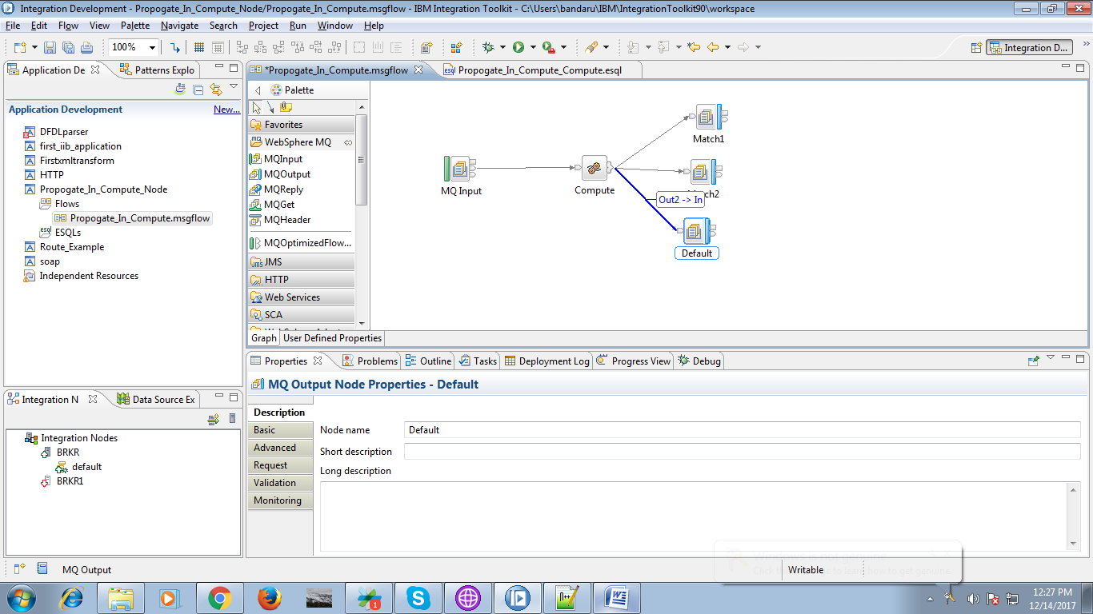

16. When you double click on compute node, following code will appears.

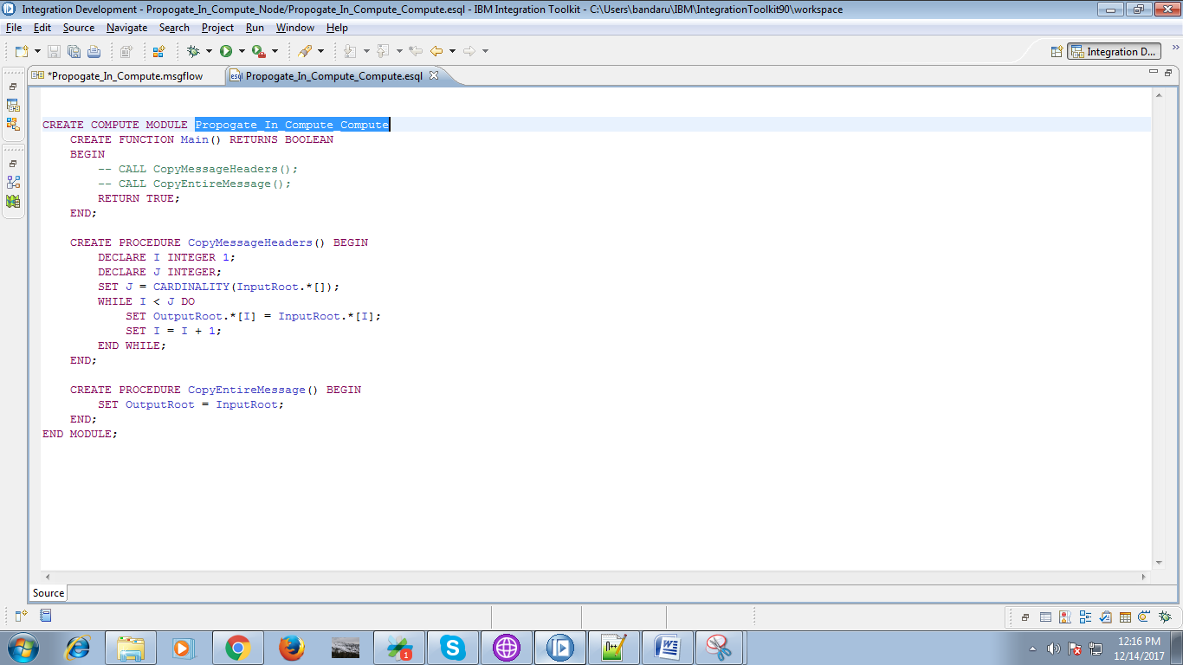

17. Edit the code by following code.

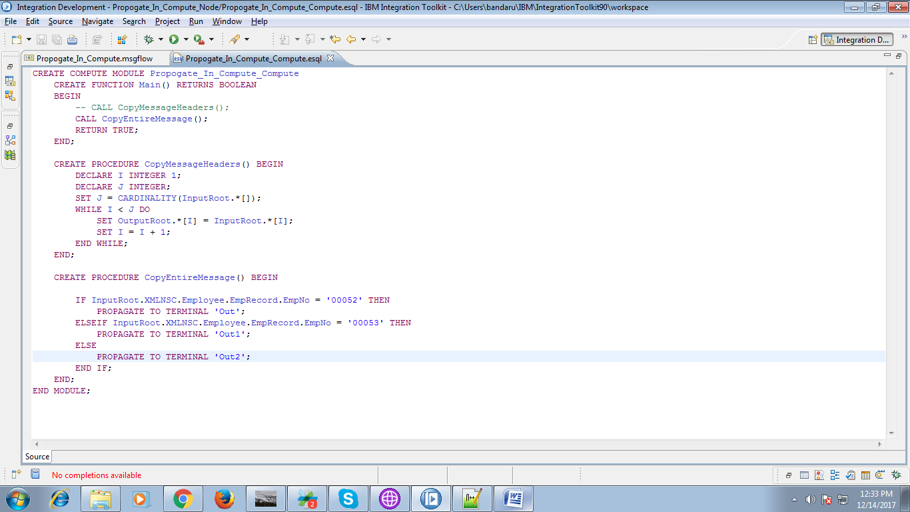

18. When you right click on your application, you can find deploy option as given below. Deploy the application on broker.

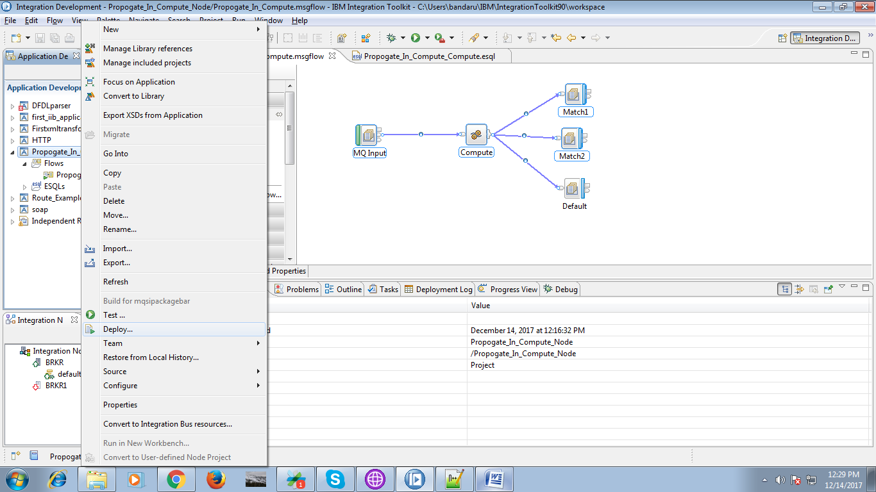

19. The Input file contains following data.

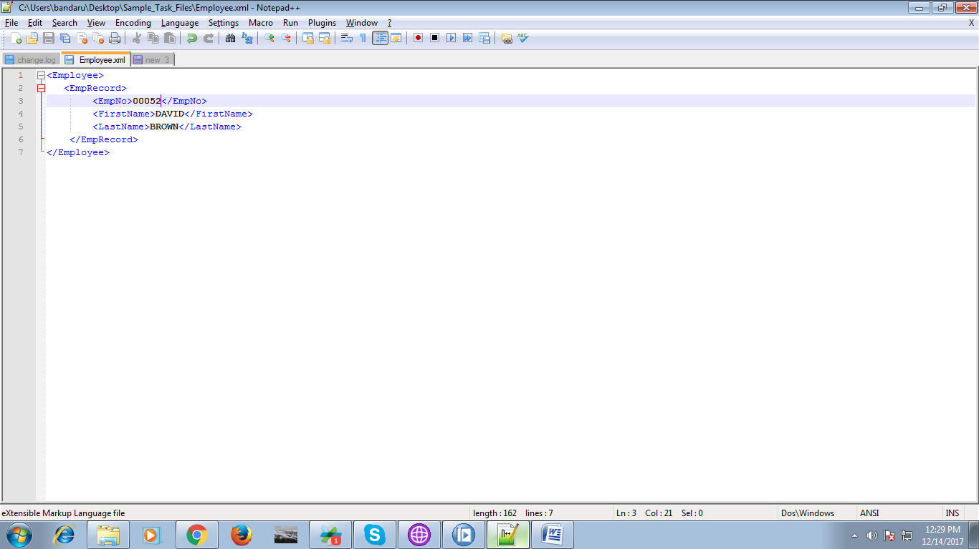

20. Now open "rfhutill" and select input queue and click "Open File". Browse you input file as shown below.

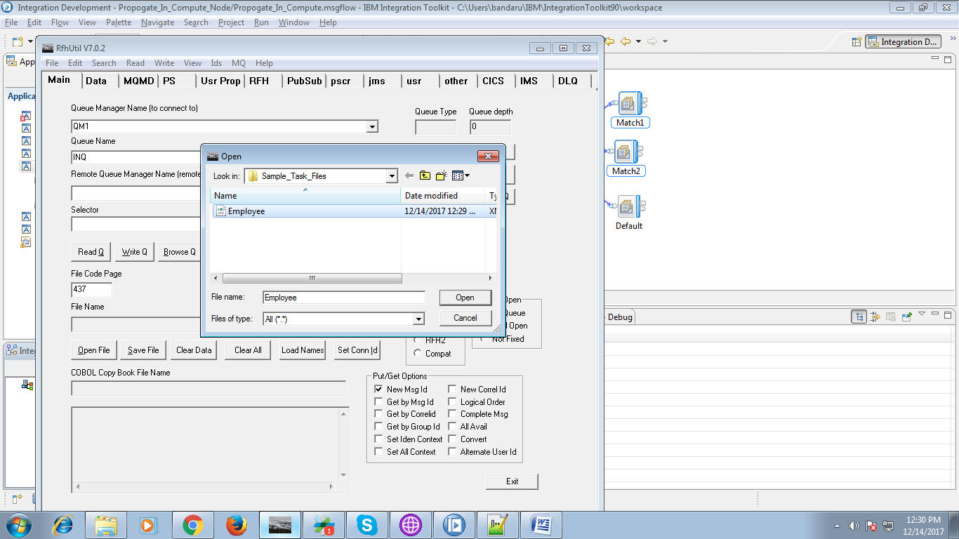

21. Now hit "Write Q". If you run your flow in debug, your flow will triggers and can check how message flows.

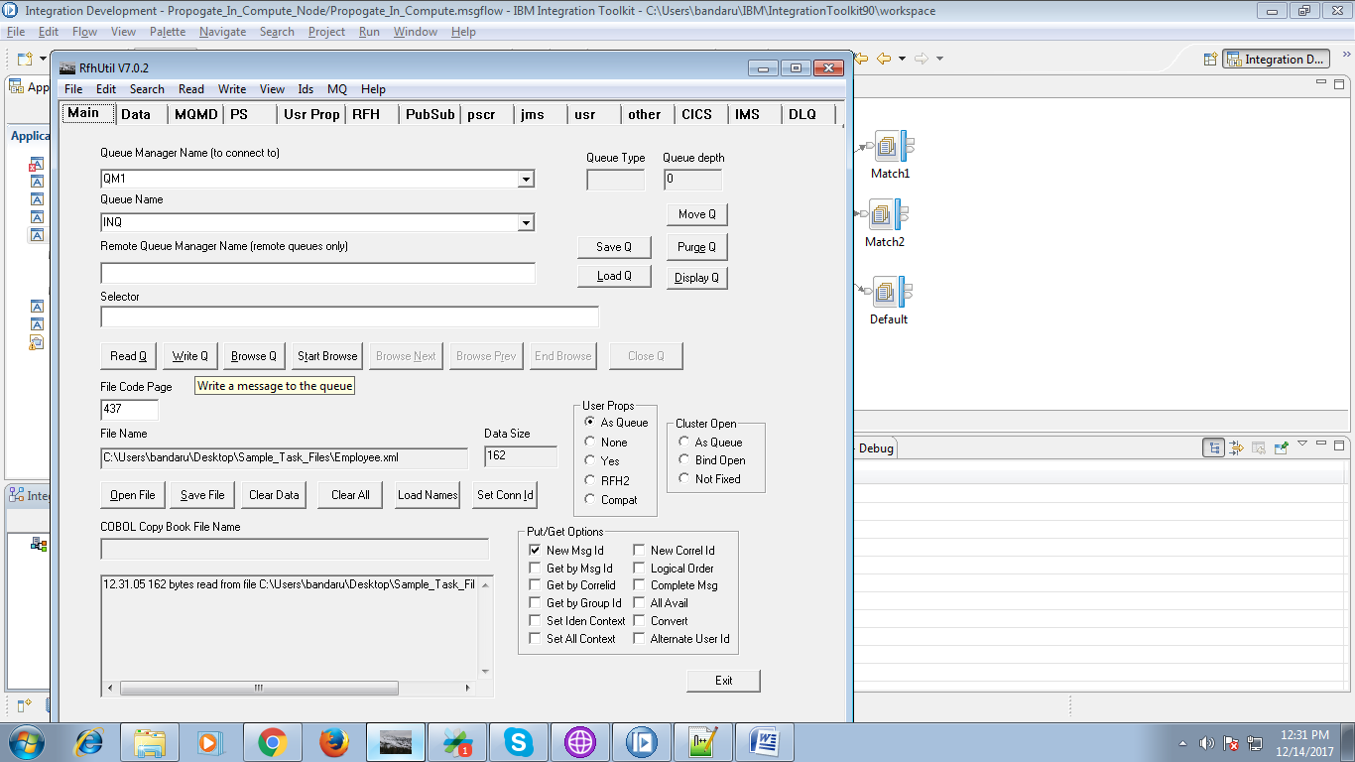

22. Since none of the condition matched, it enters into default queue. following two fig shows.

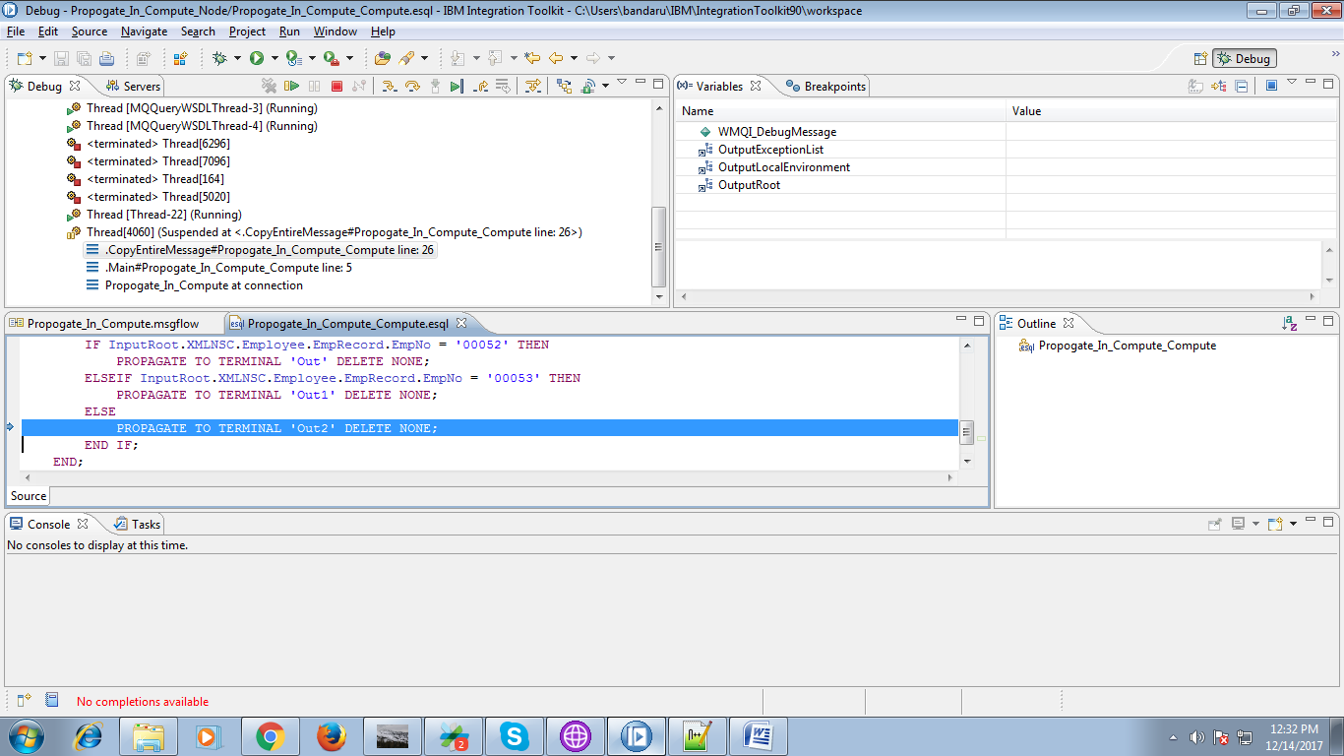

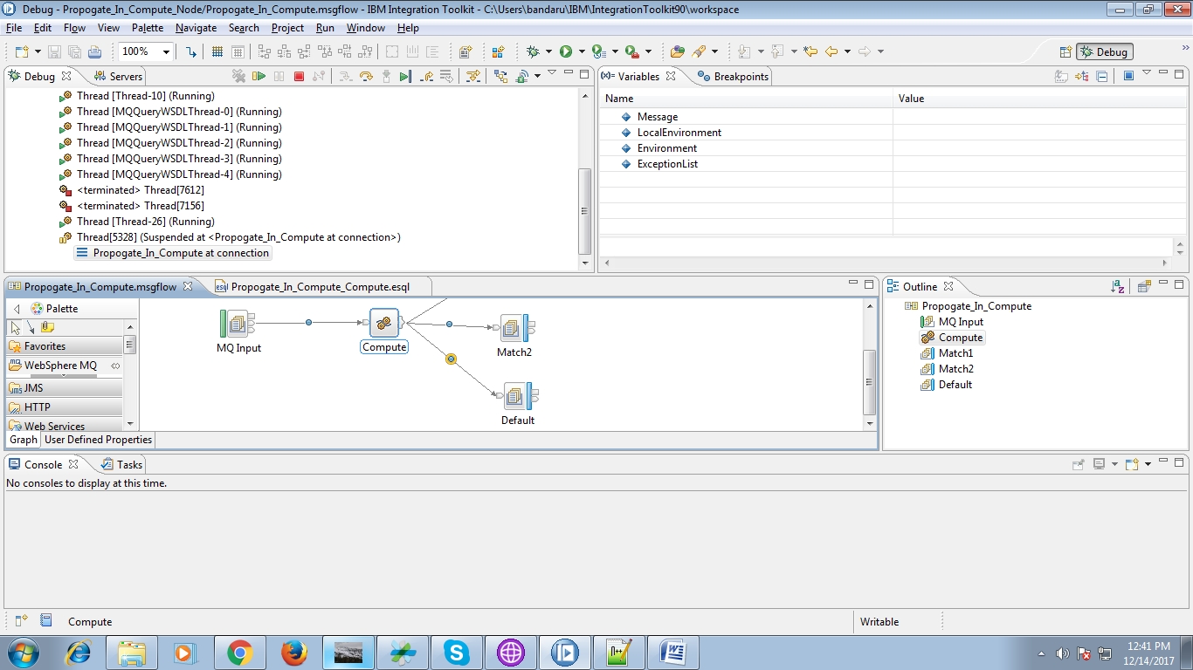

23. Now select "Default" queue and hit "Browse Q" tab as shown in below two figs..

