String Functions

1. Click on File and select "New"=> "Application"

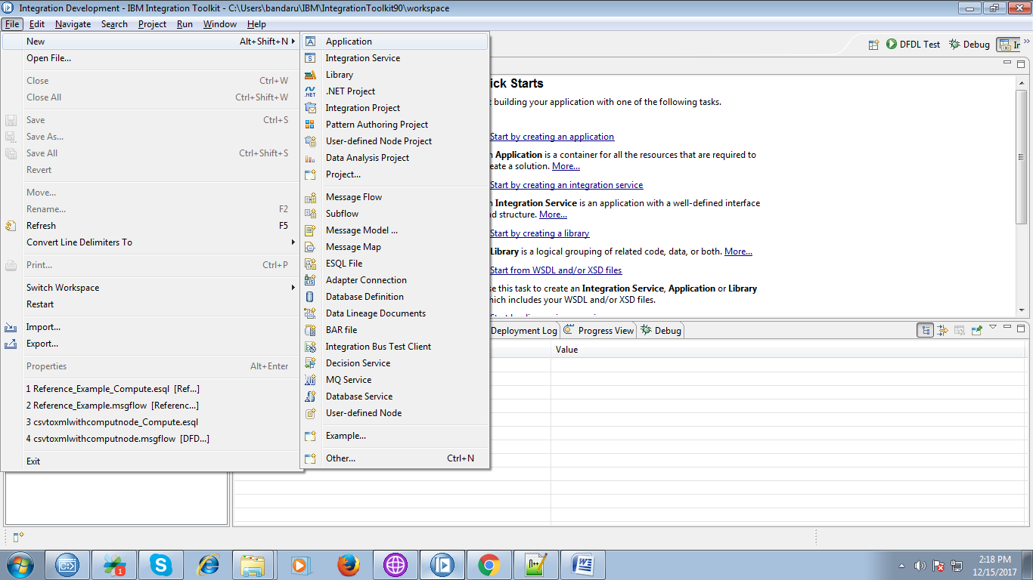

2. A pop-up will appears to provide name for your application and click "Finish".

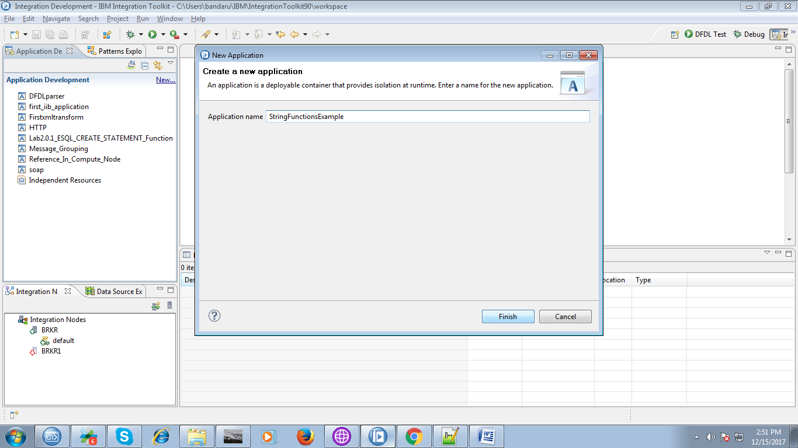

3. Under your application, you able to see "New" click on it.

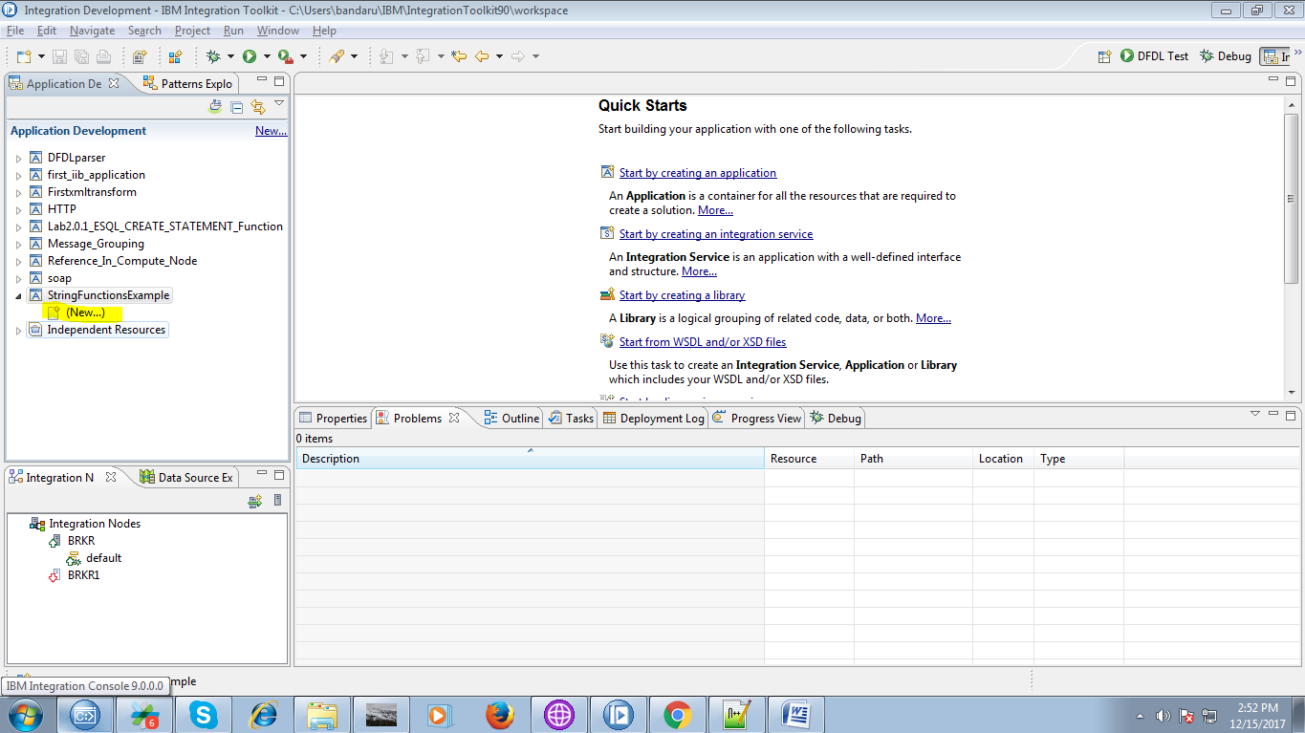

4. Select "Message Flow" from given options.

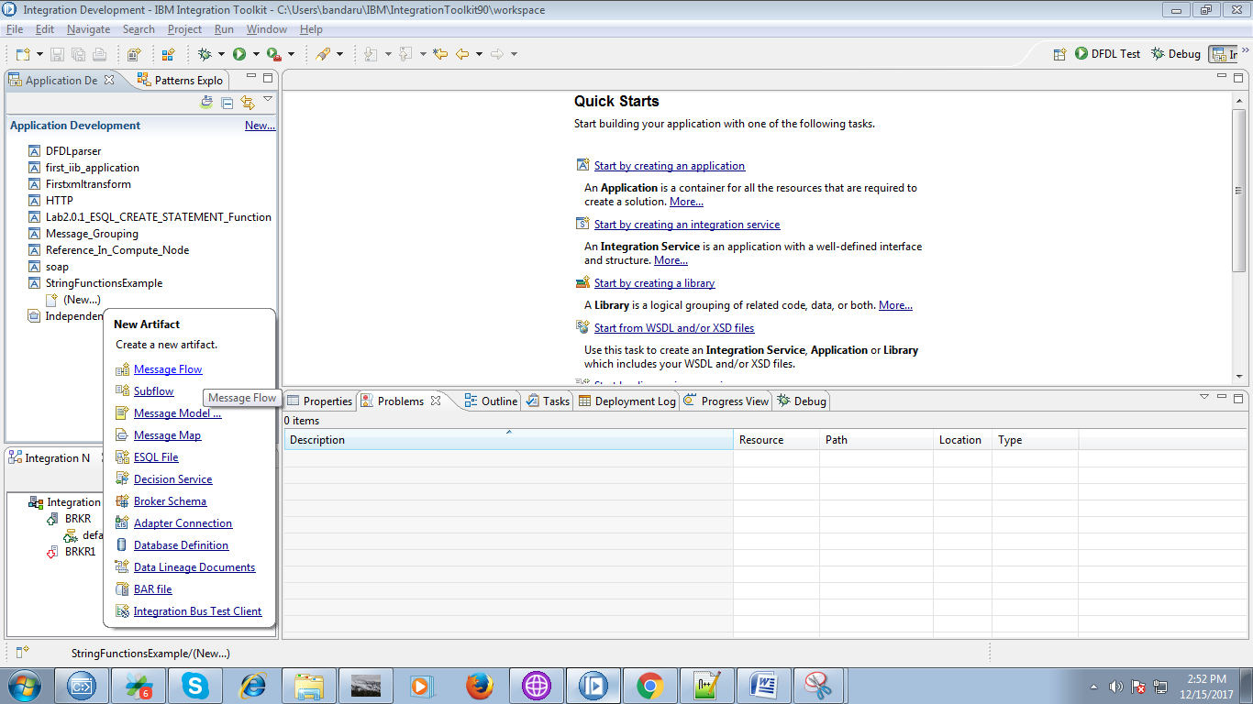

5. Name your flow and click "Finish" button.

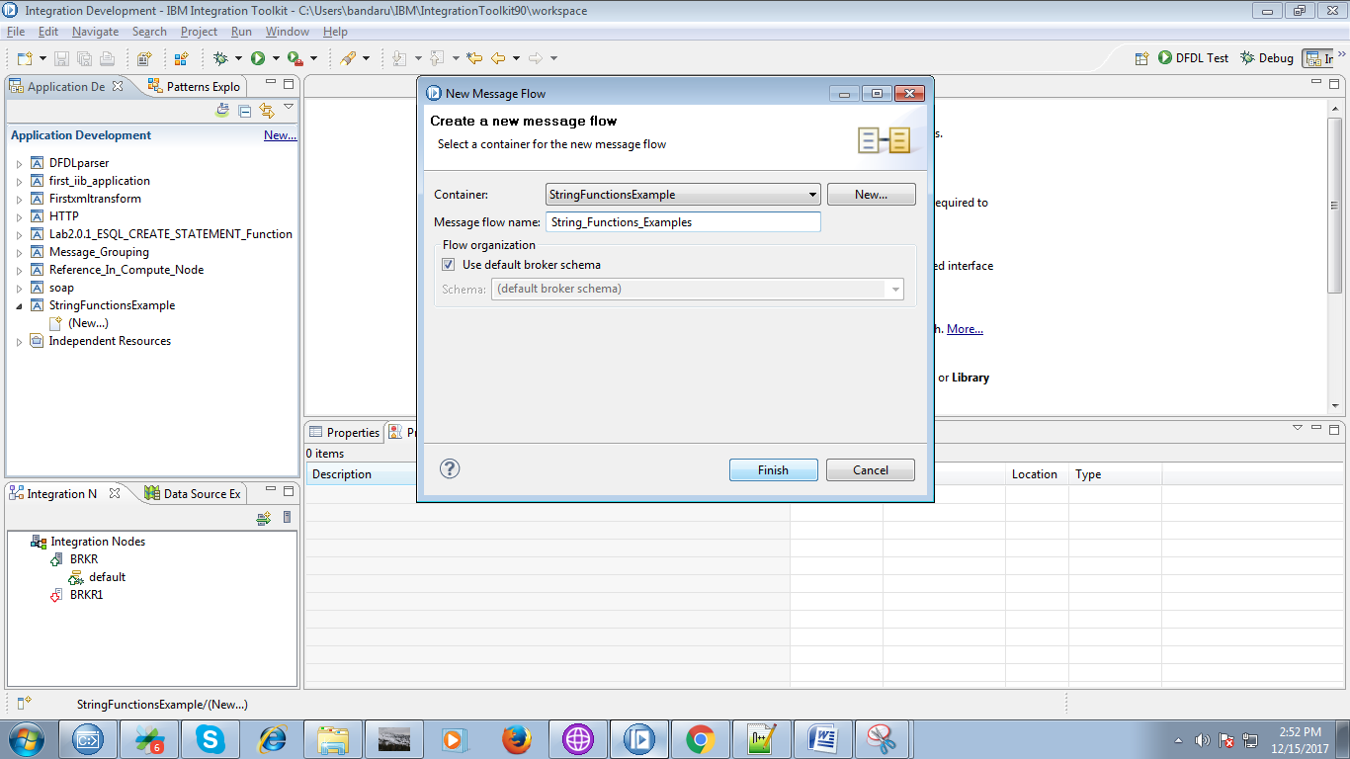

6. Drag the "MQInput" from "WebSphere MQ" and name the queue.

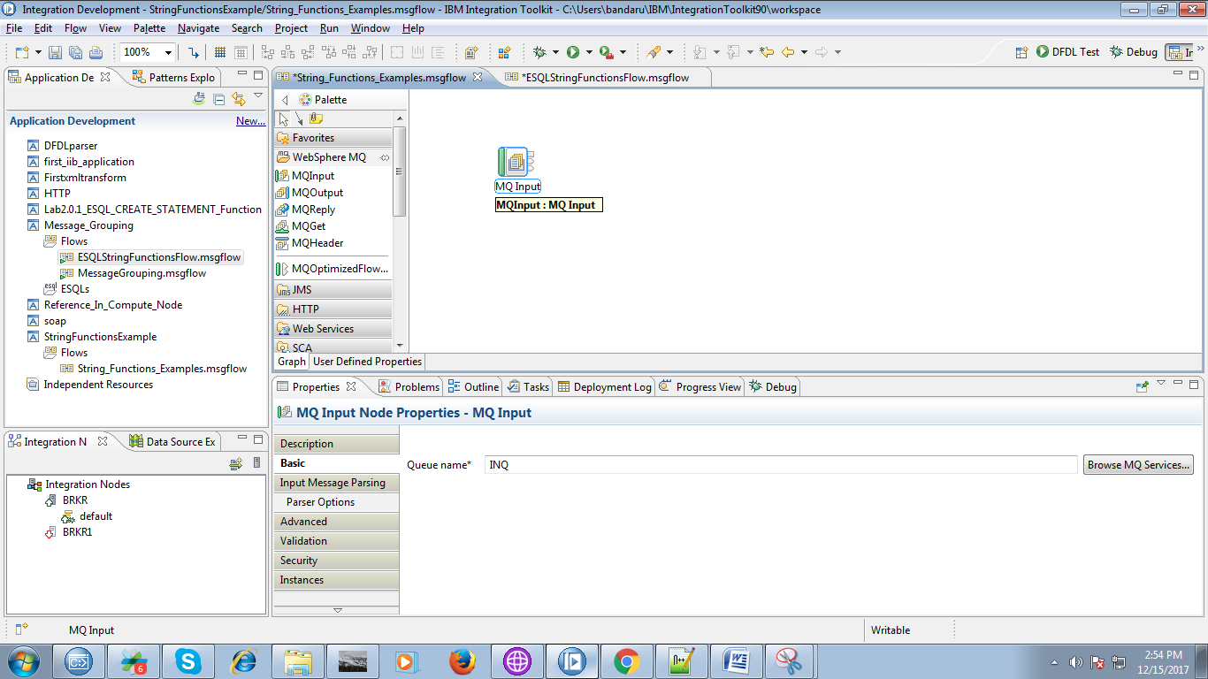

7. Drag the "Compute node" from "Transformation" section.

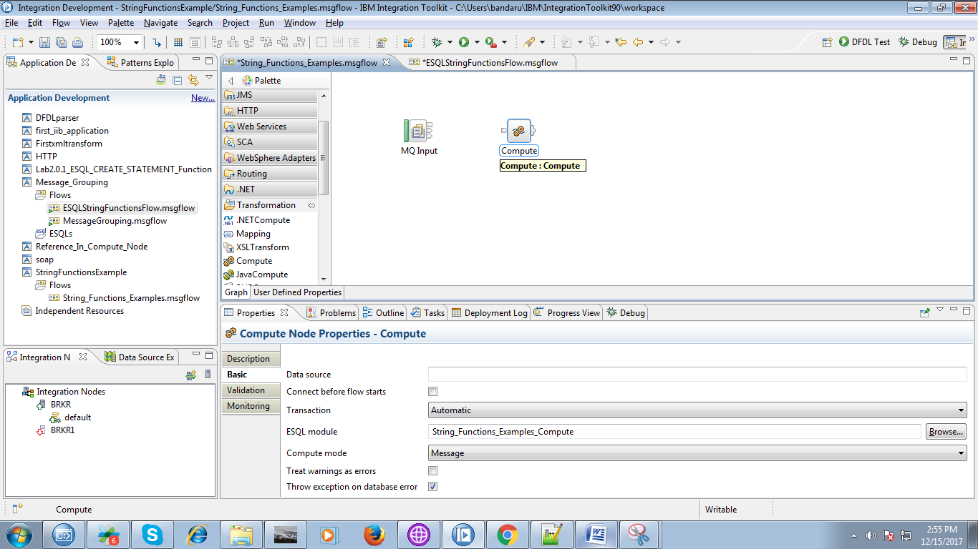

8. Connect the "output" terminal of the inputQueue to "input" terminal of the compute node.

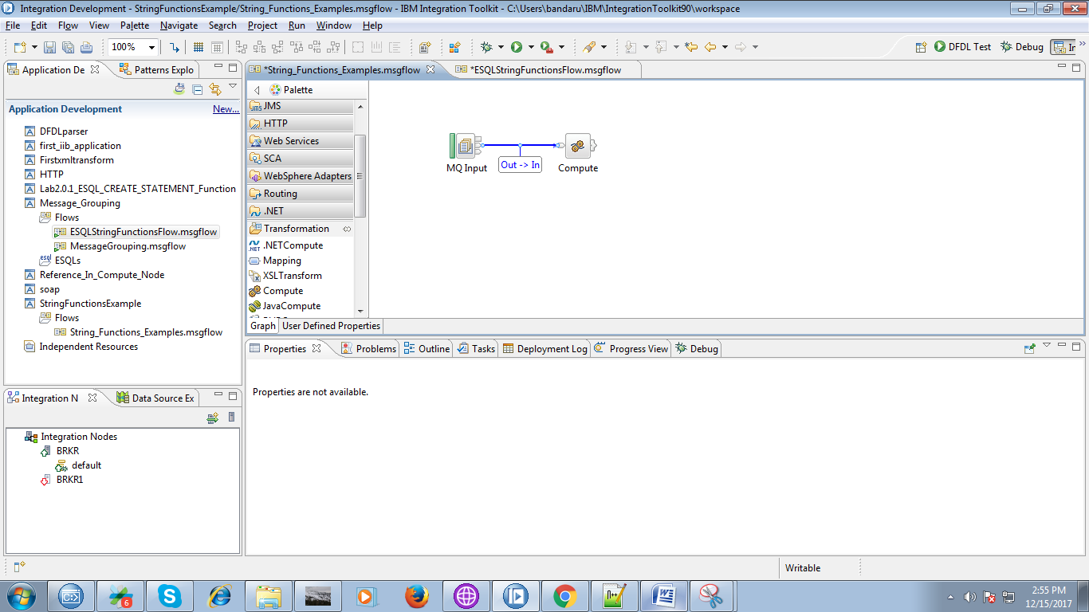

9. Drag the "MQOutput" from "WebSphere MQ" section and name it.

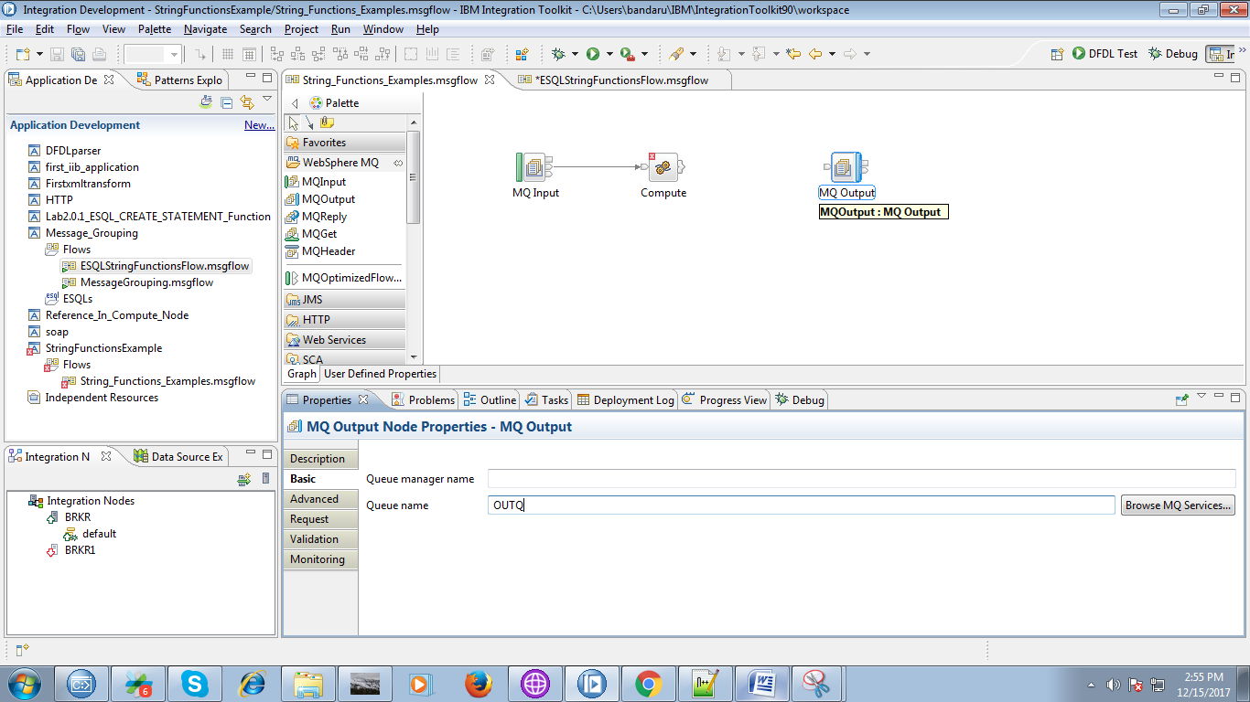

10. Right click on output terminals of the compute node and select "Out" terminal as below fig.

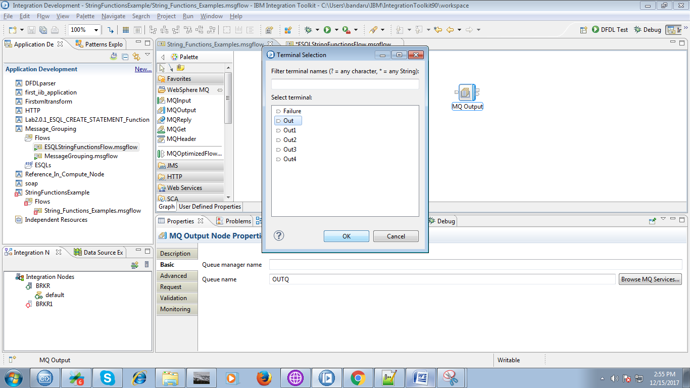

11. Connect "output" terminal of the compute node to "input" terminal of the outputQueue.

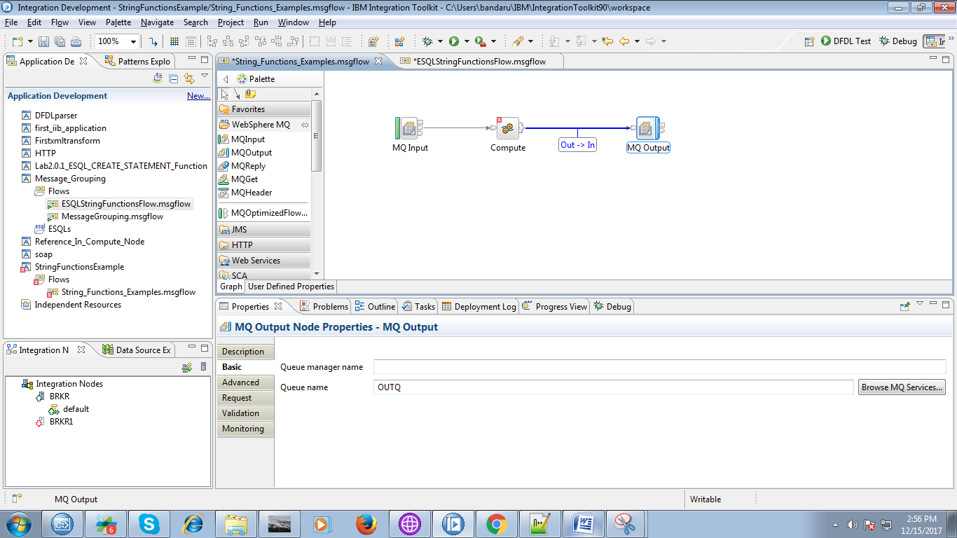

12. Right click on the compute node than following code will appears.

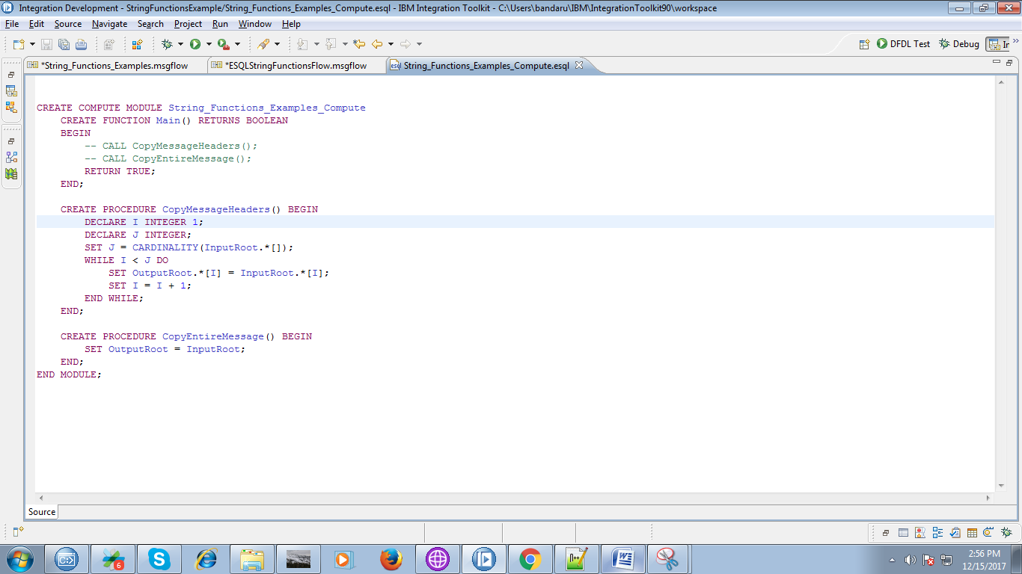

13. Override the code with below fig code.

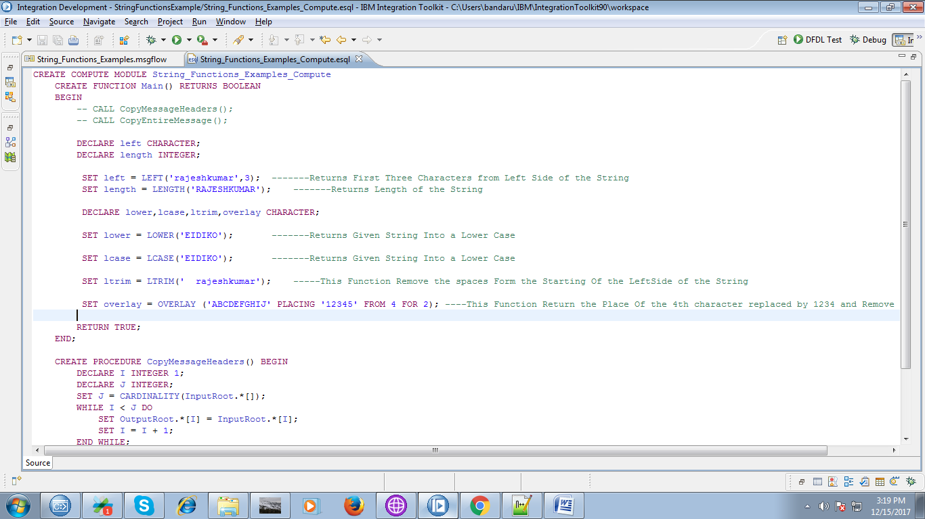

14. Overall flow looks like following fig.

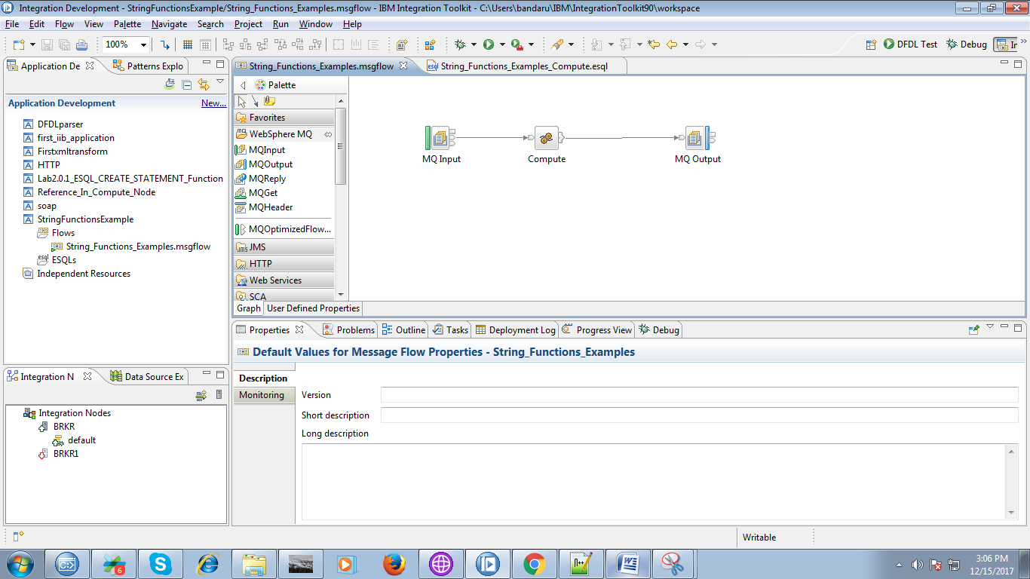

15. Open "IBM WebSphere MQ Explorer" and create local queues which used in flow.

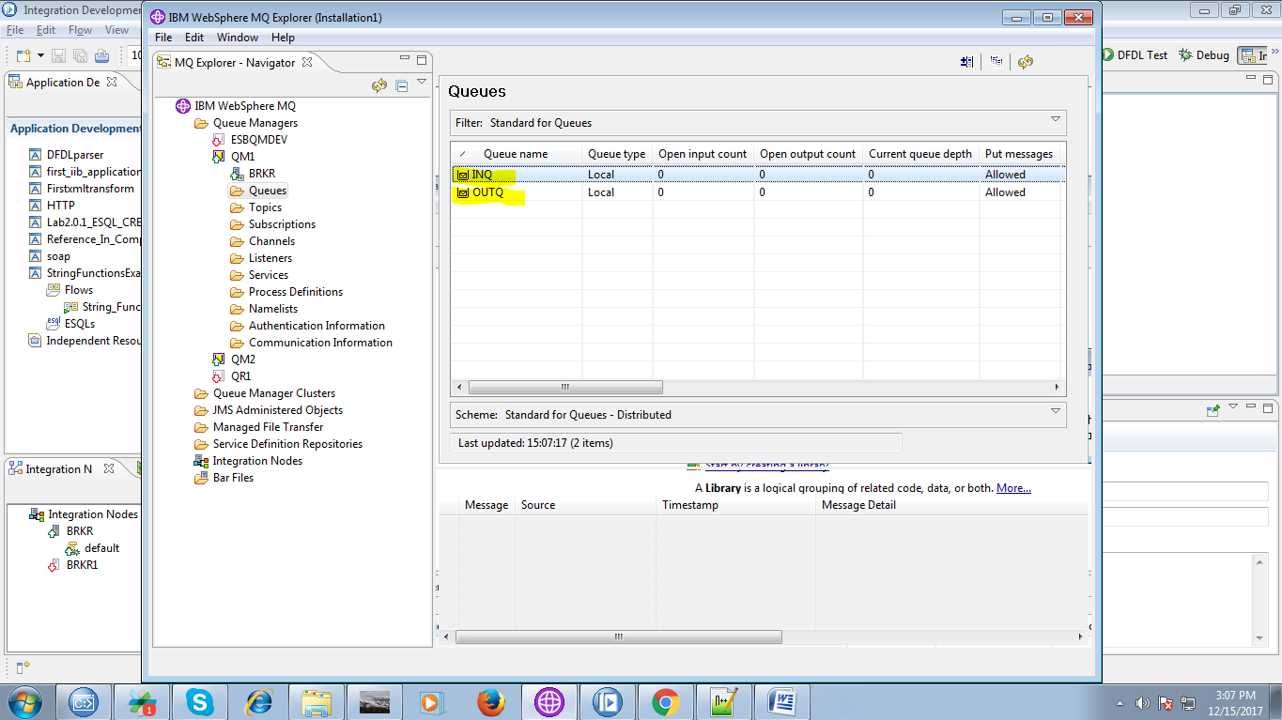

16. Right Click on your application, you able to see "Deploy" option click on it.

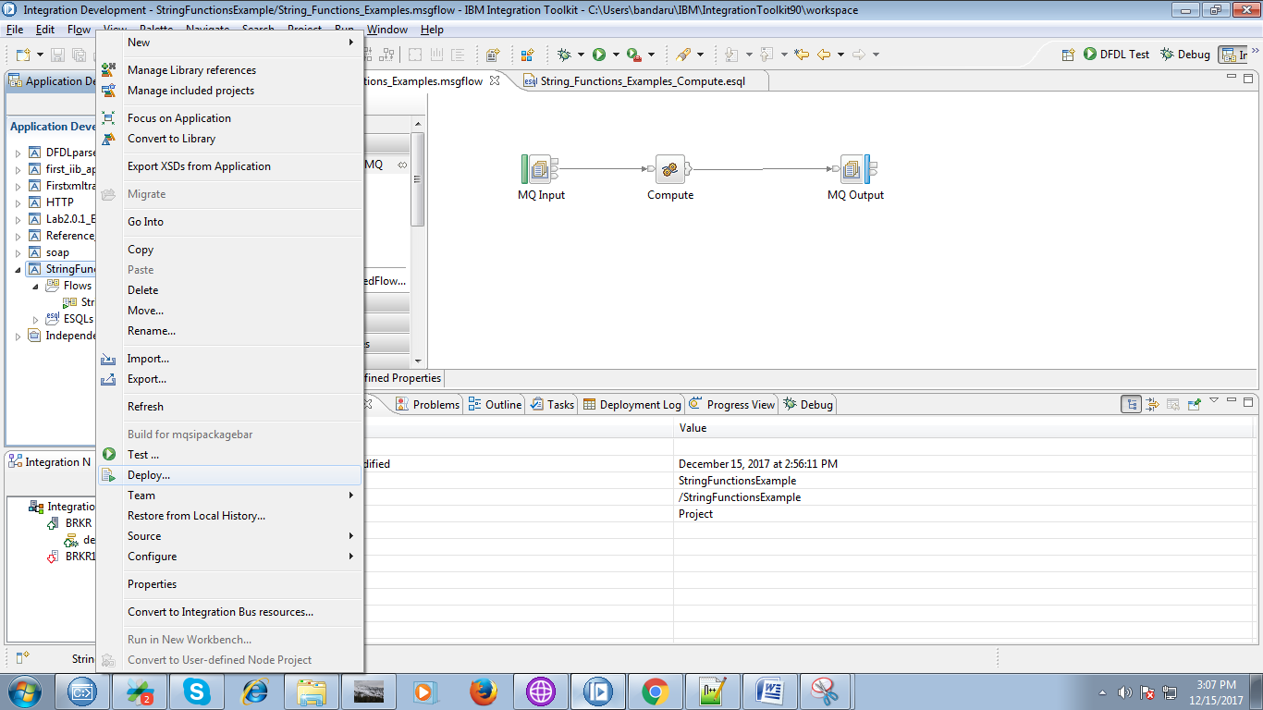

17. A pop-up will appears showing your brokers and execution group. select your execution group and click on "Finish" button.

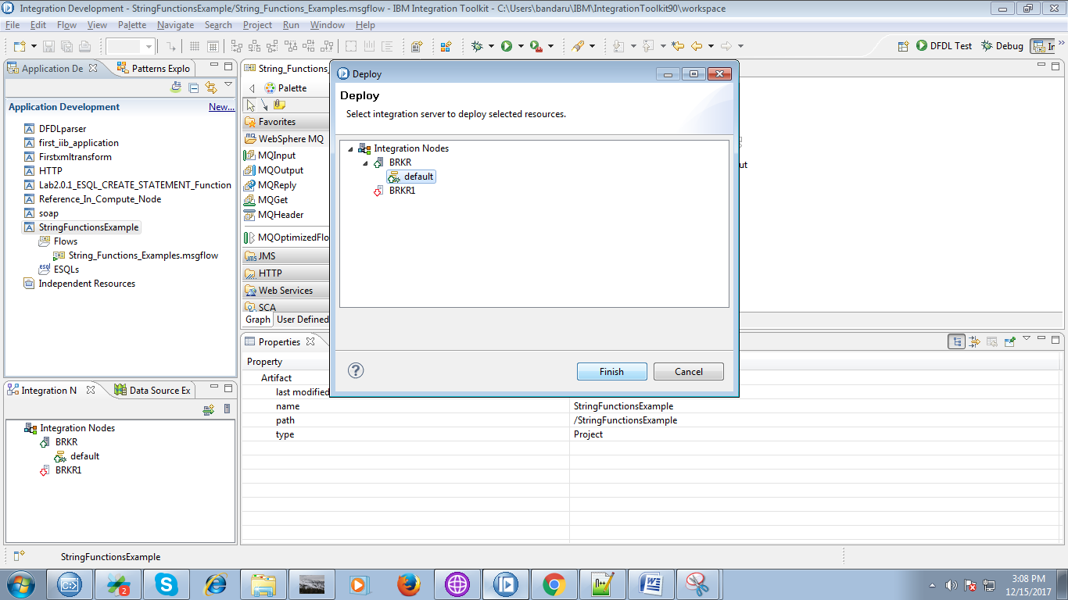

18. Put a message in "Input" queue as shown in below fig.

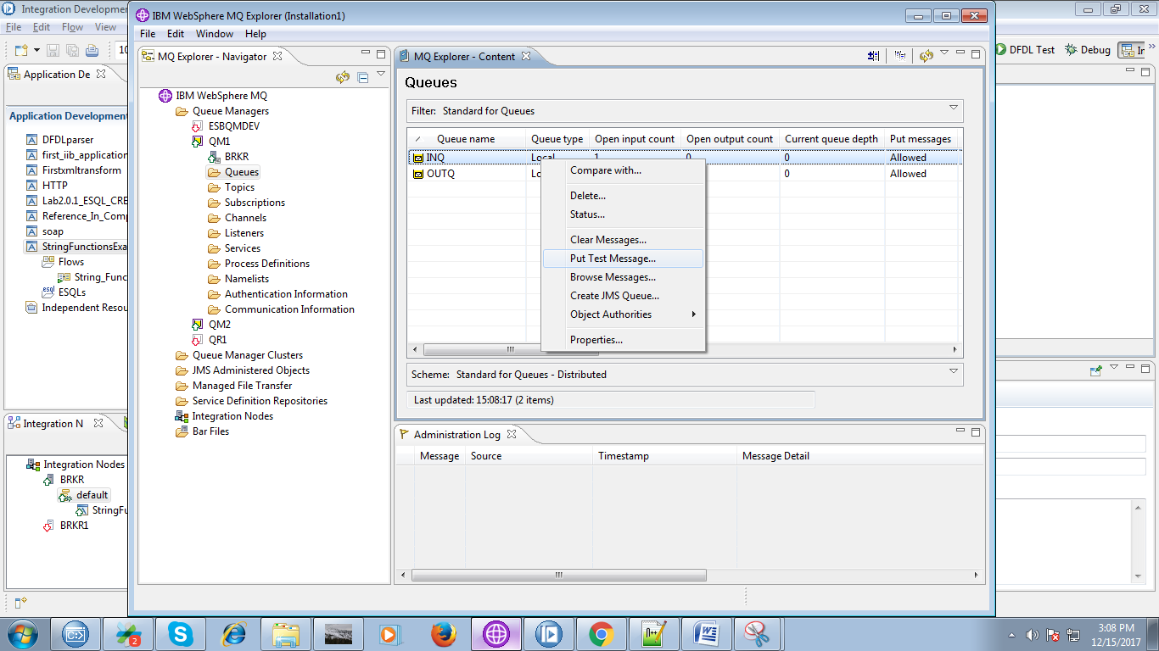

19. Type any message to trigger your flow.

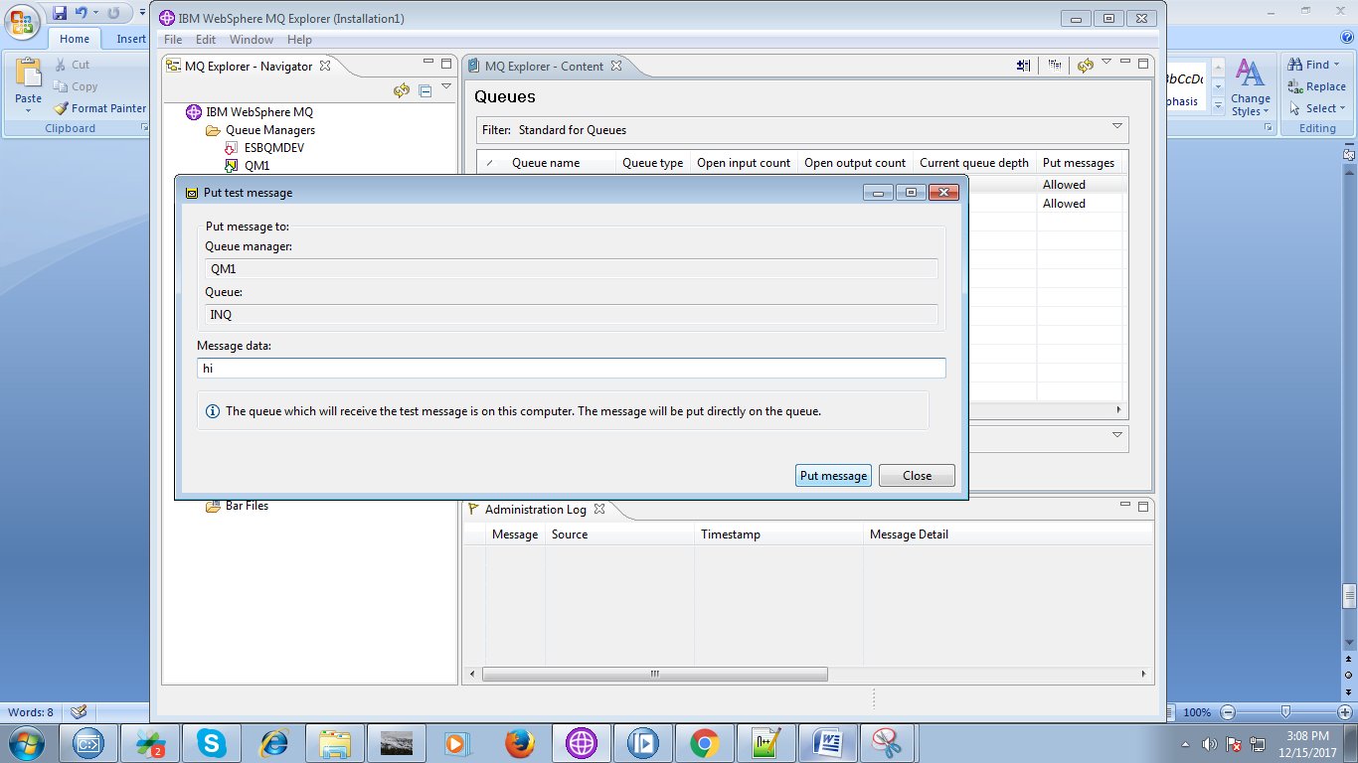

20. When you are running your flow in debug mode.

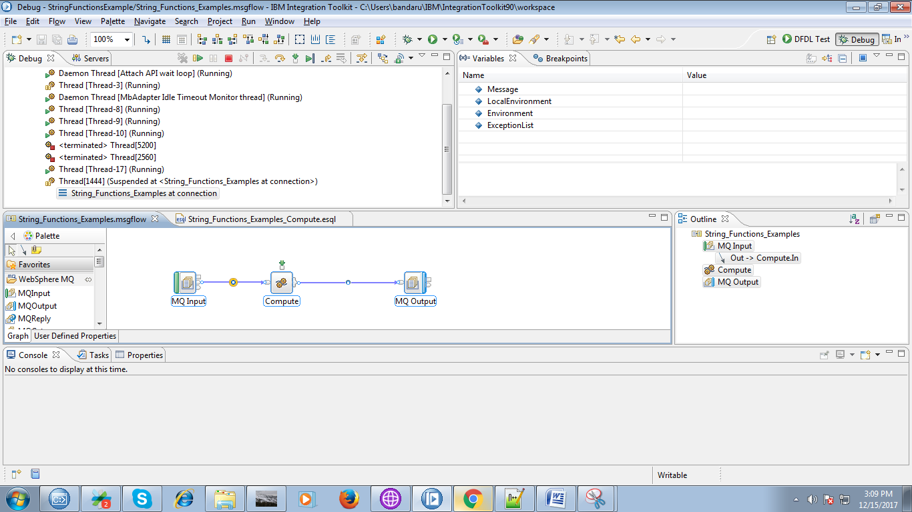

21. You can see your flow results in debug mode as below two figs.

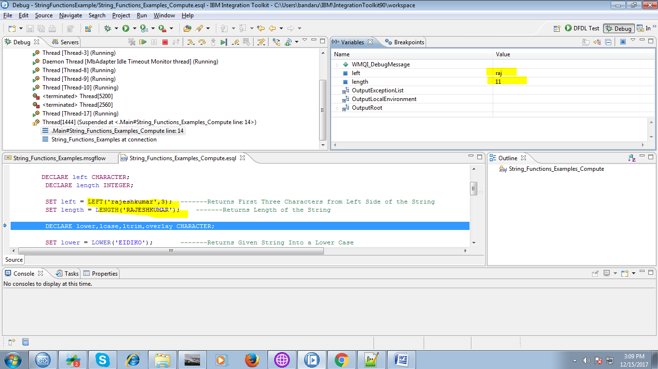

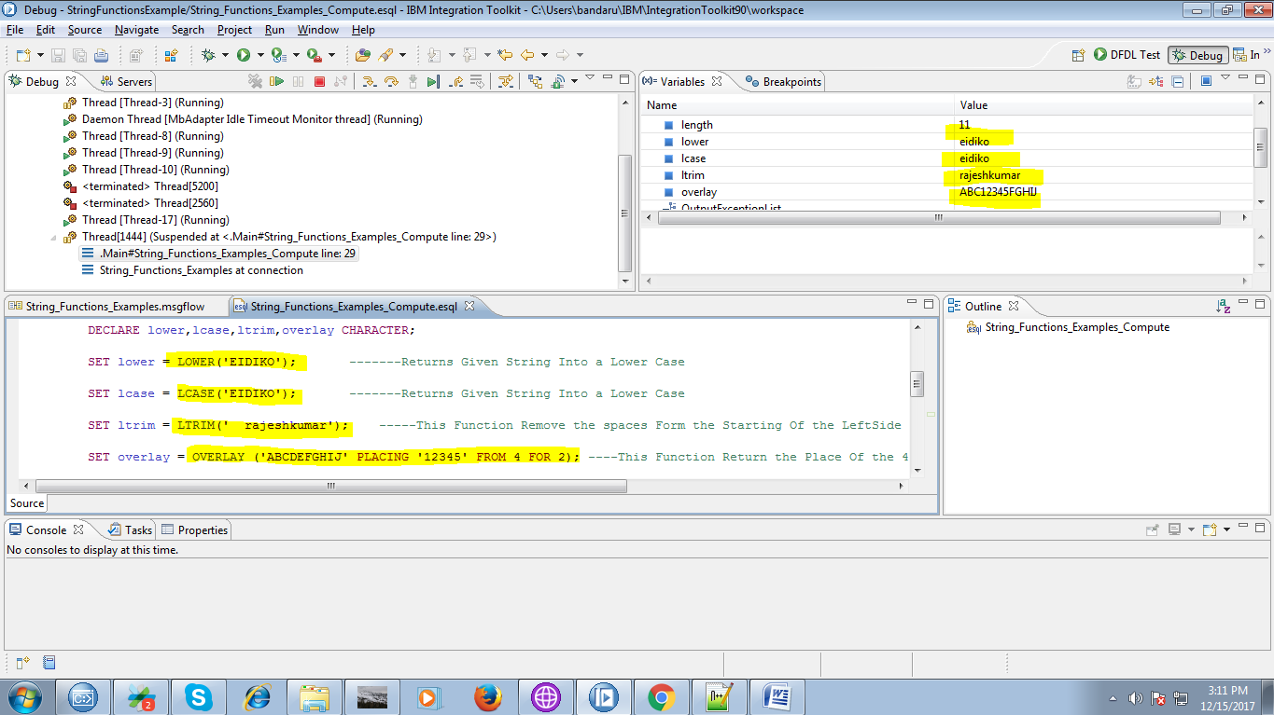

22. The output of the compute node after finishing process.

