Filter Node

1. Click on File and select "New"=>"Application" as shown below.

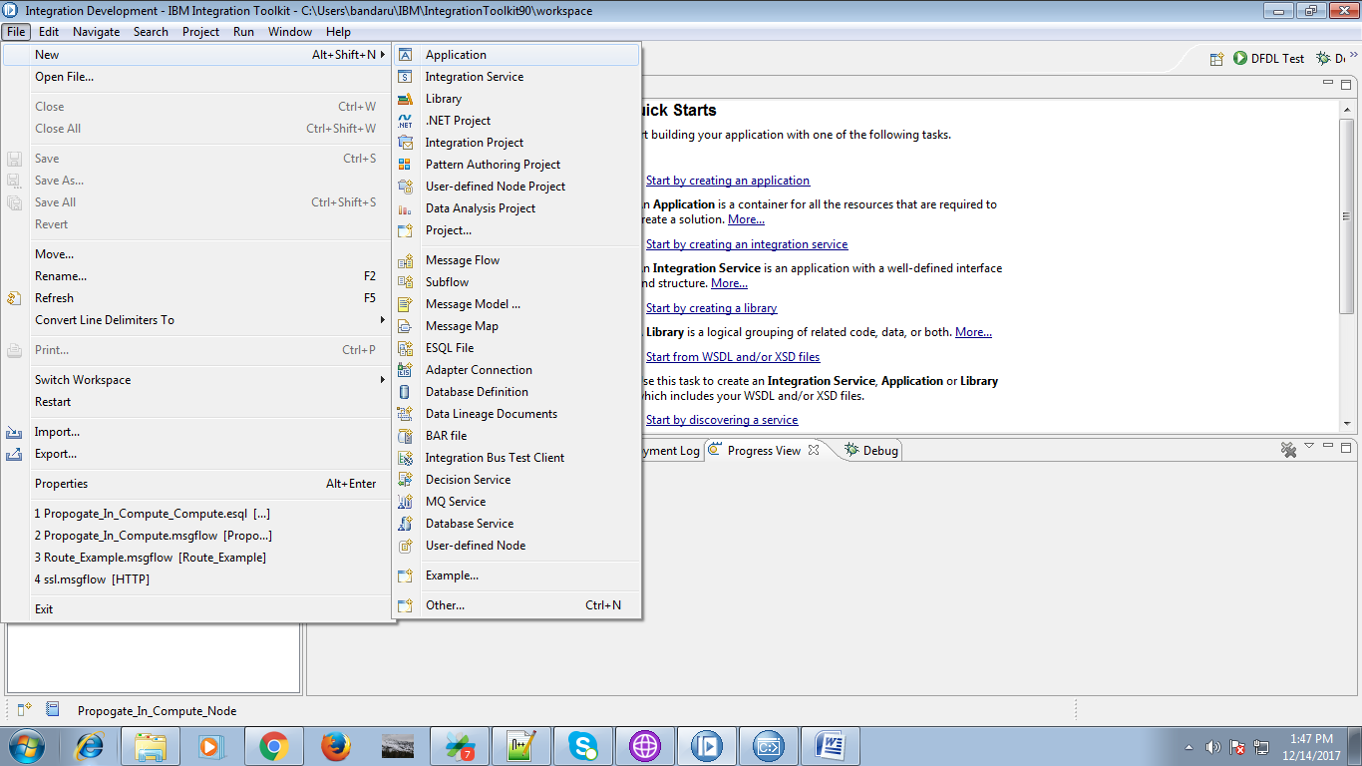

2. A pop-up will appears, give a name for your application and hit "Finish" button.

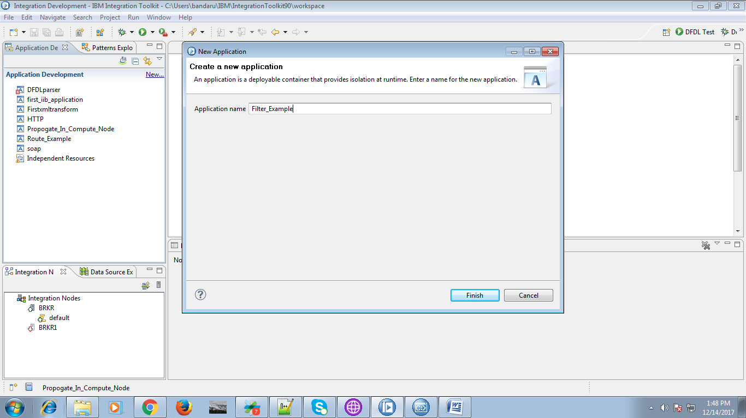

3. Under your application you will find "New" as shown below click on it.

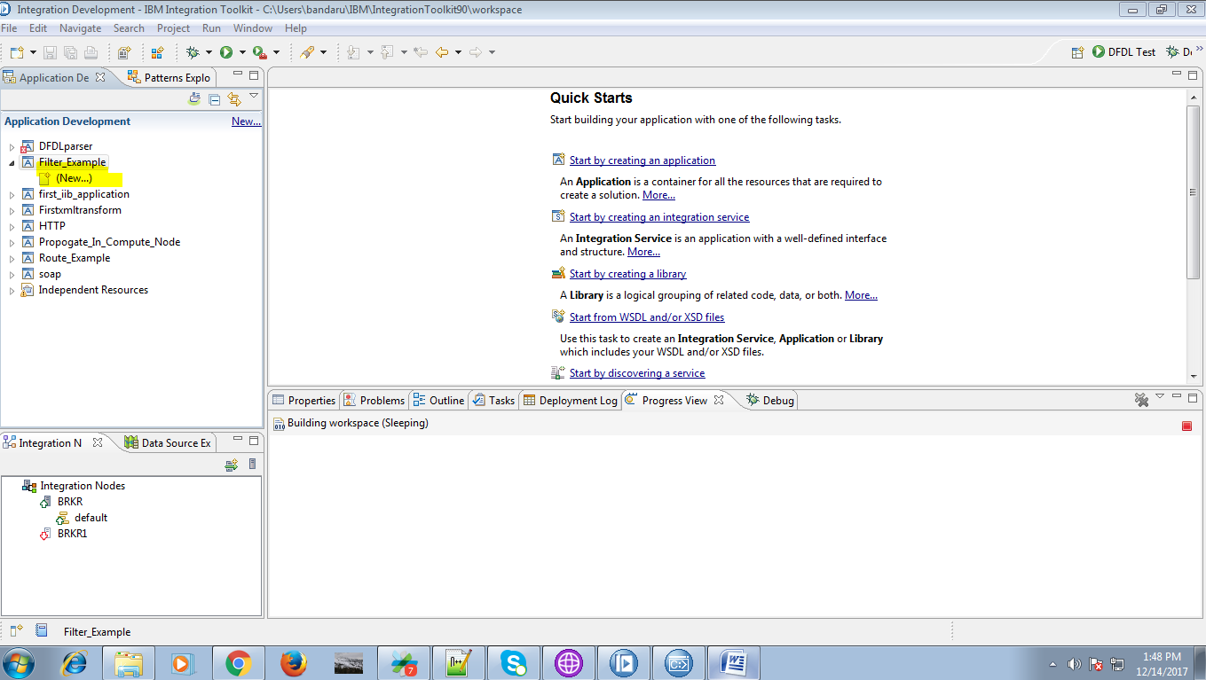

4. Than select "Message Flow" from given option.

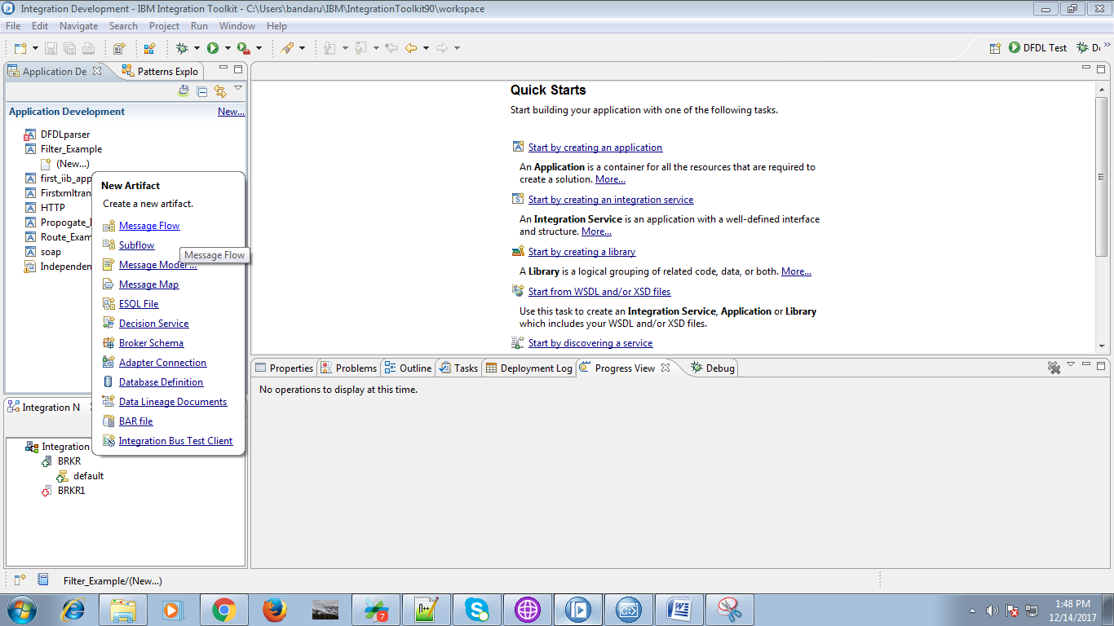

5. Give a name for your flow and hit "Finish" button.

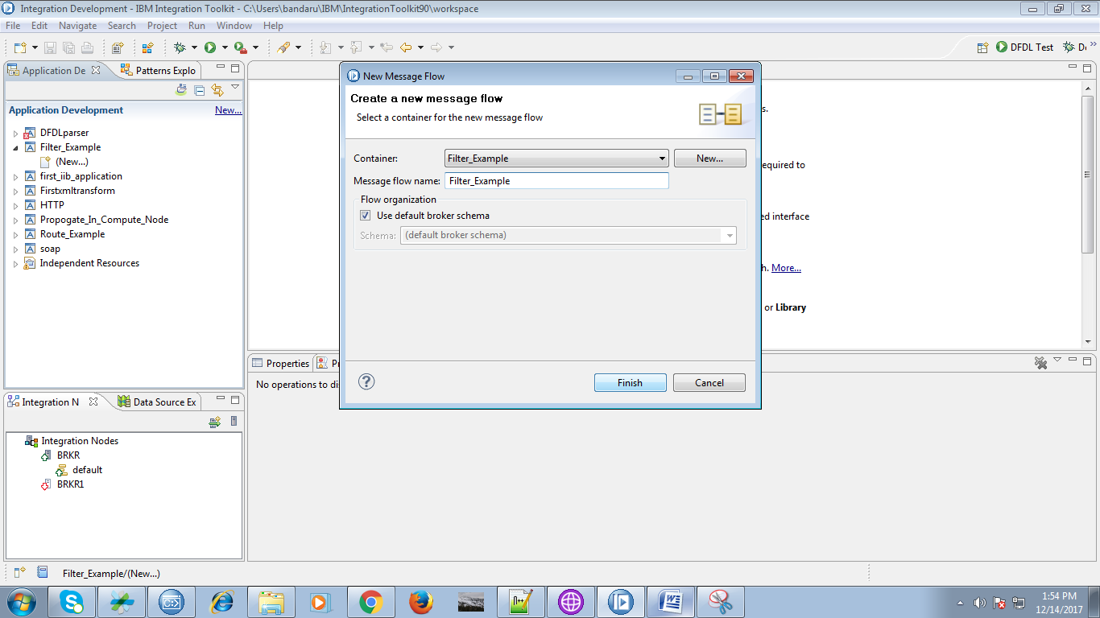

6. Drag the "MQInput" from the "WebSphere MQ" and give it a name as shown below.

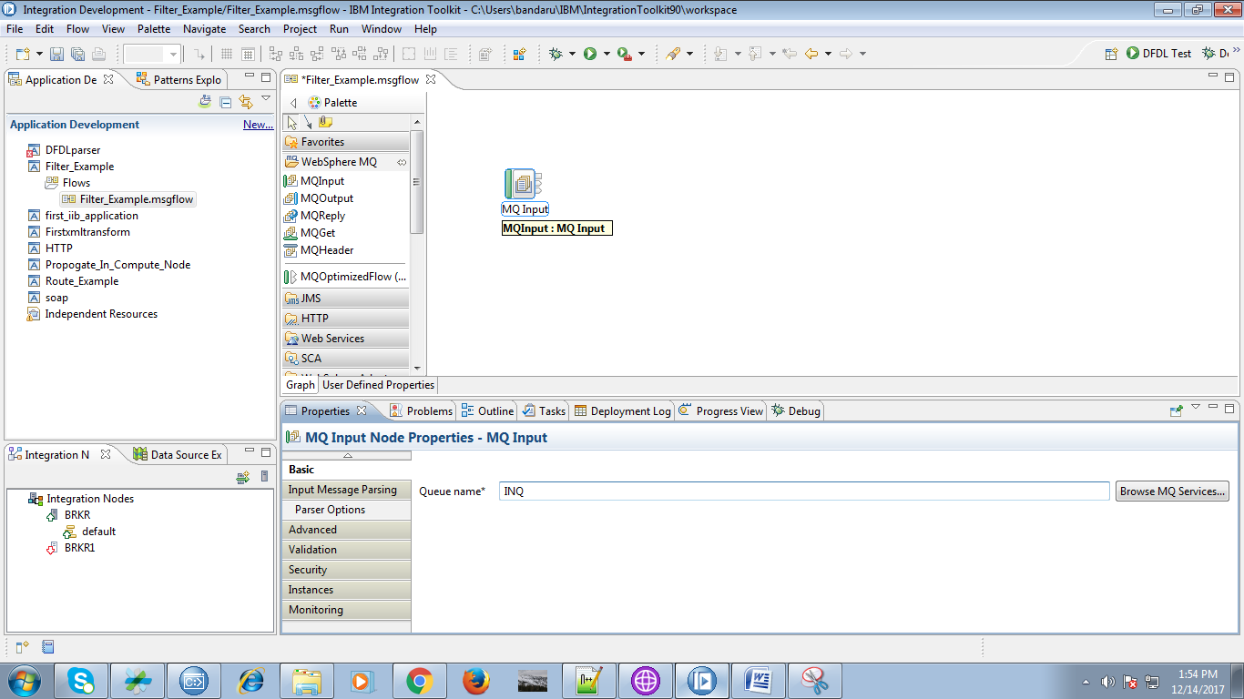

7. For the input queue under "Input Message Parsing" select Message domain as XMLNSC as shown below.

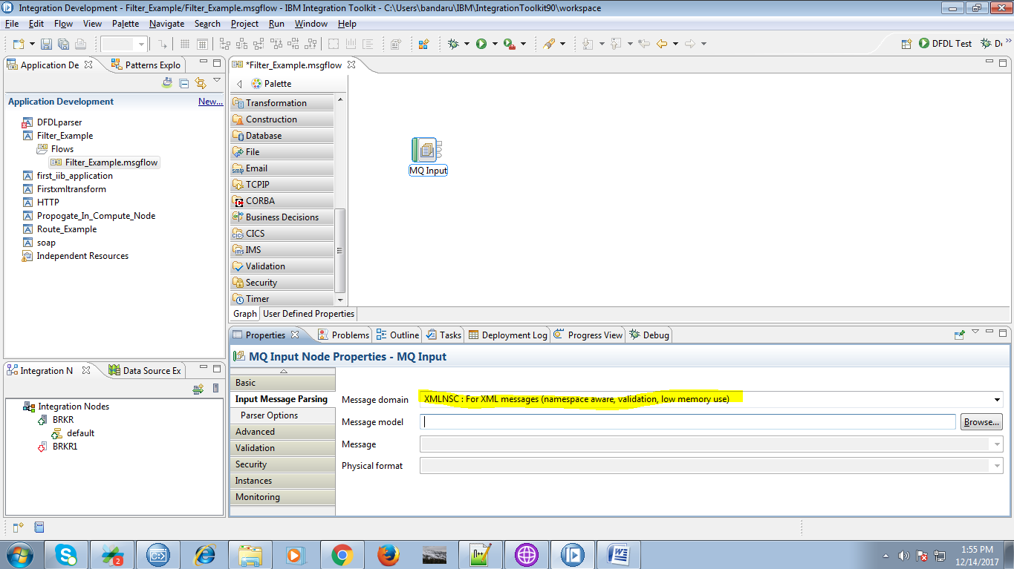

8. Drag filter node from route section as shown in below fig.

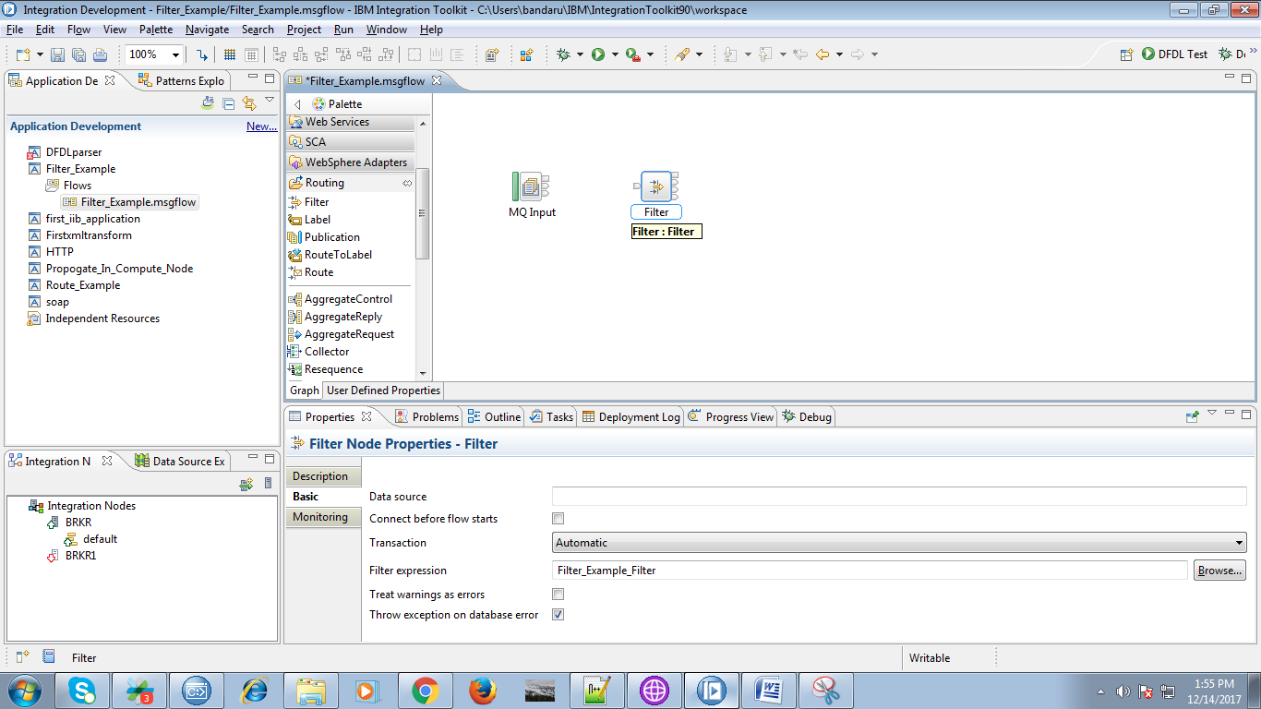

9. Connect "out" terminal of inputQ to "in" termainal of Filter as shown below.

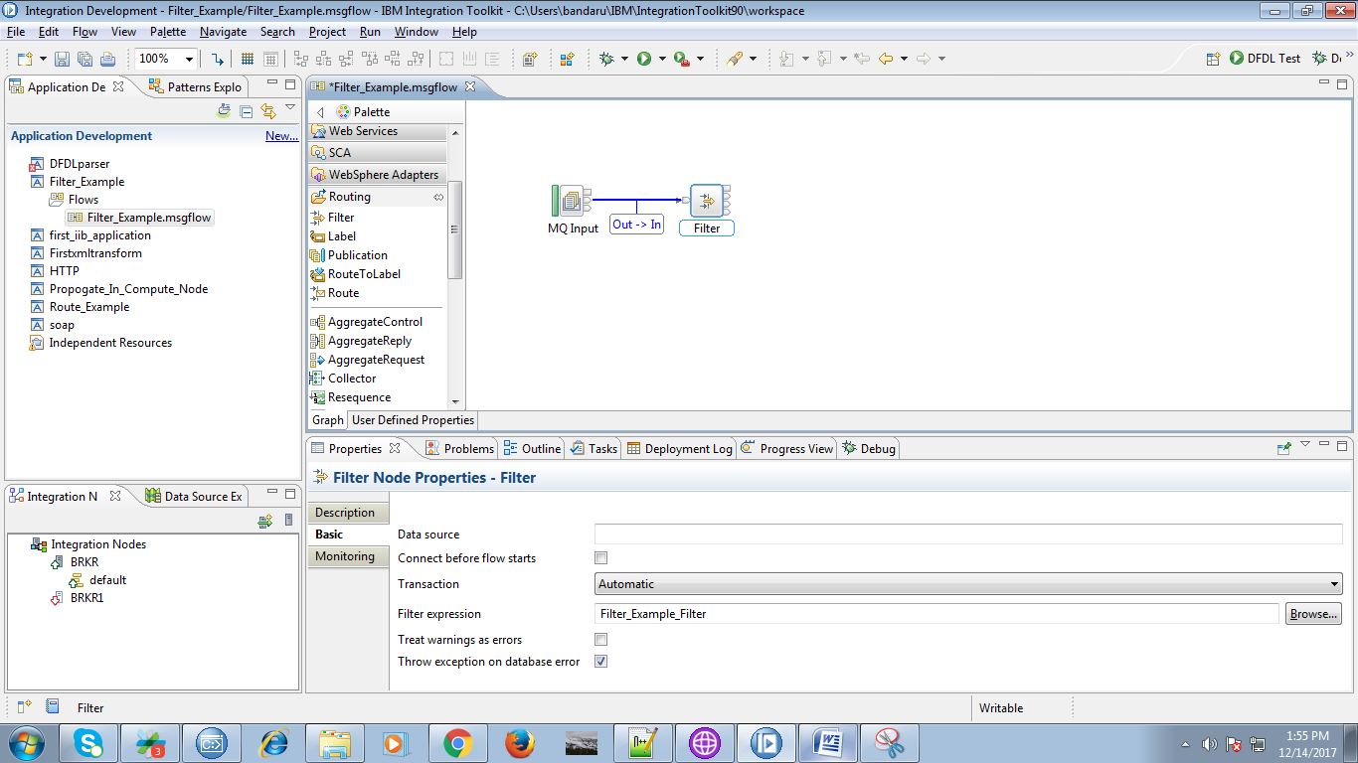

10. Drag a "MQOutput" from "WebSphere MQ" section and give a proper understanding as shown below.

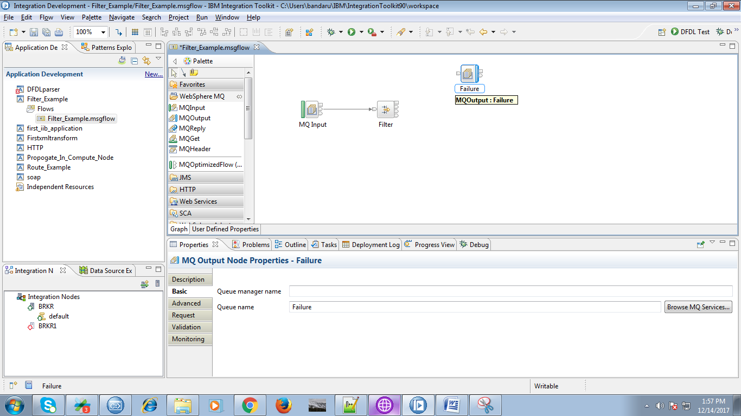

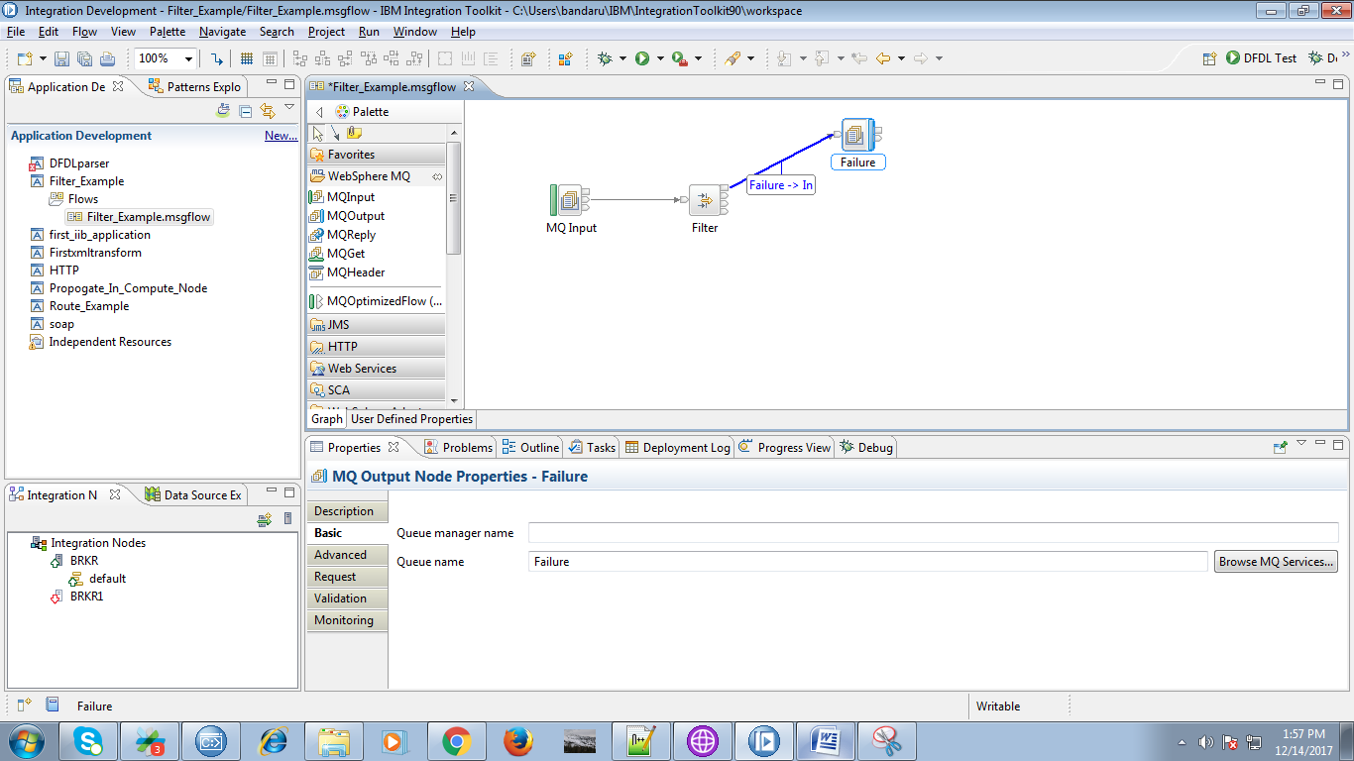

11. Connect "Failure" terminal of filter to "input" terminal of output queue.

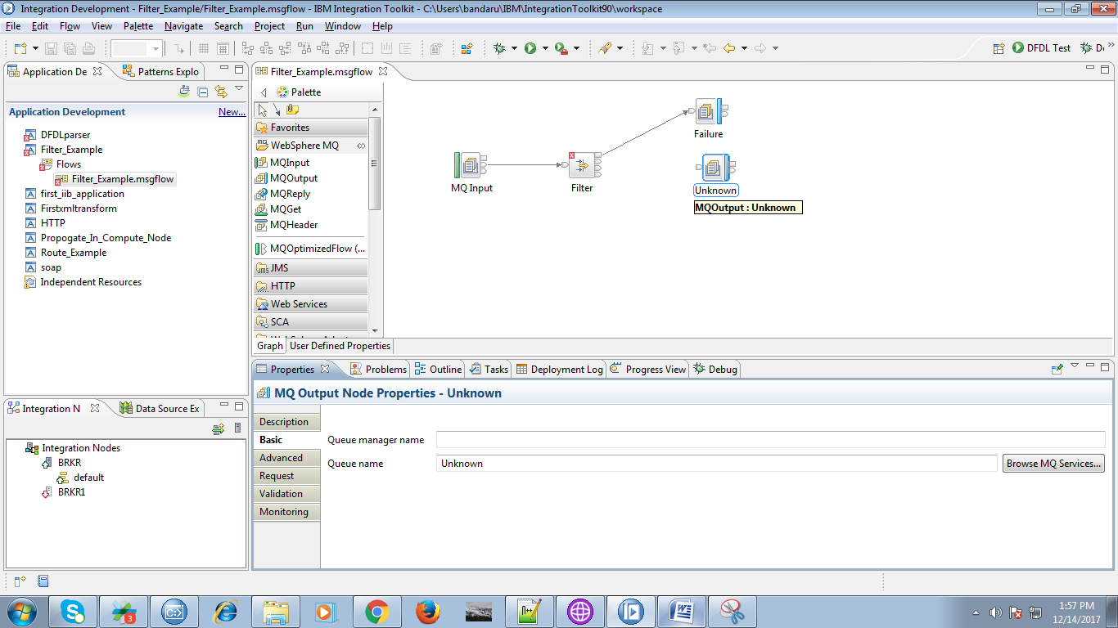

12. Drag a "MQOutput" from "WebSphere MQ" section and give a proper understanding and give connections as below.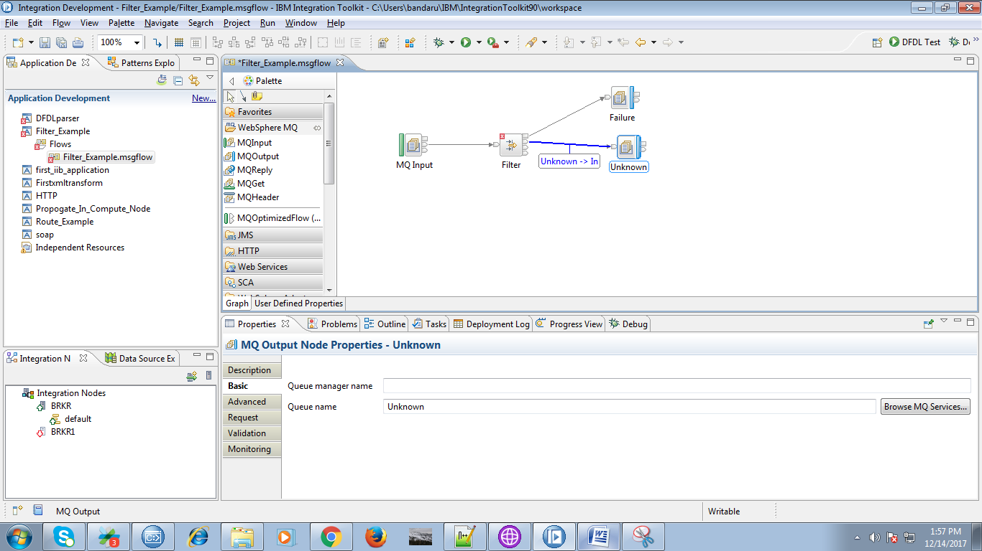

13. Drag a "MQOutput" from "WebSphere MQ" section and give a proper understanding and give connections as below.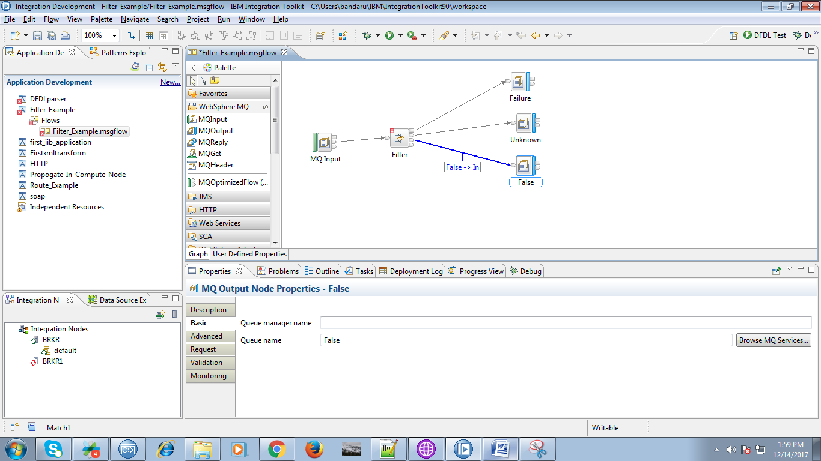

14. Drag a "MQOutput" from "WebSphere MQ" section and give a proper understanding and give connections as below.

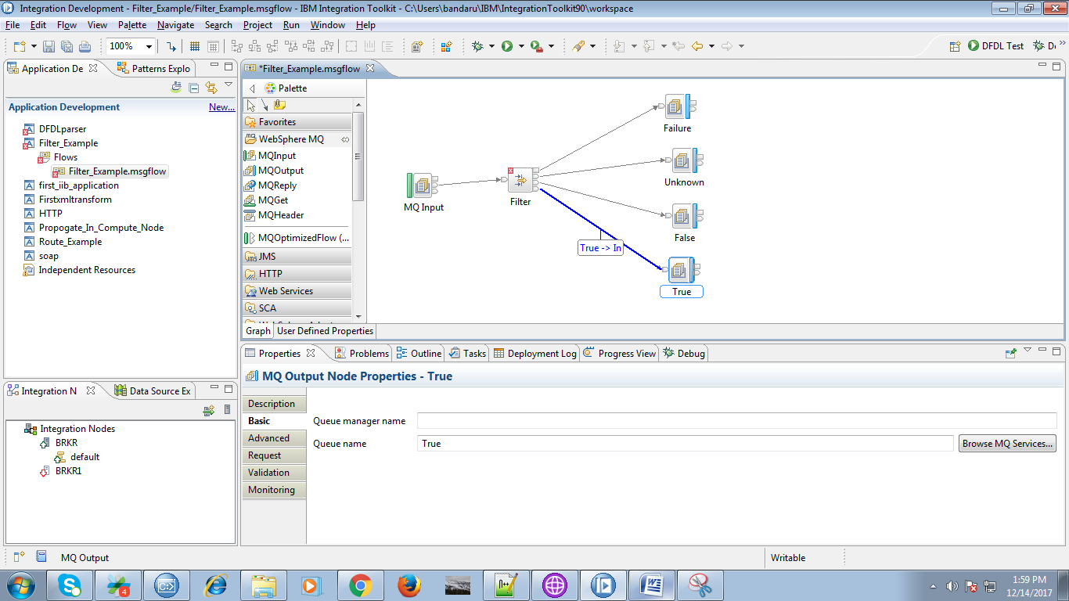

15. When you double click on filter node following ESQL code will prompt.

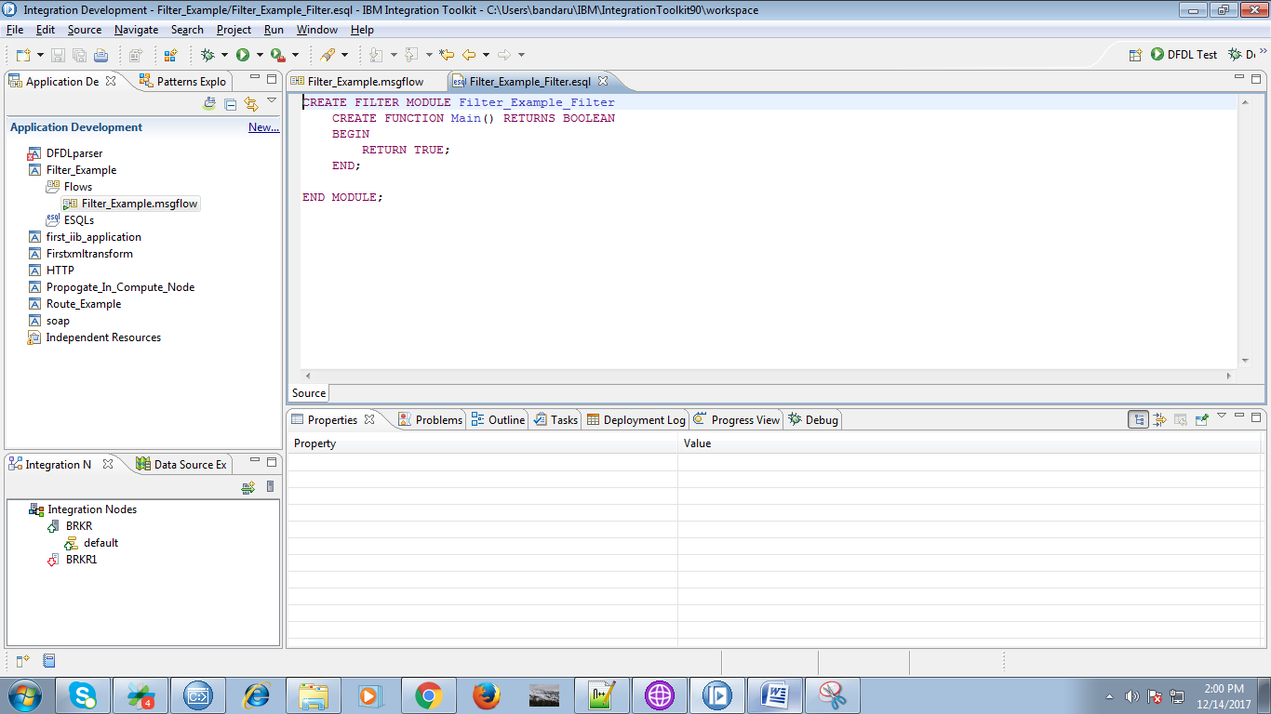

16. Override the following code.

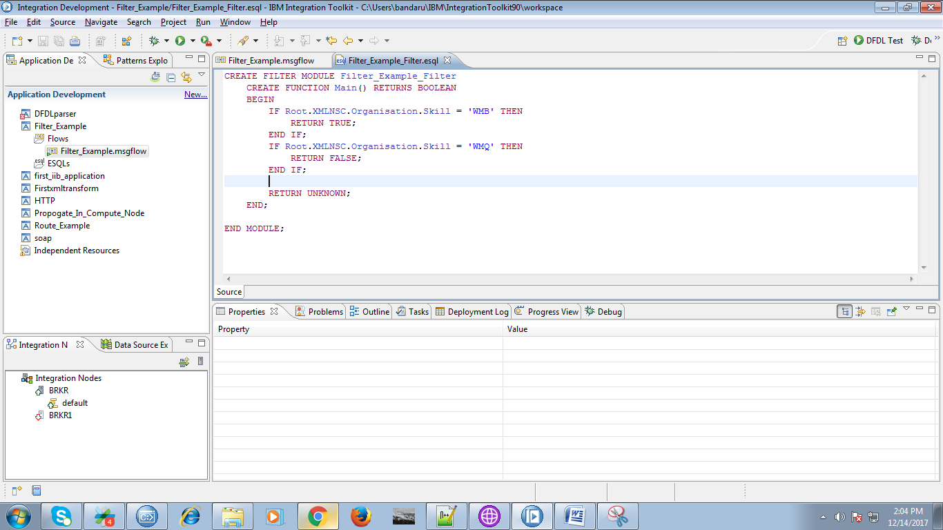

17. When you right click on your application, you will find "Deploy" option as below fig.

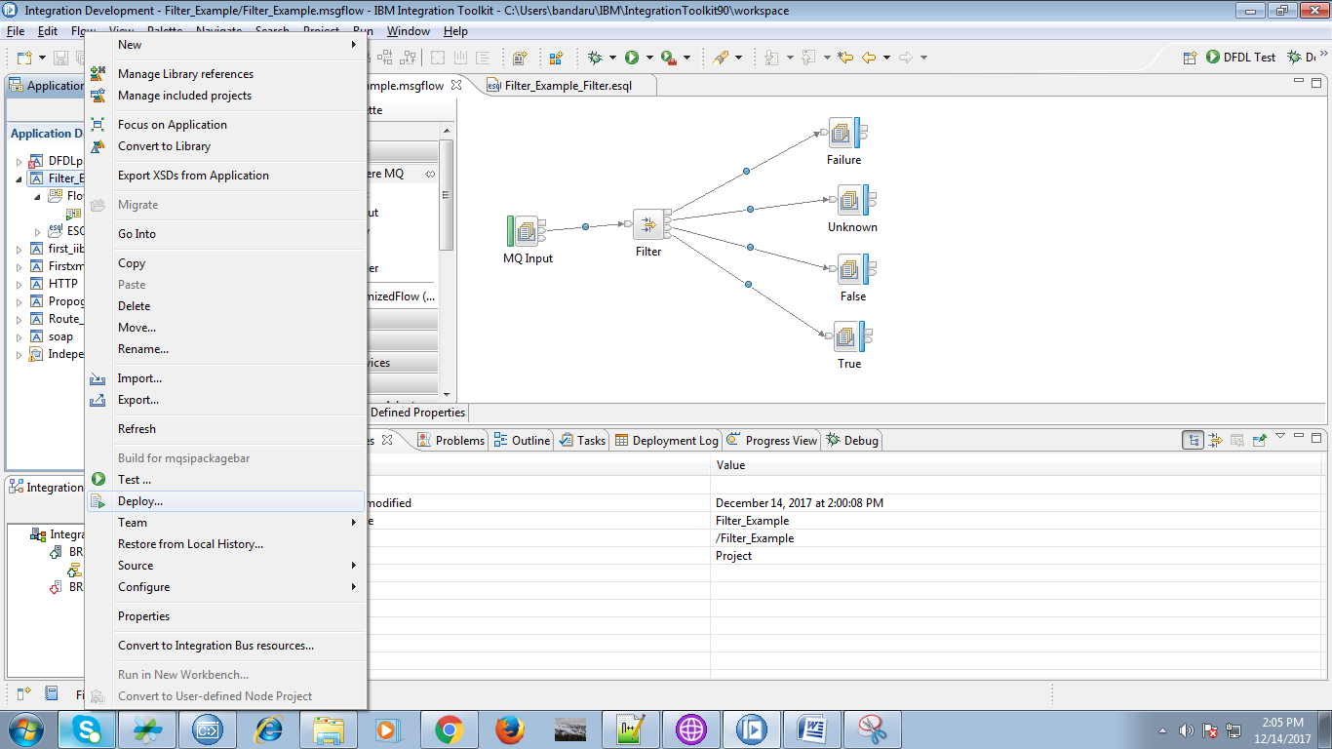

18. Now select execution group and hit "Finish".

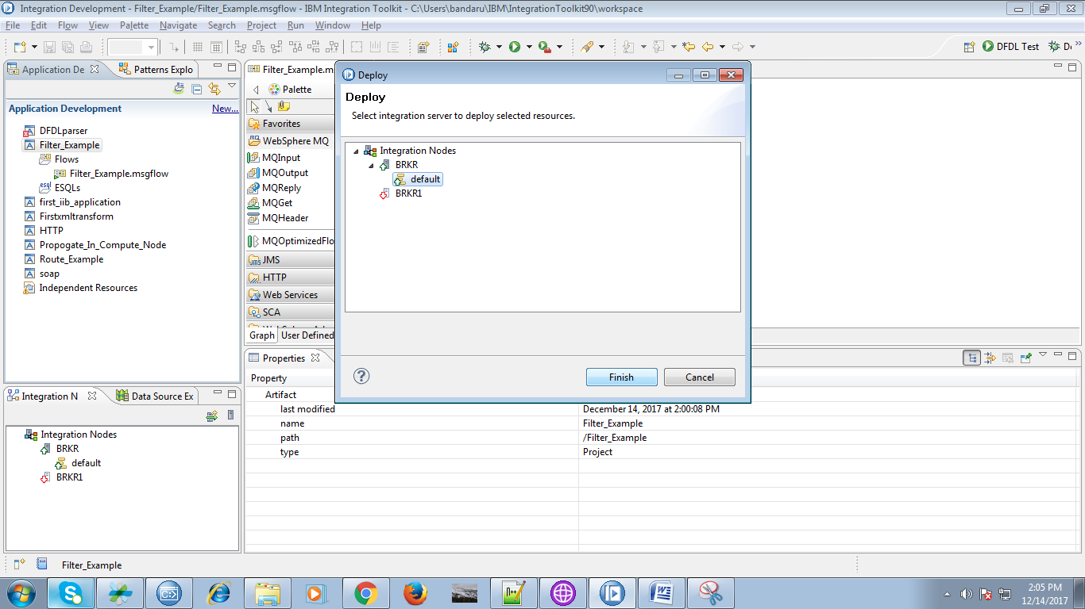

19. Create local queues in "IIB Websphere MQ Explorer" which were given in flow.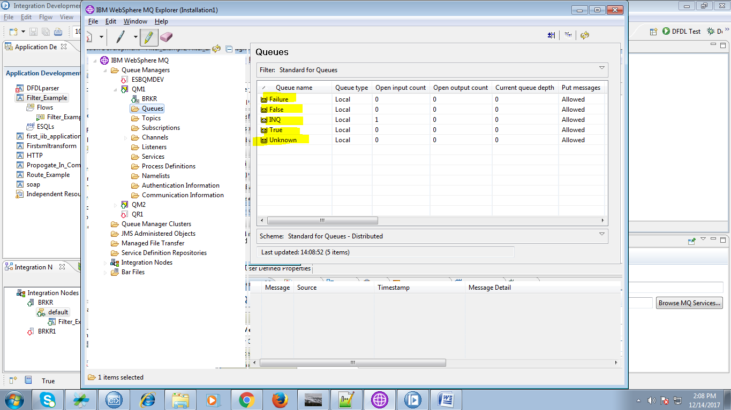

20. Open "rfhutil" and give input file.

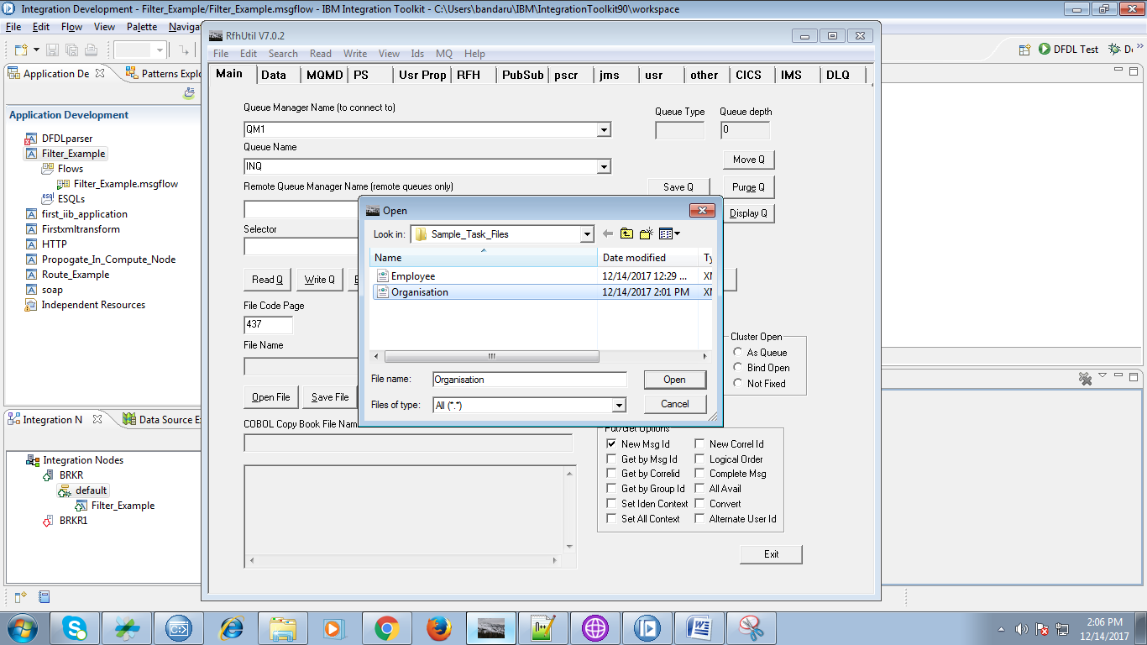

21. Input file contains following content.

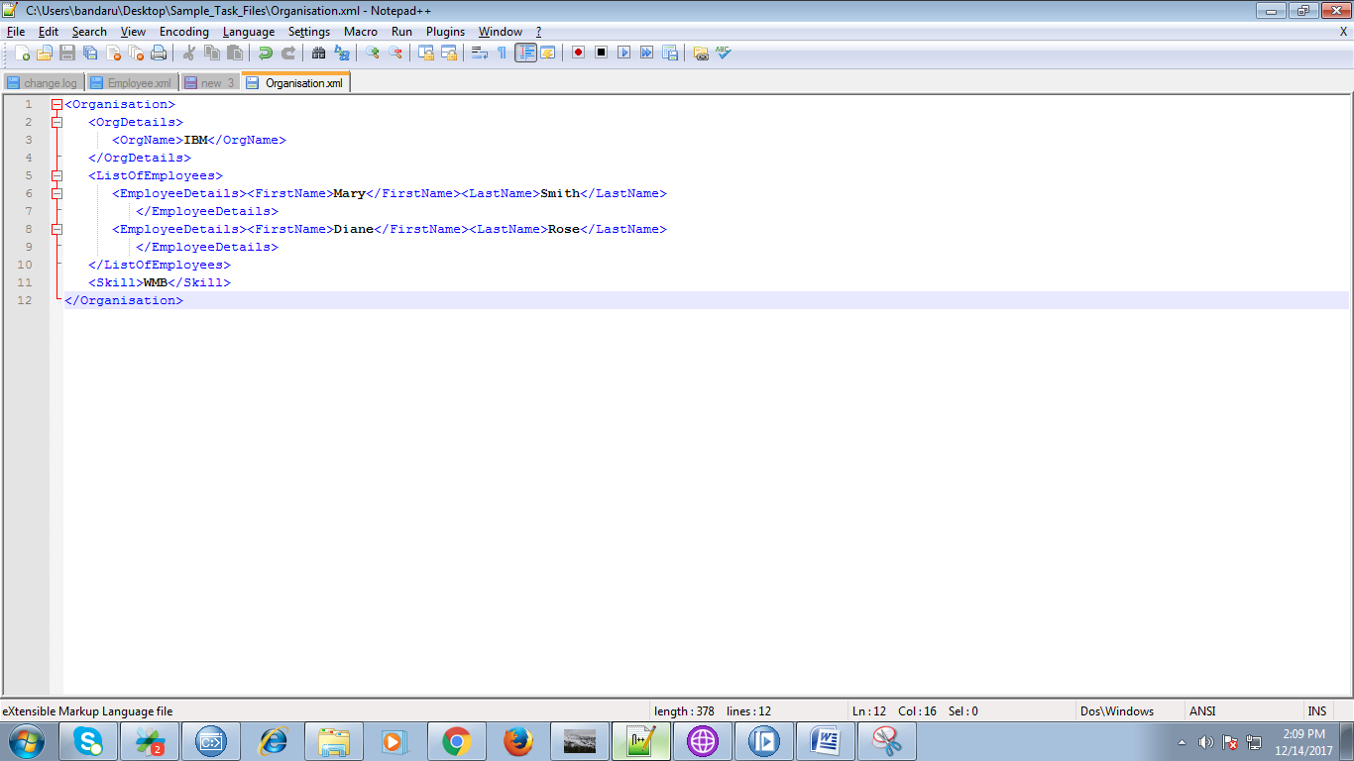

22. While in debug mode of your flow, following shows condition satisfied section.

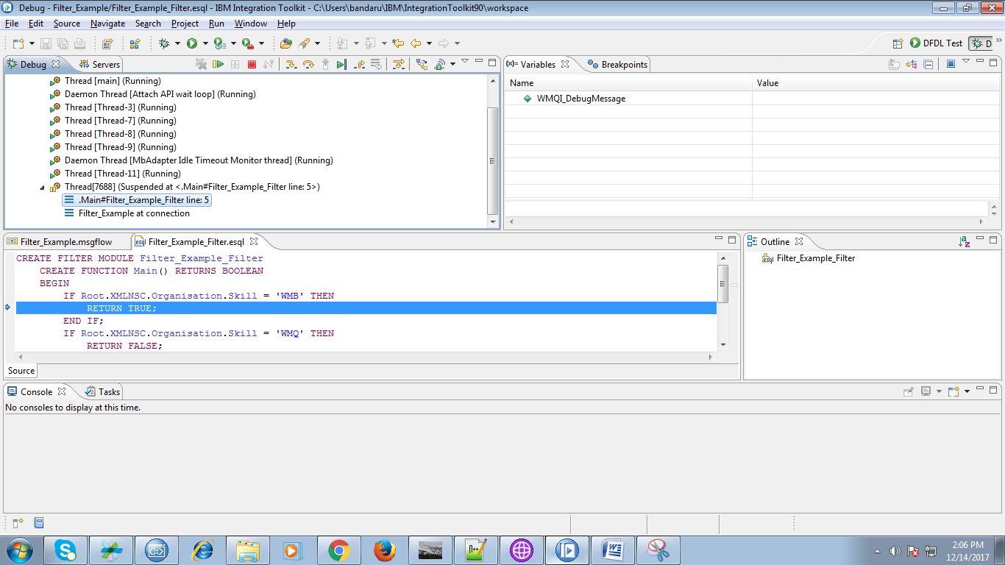

23. The output of filter you can seen while in debug mode.

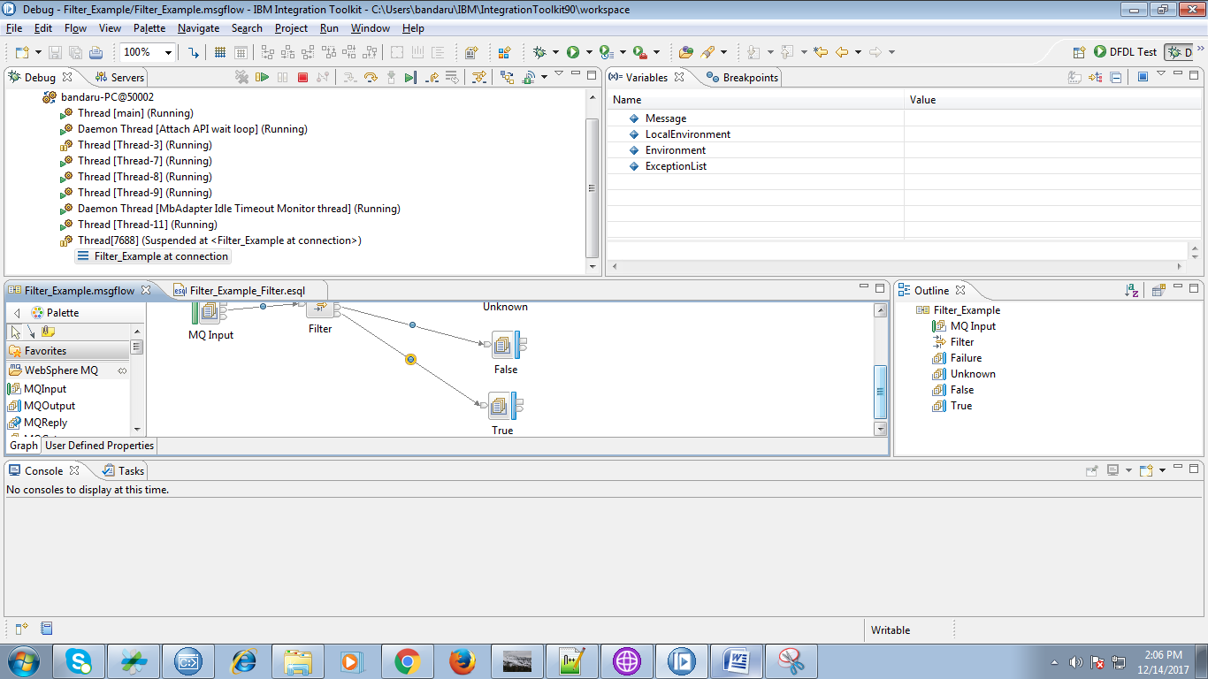

24. You can browse respective output queue to see result as shown below.

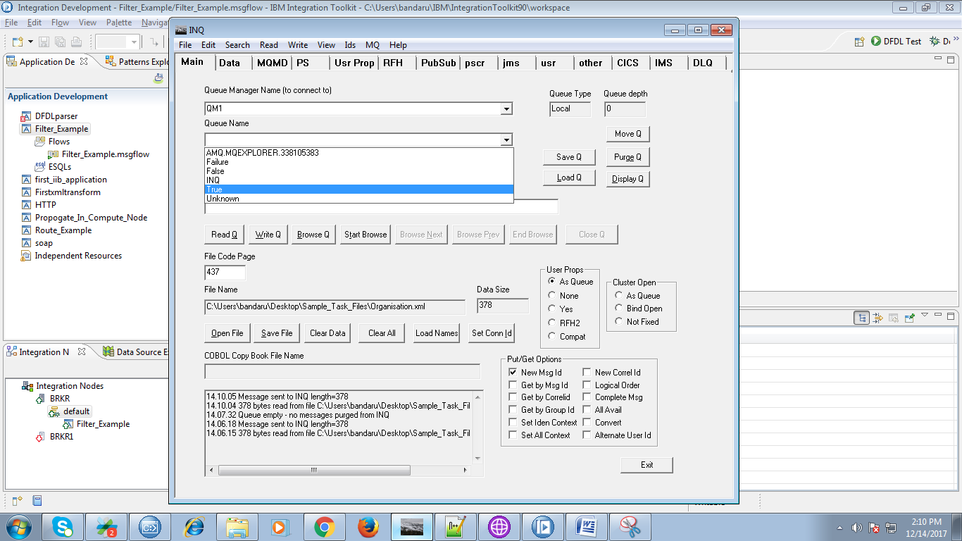

25. Now hit "Browse Q" button.

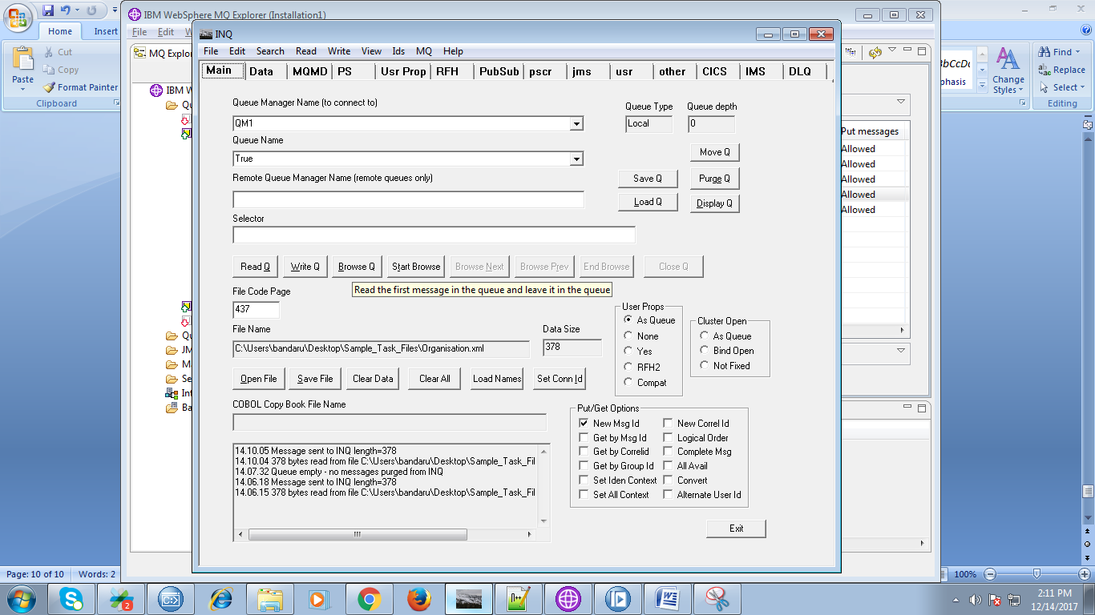

26. You can see respective output in "Data" tab.

