Iterate Statement

* Iterate (like: continue statement) statement is used to skip next consecutive statement based on condition.
* LOOP executes the sequence of statements repeatedly and unconditonally.
* If you want to come out of the LOOP statement then use LEAVE statement.
* LEAVE statement is used to terminate(like: Break statement) execution of LOOP, While, REPEAT.

1. Click on File and select "New"=> "Application" as shown below fig.

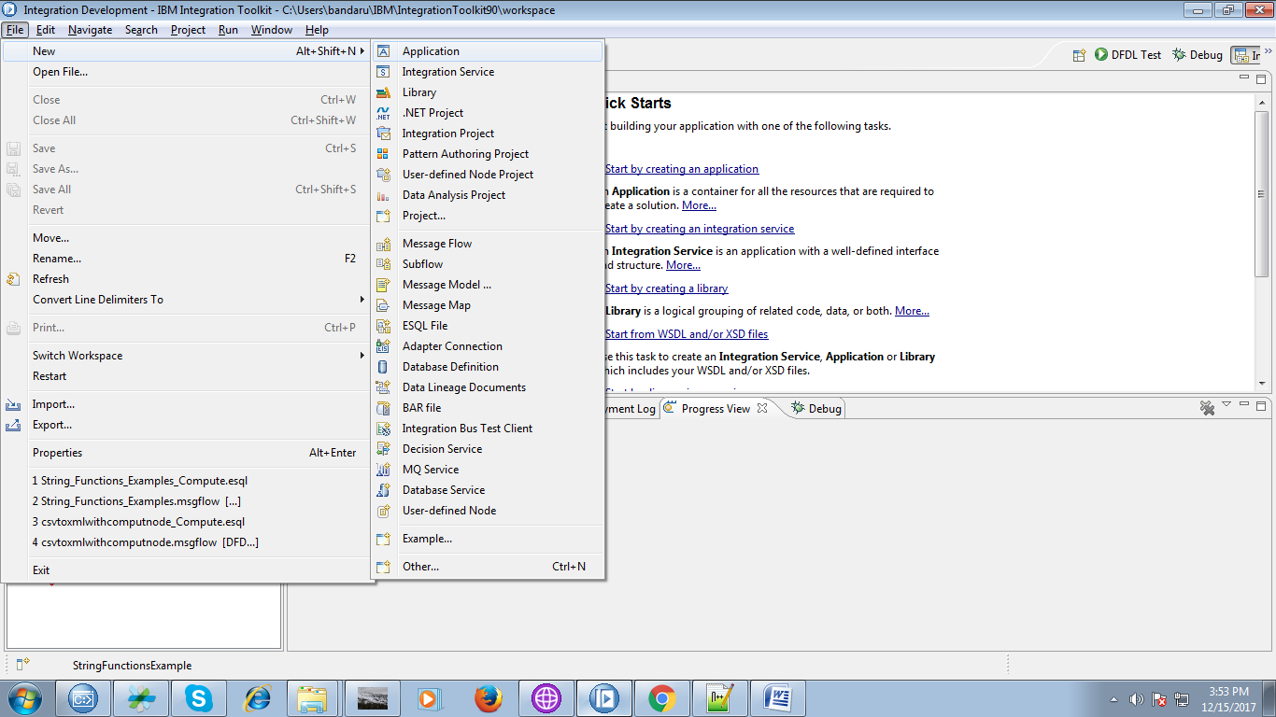

2. Give a name for your application and click "Finish" button.

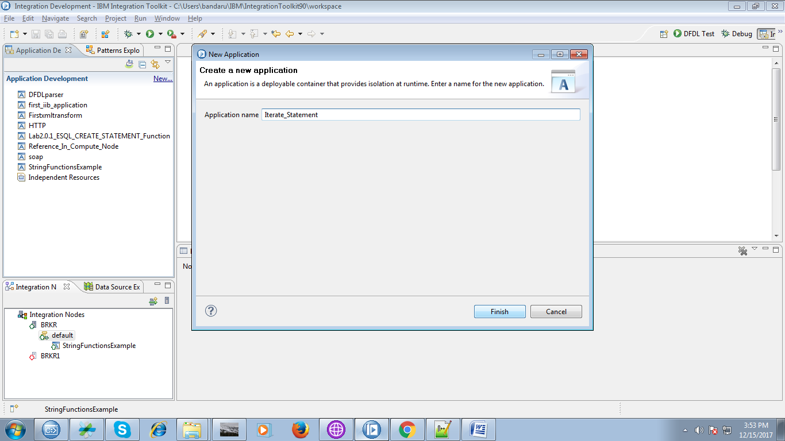

3. Under your application you able to see "New" click on it.

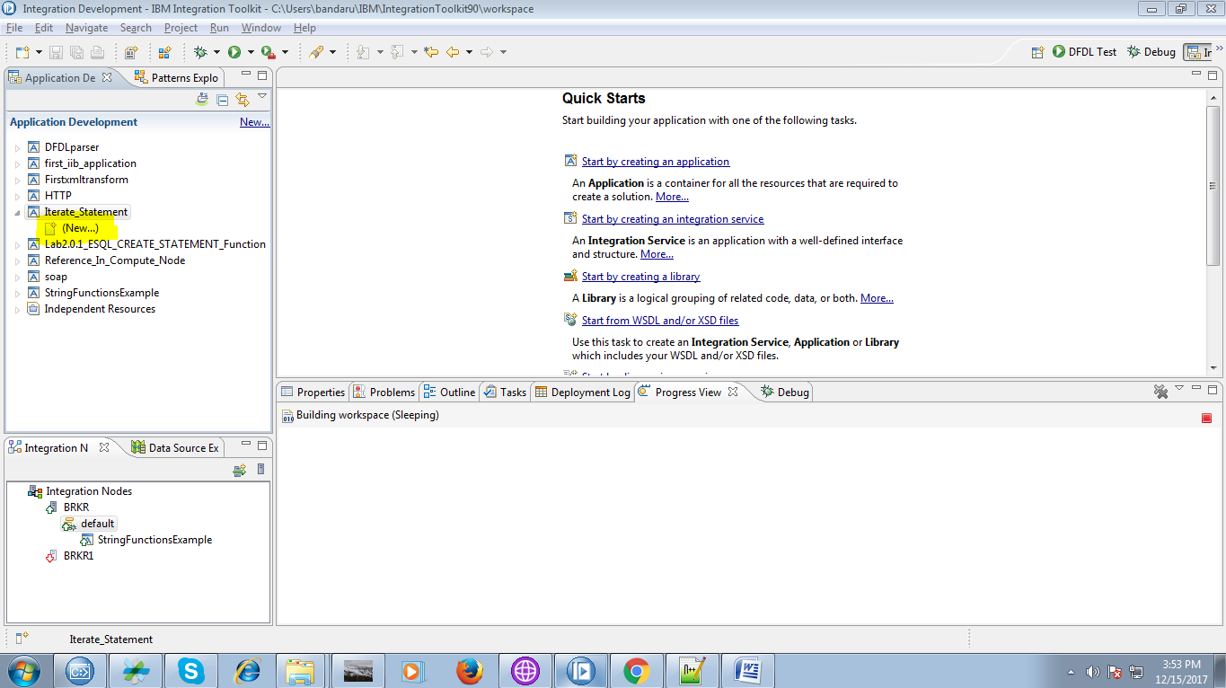

4. Select "Message Flow" from given options as shown below fig.

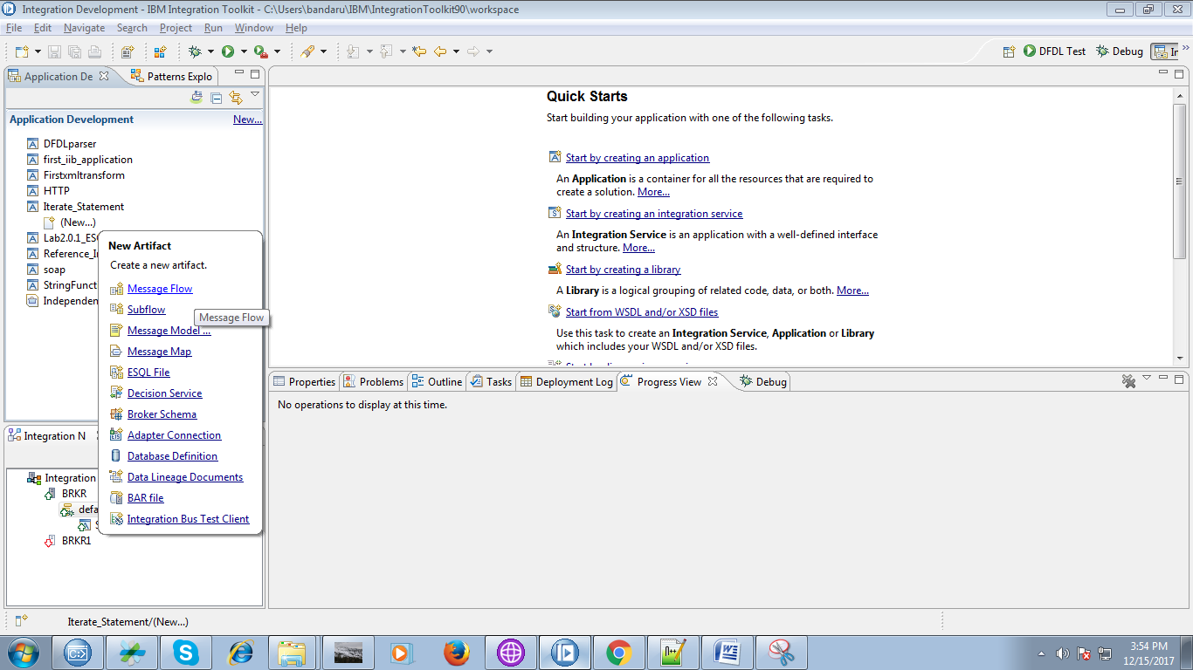

5. Give a name for your flow and click "Finish" button.

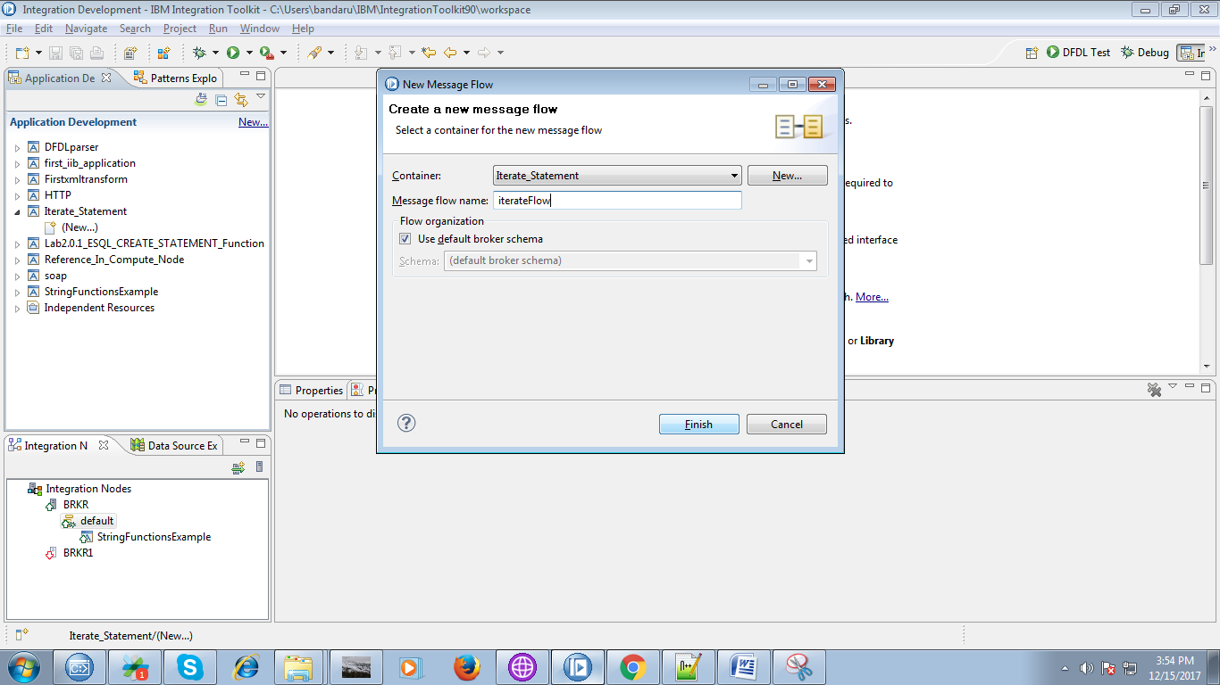

6. Drag "MQInput" from "WebSphere MQ" as shown below fig and name the queue.

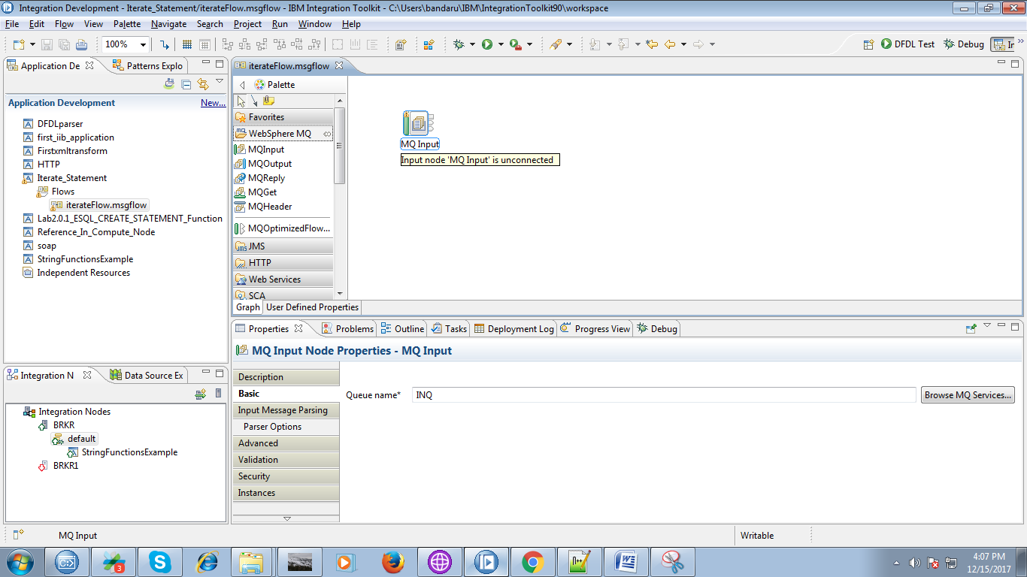

7. Drag the compute node from transfomation section.

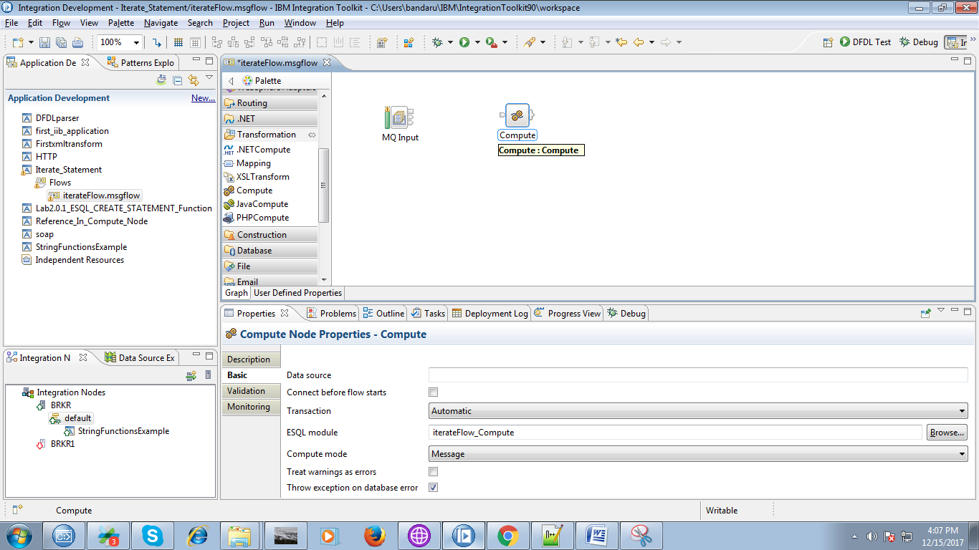

8. Connect the "output" terminal of the input queue to the "input" terminal of the compute node as shown below.

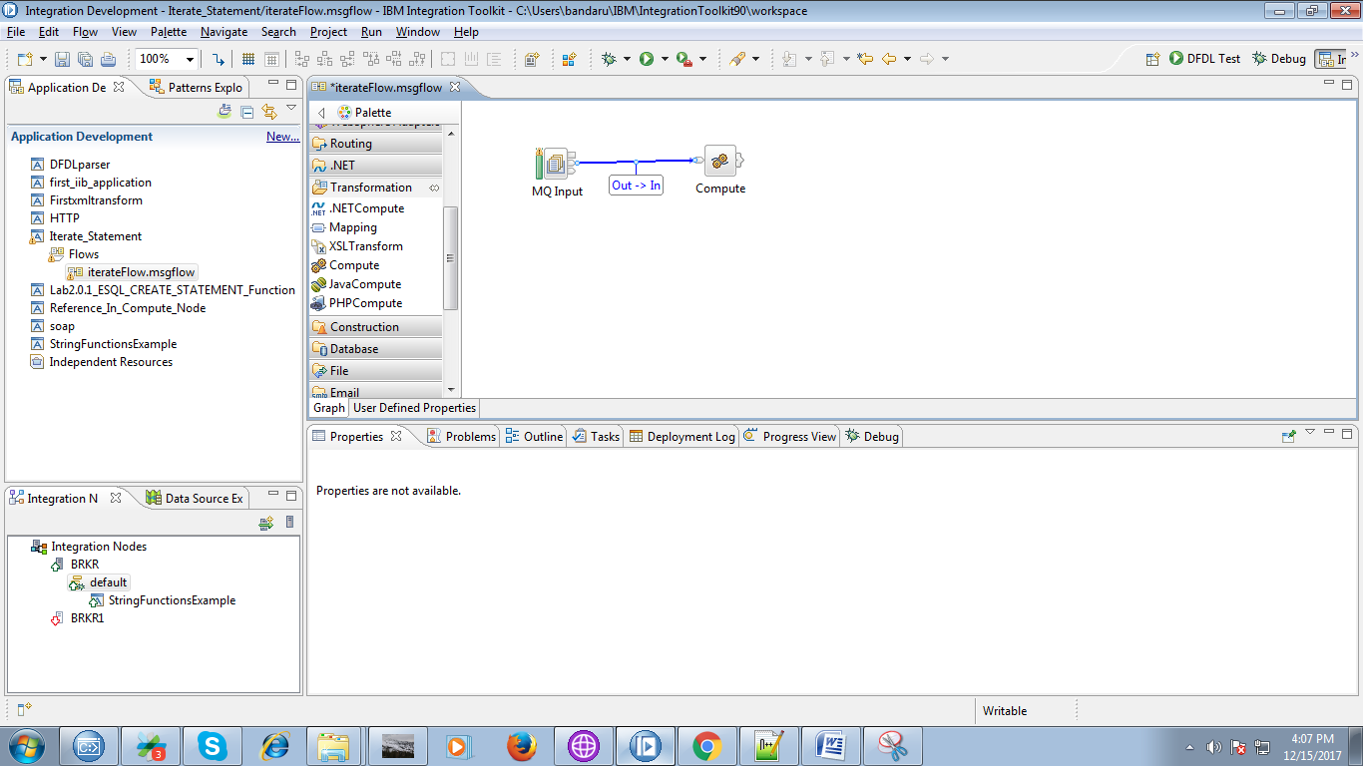

9. Drag the "MQOutput" from "WebSphere MQ" and name it.

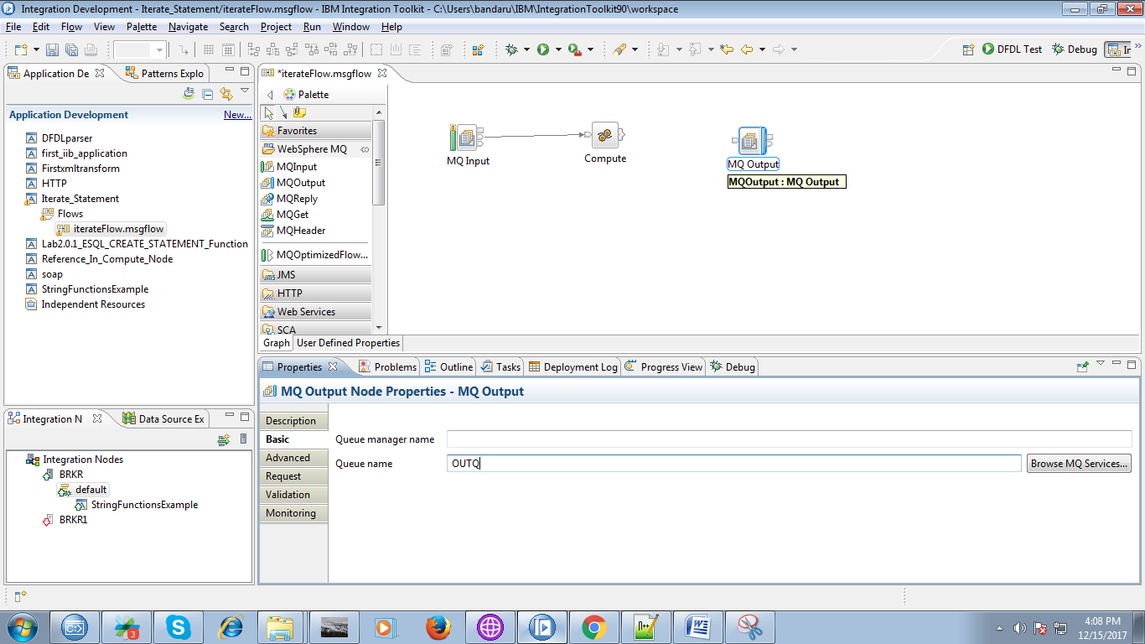

10. Click on output terminals of the compute node and select "Out" and click "OK" button.

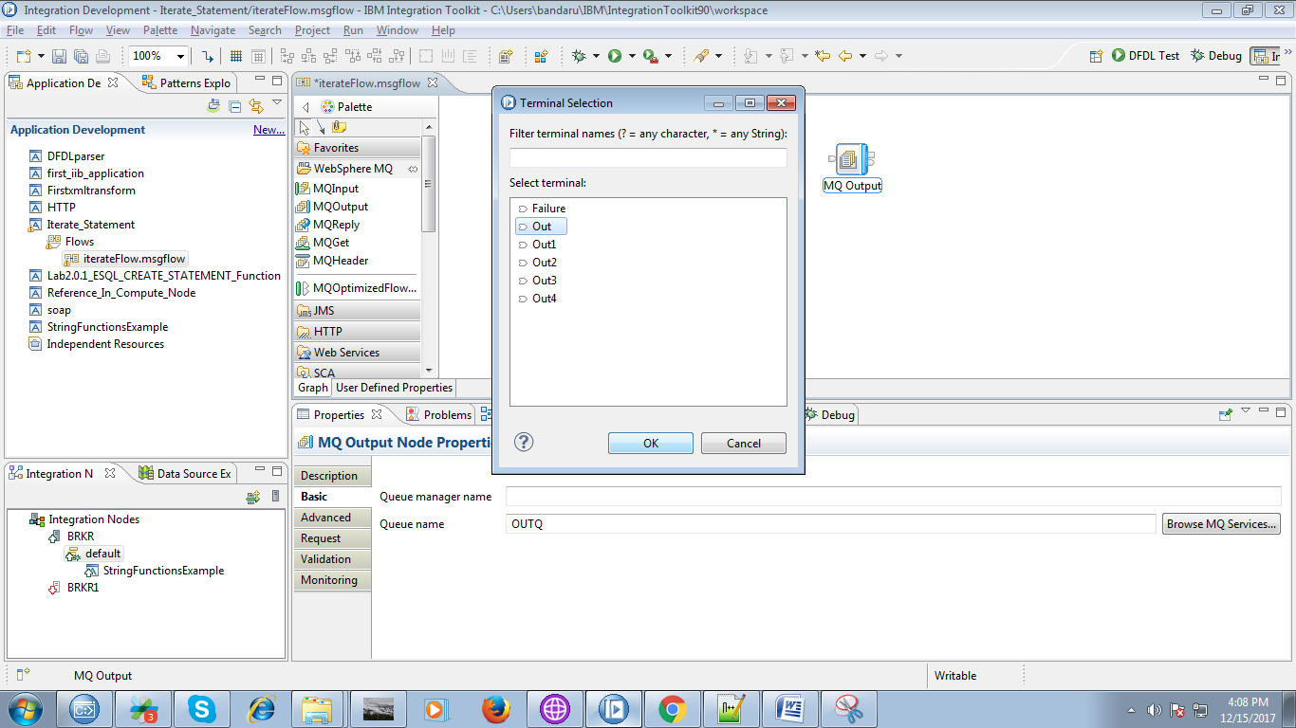

11. Connect "output" terminal of the compute node to the "input" terminal of the output queue.

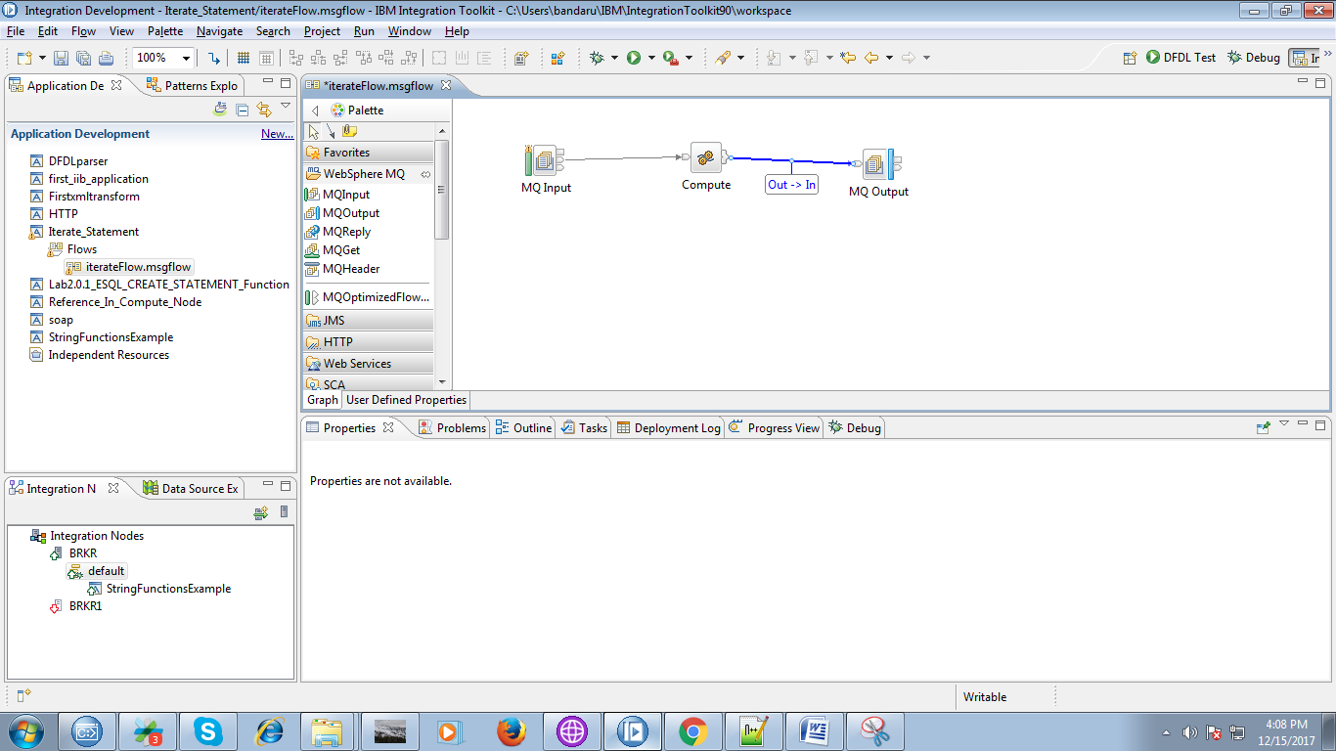

12. When you double click on compute node following code will prompt.

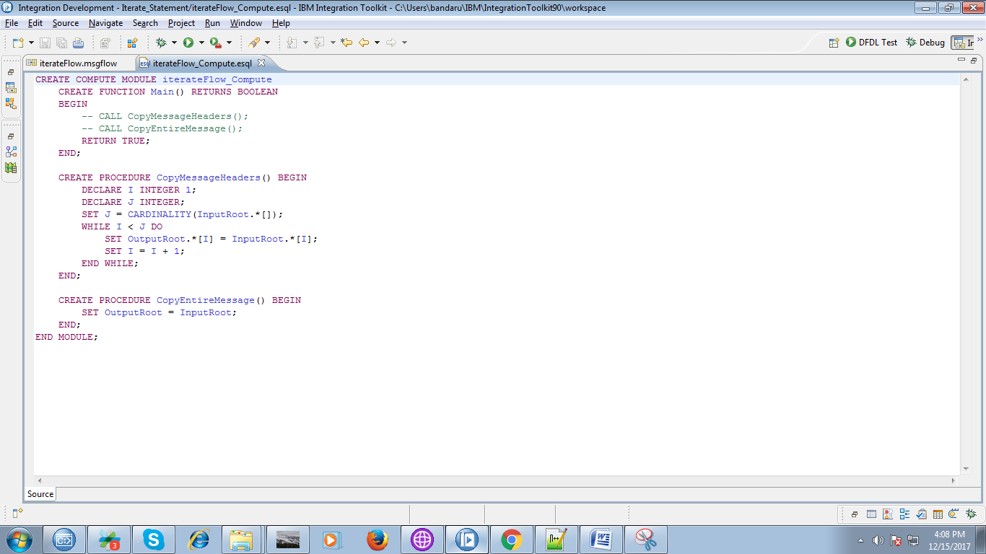

13. Replace the code in compute node with following two fig code.

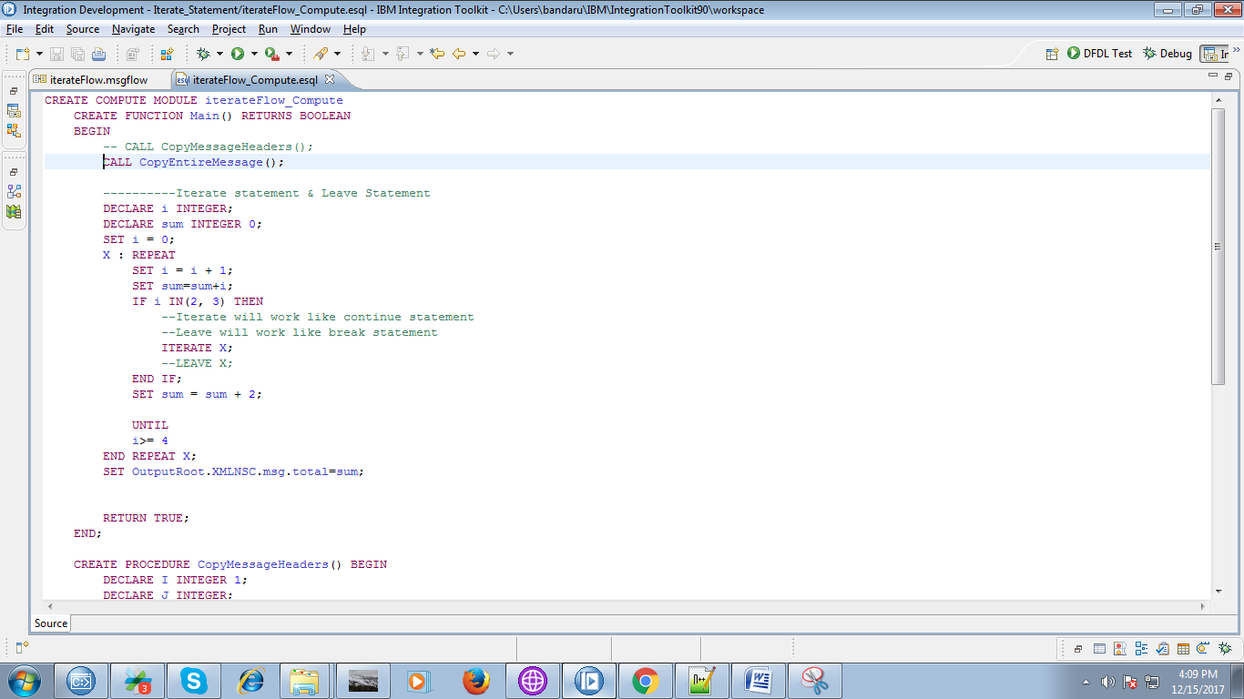

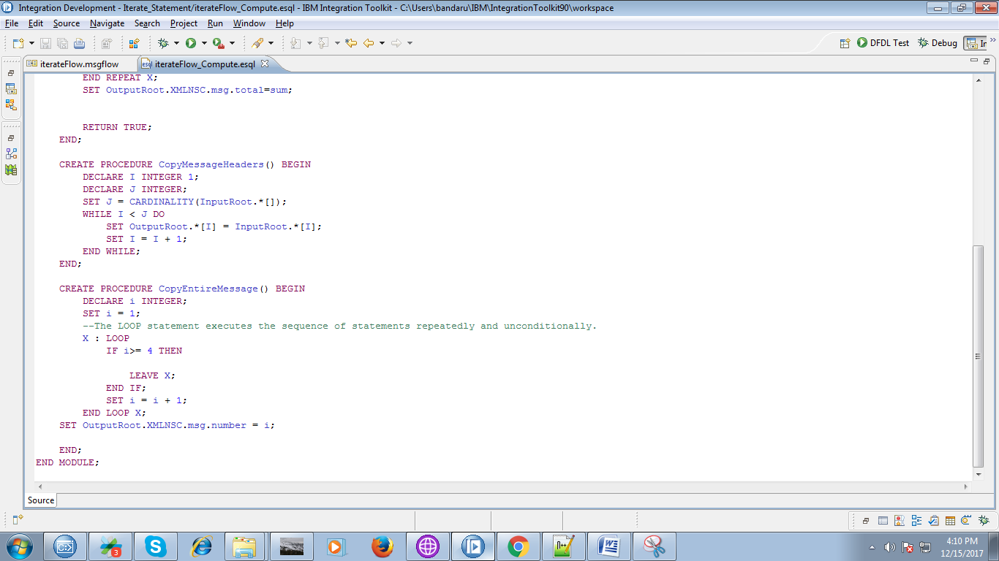

14. when you right click on your application you can see "Deploy" option.

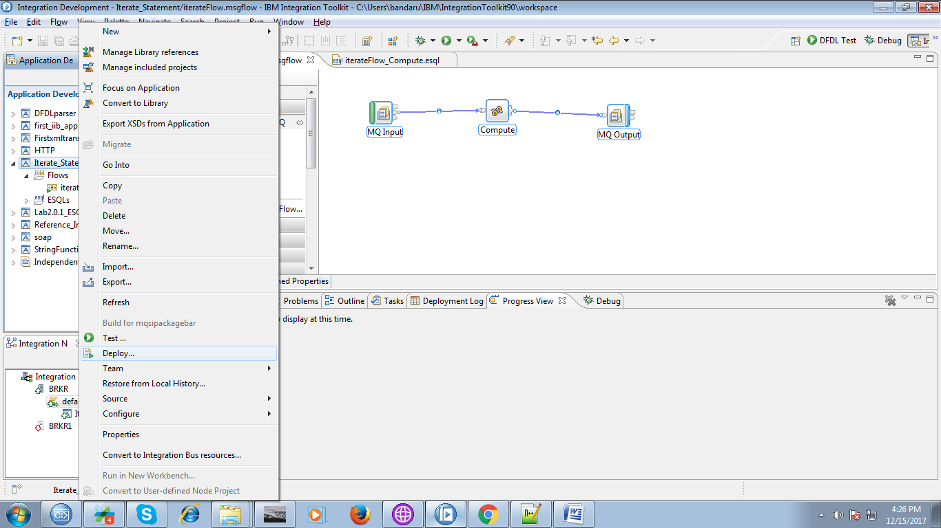

15. Select your running broker and execution group and click "Finish" button.

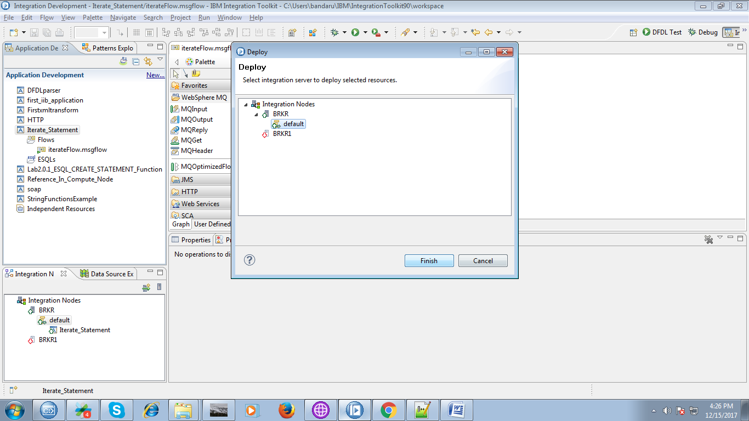

16. Create approprite local queues in "IBM Websphere MQ explorer".

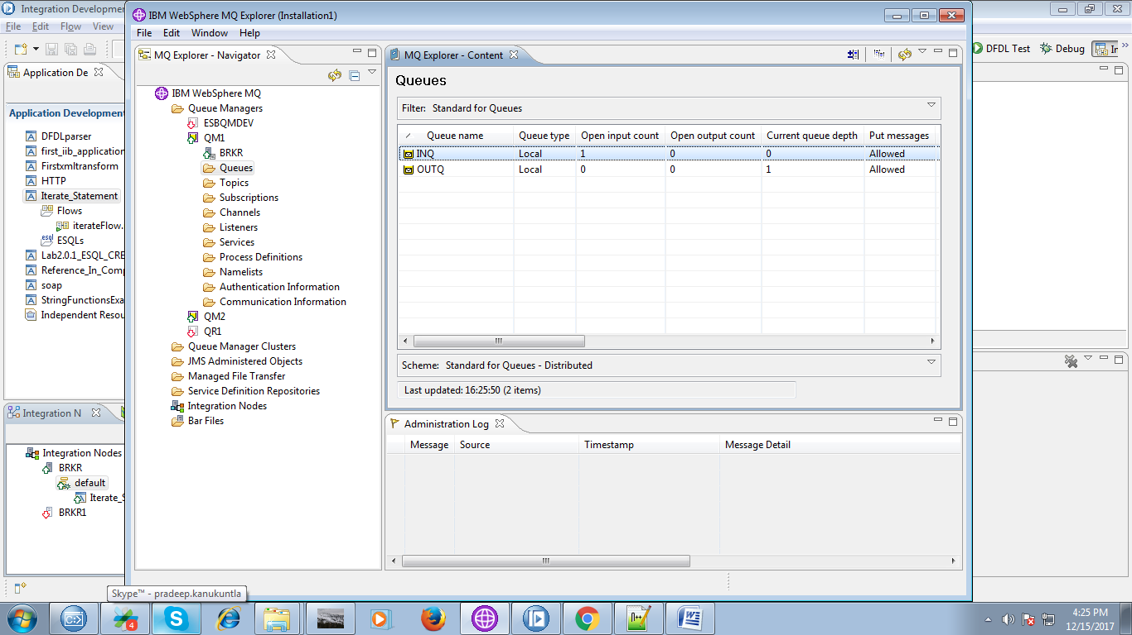

17. Right click on your input queue and select "Put Text Message" to trigger your flow.

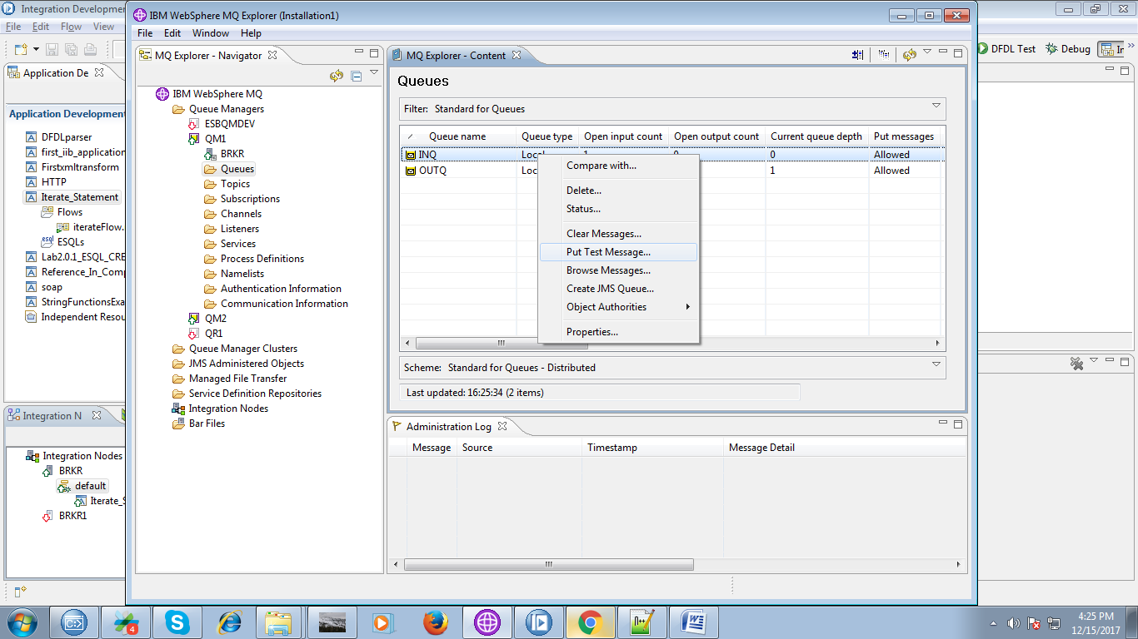

18. Place any dummy code and hit "Put Message".

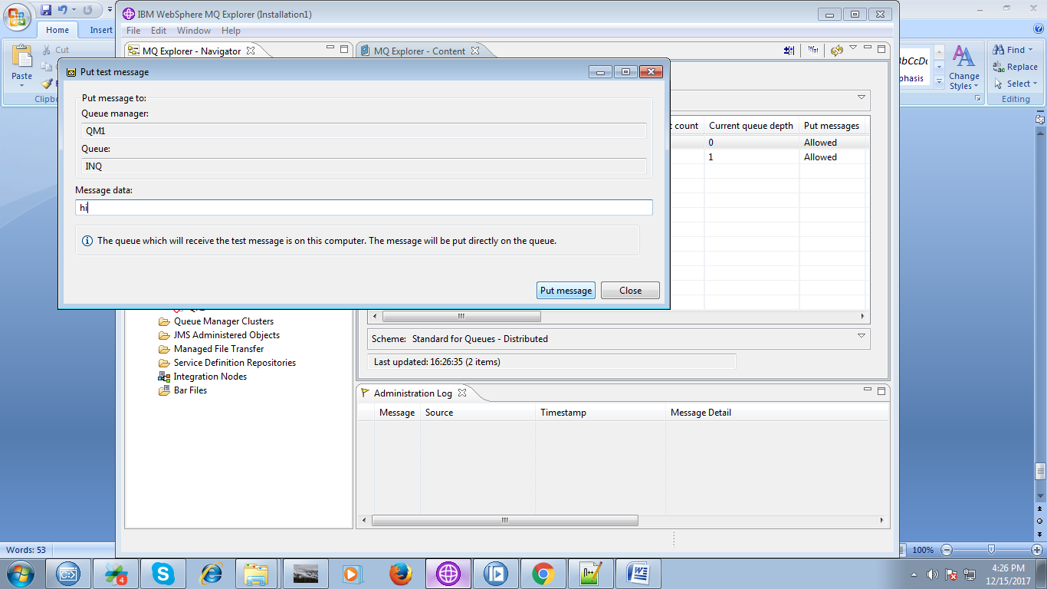

19. You can observe your flow variables in debug mode.

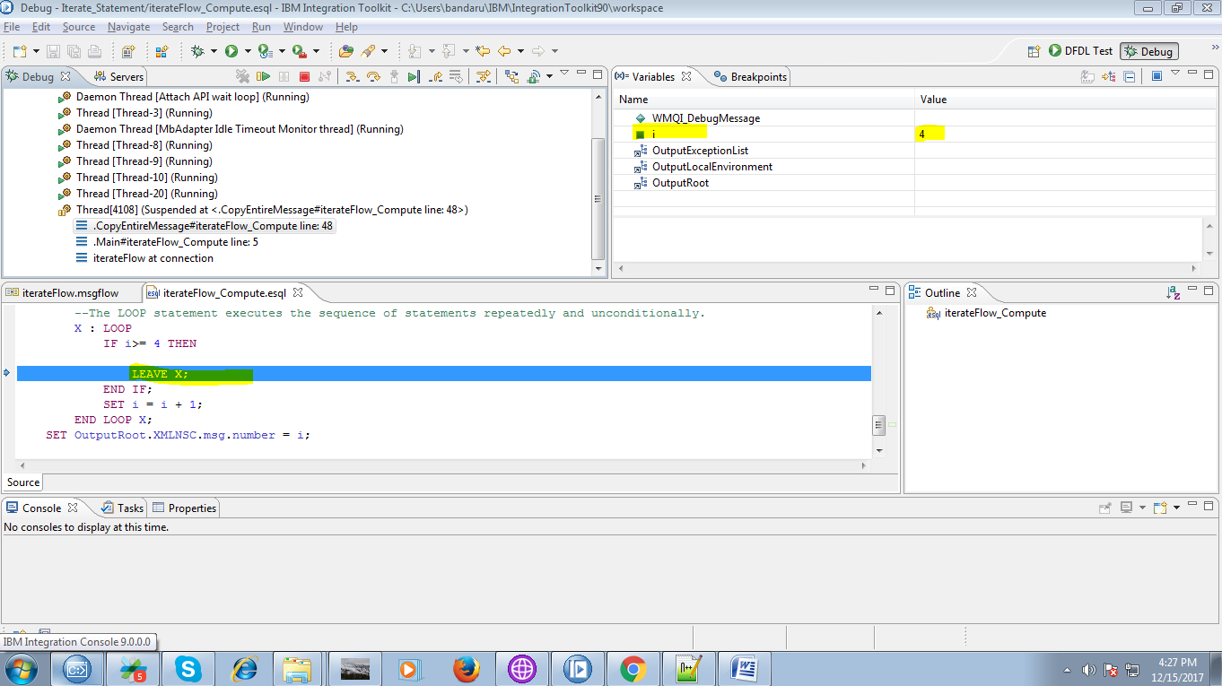

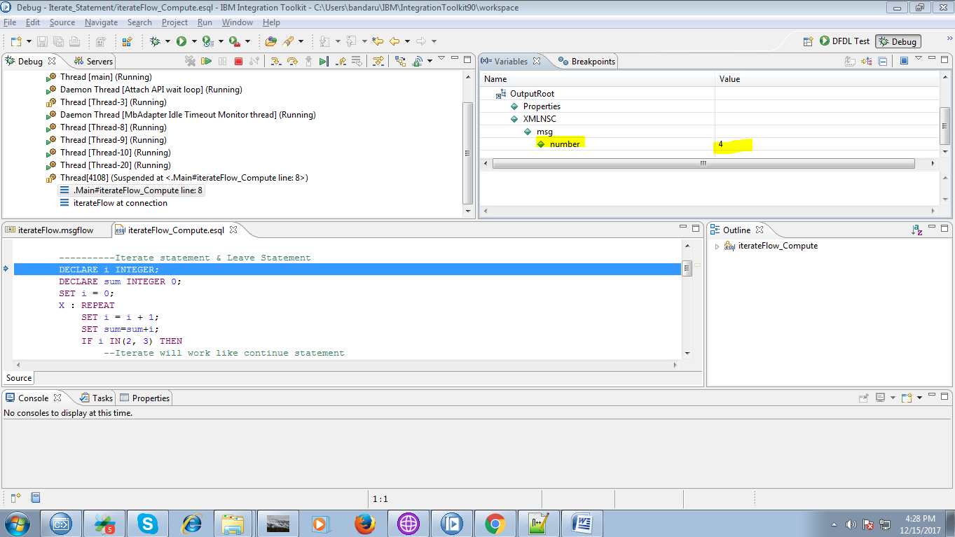

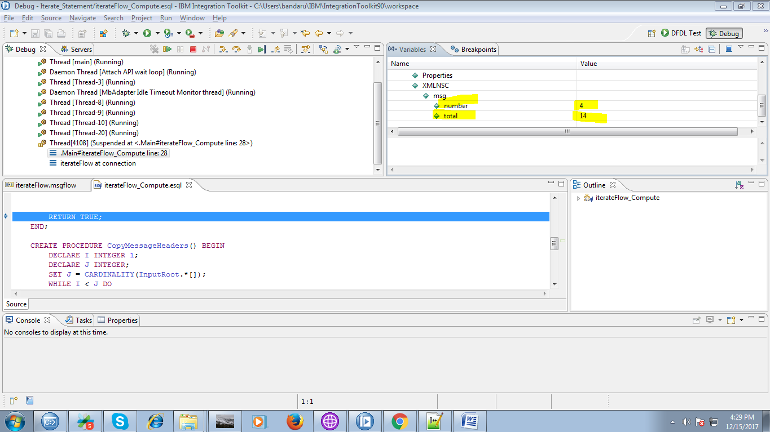

20. Compute node output as follows in below fig.

