**Procedure**

To set up a syndication relationship, complete the following steps:

1. Ensure both the subscriber and syndicator are running and that they can access each other over a network.
2. On your subscriber machine, log in to IBM WebSphere Portal.
3. Go to **Administration > Access > Credential Vault** and create a credential vault slot to allow you to access the syndicator

1**. Click on** [**Add a vault segment**](javascript:PC_Z7_CGAH47L00GP790IDB90MNI0GU5000000_submit(document.PC_Z7_CGAH47L00GP790IDB90MNI0GU5000000_form,'task_add_seg')) > Give the Vault segment name and click ok

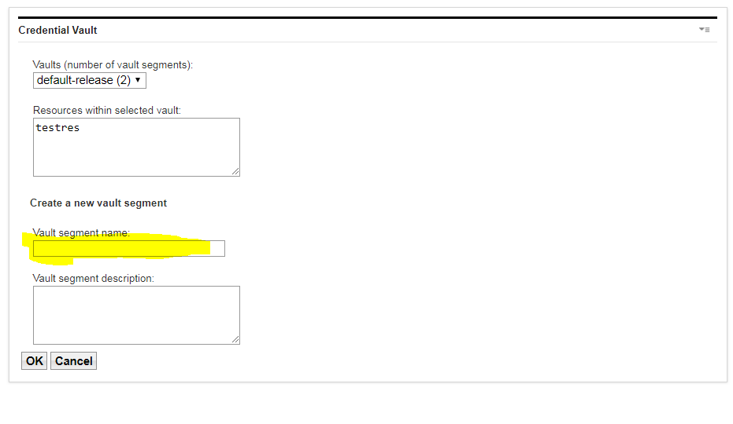

2. **click on Add a vault Slot** > Give the name > then give the Vault resource associated with vault slot name **> select the  Vault segment** > **check the box Vault slot is shared**

and give the userid and password ( user must be exist on the syndicator machine) then click ok.

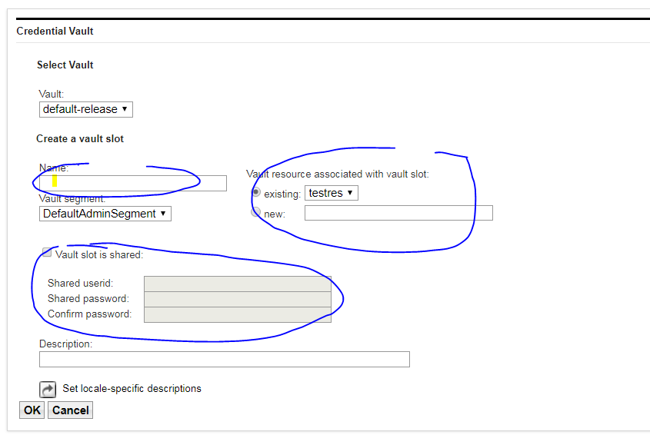

1. Go to **Administration > Portal Content > Subscribers**.
2. Click **Subscribe Now**.

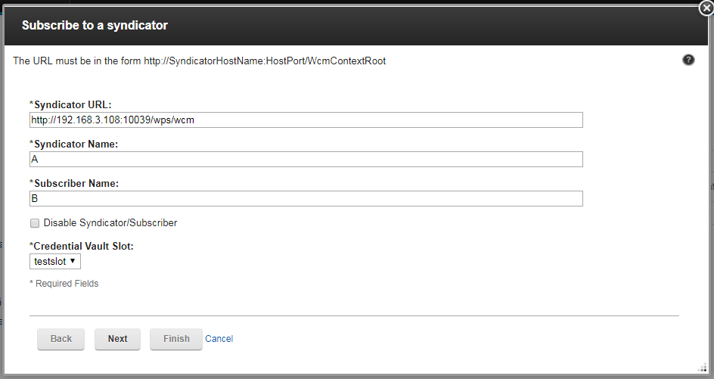

1. Enter the syndicator URL in the form of http://HostName:HostPort/WcmContextRoot. For example:

**http://authoring:10039/wps/wcm**

**authoring = host name of the Syndicator machine**

1. Enter a name for the syndicator item. With this name syndicator is created on the syndicator server, so enter a name that helps identify the syndication relationship you are creating.
2. Enter a name for the subscriber item. With this name subscriber is created on the subscriber server, so enter a name that helps identify the syndication relationship you are creating.
3. Select the credential vault slot you created previously.
4. Click **Next**

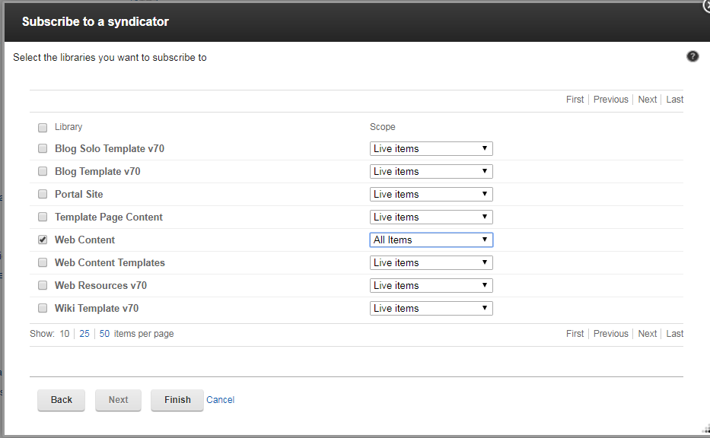

1. Select the libraries you want to subscribe to.
   1. Click **Add Libraries** to select a library to syndicate and the syndication type:

**Live items:**

Live item syndication is mostly used when syndicating to a staging or delivery server. The following items are syndicated:

* + - Published
    - Expired

Draft items, projects and items in a project are not syndicated.

**Live and projects:**

The advantage of using "Live and projects" syndication is to gradually syndicate projects to a staging or delivery server rather that waiting to syndicate all the items in a project after they all achieve a published state. The following items are syndicated:

* + - Published
    - Expired
    - Projects
    - Draft items in a project

Draft items outside of projects are not syndicated.

**All items:**

All item syndication is mostly used when syndicating between servers within an authoring environment. The following items are syndicated:

* + - Published
    - Expired
    - Projects
    - Draft items in a project
    - Other draft items
    - Versions
    - Deleted items
  1. Select libraries from the current list and click **Remove Libraries** to remove a library from the list of syndicated libraries.

1. Click **Finish**.
2. Now In Syndicator Machine Go to **Administration > Portal Content > Syndicator**

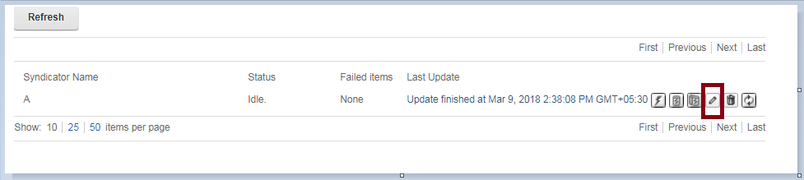

click on pencil icon

Select the Syndicator which is created, in that change the Subscriber URL localhost to subscriber hostname.

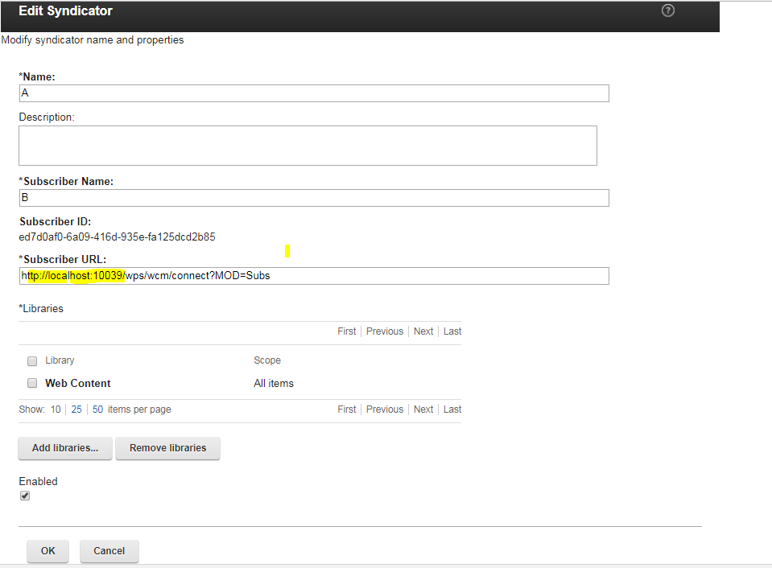

click ok

1. To begin syndication, click either **Update Subscriber** or **Rebuild Subscriber** button.

