**1. Centralized Database:**

A centralized database is basically a type of database that is stored, located as well as maintained at a single location only. This type of database is modified and managed from that location itself. This location is thus mainly any database system or a centralized computer system. The centralized location is accessed via an internet connection (LAN, WAN, etc). This centralized database is mainly used by institutions or organizations.

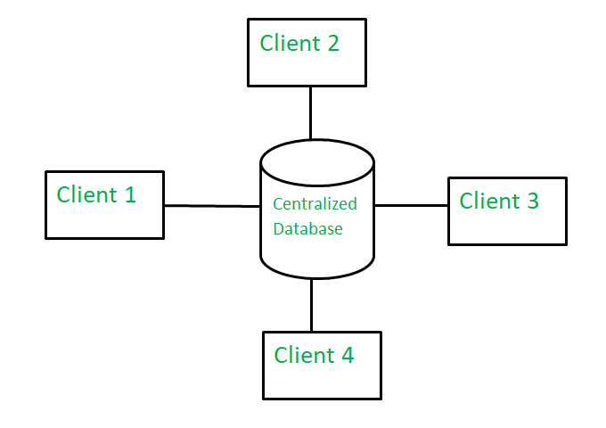  
**Advantages:**

* Since all data is stored at a single location only thus it is easier to access and coordinate data.
* The centralized database has very minimal data redundancy since all data is stored in a single place.
* It is cheaper in comparison to all other databases available.

**Disadvantages:**

* The data traffic in the case of a centralized database is more.
* If any kind of system failure occurs in the centralized system then the entire data will be destroyed.

**2. Distributed Database:**

A distributed database is basically a type of database which consists of multiple databases that are connected with each other and are spread across different physical locations. The data that is stored in various physical locations can thus be managed independently of other physical locations. The communication between databases at different physical locations is thus done by a computer network.

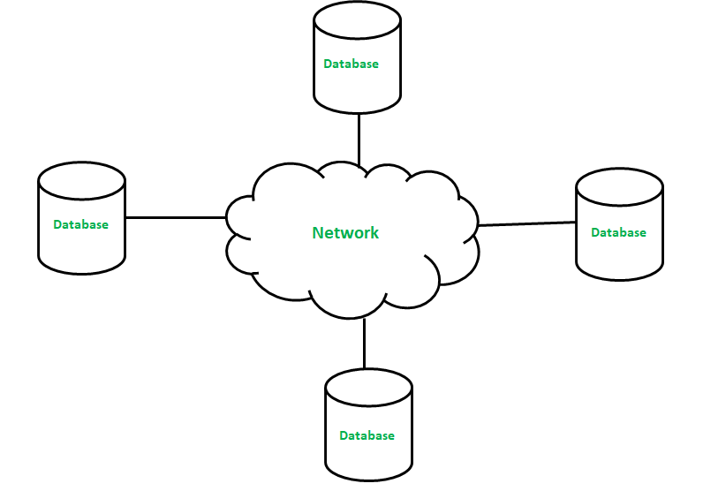  
**Advantages:**

* This database can be easily expanded as data is already spread across different physical locations.
* The distributed database can easily be accessed from different networks.
* This database is more secure in comparison to a centralized database.

**Disadvantages:**

* This database is very costly and is difficult to maintain because of its complexity.
* In this database, it is difficult to provide a uniform view to users since it is spread across different physical locations.