The reactive-stack web framework, **Spring WebFlux**, has been added to *Spring 5*. It is **fully non-blocking, supports**[**reactive streams**](http://www.reactive-streams.org/)**back pressure**, and runs on such servers as Netty, Undertow, and Servlet 3.1+ containers. In this **spring webflux tutorial**, we will learn the basic concepts behind reactive programming, webflux APIs and a fully functional hello world example.

**1. Reactive Programming**

Reactive programming is a programming paradigm that promotes an asynchronous, non-blocking, event-driven approach to data processing. Reactive programming involves modeling data and events as observable data streams and implementing data processing routines to react to the changes in those streams.

Before digging deeper into the reactive world, let us understand the difference between blocking and non-blocking request processing.

**1.1. Blocking vs Non-blocking (*Async*) Request Processing**

**Blocking Request Processing**

In traditional MVC applications, **a new servlet thread is created (or obtained from the thread pool) when a request comes to the server**. It delegates the request to worker threads for I/O operations such as database access etc. During the time worker threads are busy, the servlet thread (request thread) remains in waiting status, and thus it is blocked. It is also called **synchronous request processing**.

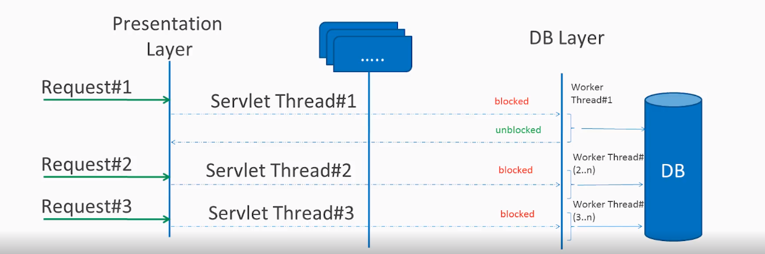Blocking request processing

As a server can have some finite number of request threads, it limits the server’s capability to process that number of requests at maximum server load. It may hamper the performance and limit the full utilization of server capability.

**Non-blocking Request Processing**

**In non-blocking or asynchronous request processing, no thread is in waiting state.** There is generally only one request thread receiving the request.

All incoming requests come with an event handler and callback information. Request thread delegates the incoming requests to a thread pool (generally a small number of threads) which delegates the request to its handler function and immediately starts processing other incoming requests from the request thread.

When the handler function is complete, one thread from the pool collects the response and passes it to the call back function.

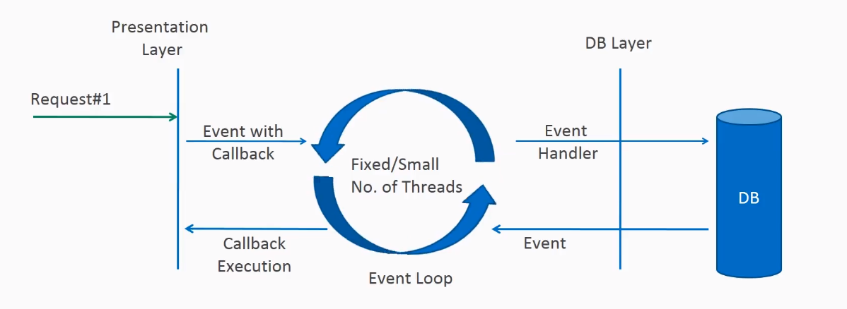Non-blocking request processing

Non-blocking nature of threads helps in scaling the performance of the application. A small number of threads means less memory utilization and less context switching.

**1.2. What is Reactive Programming?**

The term, “reactive,” refers to programming models that are **built around reacting to changes**. It is built around the publisher-subscriber pattern ([observer pattern](https://howtodoinjava.com/design-patterns/behavioral/observer-design-pattern/)). In the reactive style of programming, we make a request for resources and start performing other things. When the data is available, **we get the notification along with data in the callback function**. The **callback function handles the response** as per application/user needs.

One important thing to remember is back pressure. In non-blocking code, **back-pressure controls the rate of events so that a fast producer does not overwhelm its destination**.

Reactive web programming is well-suited for applications that involve streaming data and real-time interactions. By using non-blocking and event-driven mechanisms, we can design excellent solutions for these applications.

However, reactive programming can also benefit traditional CRUD applications, it is worth mentioning that while reactive APIs offload tasks to non-blocking threads, they also require proper thread management. Incorrect handling of threads or blocking operations within a reactive context can lead to thread contention and performance issues.

Also, reactive programming adds more unnecessary complexity without substantial gains in low concurrent traditional applications. For such applications, a traditional synchronous approach may be more straightforward and suitable.

If you are developing the next *Facebook* or *Twitter* with lots of data, real-time analytics applications, chat applications, or live update websites, a reactive API might be just what you are looking for.

**2. Reactive Streams API**

The new Reactive Streams API was created by engineers from Netflix, Pivotal, Lightbend, RedHat, Twitter, and Oracle, among others and is now part of Java 9. It defines four interfaces:

[**Publisher**](https://github.com/reactive-streams/reactive-streams-jvm/blob/v1.0.2/api/src/main/java/org/reactivestreams/Publisher.java)

The publisher emits a sequence of events to subscribers according to the demand received from its subscribers. A publisher can serve multiple subscribers.

Publisher.java

**public** **interface** Publisher<T> {

**public** **void** subscribe(Subscriber<? **super** T> s);

}

[**Subscriber**](https://github.com/reactive-streams/reactive-streams-jvm/blob/v1.0.2/api/src/main/java/org/reactivestreams/Subscriber.java)

Receives and processes events emitted by a Publisher. Please note that no notifications will be received until Subscription#request(long) is called to signal the demand. It has four methods to handle various kinds of responses received.

Subscriber.java

**public** **interface** Subscriber<T> {

**public** **void** onSubscribe(Subscription s);

**public** **void** onNext(T t);

**public** **void** onError(Throwable t);

**public** **void** onComplete();

}

[**Subscription**](https://github.com/reactive-streams/reactive-streams-jvm/blob/v1.0.2/api/src/main/java/org/reactivestreams/Subscription.java)

Defines a one-to-one relationship between a Publisher and a Subscriber. It can only be used once by a single Subscriber. It is used to both signal desire for data and cancels demand (and allow resource cleanup).

Subscription.java

**public** **interface** Subscription<T> {

**public** **void** request(**long** n);

**public** **void** cancel();

}

[**Processor**](https://github.com/reactive-streams/reactive-streams-jvm/blob/v1.0.2/api/src/main/java/org/reactivestreams/Processor.java)

Represents a processing stage consisting of both a Subscriber and a Publisher and obeys both contracts.

Processor.java

**public** **interface** Processor<T, R> **extends** Subscriber<T>, Publisher<R> {

}

Two popular implementations of reactive streams are [RxJava](https://howtodoinjava.com/java/library/rxjava-tutorial/) (https://github.com/ReactiveX/RxJava) and **Project Reactor** (https://projectreactor.io/).

**3. What is Spring WebFlux?**

**Spring WebFlux is a parallel version of**[**Spring MVC**](https://howtodoinjava.com/series/spring-mvc-tutorials/)**and supports fully non-blocking reactive streams**. It supports the back pressure concept and uses **[Netty](https://netty.io/)** as the inbuilt server to run reactive applications. If you are familiar with the Spring MVC programming style, you can easily work on webflux also.

**Spring webflux uses project reactor as the reactive library.** Reactor is a Reactive Streams library; therefore, all of its operators support non-blocking back pressure. It is developed in close collaboration with Spring.

Spring WebFlux heavily uses two publishers :

* **Mono**: Returns 0 or 1 element.

Mono<String> mono = Mono.just("Alex");

Mono<String> mono = Mono.empty();

* **Flux**: Returns 0…N elements. A Flux can be endless, meaning that it can keep emitting elements forever. Also it can return a sequence of elements and then send a completion notification when it has returned all of its elements.

Flux<String> flux = Flux.just("A", "B", "C");

Flux<String> flux = Flux.fromArray(**new** String[]{"A", "B", "C"});

Flux<String> flux = Flux.fromIterable(Arrays.asList("A", "B", "C"));

*//To subscribe call method*

flux.subscribe();

In Spring WebFlux, we call reactive APIs/functions that return Monos and Fluxes, and your controllers will return monos and fluxes. When you invoke an API that returns a mono or a flux, it will return immediately. The function call results will be delivered to you through the mono or flux when they become available.