1. Download and Install node js from location <https://nodejs.org/en/>
2. Set the environment pat for node.js by following step 3
3. Select MYComputer and Right click  
     
   > Properties  
     
   > Advanced System Settings  
     
   > Environment Variables  
     
   > Select "Path" in System variables  
     
   > Append the the path C:\Program Files\nodejs by selecting edit, make sure you are not deleting any existing path value

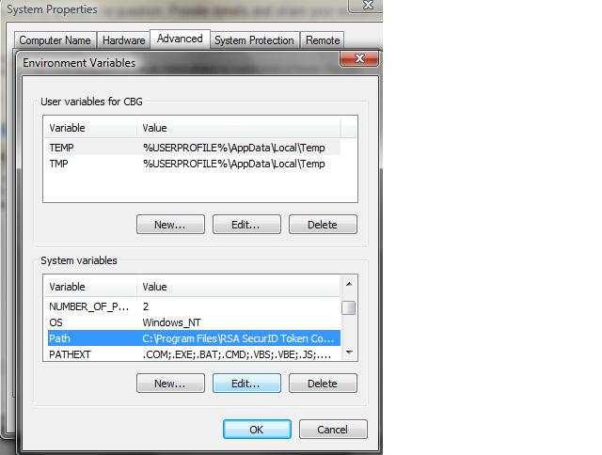

> OK > OK > Ok

1. **Restart the machine**

----------------------------------------  
Verify the Environment setup:  
> Launch Command Prompt  
  
> Type node -v (It provides details)

Download the sublime text editor from

<https://www.sublimetext.com/download>   
Sublime version 3 should be installed

1. It is a platform to write and execute Java programs, Perl, Python, PHP, Ruby etc...  
     
   It provides Editor, context help, help for syntax errors, Auto compilation and debugging.
2. **Create JavaScript build system in Sublime Text**

In sublime  go to Tools > Build System > New Build System

Create the build system with any name with below property

"cmd": ["C:/Program Files/nodejs/node.exe", "$file"],

"selector": "source.js"

}

While running program select above build system

7 To run the javascript code

Open a new file

Write the code

Save file as <filename>.js

Ctrl+b will give the out put

8 comment any code you can use ctrl+/ key it will comment out the code