Purpose

To define the standard operating procedures to be followed by the Circle Offices and the responsibilities of individuals involved. It also aims to describe good practice in correction of digitized land records data on the basis of Hand-Chitha and management techniques for Ratification of Legacy Land Records Data using Dharitree application software component of the ILRMS Assam.

This SOP should be used when any form of legacy data is changed for correction by the authorized officials of the Circle Offices.

Roles and Responsibilities

The personnel responsible for using and implementing this SOP are listed below. Each rectification of the legacy land records data should allocate the responsibilities linked to these roles.

- Deputy Commissioner (DC)/Additional Deputy Commissioner (ADC)

  - Responsible for ensuring that all officers/staff of revenue Circle Offices adhere to the principles and practice outlined in this SOP.

- Circle Officer (CO)

  - Responsible for all aspects of the rectification of legacy land records data once it comes into existence. This includes checks on the accuracy and integrity of changed legacy land records forwarded for approval by the Lot Mandal.
  - Responsible for overseeing and providing guidance to the LM of correction of land records data as per the Hand-Chitha and ensuring that all LMs adhere to the principles and practice outlined in this SOP.

- Lot Mandal (LM)
  - Responsible for all aspects of changes in the legacy data suggested as per hand chitha for approval by the Circle Officer concerned.
  - Responsible for uploading the scanned copy of the Hand-chitha pages for which changes is made.

Procedure

To carry out the data rectification process, Legacy Data Rectification utility has already been developed by NIC Assam State Centre and integrated with the exiting Dharitree application software.

Stage Involved

Stage | User Role |  | Steps
1.Preparation of data for rectification as per hand-chitha. | Lot Mandal | >>> | Identification of chitha details for rectification | >>> | - Logging into Dharitree account  - Use “Legacy Data Ratification” Module from Main Menu  - Enter the Dag specific details for which rectification is required.  - Upload the scanned copy of the Hand-chitha pages for which changes is done. | >>> | Submit the changes to Circle Officer for Verification & Approval along with auto generated remarks.

Stage | User Role |  | Steps
2.Verification & Approval of rectified data. | Circle Officer | >>> | Process Verification & Approval of rectified data for making the changes permanent into database | >>> | - Logging into Dharitree account  - Use “Pending Cases for Legacy Data Rectification” Module from Main Menu  - Approved/Reject the rectified details.  Or  Forwarded to DC/ADC for approval | >>> | Submit the approved changes for replacing the data with newly approved data along with auto generated remarks
3. Report on changed Legacy data | DLRS, DC, ADC (Rev), CO, LM | >>> | Report Process about changes in legacy data | >>> | - Logging into Dharitree account  - Use “Legacy Data Ratification” Module from Main Menu  - Select “Report on changed legacy Data” | >>> | Location wise report on changes.

Legacy Data Rectification Process (User Manual)
Work Flow:
Verifies the rectification of Land Legacy Data applied by the Lot Mandal with “Hathor chitha&Jamabandi” and will pass the order for modification which will automatically get corrected in chitha & Jamabandi after CO’s approval.
Registers Rectification of Land Legacy Data from the different modules incorporated under “Legacy Data Updation” in the menu bar.
Lot Mandal
Login

Circle Officer

The Following are the list of modules added for Legacy Data Ratification.

Utility Menu
Rectification of
Basic Dag details in Chitha & Jamabandi (Like Patta Type, Patta Number, Land Area, Revenue, Local Tax, Land Class >> GO
Chitha&Jamabandi Dag Compare for mismatch according to Patta>> GO
Dag Numbers containing (ক,খ, Dot, Space, any unwanted characters etc.)>> GO
Jamabandi Edit Entry Module>> GO
Updation / Modification for Jamabandi Remark(s) >> View
Updation / Modification for Chitha & Jamabandi Pattadar Edit >>View
Removal of Dag(s) from Jamabandi >> View
Report on changed Legacy data

Guidelines for all the process mentioned above:

- Basic Dag details in Chitha & Jamabandi (Like Patta Type, Patta Number, Land Area, Revenue, Local Tax, Land Class.

This module can be used to modify any details of a dag such as the patta type, land class code, revenue, local tax value, land area as well as change the patta no. This will be automatically reflected in the Chitha and the Jamabandi after circle officer has verified.

Steps:
- Lot Mandal
  - Logging into Dharitree account (Using Lot Mandal role)
  - Click on <Legacy Data Updation> Menu option.
  - Enter the Dag No for which rectification is required and Click on as depicted in the following figure.
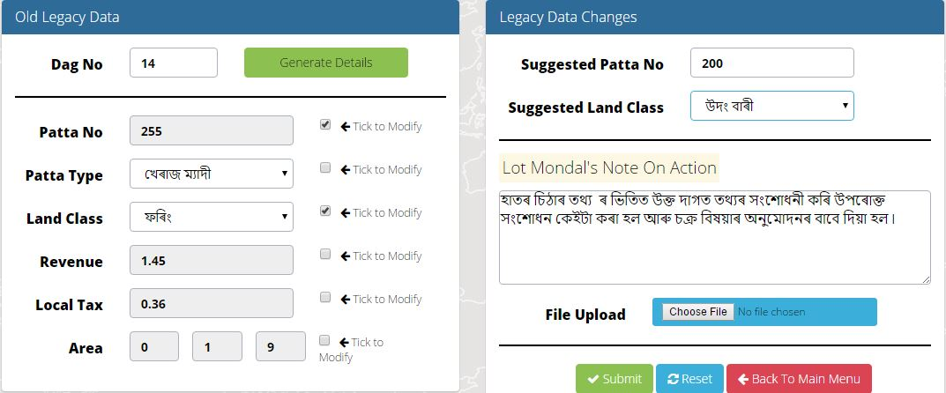

  - Check appropriate filed(s) from “Old Legacy Data” Section (Left side of above figure). The Select field will be appeared in the “Legacy Data Changes” Section (Right side of above figure).
  - Enter the value for changes.
  - The Lot Mandal’s Comments will be generate automatically.
  - Click <Choose File> to upload the scanned copy of Hand-Chitha page for further verification by Circle Officer.
  - Click on to send the rectified details to the Circle Officer concerned for approval.

- Circle Officer
  - Logging into Dharitree account (Using CO Role)
  - Click on <Pending Cases for Legacy Data Rectification> Menu option
  - Pending cases will be appeared as shown below

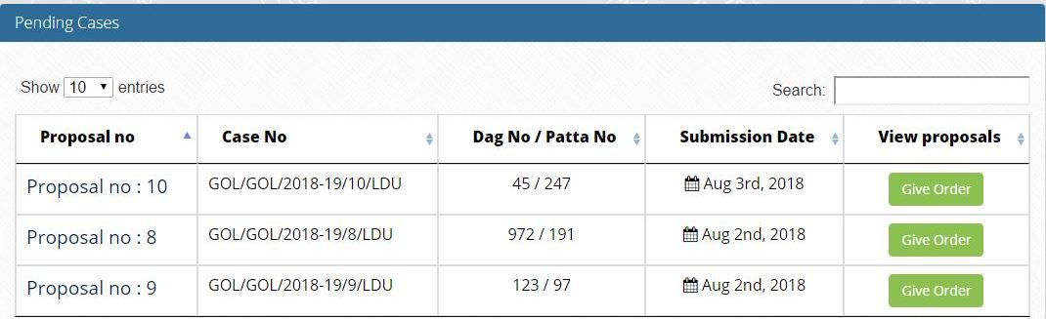
  - Click on to approved the rectified details and following will be displayed:

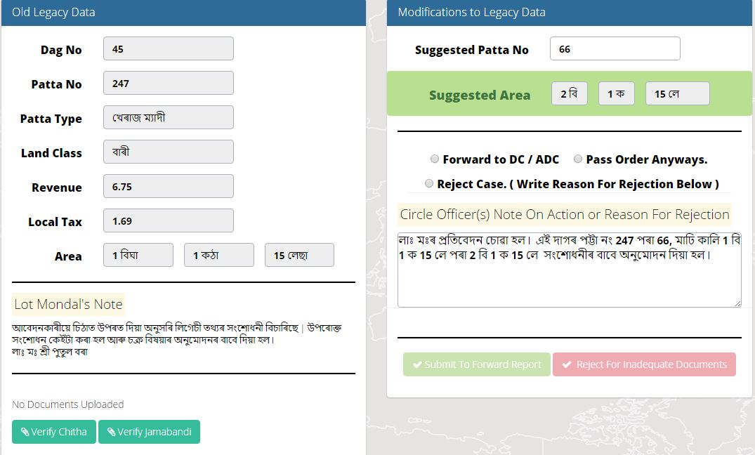
  - Circle officer will verify and can submit for the modification or can further forward it to DC/ADC for further action.

The Chitha and Jamabandi will automatically be updated.

- Chitha & Jamabandi Dag Compare for mismatch according to Patta.
This module is basically patta no wise comparison of the dags associated with that patta no recorded in Chitha and Jamabandi separately. The result of this module is to give an overview if any dag no associated with a patta no exists in Chitha but missing from Jamabandi or vice versa.
Steps:

- Lot Mandal

  - Logging into Dharitree account (Using Lot Mandal role)
  - Click on <Legacy Data Updation> Menu option.
  - Select Chitha&Jamabandi Dag compare according to Patta from the menu.
  - Select the location along with the patta type. The result will be the figure below.

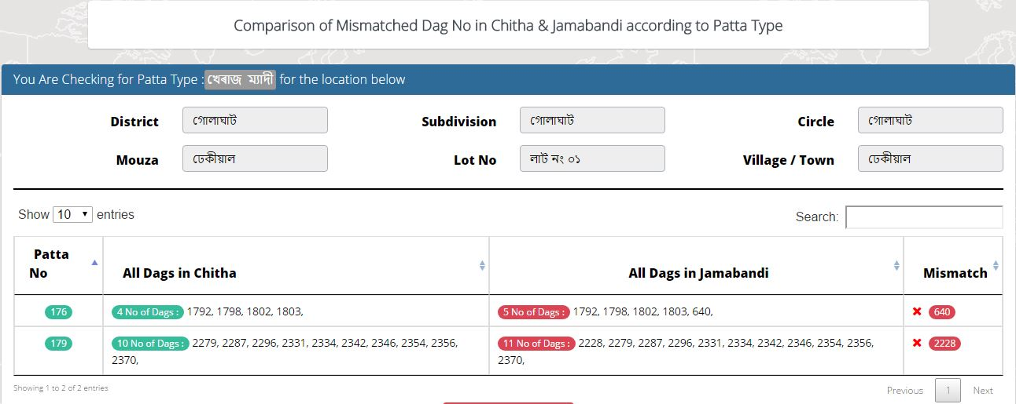
Depending on that the lot Mandal will verify with the “hand chitha or jamabandi” and then decide what needs to be done. Once decided then he/she can use any of the new modules for correction and modification.

- Dag Numbers containing (ক,খ, Dot, Space, any unwanted characters etc.).

This module can be used to modify dag numbers containing (ক,খ..etc) for better accuracy of the data. Before assigning any new dag please check the chitha as well as the jamabandi so as to make sure that the new dag no already don’t exist.

Steps:

- Lot Mandal
  - Logging into Dharitree account (Using Lot Mandal role)
  - Click on <Legacy Data Updation> Menu option.
  - Select Modification of Dag Number containing (ক,খ, dot,space,any special characteretc) from the menu.
  - Select the location. If any such dag exists then that will appear on the screen as shown below.

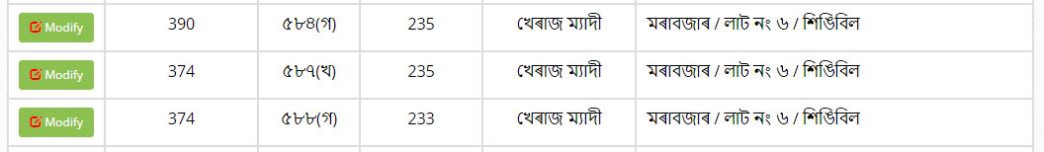

  - Click modify button to modify the dag number.

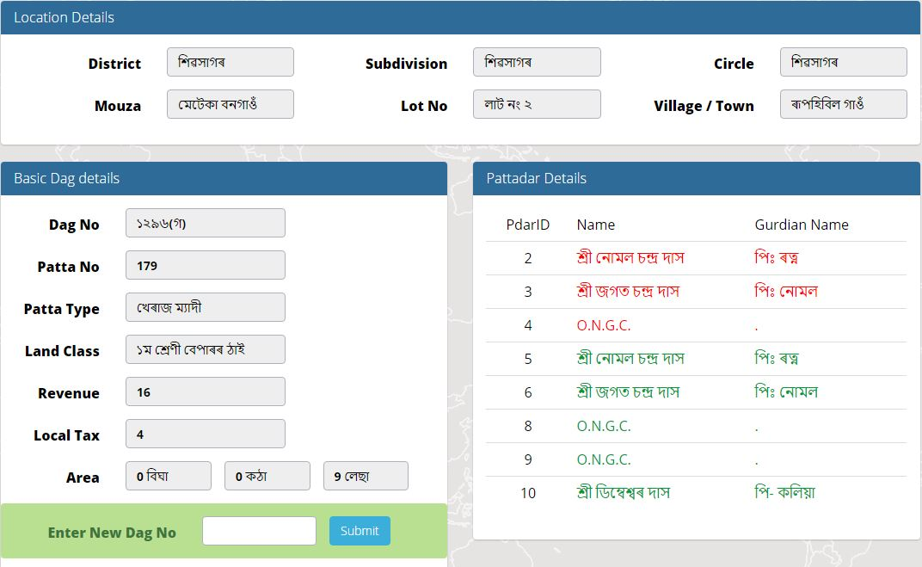

  - Details of the dag along with the pattadar’s of that dag are displayed. Enter the rectified or should be new dag no and click on the submit button to make the changes.

- Jamabandi Edit Entry Module.
This module is basically the upgraded version of Jambandi edit entry module incorporated earlier in online Dharitree.
Steps:
- Lot Mandal
  - Logging into Dharitree account (Using Lot Mandal role)
  - Click on <Legacy Data Updation> Menu option.
  - Select Jamabandi Edit entry Module from the menu.
  - Select the location along with the patta no and patta type. Then click submit.
  - There are 3 option for rectification.
- Jamabandi Pattadar Edit / View :

This option can be used to rectify pattadar details such as strike out, un-strike out, rectify pattadar(s) name.

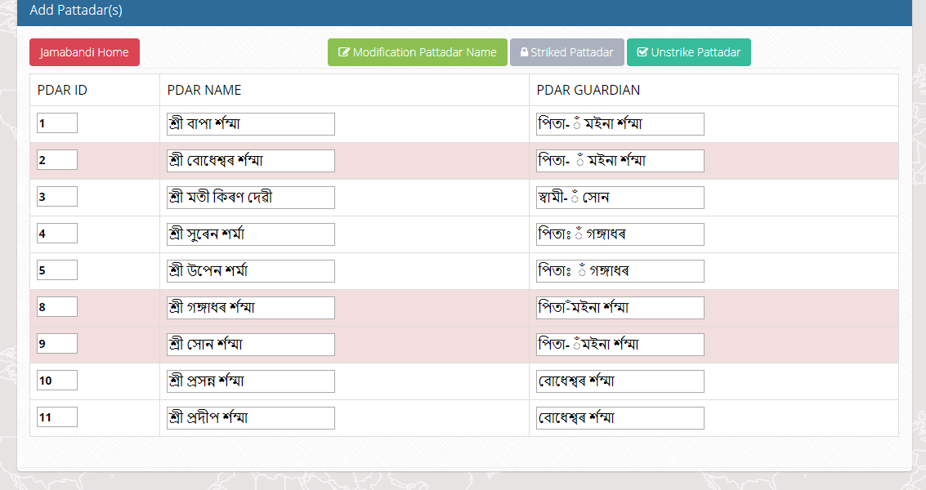

    - When You Click on the option Modification Pattadar Name
Then all the pattdar name would be seen. There is a button naming Modify on the right hand side against each pattadar name(s). Click On that link then a pop-up would be seen.
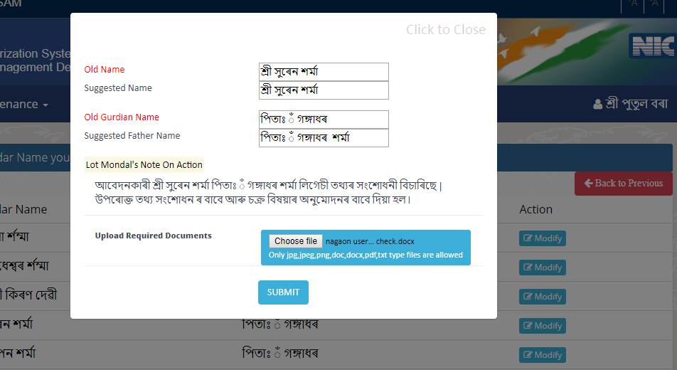

Type the name on that input box. You have to filled up both the name(s) (Pattadar Name and guardian Name) and submit the form.
Note : If the name is same as older then copy and paste it from the above input box. You have to filled up both the input box.

    - When You Click Striked Pattadar button then all the un-strike pattadar(s) list would be seen. Using CTRL button from your keyboard you can select multiple pattdar name there. Also type the LM Note as per your requirement .

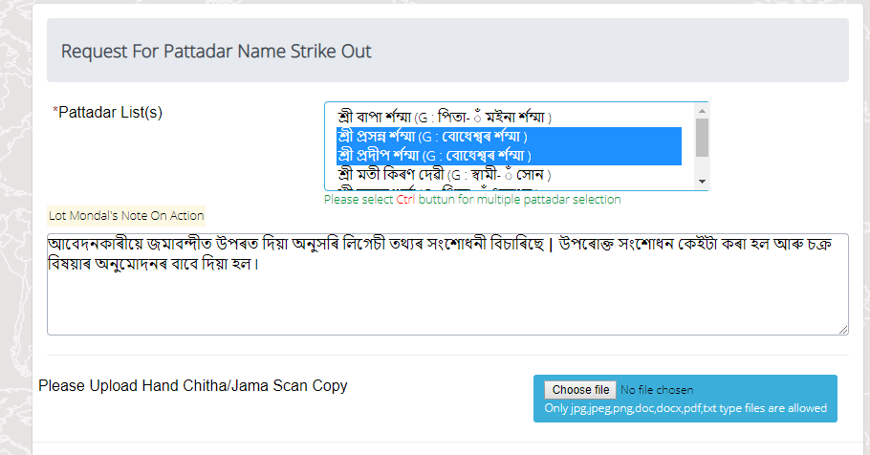
    - When You Click Un-Striked Pattadar button then all the strike out pattadar(s) list would be seen. Using CTRL button from your keyboard you can select multiple pattdar name there. Also type the LM Note as per your requirement.
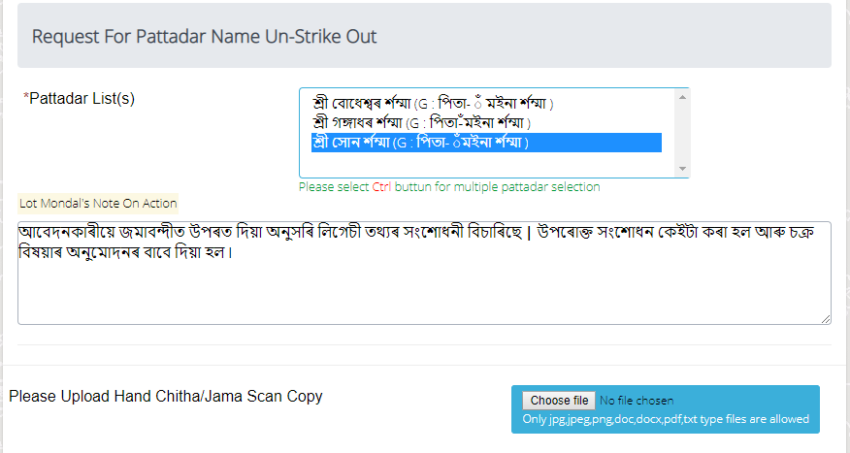
    - Add new pattadar name(s). Use this module only when remark(s) is on the jamabandi copy but pattadar(s) name is missing on both chitha & jamabadi copy also.
(Note: i) If pattadar(s) name is on jambandi but not in chitha Please don’t use this module at that time. Otherwise pattadar(s) name will be repeat again. There is another module for pattadar(s) name transfer. Call Helpdesk person or ask consultant for any kind of query.
ii ) If remark(s) is missing then use backlog mutation module for pattadar(s) name insertion. )
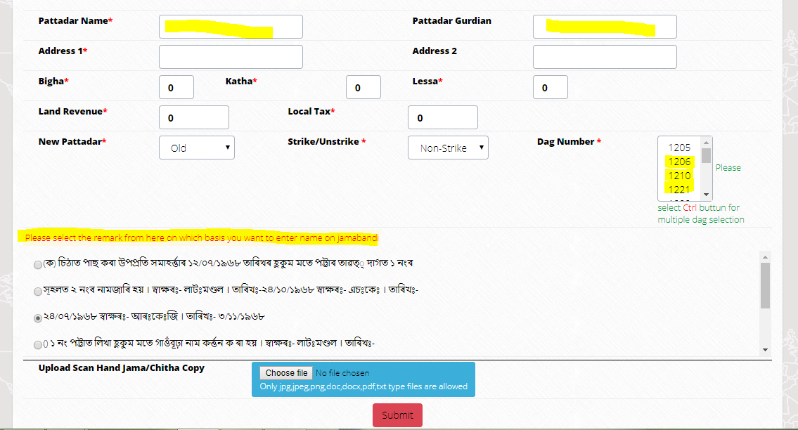

- Jamabandi Remarks Edit / View :

This option can be used to rectify Old Jamabandi Remarks and add backdated Jamabandi Remarks that are not updated on the jamabandi.
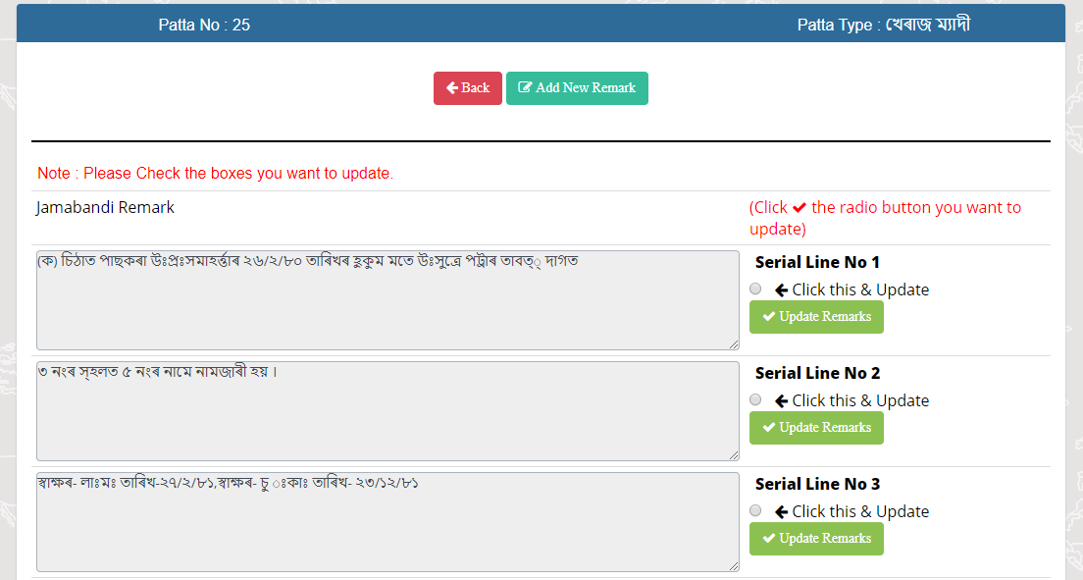

If you want to add new remarks then Click on the button Add New Remark and type the remarks on the text box given there and submit the form. Please Type the LM note as per requirement.

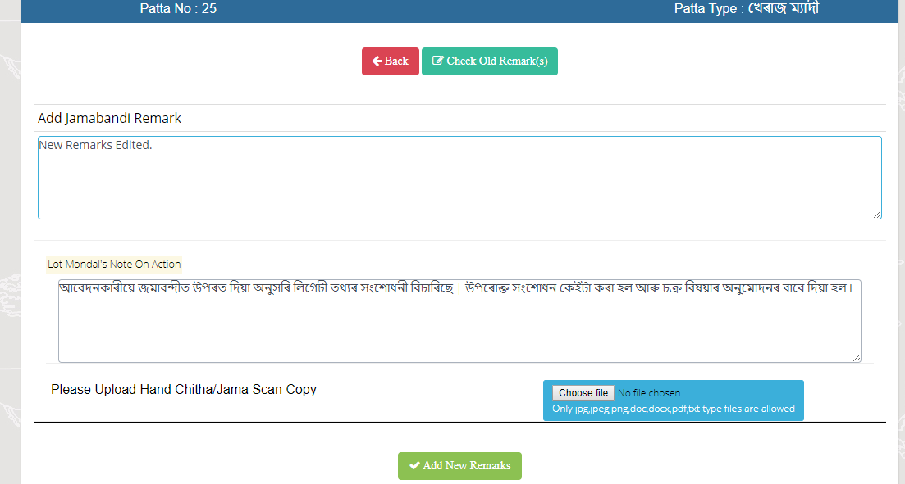

If you want to edit old remarks then check the radio button and submit Update Remarks Button . Then old remarks would be seen above the text box. In the text box you can type the order as per your requirement and submit the form. Please Type the LM note as per requirement.
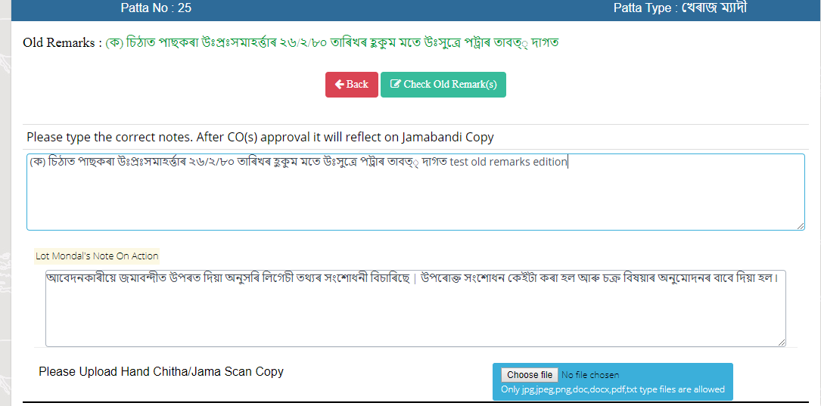

- Remove Dags from this Patta :

This option can be used to delete those dag(s) that are in jamabandi but not in chitha. Software will automatically display the unmatched dag(s) between chitha and jamabandi against that patta. Then check on the checkbox on the right hand side and submit the form.
Please Type the LM note as per requirement.

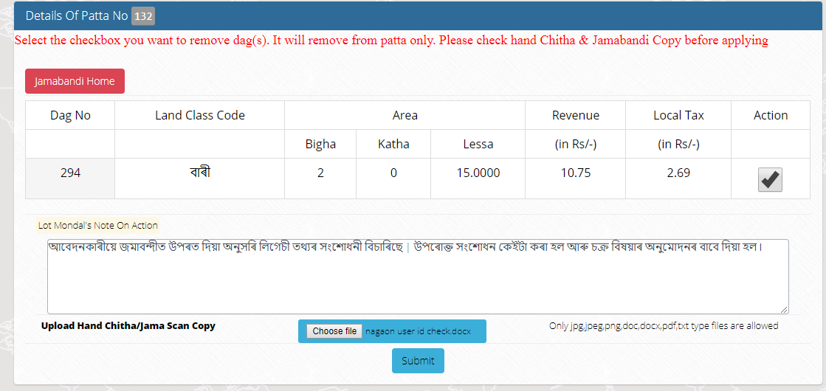

Above mention are the features provided to make the above said modification. Any changes made are recorded for circle officer’s approval. You can also check the request whether it is approved / Rejected / Pending.
Updation / Modification for Jamabandi Remark(s) >> View
Updation / Modification for Chitha & Jamabandi Pattadar Edit >> View
Removal of Dag(s) from Jamabandi >> View
Likewise:
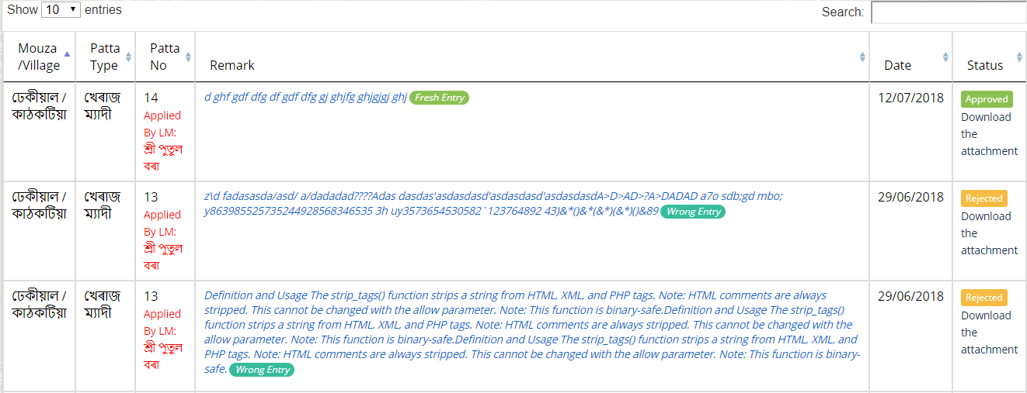
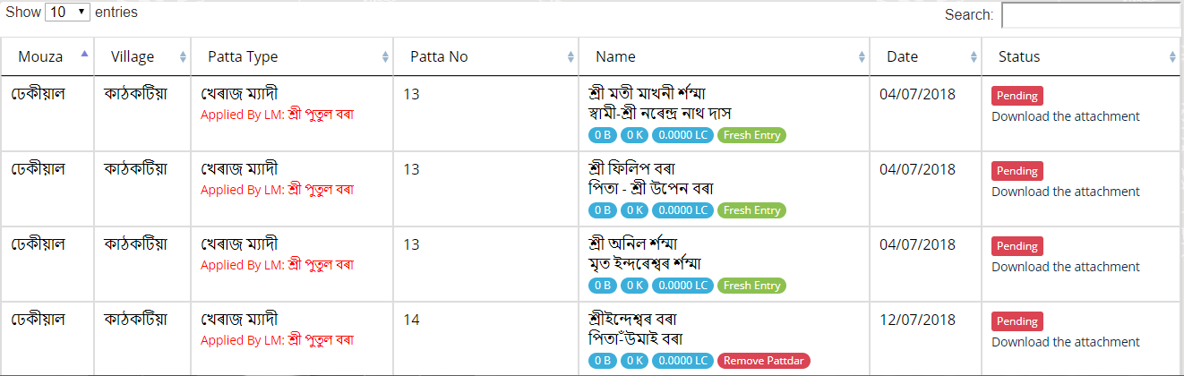
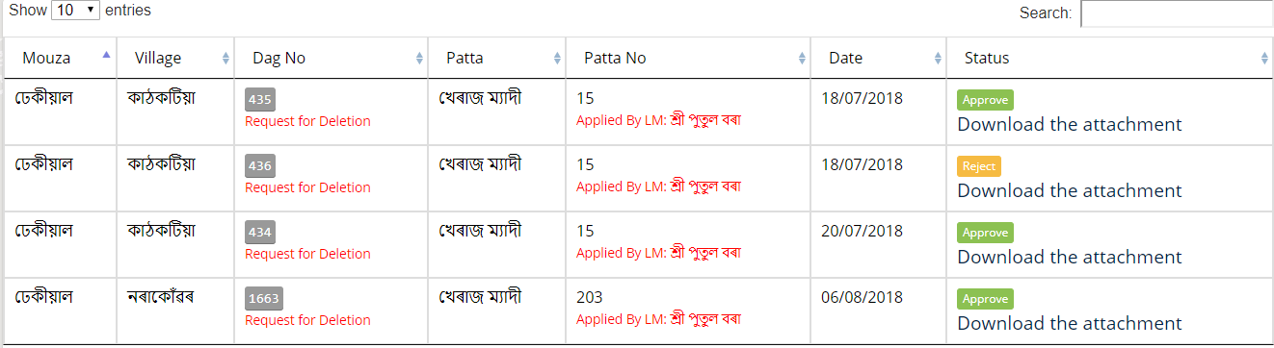

- Circle Officer
  - Log into Dharitree account.
  - Click on Menu option Legacy Data Updation.
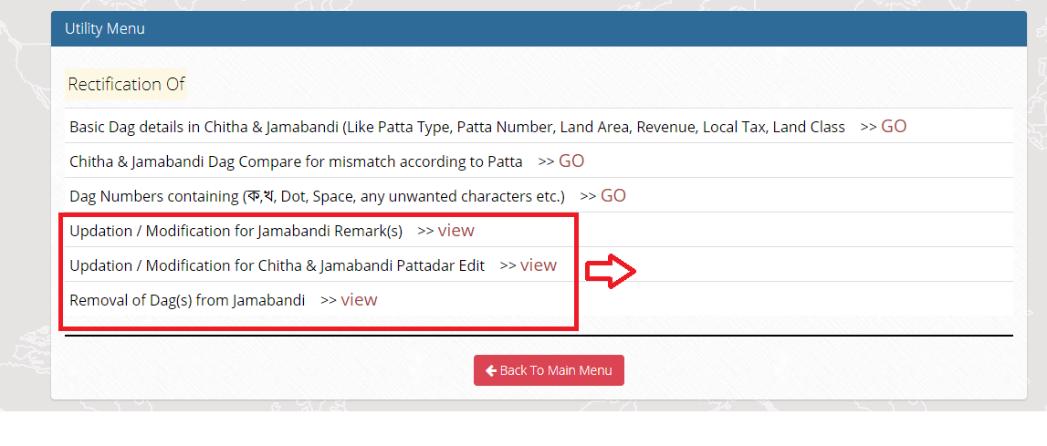
There are three View button(s). On click the view button, the entire pending request(s) would be seen
to you.
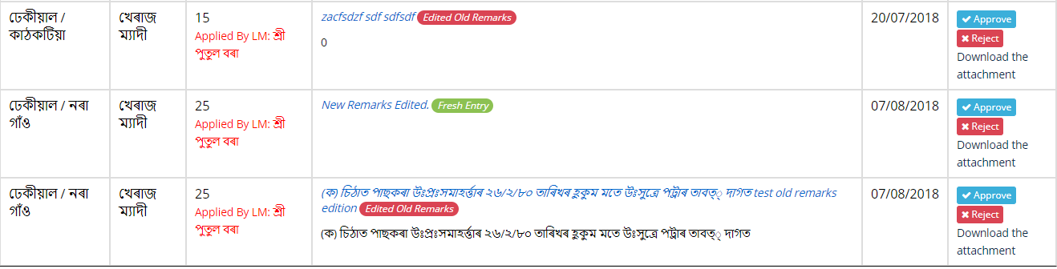
There are three options on the right hand side. Download the attachment file which is uploaded by LM. If you satisfy with the attachment and found it it’s a genuine, then click on the approve button. On clicking the Approve button a popup would be seen. Type your order on that text box properly which will reflect final Jamabandi Copy also. If you found it’s not a genuine or document is not proper to pass this order Reject such kind of request(s).

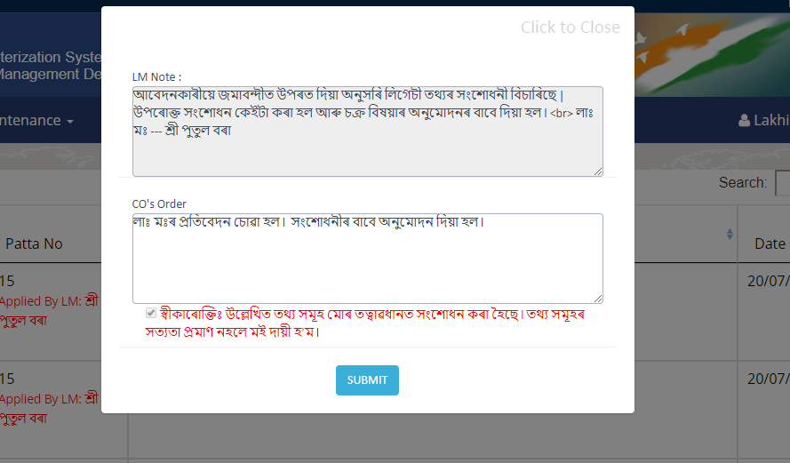

- Report on changed legacy Data Monitoring of changed Legacy data – Report
  - Logging into Dharitree account
  - Use “Legacy Data Ratification” Module from Main Menu
  - Select “Report on changed legacy Data”
Select location

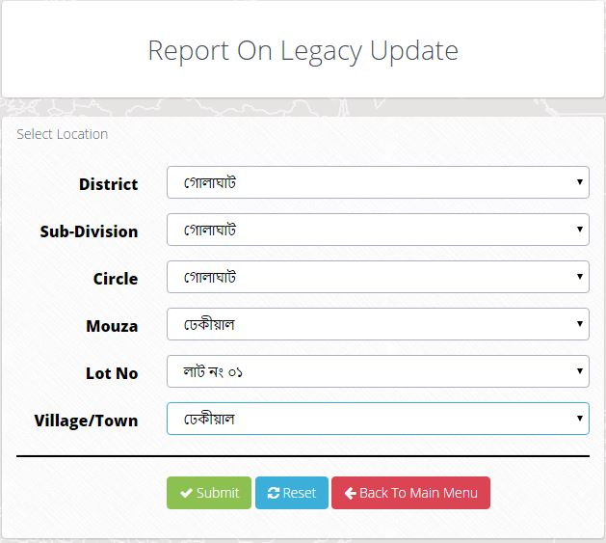
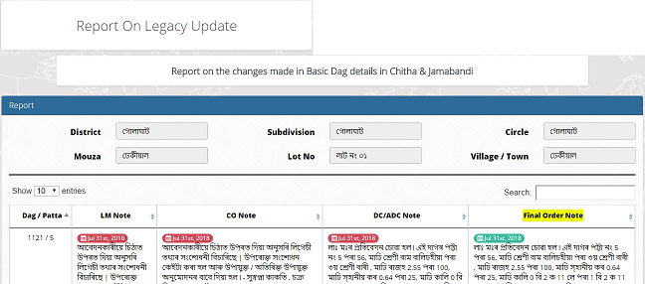

--xx--

