Purpose

To define the standard operating procedures to be followed by the Circle Offices and the responsibilities of individuals involved. It also aims to describegoodpracticein correction of digitized land records data on the basis of Hand-Chithaand management techniquesfor Backlog Entry of Land Records Data using Dharitree application software component of the ILRMS Assam.

This SOP should be used when any form of Mutation/Partition (Office & Field) backlog entry by the authorized officials of the Circle Offices.

Roles and Responsibilities

Thepersonnel responsible for usingand implementing this SOP are listed below. Each rectification of the backlog dataentry should allocate the responsibilitieslinked to these roles.

- Deputy Commissioner (DC)/Additional Deputy Commissioner(ADC)

  - Responsible for ensuring that all officers/staff of revenue Circle Offices adhere to the principles and practice outlined in this SOP.

- Circle Officer (CO)

  - Responsible for all aspects of the backlog dataentry once it comes into existence. This includeschecks on the accuracy and integrity of backlog entry land records forwarded for approval by the Lot Mandal.
  - Responsible for overseeing and providing guidance to the LM of backlog entry of land records data as per the Hand-Chitha and ensuring that all LMs adhere to the principles and practice outlined in this SOP.

- Lot Mandal (LM)

  - Responsible for all aspects of changes in the legacy data suggested as per hand chithafor approval by the Circle Officer concerned.
  - Responsible for uploading the scanned copy of the Hand-chitha pages for which changes is made.

Procedure

To carry out the Backlog Data entry,Backlog Entry Module has already been developed by NIC Assam State Centre and integrated with the exitingDharitree application software under Utility Option.

Stage Involved

Stage | User Role |  | Steps
1.Preparation of data for backlog entry as per hand-chitha. | Lot Mandal | >>> | Identification of chitha details for backlog entry | >>> | - Logging into Dharitree account  - Use “Request for Backlog entry” Module from utility option.  - Select the village for which backlog entry is required. | >>> | Submit the request to Circle Officer for Activation of the village for backlog data entry.

Stage | User Role |  | Steps
2. Activation of Village for Data entry | Circle Officer |  | Verify the request send by LM and activation of the village for Backlog entry. |  | - Logging into Dharitree account  - Use “Pending Cases of request for backlog entry” Module from Utility Menu  - Activate or Deactivate the village for backlog entry
3. Backlog Data entry | Lot Mondal | >>> | Dagwise details Backlog entry | >>> | - Logging into Dharitree account  - Use “Backlog Entry for Field/Office mutation” Module from Main (Utility) Menu  - Approved/Reject the rectified details. | >>> | Submit the data for necessary verification and
- Verification & approval of Backlog Entry | Circle Officer |  | Verification & approval/rejection of backlog entry request sent by Lot Mondal |  | - Logging into Dharitree account.  - Use “Pending Cases for Backlog Entry” Module from Main Menu  - Approved/Reject the rectified details. |  | Submit the approved data along with auto generated remarks.
5.Report on Backlog data Entered |  | >>> | Report Process about Backlog entry | >>> |  | >>> | Location (Village)wise report on changes.

In LM Account all the back log modules will be locked initially. To unlock or activate the modules send request to Circle Officer on clicking the "Send Request for Backlog".
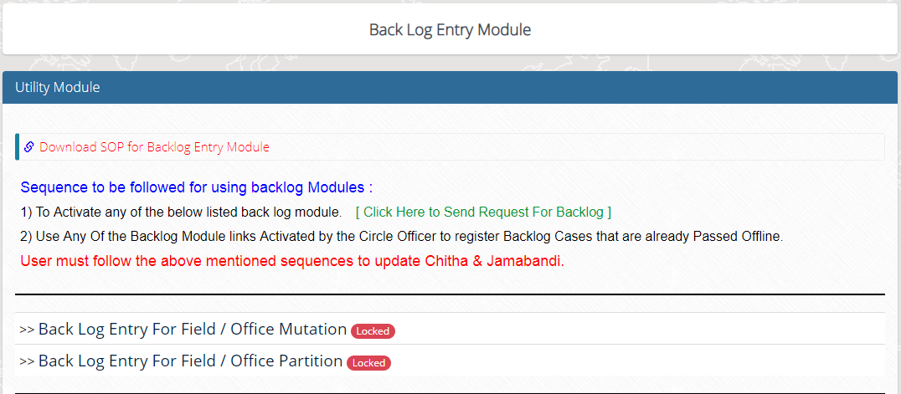

Use backlog request form.
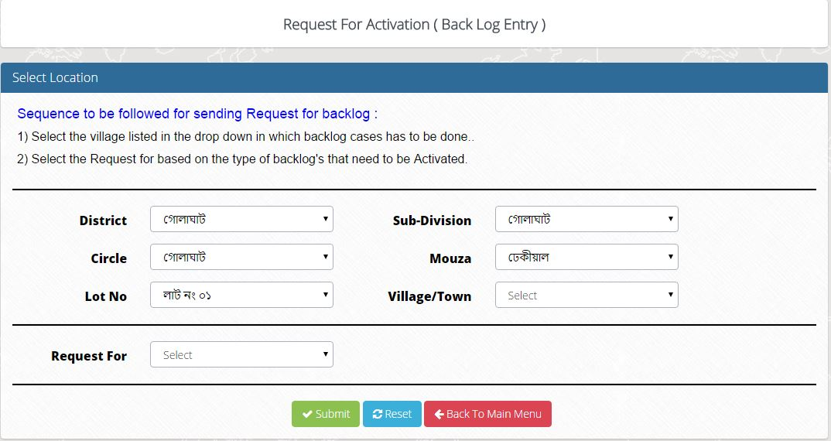
In co account the request will be listed for activation as well as deactivation.
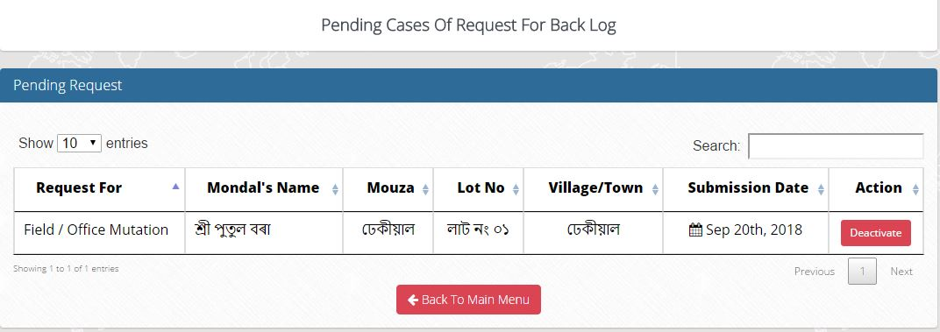
xxxxxxx
In LM Account after accepting the request, the module will be activated.
Click on the corresponding link to register back log entries. All entries will be listed in Circle Officers account.
Fill up the form accordingly.
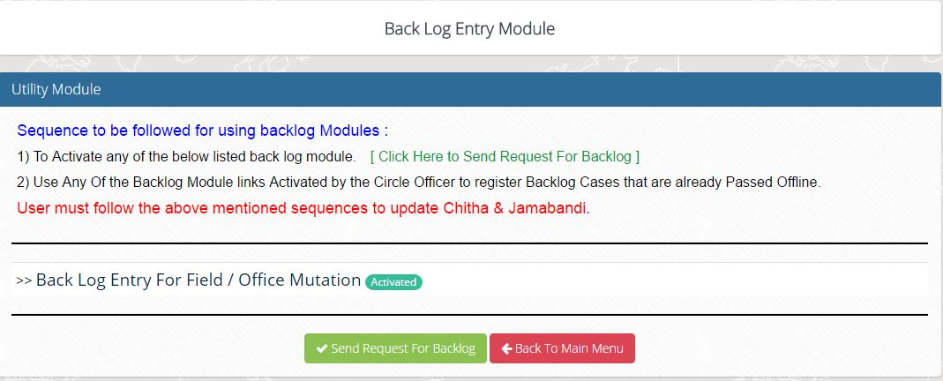
Make sure all the fields are entered correctly. And save the back log mutation case.
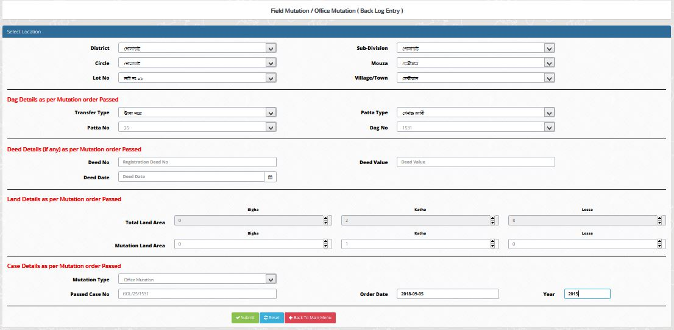
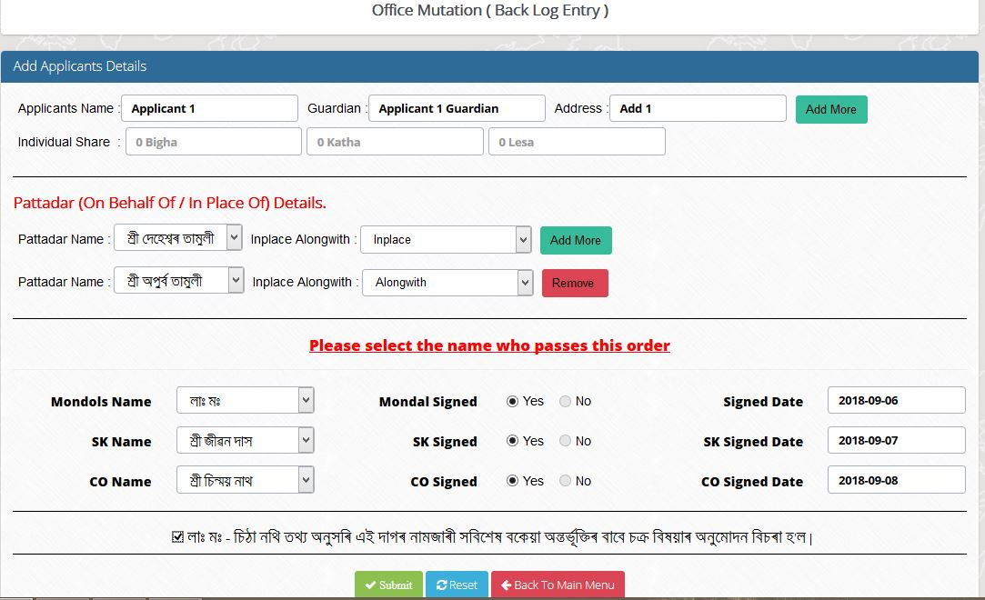
Xxxxxx

xxxxx
Xxxxxx

xxxxx

In co account all the backlog cases are listed for final order b circle officer.
Click the pass order button to view the complete mutation details.
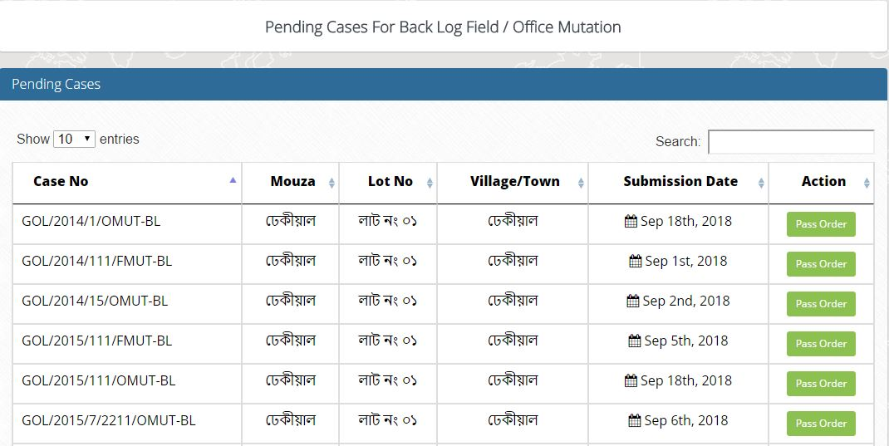
Click on save to pass the final order. Chitha will be automatically corrected and the jamabandi has to be manually updated.
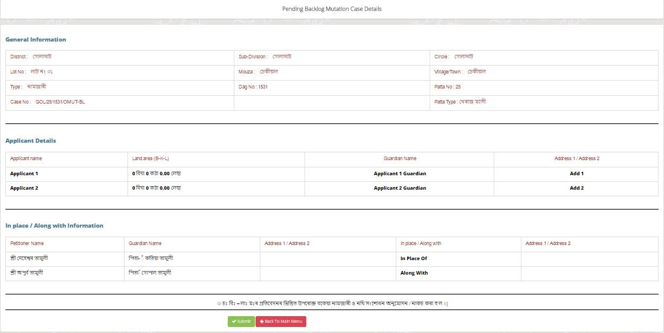
After the final order is passed the following are the results of Field Mutation in chitha and jamabandi.
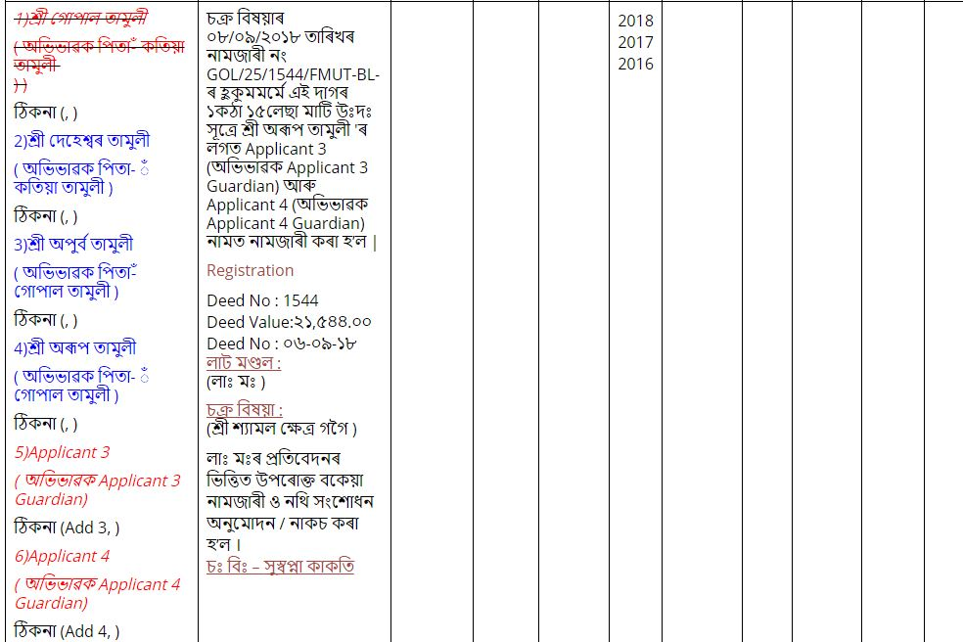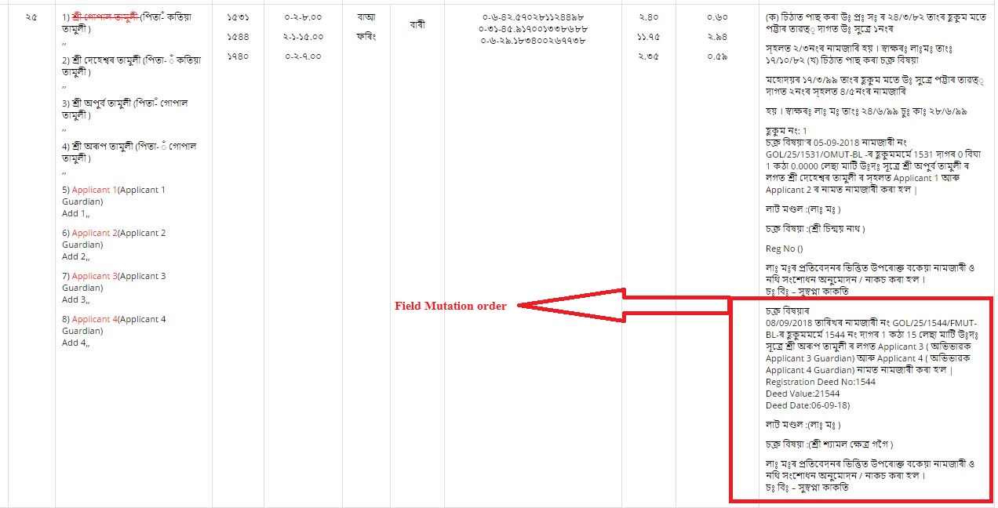
Xxxxxx

Xxxxx
Xxx
Xxxxxx
Xxxxxx
Xxxxxxx
Xxxx
Xxxxxxxx
Xxxxxxx
Xxxxxx
Xxxxxx

Xxxxx
Xxxxxxx
Xxxxxxx
xxxxxxxxxxxxxx

Xxxxxx

Xxxxx
Xxx
Xxxxxx
Xxxxxx
Xxxxxxx
Xxxx
Xxxxxxxxxxxxxx
Xxxxxxx
Xxxxxx
Xxxxxx
xxxxxxx
Xxxxx
Xxxxxxx
Xxxxxxx
Xxxxxxxxxxxxxx
xxxxxxx
xxxxxxxx

Xxxxxx

Xxxxx
Xxx
Xxxxxx
Xxxxxx
Xxxxxxx
Xxxx
Xxxxxxxx
Xxxxxxx
Xxxxxx
Xxxxxx

Xxxxx
Xxxxxxx
Xxxxxxx
xxxxxxxxxxxxxx

After the final order is passed the following are the results of Office Mutation in chitha and jamabandi.
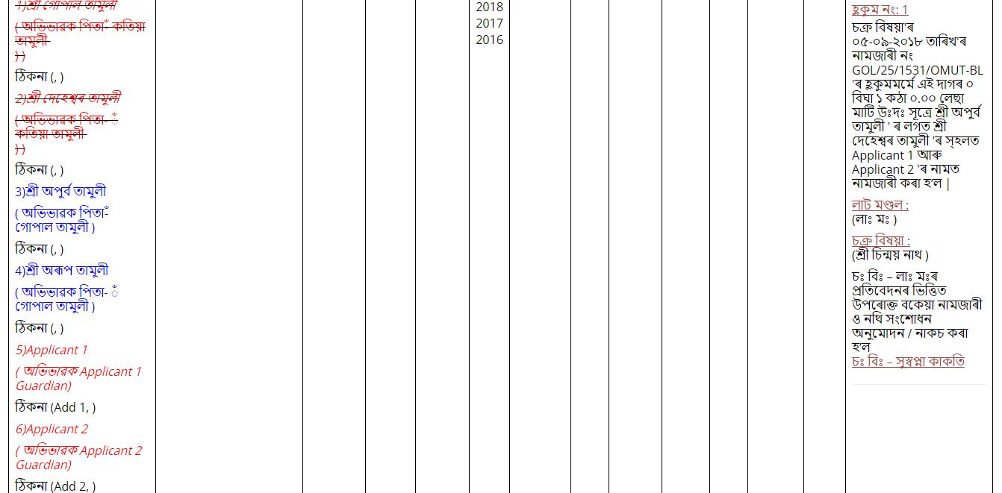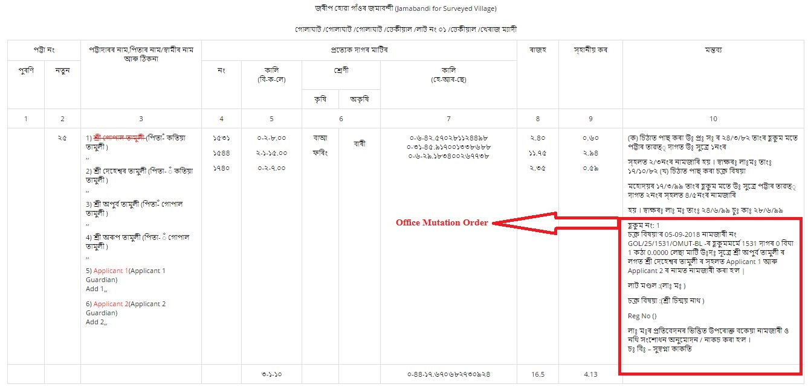
Xxxxxx

Xxxxx
Xxx
Xxxxxx
Xxxxxx
Xxxxxxx
Xxxx
Xxxxxxxx
Xxxxxxx
Xxxxxx
Xxxxxx

Xxxxx
Xxxxxxx
Xxxxxxx
xxxxxxxxxxxxxx

Xxxxxx

Xxxxx
Xxx
Xxxxxx
Xxxxxx
Xxxxxxx
Xxxx
Xxxxxxxx
Xxxxxxx
Xxxxxx
Xxxxxx

Xxxxx
Xxxxxxx
Xxxxxxx
xxxxxxxxxxxxxx

Xxxxxx

Xxxxx
Xxx
Xxxxxx
Xxxxxx
Xxxxxxx
Xxxx
Xxxxxxxx
Xxxxxxx
Xxxxxx
Xxxxxx

Xxxxx
Xxxxxxx
Xxxxxxx
xxxxxxxxxxxxxx

Mutation Case (Office & Field) Backlog Entry Flow Diagram

Lot Mandal |  | Circle Officer
Request for village wise Backlog Entry |  | Request Received for Backlog Entry
Dag-wise details entry as backlog from the Hand Chitha with auto generated Remarks | Yes | Activate Backlog Entry? | No
Save & Forward to the CO for Approval |  | Request Received for Approval | Exit
 |  | Approved?  Yes | No
 |  | Save the details with Auto generated Remarks |  | Dharitree

Backlog Partition. Lm fill up the application as per hand chitha/Jama copy.
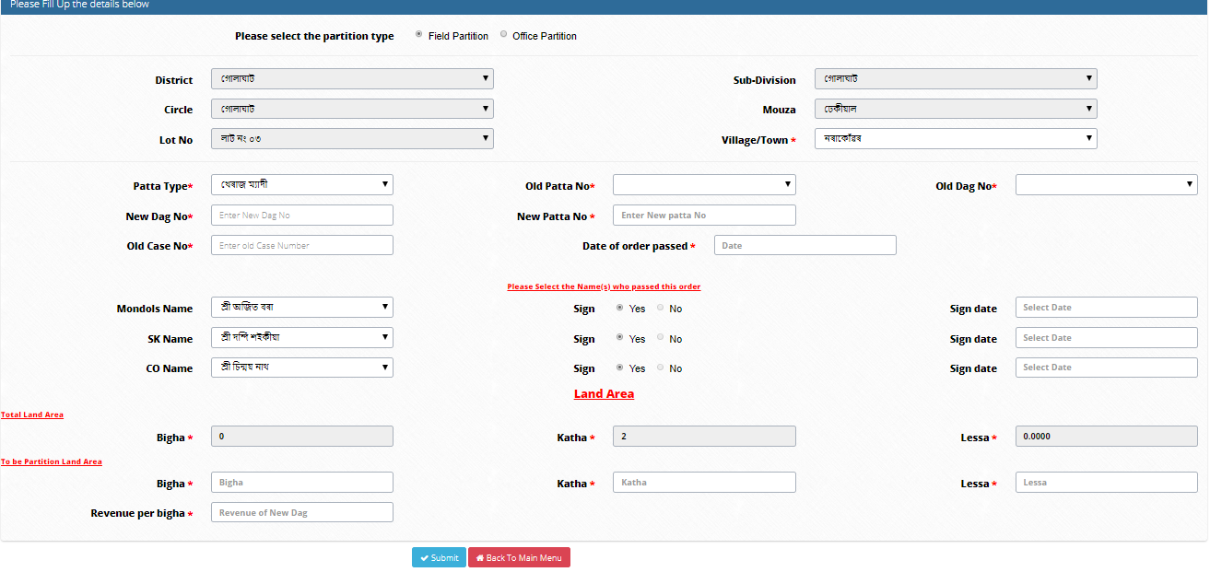
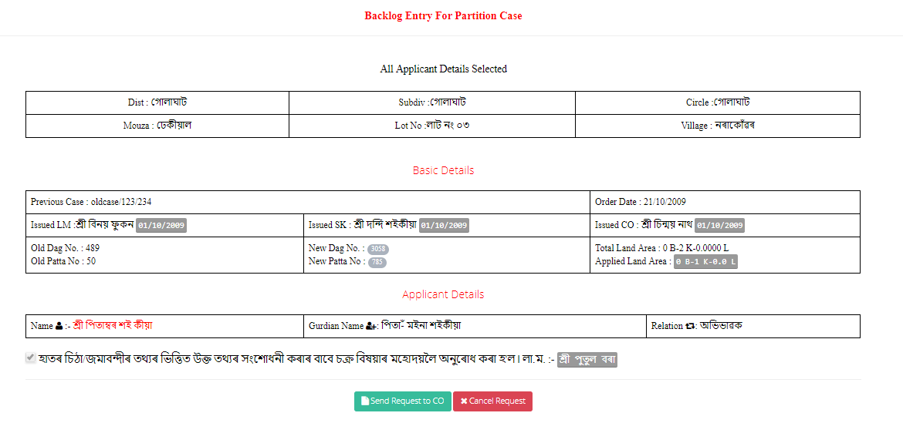
CO Level:
In co account all the backlog cases are listed for final order b circle officer.
Click the check order button to view the complete partition details.

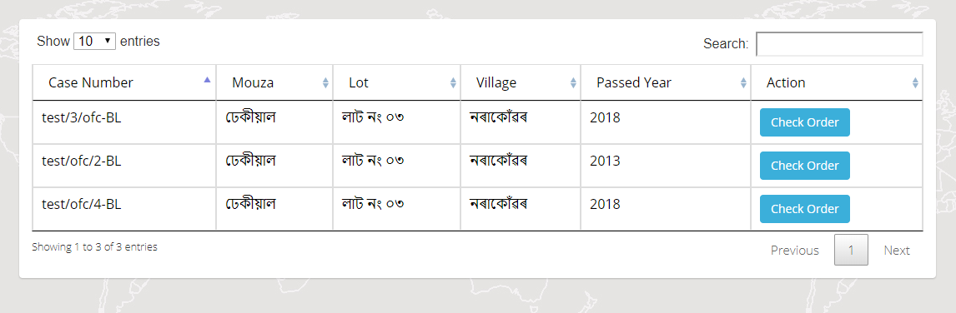
After Final Save Chitha will be automatically corrected and the jamabandi has to be manually updated.
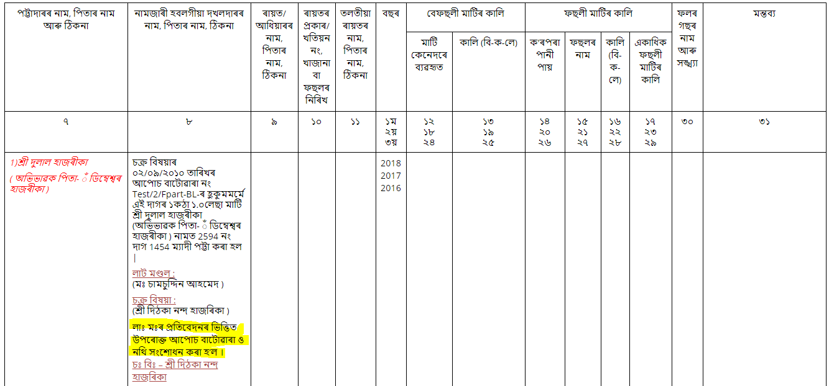
Order in chitha will be reflect like this.
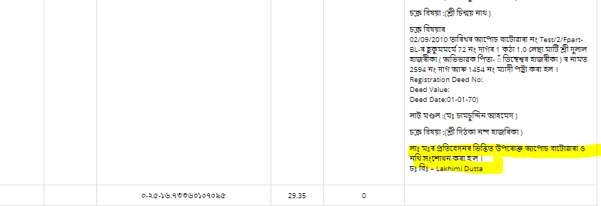
In jamabandi order will be reflect likewise.

Partition Case (Office & Field) Backlog Entry Flow Diagram

Lot Mandal |  | Circle Officer
Request for village wise Backlog Entry |  | Request Received for Backlog Entry
Dag-wise details entry as backlog from the Hand Chitha with auto generated Remarks | Yes | Activate Backlog Entry? | No
Save & Forward to the CO for Approval |  | Request Received for Approval | Exit
 |  | Approved?  Yes | No
 |  | Save the details with Auto generated Remarks |  | Dharitree

--xx--

