LAC MAPPING PROCDURE
ADC
Link for mapping: PROCESS -> LAC MAPPING -> Map
- Select District, LAC, Sub Division is optional. Fetch All village is to fetch all Villages regardless of Sub-Division
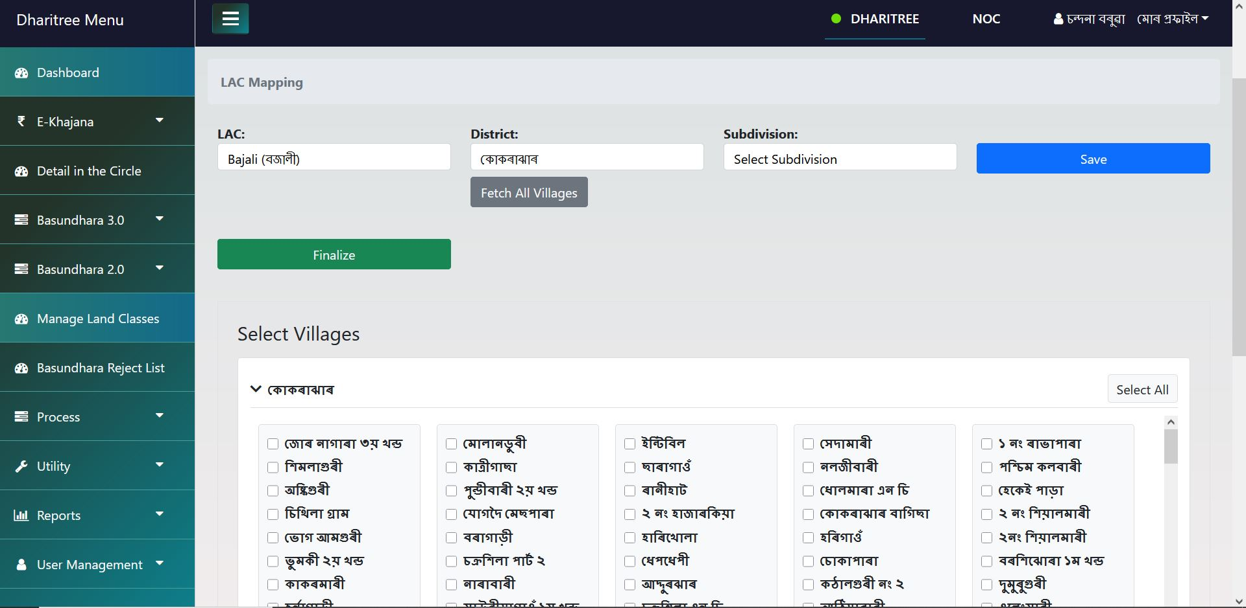
- After selecting click Save and click Finalize.
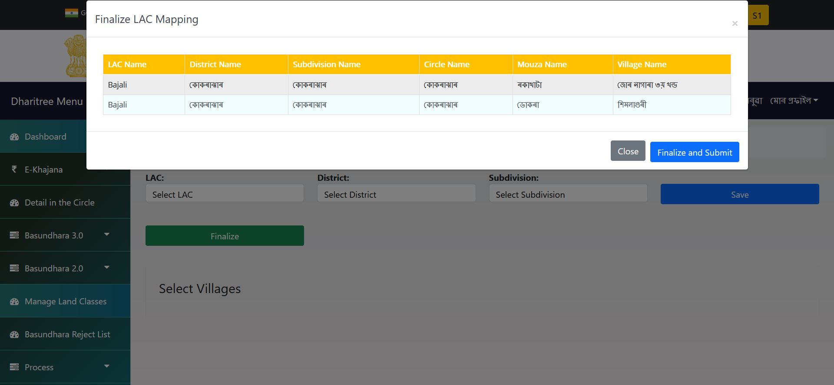

DC
Link for approval: PROCESS -> LAC MAPPING -> Approve

- Select the LAC
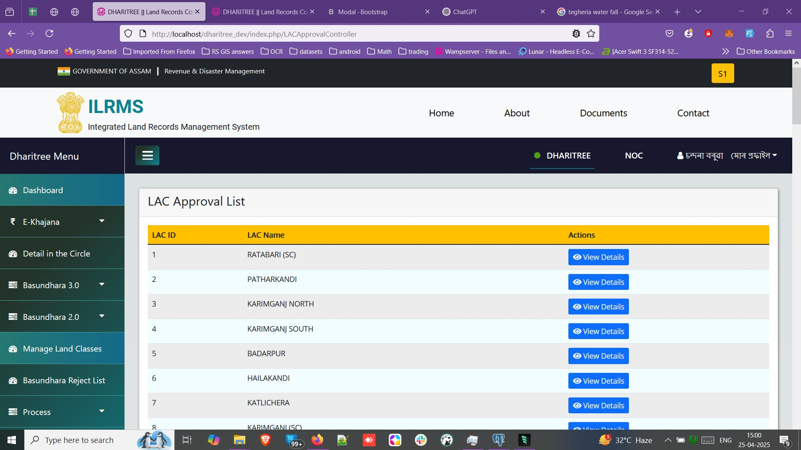
- Click on Approve
