**NAME:**

**COLLABORATOR(S):**

**CS 583 – Assignment 2**

1. We have three random variables, *A*, *B*, *C*, each of which is binary. We have the following factors over these variables: *φ*(*A*), *φ*(*B*), *φ*(*C*), *φ*(*A, B*), *φ*(*A, C*), *φ*(*B, C*).
   1. Draw a Markov network graph over these variables.
   2. Draw a factor graph over these variables.
   3. Here are the values of the factors. Compute *P*(*A*, *B*, *C*).

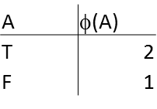 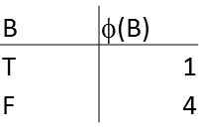 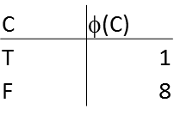

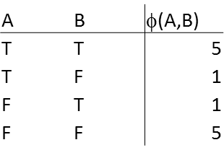 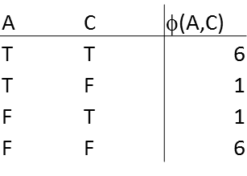 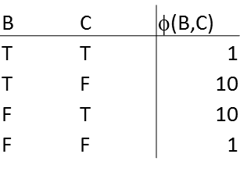

1. For the following Markov network graph, indicate whether the following independence statements are True or False.

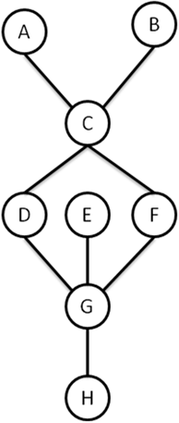

* 1. A ⊥ B
  2. A ⊥ B | C
  3. A ⊥ G | D
  4. A ⊥ G | D, F
  5. A ⊥ H | G

1. We have a document classification task. We have four documents, *D*1, *D*2, *D*3, and *D*4. We are interested in classifying each of these documents into one of two topics: Artificial Intelligence (AI) or Databases (DB). Each document has one or both of the following words: Agent and SQL.

We will represent this data as follows: the labels of *D*1 through *D*4 are: *Y*1, *Y*2, *Y*3, and *Y*4. Each *Yi* can take one of two values: AI or DB. The presence of word Agent in document *Di* represented as *X*1i, and the presence of the word SQL in document *Di* represented as *X*2i. The documents and their contents are as follows:

*D*1: *X*11 = True, *X*21 = False (i.e, *D*1 contains only the word Agent)

*D*2: *X*12 = True, *X*22 = True (i.e., *D*2 contains both words)

*D*3: *X*13 = False, *X*23 = True (i.e, *D*3 contains only the word SQL)

*D*4: *X*14 = True, *X*24 = True (i.e., *D*4 contains both words)

We also have the additional knowledge that *D*1 cites *D*2, and *D*3 cites *D*4. We construct the following CRF, with the following feature functions.

*f*1(*X*1i, *Y*i) = 1 if X1i = T and Yi = AI, 0 otherwise; *w*1 = -1.

*f*2(*X*1i, *Y*i) = 1 if X1i = T and Yi = DB, 0 otherwise; *w*2 = +1.

*f*3(*X*2i, *Y*i) = 1 if X2i = T and Yi = AI, 0 otherwise; *w*3 = +1.

*f*4(*X*2i, *Y*i) = 1 if X2i = T and Yi = DB, 0 otherwise; *w*4 = -1.

*f*5(*Y*i, *Y*j) = 1 if Yi­=Yj, 0 otherwise; *w*5 = -1.

*f*6(*Y*i, *Y*j) = 1 if Y­i≠Yj, 0 otherwise; *w*6 = +1.

*φ1(X*1*i, Yi) = e-(w1f1+ w2f2)*

*φ2(X*2*i, Yi) = e-(w3f3+ w4f4)*

*φ3(Yi, Yj) = e-(w5f5+ w6f6)*

The factor graph is given as follows:

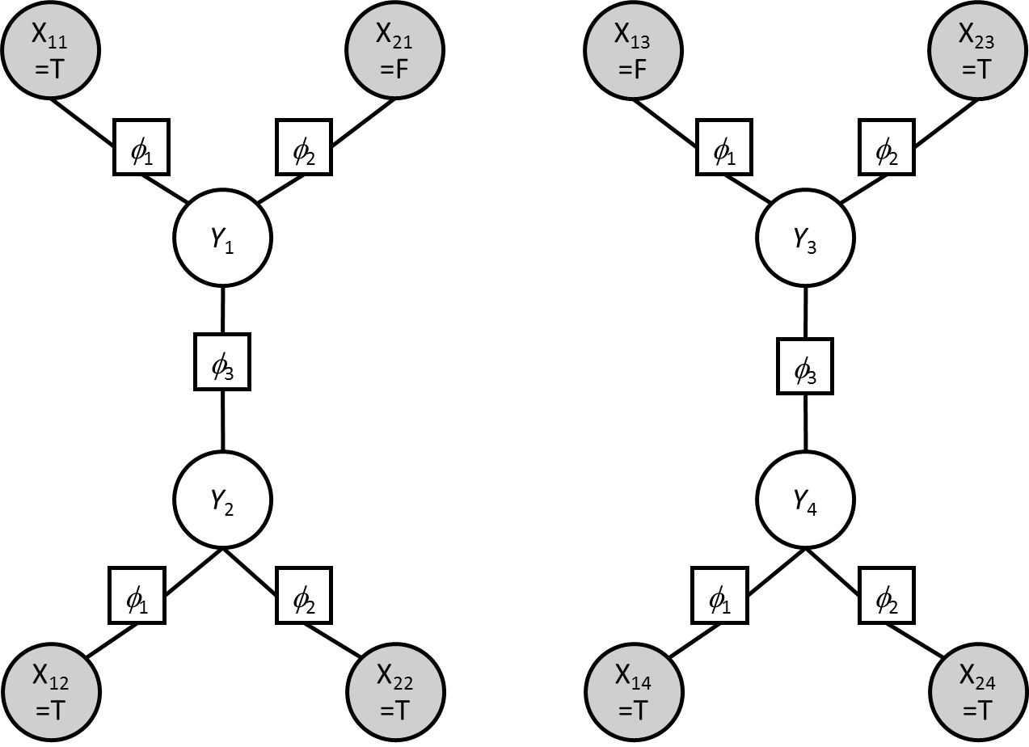

Calculate P(***Y***|***X***), that is P(*Y1*, *Y*2, *Y*3, *Y*4 | *X*11=T, *X*21=F, *X*12=T, *X*22=T, *X*13=F, *X*23=T, *X*14=T, *X*24=T). What is the MAP assignment to ***Y*** given ***X***? Show your work.

1. We are given the following Markov network structure, H.

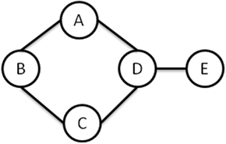

* 1. Find a minimal I-Map Bayesian network structure G1 for H. Use the variable order of A, B, C, D, E.
  2. Find a minimal I-Map Bayesian network structure G2 for H. Use the variable order of E, D, C, B, A.
  3. Is G1 a P-Map for H? If not, which independencies are missing?
  4. Is G2 a P-Map for H? If not, which independencies are missing?

1. We are given the following Bayesian network structure G.

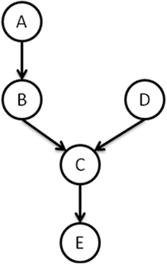

* 1. Find a minimal I-Map Markov network structure H for G. Use any method/variable order you like; make sure H is a *minimal* I-Map.
  2. Is H a P-Map for G? If not, which independencies are missing?