**NAME:**

**COLLABORATOR(S):**

**CS 583 – Assignment 3**

1. We are given the following Bayesian network where F is a deterministic OR of C and D. Are the following independence statements true or false?

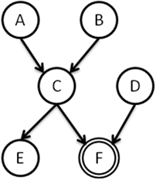

* 1. A ⊥ B
  2. A ⊥ B | D=T
  3. A ⊥ B | D=F
  4. A ⊥ B | F=T
  5. A ⊥ B | F=F
  6. A ⊥ E | D=T
  7. A ⊥ E | D=F
  8. B ⊥ E | D=T, F=T
  9. B ⊥ E | D=F, F=F
  10. B ⊥ E | D=F, F=T
  11. C ⊥ D

1. We have a Fever variable and *n* possible diseases that might cause fever. The structure is as follows. The CPD of P(Fever|D1, D2, …, Dn) is a noisy-or, with parameters λ0, λ1, λ2, …, λ*n.*

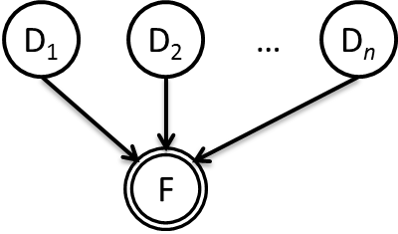

* 1. What is the probability of fever, if no disease is present?
  2. What is the probability of fever, if all dieseas are present?
  3. What is the probability of fever, if the diseases with an odd count (D1, D3, D5, …) are present and even count (D2, D4, D6, …) are not present. Assume *n* is even.

1. Given the following plate model, draw an unrolled version of the Bayesian network, where there are three items of type Object1 and two items of Object2 type. What probability distributions do we need to specify for this plate model?

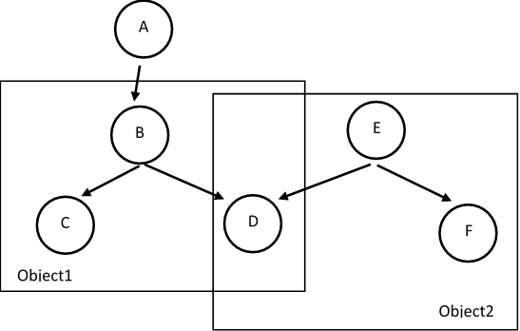

**Extra Questions** – Please do not submit solutions to the following questions. These are only for those of you would like to get extra practice on the course material.

1. Using Hugin, create and test
   1. A network where a node is a deterministic OR of its parents.
   2. A network where a node is a NoisyOR of its parents.
2. Create a simple Hidden Markov Model, along with its parameters, and compute P(**S**|**O**) and MAP (**S**|**O**).