**NAME:**

**COLLABORATOR(S):**

**CS 583 – HOMEWORK 4**

1. For the following linear chain, please calculate the requested probabilities using variable elimination. You can use any order you like. Show your work.

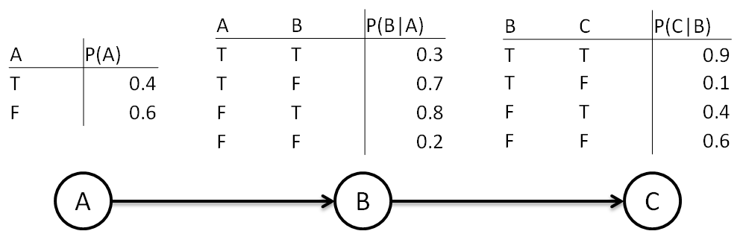

* 1. P(C)
  2. P(C|A=t)
  3. P(C|A=t,B=t)

1. For the following Bayesian network, perform variable elimination to compute P(E). Fill in the tables. Assume the variables are binary. In the first part, use the given order. In the second part, choose an order that requires fewer operations.

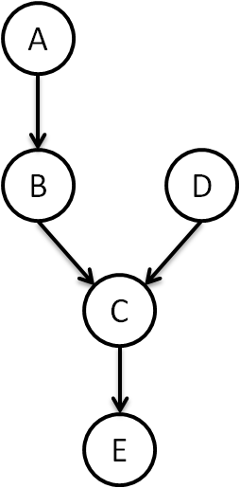

* 1. Fill the following table for computing P(E) using the variable elimination order of B, C, A, D.

|  |  |  |  |  |  |  |  |
| --- | --- | --- | --- | --- | --- | --- | --- |
| **Variable** | **All Factors** | **Participates** | **New Factor After \*** | **# *s** | **New Factor After +** | **# +s** | **# Ops** |
| B |  |  |  |  |  |  |  |
| C |  |  |  |  |  |  |  |
| A |  |  |  |  |  |  |  |
| D |  |  |  |  |  |  |  |
| Normalize |  |  |  |  |  |  |  |
| Total |  |  |  |  |  |  |  |

* 1. Find a variable elimination order for computing P(E) that requires fewer computations than part a above. Fill the following table for computing P(E) using that variable elimination order.

|  |  |  |  |  |  |  |  |
| --- | --- | --- | --- | --- | --- | --- | --- |
| **Variable** | **All Factors** | **Participates** | **New Factor After \*** | **# *s** | **New Factor After +** | **# +s** | **# Ops** |
|  |  |  |  |  |  |  |  |
|  |  |  |  |  |  |  |  |
|  |  |  |  |  |  |  |  |
|  |  |  |  |  |  |  |  |
| Normalize |  |  |  |  |  |  |  |
| Total |  |  |  |  |  |  |  |

1. For the following Markov network, calculate the requested probabilities using variable elimination. You can use any order you like.

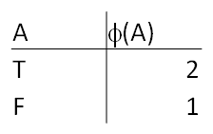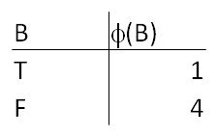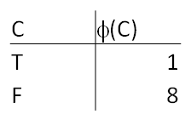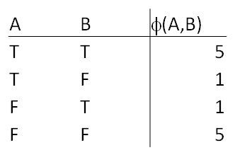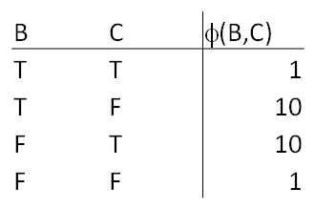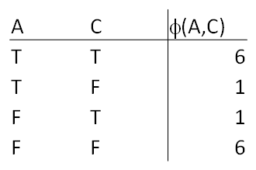

* 1. P(A)
  2. P(A|B=t)
  3. P(A|B=t, C=f)

1. We are given the following Bayesian network. For each of the following queries, indicate which variables are irrelevant.

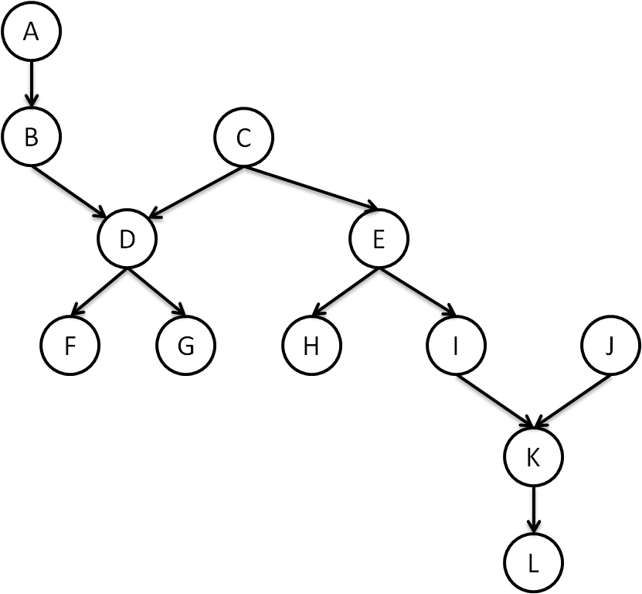

* 1. P(E)
  2. P(E|K)
  3. P(E|L)
  4. P(E|G)
  5. P(E|G, J)

1. For the following Bayesian network, create a join tree. First, moralize the graph. Then, pick an order using the min-fill heuristic. After finding the maximal cliques, connect those maximal cliques using maximal sepsets. Make sure that the final tree is a clique tree; that is, it is family preserving and it has the running intersection property.

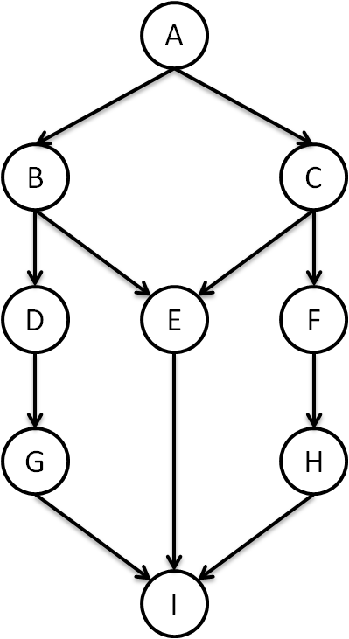

1. We are given the following pair-wise Markov random field.

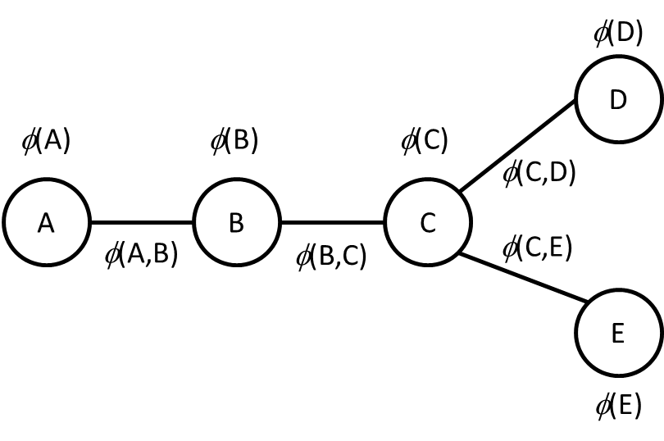

All variables are binary. The potentials are defined as follows.

A prefers to be True: *φ*(A) = <2, 1>. B and C do not have any preferences: *φ*(B) = *φ*(C) = <1, 1>. D and E prefer to be False: *φ*(D) = *φ*(E) = <1, 2>. The pair-wise potentials prefer positive correlations. *φ*(*Xi*, *Xj*) = 4 if *Xi* = *Xj*, 1 otherwise, for *Xi*, *Xj* ∈ {A, B, C, D}. For example, *φ*(A=T, B=T) = *φ*(A=F, B=F) = 4 and *φ*(A=T, B=F) = *φ*(A=F, B=T) = 1.

Here is a junction tree for this network where potentials are assigned to their cluster nodes.

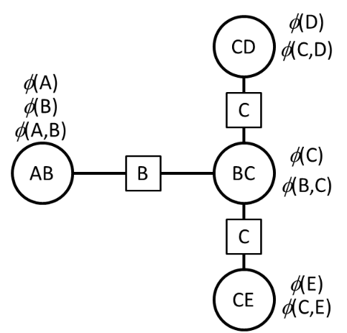

* 1. Perform message-passing on this junction tree. Compute all the messages. That is, compute
     1. δAB→BC
     2. δBC→CD
     3. δBC→CE
     4. δCD→BC
     5. δCE→BC
     6. δBC→AB
  2. What is the marginal probability of each individual variable? That is, compute the following using the potentials assigned to cluster nodes and messages those cluster nodes received from their neighbors
     1. P(A)
     2. P(B)
     3. P(C)
     4. P(D)
     5. P(E)