**NAME:**

**COLLABORATOR(S):**

**CS 583 – Assignment 5**

For all problems, please use the random numbers provided in random.csv file.

1. **Forward Sampling**: For the student network provided in class, assume that the evidence set is empty. We would like to compute marginal probabilities. We can of course perform variable elimination on this network because it is small, but for the purposes of this exercise, we will perform sampling. Perform forward sampling, assuming the variable order of D, I, S, G, L. For random number generator, use the random numbers provided in the random.csv file.
   1. Complete the following table. Continue sampling until you run out of random numbers. Add rows as needed. The first row is given as an example.

|  |  |  |  |  |
| --- | --- | --- | --- | --- |
| **D** | **I** | **S** | **G** | **L** |
| r=0.489  P(D)=<0.6,0.4>  sampled: d0 | r=0.833  P(I)=<0.7,0.3>  sampled: i1 | r=0.869  P(S|i1)=<0.2,0.8>  sampled: s1 | r=0.652  P(G|d0,i1)=<0.9,0.08,0.02>  sampled: g1 | r=0.581  P(L|g1)=<0.1,0.9>  sampled: l1 |
|  |  |  |  |  |

* 1. What is P(I) with respect to your sample?

1. **Rejection Sampling:** Assume the evidence is S=s0, G=g3. Perform rejection sampling on the network. When an instance is guaranteed to be rejected, do not waste any more resources on that instance; move to the next instance immediately. If an instance is rejected, note it as so.
   1. Complete the following table. Continue sampling until you run out of random numbers. Add rows as needed. The first two rows are given as examples.

|  |  |  |  |  |  |
| --- | --- | --- | --- | --- | --- |
| **D** | **I** | **S=s0** | **G=g3** | **L** | **Rej?** |
| r=0.489  P(D)=<0.6,0.4>  sampled: d0 | r=0.833  P(I)=<0.7,0.3>  sampled: i1 | r=0.869  P(S|i1)=<0.2,0.8>  sampled: s1 | --- | --- | Yes |
| r=0.652  P(D)=<0.6,0.4>  sampled: d1 | r=0.581  P(I)=<0.7,0.3>  sampled: i0 | r=0.042  P(S|i0)=<0.95,0.05>  sampled: s0 | r=0.748  P(G|d1,i0)=<0.05,0.25,0.7>  sampled: g3 | r=0.549  P(L|g3)=<0.99,0.01>  sampled: l0 | No |
|  |  |  |  |  |  |

* 1. What is P(I|S=s0, G=g3) with respect to your sample?

1. **Likelihood Weighting:** Assume the same evidence as in question 2. That is, S=s0, G=g3. Perform likelihood weighting.
   1. Complete the following table. Continue sampling until you run out of random numbers. Add rows as needed. The first row is given as an example.

|  |  |  |  |  |  |
| --- | --- | --- | --- | --- | --- |
| **D** | **I** | **S=s0** | **G=g3** | **L** | **Weight** |
| r=0.489  P(D)=<0.6,0.4>  sampled: d0 | r=0.833  P(I)=<0.7,0.3>  sampled: i1 | No sampling. w=1*P(s0|i1) w=1*0.2=0.2 | No sampling.  w=0.2*P(g3|d0,i1)  w=0.2*0.02=0.004 | r=0.869  P(L|g3)=<0.99,0.01>  sampled: l0 | 0.004 |
|  |  |  |  |  |  |

* 1. What is P(I|S=s0, G=g3) with respect to your sample?

1. **Gibbs Sampling for Bayesian Networks – with no evidence:** Given no evidence, perform Gibbs sampling on the student network, using the random numbers in the random.csv file. Assume we initialize the network as follows: D=d0, I=i0, S=s0, G=g2, L=l1. Visit the variables in the following order: D, I, S, G, L. Complete the following table. Continue sampling until you complete the first three iterations only. The first row is the initialization. Feel free to reuse probability computations as appropriate.

|  |  |  |  |  |  |
| --- | --- | --- | --- | --- | --- |
|  | **D** | **I** | **S** | **G** | **L** |
| Initialization | d0 | i0 | s0 | g2 | l1 |
| Iteration 1 |  |  |  |  |  |
| Iteration 2 |  |  |  |  |  |
| Iteration 3 |  |  |  |  |  |

1. **Gibbs Sampling for Bayesian Networks – with evidence:** Assume the evidence is S=s0, G=g3. Perform Gibbs sampling on the student network, using the random numbers in the random.csv file. Assume we initialize the remaining variables as follows D=d0, I=i0, L=l1. Visit the variables in the following order: D, I, L. Complete the following table. Continue sampling until you complete the first three iterations only. The first row is the initialization. Feel free to reuse probability computations as appropriate.

|  |  |  |  |  |  |
| --- | --- | --- | --- | --- | --- |
|  | **D** | **I** | **S=s0** | **G=g3** | **L** |
| Initialization | d0 | i0 | s0 | g3 | l1 |
| Iteration 1 |  |  |  |  |  |
| Iteration 2 |  |  |  |  |  |
| Iteration 3 |  |  |  |  |  |

1. **Gibbs Sampling for Markov Networks – with no evidence:** For this and the following question, assume a fully connected Markov network over variables A, B, and C. Assume the following factors. Perform Gibbs sampling on this network, using the random numbers in random.csv. Assume we initialize the variables as follows: A=T, B=F, C=F. Visit the variables in the following order: A, B, C.

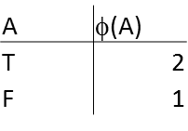 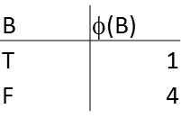 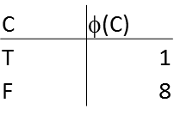 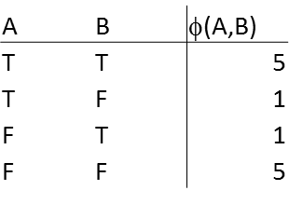 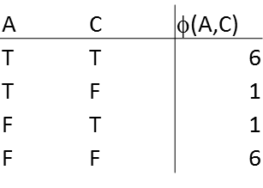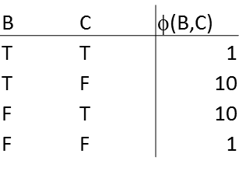

Complete the following table. Continue sampling until you complete the first three iterations only. The first row is the initialization. Feel free to reuse probability computations as appropriate.

|  |  |  |  |
| --- | --- | --- | --- |
|  | **A** | **B** | **C** |
| Initialization | T | F | F |
| Iteration 1 |  |  |  |
| Iteration 2 |  |  |  |
| Iteration 3 |  |  |  |

1. **Gibbs Sampling for Markov Networks – with evidence:** For this question, use above Markov network. Assume the evidence is B=T. Perform Gibbs sampling on this network, using the random numbers in random.csv. Assume we initialize the remaining variables as follows: A=T, C=F. Visit the variables in the following order: A, C. Complete the following table. Continue sampling until you complete the first three iterations only. The first row is the initialization. Feel free to reuse probability computations as appropriate.

|  |  |  |  |
| --- | --- | --- | --- |
|  | **A** | **B=T** | **C** |
| Initialization | T | T | F |
| Iteration 1 |  |  |  |
| Iteration 2 |  |  |  |
| Iteration 3 |  |  |  |

1. **MAP for Bayesian networks:** we are given the following Bayesian network. Answer the following questions.

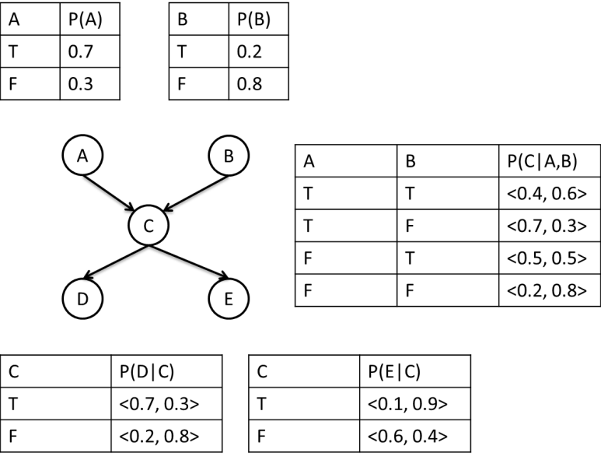

* 1. What is the MAP assignment, given no evidence?
  2. What is the MAP assignment, given C=T?
  3. What is the MAP assignment to (A, B), given no evidence?
  4. What is the MAP assignment to (A, B), given D=T, E=F?

1. **MAP for Markov networks:** We are given the following factor graph and the potential functions. Answer the following questions. Do not use calculators.

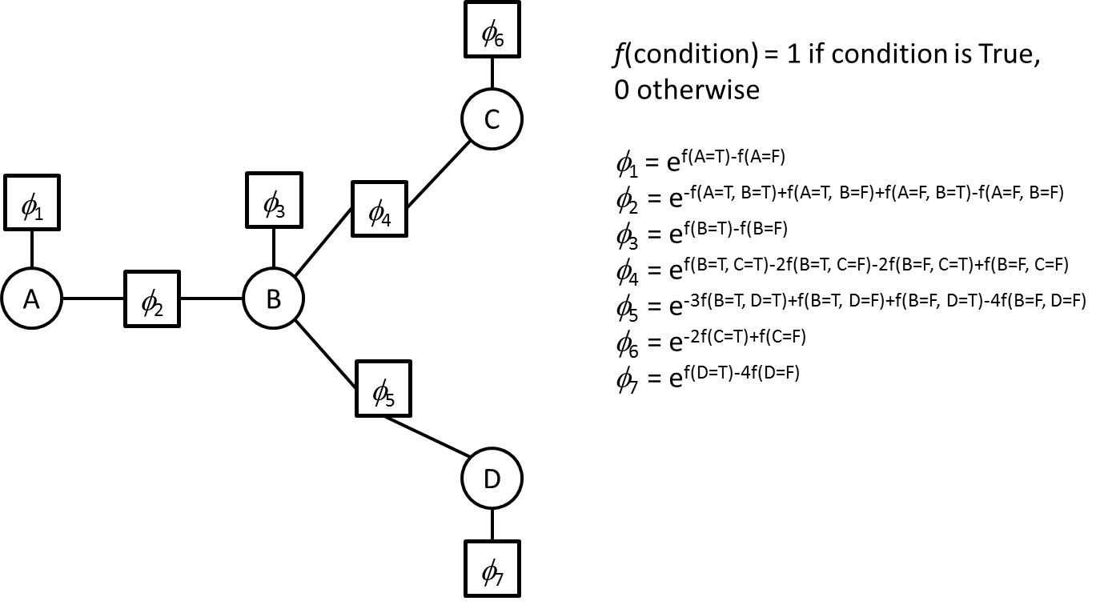

* 1. What is the MAP assignment, given no evidence?
  2. What is the MAP assignment, given C=T, D=T?